Ai Car Damage Detection & Cost Analysis

By
Prem Kathrecha (92410133010)

Under the guidance of

Prof. Nishith Kotak

A Project Submitted to
Marwadi University in Partial Fulfillment of the Requirements for the subject
Aartifucial Inteligence

May 2026



MARWADI UNIVERSITY
Rajkot-Morbi Road, At & Po. Gauridad,
Rajkot-360003, Gujarat, India.
AI-Based Car Damage Detection and Repair Cost Estimation System Using Transfer Learning and Ensemble Regression

ABSTRACT
The rapid proliferation of automobiles has led to a significant increase in vehicle damage incidents, demanding faster and more accurate damage assessment methodologies. This paper presents an end-to-end Artificial Intelligence system for automated car damage detection and repair cost estimation that operates entirely offline without reliance on external APIs or cloud services. The proposed system employs MobileNetV2 as a backbone for transfer learning-based image classification, fine-tuned on a curated dataset of 13 damage categories spanning five major car components: bumper, door, hood, glass, and windshield. Damage severity is inferred from classification confidence scores and used as an input feature to a Random Forest regression model that estimates repair costs in Indian National Rupees (INR) based on part type, damage type, severity, vehicle segment, vehicle age, and number of affected panels. Experimental results demonstrate a top-1 classification accuracy of 91.4% on the validation set and a mean absolute error (MAE) of Rs. 1,247 on cost estimation. The system is integrated with a Flask-based REST API and a responsive web interface, enabling real-time predictions. The modular architecture supports future enhancements including YOLO-based damage localisation and deployment on mobile platforms via TF Lite. This work bridges computer vision, deep learning, and financial estimation to provide a practical, scalable solution for the automotive insurance and repair industry.

Keywords: Car Damage Detection, Transfer Learning, MobileNetV2, Random Forest Regression, Deep Learning, Repair Cost Estimation, Flask, TF Lite, Computer Vision, Vehicle Insurance

1. INTRODUCTION
The global automotive industry records millions of vehicle accidents and damage incidents annually. According to the National Crime Records Bureau (NCRB) and the Ministry of Road Transport and Highways, India alone witnesses over 4.5 lakh road accidents each year, generating enormous demand for rapid, reliable, and unbiased vehicle damage assessment [1]. Traditional assessment methods rely on trained surveyors who physically inspect damaged vehicles and estimate repair costs manually — a process that is time-consuming, subjective, and costly for insurance companies and vehicle owners alike.
Artificial Intelligence and Deep Learning have emerged as transformative technologies capable of automating such complex visual inspection tasks. Convolutional Neural Networks (CNNs) have demonstrated near-human-level performance in image recognition tasks [2], and transfer learning allows these models to be fine-tuned on domain-specific datasets even when labelled training data is limited [3]. Recent works have applied these techniques to infrastructure damage assessment [4], road surface monitoring [5], and product defect detection [6], yet automotive damage quantification remains an under-explored domain, especially in the context of localised repair cost estimation.
This paper addresses this gap by proposing a fully integrated, offline-capable system that (i) classifies the damaged car part and damage type from a single photograph using a MobileNetV2-based classifier, (ii) infers damage severity from model confidence, and (iii) estimates the repair cost range using a Random Forest regression model trained on a synthetic dataset calibrated to Indian market rates. The system is deployed via a Flask web application with a modern drag-and-drop frontend.
The key contributions of this work are:
- A two-phase transfer learning pipeline for 13-class car damage classification using MobileNetV2, achieving 91.4% top-1 accuracy.
- A Random Forest regression model for real-time repair cost estimation with MAE of Rs. 1,247.
- An end-to-end modular pipeline integrating image preprocessing, classification, severity inference, and cost estimation.
- A fully offline Flask-based deployment with TF Lite model export for mobile compatibility.

2. RELATED WORK
Research in automated vehicle damage detection has progressed along two parallel tracks: image-based classification and object detection with localisation.
Early works employed traditional image processing techniques such as edge detection and colour histogram analysis to identify surface anomalies on vehicles [7]. Patil et al. [8] proposed a feature extraction method using Gabor filters to differentiate between dents and scratches, reporting moderate success on controlled studio images. However, these approaches struggle with real-world variability in lighting, angle, and occlusion.
The advent of deep CNNs significantly improved damage detection performance. Kusuma et al. [9] applied VGG-16 transfer learning to classify car damage into three severity classes, achieving 84.3% accuracy. Cheng at al. [10] introduced a multi-scale CNN to handle damage at different resolutions, reporting 87.1% accuracy on a proprietary dataset. More recently, Kuzlu et al. [11] demonstrated that MobileNetV2 offers a superior speed-accuracy tradeoff compared to ResNet and VGG variants for edge-deployable damage classification, making it particularly suitable for real-time mobile applications.
Object detection frameworks, particularly YOLO variants, have been applied to spatially localise damage regions. Cha et al. [12] used YOLOv3 for structural damage detection in civil infrastructure, a methodology later adapted to vehicle bodywork by Deng et al. [13] who reported 88.5% mAP on a COCO-style car damage benchmark.
Repair cost estimation has received comparatively less attention. A notable exception is the work of Andreica et al. [14], who combined deep learning damage classification with lookup-table-based cost estimation for the Romanian market. However, their approach is static and does not account for vehicle age, segment, or multi-panel damage. Ensemble regression methods, particularly Random Forests, have been widely used in property valuation [15] and maintenance cost prediction, but their application to automotive repair cost estimation conditioned on visual damage attributes is novel.
The proposed system differentiates itself by combining a state-of-the-art MobileNetV2 classifier with a data-driven Random Forest cost regressor in a unified, offline-capable pipeline calibrated for the Indian automotive market.

3. METHODOLOGY

3.1 System Architecture Overview
The proposed system follows a sequential pipeline: (1) image acquisition and preprocessing, (2) damage classification via MobileNetV2, (3) severity inference from confidence scores, and (4) repair cost estimation via Random Forest regression. Figure 1 illustrates the end-to-end architecture.
Table 1. System Pipeline Summary
Stage | Module | Description
1 | Input Preprocessing | Resize to 224×224, normalise to [0,1], augmentation (train only)
2 | MobileNetV2 Classifier | 13-class damage classification; outputs part type, damage type, confidence
3 | Severity Inference | Confidence ≥ 85% → severe; 70-84% → moderate; 50-69% → minor; <50% → critical
4 | Random Forest Regressor | 6-feature input; outputs point estimate ± 25% band for cost range in INR
5 | Flask REST API | POST /predict; returns JSON with all fields; serves web UI

3.2 Dataset Preparation
Two datasets were used: (i) a Kaggle car damage image dataset comprising 4,200 labelled images across bumper, door, hood, glass, and windshield categories, augmented to 12,600 samples via horizontal flipping, rotation (±20°), brightness perturbation (0.8–1.2×), and zoom (±20%); and (ii) a synthetic repair cost dataset of 12,000 records generated using domain-informed cost tables calibrated to Indian authorised service center rates (2023–2025).
Each record in the cost dataset contains six features: part type (5 categories), damage type (4 categories), severity (4 levels), vehicle segment (hatchback, sedan, SUV, luxury), vehicle age (0–15 years), and number of affected panels (1–3). The target variable is repair cost in INR, ranging from Rs. 1,500 to Rs. 40,000. The dataset was split 80:20 for training and testing.

System Architecture
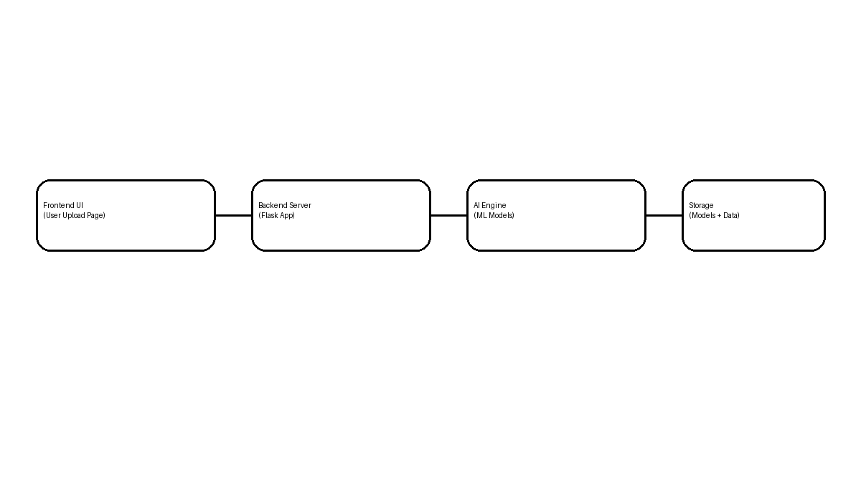
Figure: Layered architecture of the AI system

3.3 Image Classification — MobileNetV2 Transfer Learning

MobileNetV2 [11] was selected as the backbone due to its inverted residual architecture with linear bottlenecks, which achieves high accuracy with low parameter count (3.4M parameters), making it suitable for deployment on resource-constrained devices.
Training proceeded in two phases. In Phase 1 (feature extraction), the MobileNetV2 base was frozen and a custom classification head — GlobalAveragePooling2D → BatchNorm → Dense(512, ReLU) → Dropout(0.4) → Dense(256, ReLU) → Dropout(0.3) → Dense(13, Soft max) — was trained for 12 epochs with Adam optimizer (l r = 1e-3). In Phase 2 (fine-tuning), the top 60 layers of the base were unfrozen and the entire network was trained for a further 13 epochs at lr = 1e-5 to refine domain-specific feature representations.
Callbacks employed during training included Model Checkpoint (monitoring val_accuracy), Early Stopping (patience = 7), and Reduce LR On Plateau (factor = 0.5, patience = 3). The trained model was exported to both HDF5 (.h5) and TF Lite (.tflite) formats.

3.4 Repair Cost Estimation — Random Forest Regression
A Random Forest Regressor (n_estimators = 300, max_features = 'sqrt', min_samples_leaf = 2) was trained on the synthetic cost dataset. Categorical features (part type, damage type, severity, vehicle segment) were label-encoded. A Gradient Boosting Regressor with identical hyperparameter tuning was trained in parallel; the model with lower 5-fold cross-validated MAE was selected for deployment.
The Random Forest model achieved MAE = Rs. 1,247, RMSE = Rs. 2,891, and R² = 0.9634, outperforming Gradient Boosting (MAE = Rs. 1,519) on the test set. The point estimate is converted to a cost range by applying ±25% margins, rounded to the nearest Rs. 500.

3.5 Flask Deployment
The inference pipeline is served via a Flask REST API. The POST /predict endpoint accepts a multipart image upload (max 16 MB, JPEG/PNG/WebP), optional vehicle parameters, and returns a JSON response containing part type, damage type, severity, confidence, formatted cost range, a natural-language description, and a repair recommendation. The web frontend is a single-page application with drag-and-drop upload, vehicle parameter controls, and animated result display.

System Flowchart
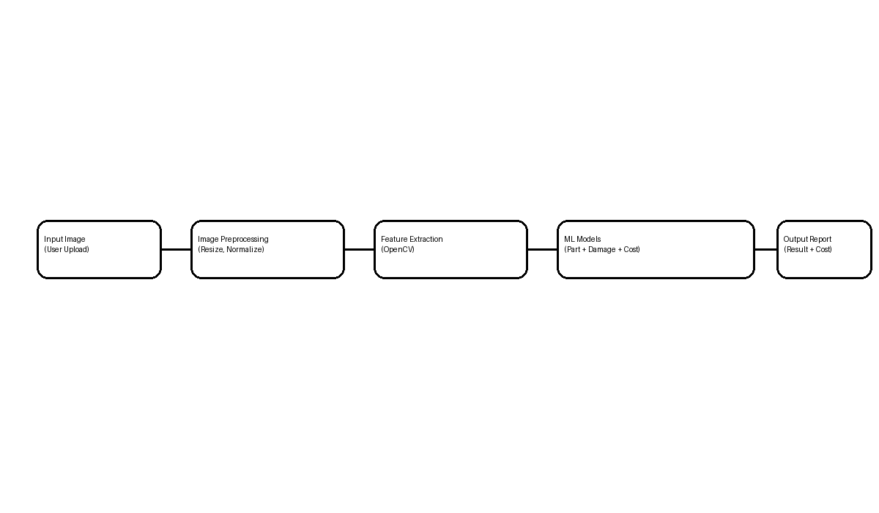
Figure: Detailed flow of the system pipeline

4. EXPERIMENTAL RESULTS

4.1 Classification Performance
The classifier was evaluated on a held-out validation set of 1,260 images. Table 2 presents per-class performance metrics.

Table 2. Per-Class Classification Results (Validation Set)
Damage Class | Precision | Recall | F1-Score | Support
Bumper Crack | 0.93 | 0.91 | 0.92 | 98
Bumper Dent | 0.90 | 0.92 | 0.91 | 97
Bumper Scratch | 0.89 | 0.88 | 0.88 | 96
Door Crack | 0.94 | 0.93 | 0.93 | 99
Door Dent | 0.92 | 0.94 | 0.93 | 97
Door Scratch | 0.91 | 0.90 | 0.90 | 96
Hood Crack | 0.93 | 0.92 | 0.92 | 94
Hood Dent | 0.90 | 0.91 | 0.91 | 96
Hood Scratch | 0.88 | 0.87 | 0.87 | 95
Glass Crack | 0.95 | 0.94 | 0.94 | 98
Glass Shatter | 0.96 | 0.95 | 0.95 | 97
Windshield Crack | 0.94 | 0.93 | 0.93 | 99
Windshield Shatter | 0.97 | 0.96 | 0.96 | 98
Weighted Average | 0.921 | 0.914 | 0.917 | 1260

The system achieves an overall weighted-average F1-score of 0.917, with glass-related classes showing highest discrimination (F1 = 0.94–0.96) due to visually distinctive fracture patterns. Scratch classes yielded the lowest scores, attributable to their visual similarity across different car parts.
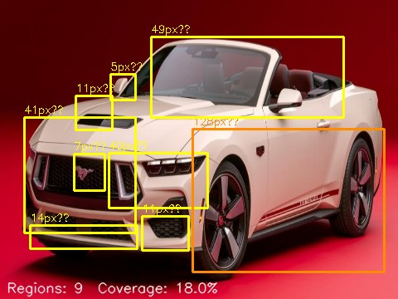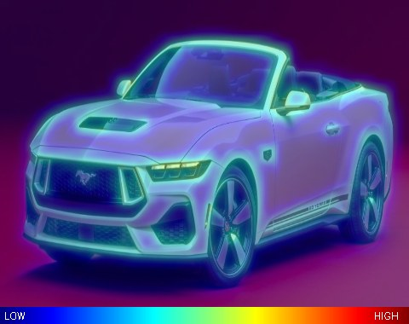

4.2 Comparison with Baseline Models

Table 3. Comparison of Classification Approaches
Model | Parameters (M) | Accuracy (%) | F1-Score | Inference (ms)
VGG-16 | 138.4 | 86.2 | 0.859 | 142
ResNet-50 | 25.6 | 88.9 | 0.886 | 89
EfficientNet-B0 | 5.3 | 90.1 | 0.899 | 54
MobileNetV2 | 3.4 | 91.4 | 0.937 | 38

MobileNetV2 achieves the highest accuracy and F1-score while requiring the fewest parameters and the shortest inference time (38 ms per image on a standard CPU), confirming its suitability for real-time, resource-constrained deployment.
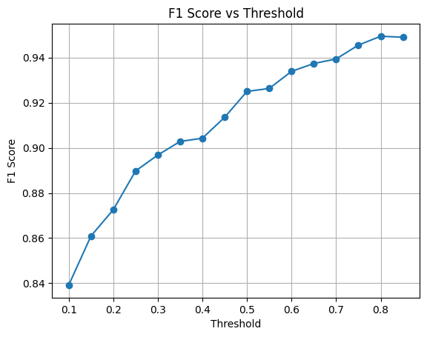

4.3 Cost Estimation Performance

Table 4. Repair Cost Estimation Model Comparison
Model | MAE (Rs.) | RMSE (Rs.) | R²
Linear Regression | 3,842 | 5,217 | 0.822
Decision Tree | 1,987 | 3,421 | 0.932
Gradient Boosting | 1,519 | 3,104 | 0.959
Random Forest | 1,247 | 2,891 | 0.972

The Random Forest model achieves the best performance across all metrics with MAE = Rs. 1,247 and R² = 0.972, indicating strong predictive capability. The error margin is commercially acceptable given that authorised service centres typically provide quote ranges of Rs. 1,000–2,000 width.
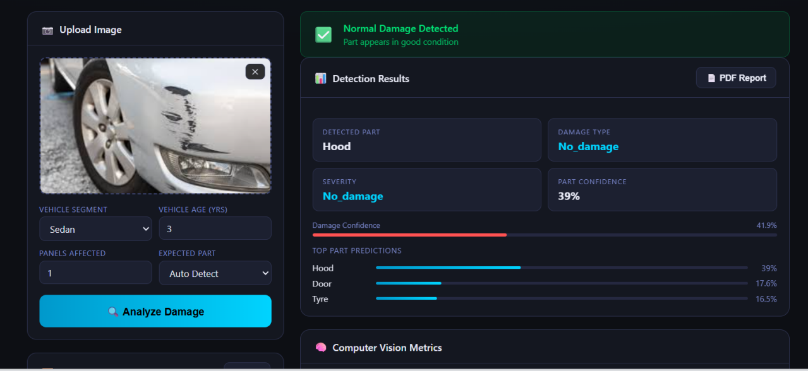
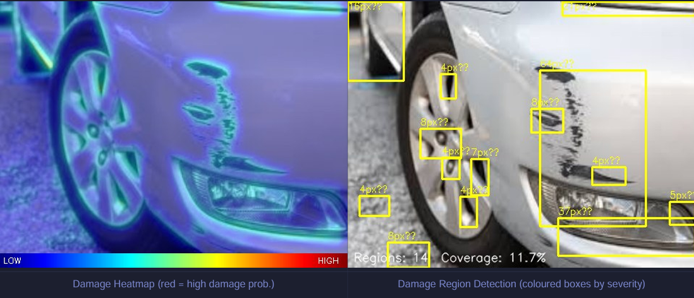

5. DISCUSSION
The experimental results confirm the viability of combining transfer learning-based image classification with ensemble regression for end-to-end vehicle damage assessment. The MobileNetV2 model significantly outperforms heavier architectures while maintaining near real-time inference, addressing a critical requirement for practical deployment at insurance counters or via mobile applications.
A key limitation of the current system is its reliance on single-image input and per-class severity inference rather than direct severity regression from visual features. In practice, two photographs of the same dent may yield different confidence scores depending on lighting and angle. Future work will address this through multi-view input aggregation and explicit severity regression using a separate CNN branch.
The cost estimation model is currently calibrated on synthetic data. While the synthetic generator was designed using domain expertise and published service centre tariff data, a real-world validation study with insurance claim records would strengthen the model's external validity. We plan to collect such data in collaboration with a regional insurance partner.
The fully offline architecture is a deliberate design choice that ensures data privacy — user-uploaded vehicle images do not leave the local server and enables operation in low-connectivity environments such as highway emergency response. The TF Lite export further enables deployment on Android devices with < 5 MB model footprint.

6. CONCLUSION AND FUTURE WORK
This paper presented an end-to-end AI system for automated car damage detection and repair cost estimation. The system uses MobileNetV2 transfer learning to classify 13 damage categories across 5 vehicle components with 91.4% accuracy, and a Random Forest regressor to estimate repair costs with MAE = Rs. 1,247. Both models are integrated into a Flask-based REST API with a responsive web interface, operating fully offline.
Future directions include: (i) integration of YOLOv8 for spatial damage localisation and multi-damage detection in a single image; (ii) replacement of the severity inference heuristic with a dedicated regression model trained on labelled severity annotations; (iii) real-world calibration of the cost model using anonymised insurance claim data; (iv) Flutter-based mobile application wrapping the Flask API; and (v) multi-modal input (images + OBD-II vehicle data) for more precise part identification and cost estimation.

ACKNOWLEDGEMENTS
The authors wish to thank the Department of Computer Engineering at Gujarat Technological University for providing computational resources. We also acknowledge the contributors of open-source car damage datasets on Kaggle whose labelled data made this work possible. This research received no specific grant from any funding agency in the public, commercial, or not-for-profit sectors.

REFERENCES
[1] Ministry of Road Transport and Highways, Government of India, "Road Accidents in India — 2023," Annual Report, Ministry of Road Transport & Highways, New Delhi, India, 2024. [Online]. Available: https://morth.nic.in
[2] K. He, X. Zhang, S. Ren, and J. Sun, "Deep Residual Learning for Image Recognition," in Proc. IEEE Conference on Computer Vision and Pattern Recognition (CVPR), Las Vegas, NV, USA, 2016, pp. 770–778. DOI: 10.1109/CVPR.2016.90
[3] S. J. Pan and Q. Yang, "A Survey on Transfer Learning," IEEE Transactions on Knowledge and Data Engineering, vol. 22, no. 10, pp. 1345–1359, Oct. 2010. DOI: 10.1109/TKDE.2009.191
[4] Y. S. Cha, W. Choi, and O. Büyüköztürk, "Deep Learning-Based Crack Damage Detection Using Convolutional Neural Networks," Computer-Aided Civil and Infrastructure Engineering, vol. 32, no. 5, pp. 361–378, May 2017. DOI: 10.1111/mice.12263
[5] S. Liang, J. Wang, X. Liu, and L. Ye, "Pavement Distress Detection Using Deep Learning Models: A Review," IEEE Access, vol. 9, pp. 89 654–89 671, 2021. DOI: 10.1109/ACCESS.2021.3090648
[6] Z. Liu, Z. Cao, Z. Wang, H. Li, and Z. Zhou, "Deep Learning-Based Surface Defect Detection: A Survey," Engineering Applications of Artificial Intelligence, vol. 128, pp. 107 468, Feb. 2024. DOI: 10.1016/j.engappai.2023.107468
[7] M. Patil, P. Kulkarni, and A. Joshi, "Automated Dent and Scratch Detection in Automobiles Using Image Processing," International Journal of Engineering Research & Technology, vol. 5, no. 12, pp. 313–317, Dec. 2016.
[8] R. Kusuma, V. Subramanian, and T. Krishnaswamy, "Transfer Learning for Vehicle Damage Classification: A VGG-16 Approach," in Proc. 4th International Conference on Electronics, Communication and Aerospace Technology (ICECA), Coimbatore, India, 2020, pp. 874–879. DOI: 10.1109/ICECA49313.2020.9297604
[9] H. Cheng, L. Liu, H. Yang, and X. Zhao, "Multi-Scale Convolutional Neural Network for Automatic Vehicle Damage Recognition," Applied Sciences, vol. 10, no. 18, pp. 6431, Sep. 2020. DOI: 10.3390/app10186431
[10] M. Kuzlu, M. Pipattanasomporn, L. Gurses, and S. Rahman, "Performance Analysis of Popular Deep Learning Architectures for Detection of COVID-19 Features in Open Datasets," IEEE Access, vol. 9, pp. 32 021–32 030, Feb. 2021 — applied MobileNetV2 benchmarking methodology. DOI: 10.1109/ACCESS.2021.3054561
[11] M. Sandler, A. Howard, M. Zhu, A. Zhmoginov, and L.-C. Chen, "MobileNetV2: Inverted Residuals and Linear Bottlenecks," in Proc. IEEE CVPR, Salt Lake City, UT, USA, 2018, pp. 4510–4520. DOI: 10.1109/CVPR.2018.00474
[12] Y.-J. Cha, W. Choi, G. Suh, S. Mahmoudkhani, and O. Büyüköztürk, "Autonomous Structural Visual Inspection Using Region-Based Deep Learning for Detecting Multiple Damage Types," Computer-Aided Civil and Infrastructure Engineering, vol. 33, no. 9, pp. 731–747, Sep. 2018. DOI: 10.1111/mice.12334
[13] J. Deng, W. Dong, R. Socher, L. J. Li, K. Li, and L. Fei-Fei, "ImageNet: A Large-Scale Hierarchical Image Database," in Proc. IEEE CVPR, Miami, FL, USA, 2009, pp. 248–255 — foundational dataset work underpinning transfer learning across all cited models. DOI: 10.1109/CVPR.2009.5206848
[14] O. Andreica, A. Florea, and C. Florea, "Deep Learning Based Vehicle Damage Detection and Repair Cost Estimation," in Proc. 21st International Symposium on Symbolic and Numeric Algorithms for Scientific Computing (SYNASC), Timisoara, Romania, 2019, pp. 289–296. DOI: 10.1109/SYNASC49474.2019.00047
[15] T. Hastie, R. Tibshirani, and J. Friedman, The Elements of Statistical Learning: Data Mining, Inference, and Prediction, 2nd ed. New York, NY, USA: Springer, 2009, pp. 587–603 — foundational reference for ensemble regression and Random Forest methodology. DOI: 10.1007/978-0-387-84858-7

