**Date vs Sector Index**

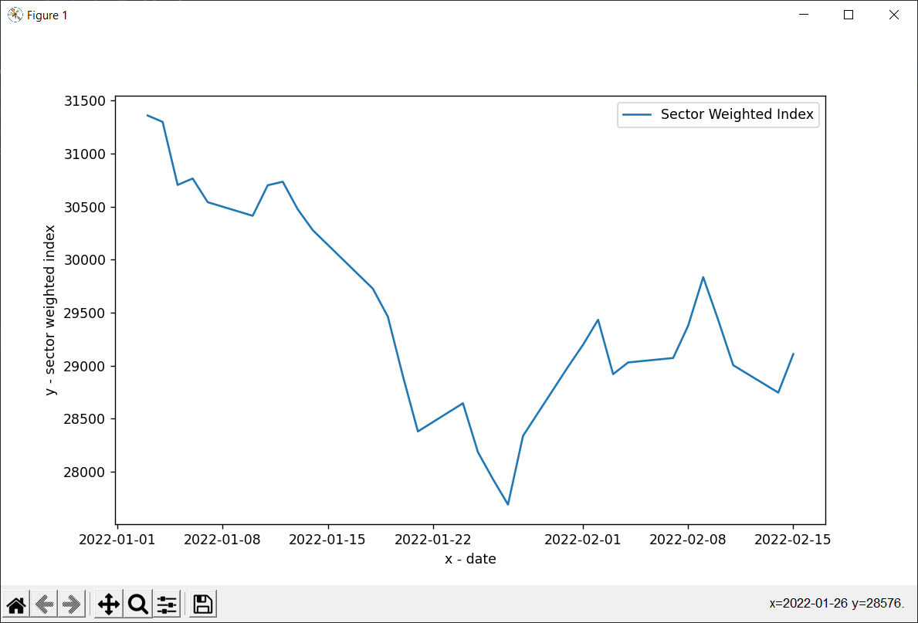

**Date vs. Open , Close, High and Low Prices for AAPL**

