**DropDown EndPoint**

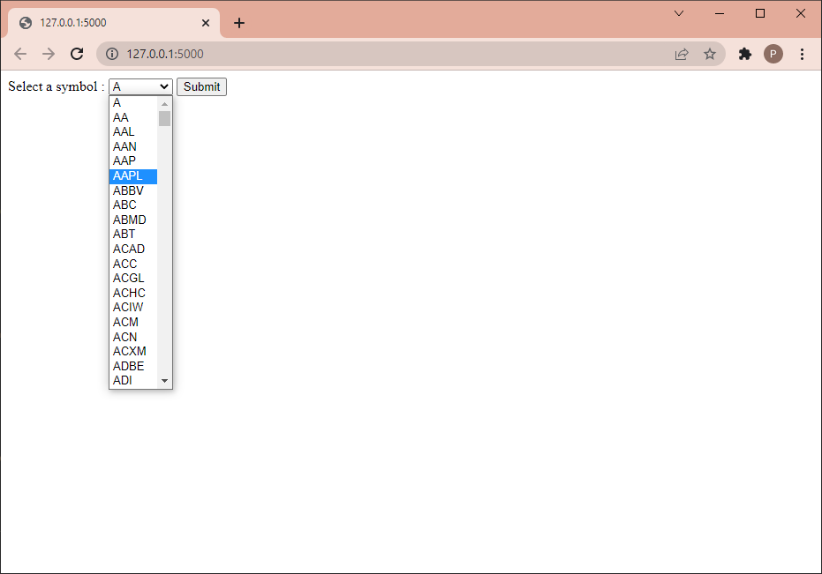

**Connects to line chart – shows line chart with different pricing for selected symbol from dropdown.**

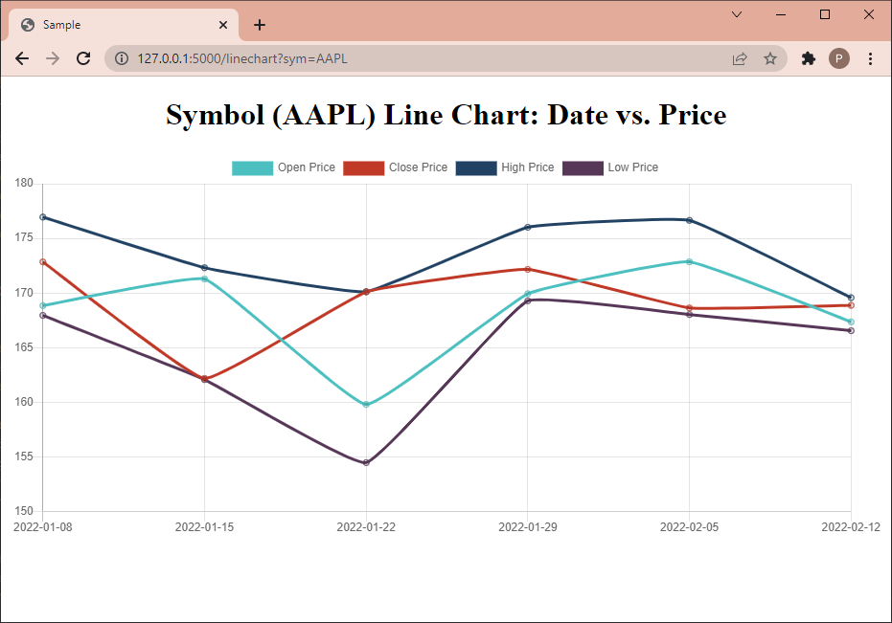

**Textbox for entering symbol**

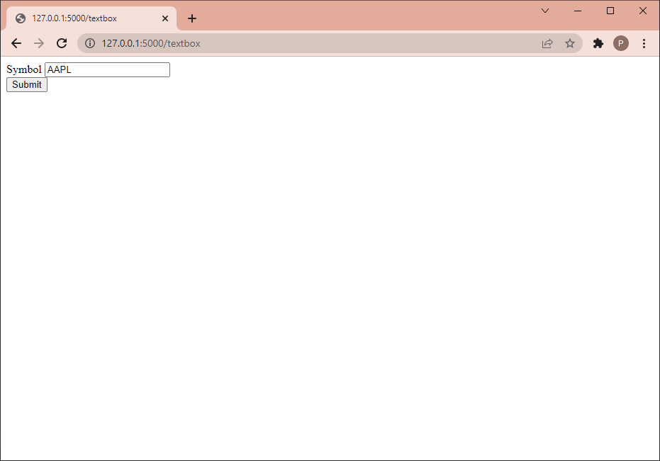

**Shows Symbol details.**

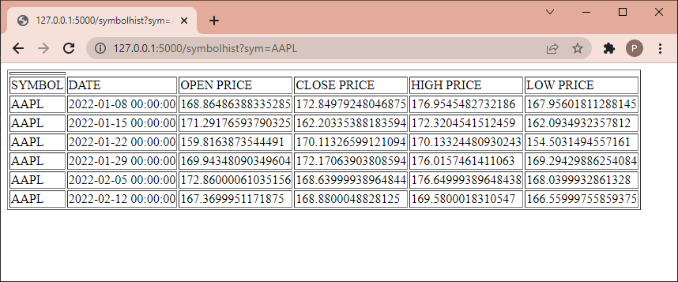

**TextBox for entering symbol**



**Shows results for entered symbol**

