**MontageAgent – Architecture & Rationale**

**Project:** MontageAgent — AI Agent for Event Photo Curation & Instagram Publishing  
**Author:** Prem Kondru (BTech Engineering Physics, IIT Guwahati; Photography Club: Montage)

Github url: <https://github.com/premkondru/MontageAgent>

App URL: <https://huggingface.co/spaces/premkondru/montage-agent>

**Purpose & Problem**

At IIT Guwahati’s Photography Club (Montage), every event generates hundreds of photos. The manual workflow involves:

1. Removing duplicates
2. Grouping by theme/moment
3. Writing captions in a consistent style
4. Assembling Instagram carousel posts

This process is repetitive, error-prone, and consumes hours of human effort.

**MontageAgent automates the workflow end-to-end:**  
**Ingest → Dedupe → Categorize → Cluster → Caption → Export/Publish**

**Interaction Flow**

1. **User Input:** Upload images, set labels, choose captioner mode, define event name, adjust max_images_per_post.
2. **Pipeline Execution:** Ingest → Embed → Deduplicate → Categorize → Cluster → Caption → Export.
3. **Captioning:**
   * **BLIP-2 mode:** Generate per-image captions, extract common words, produce abstract caption.
   * **Template mode:** Deterministic, rule-based caption.
   * Hashtags pulled from base + labels + historical RAG hints.
4. **Preview & Export:** IG-style preview, per-image inclusion/exclusion, JSON export for carousel.

**How the Agent Works**

**Reasoning**

* **Visual Understanding:** CLIP embeddings assess similarity, remove near-duplicates, and infer labels (zero-shot).
* **Captioning:** Two captioner modes:
  + **Template Mode** → Deterministic, rule-based captions.
  + **BLIP-2 (with LoRA)** → Generates captions based on a set of cluster images.
* **Stylistic Consistency:** Retrieval-augmented input (RAG) over past captions maintains tone and ensures continuity across posts.

**Planning**

* A **Supervisor (Planner)** module orchestrates a fixed pipeline:  
  *Ingest → Embed → Dedupe → Categorize → Cluster → Caption → Export*.
* The plan is deterministic, simplifying debugging and evaluation.

**Execution**

* **Executors (Workers):** Each step runs as an independent tool with clear inputs/outputs.
* **Human-in-the-loop UI:** Built with Streamlit, allowing users to include/exclude photos, adjust labels, and preview posts before export.

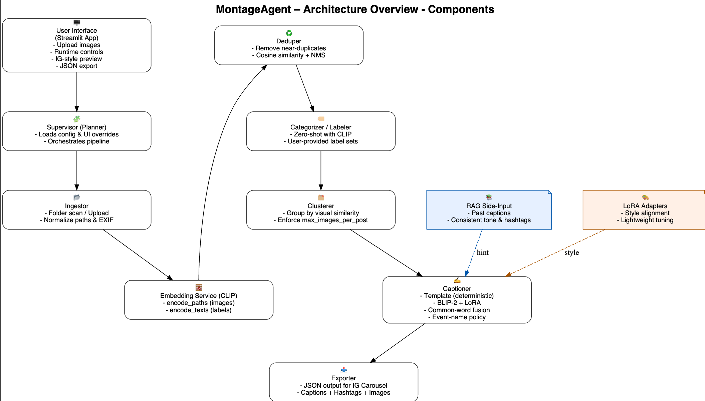

**Components**

* **User Interface:** Streamlit app with IG-style previews, zoom, toggles, runtime configs, and JSON export.
* **Supervisor (Planner):** Loads config, applies UI overrides, sequences executors.
* **Ingestor:** Scans folders/uploads, builds image list.
* **Embedding Service (CLIP):** Provides encode_paths and encode_texts for similarity, clustering, and label assignment.
* **Deduper:** Removes near-duplicates via cosine similarity.
* **Categorizer/Labeler:** Zero-shot label assignment using CLIP and user-provided label sets.
* **Clusterer:** Groups images by visual similarity; enforces max_images_per_post with balanced sampling.
* **Captioner:**
  + **Template mode:** Deterministic phrasing.
  + **BLIP-2 mode:** Batch captioning + LoRA fine-tuning; fuses outputs into one abstract caption. Supports event-name injection policies (off | hint | only_proper_noun).
* **Exporter:** Builds JSON for Instagram Posts upload: {caption, hashtags, images[]}.

**Key Design Choices & Agent Patterns**

[**https://www.anthropic.com/engineering/building-effective-agents**](https://www.anthropic.com/engineering/building-effective-agents)

[**https://arxiv.org/pdf/2405.1046**](https://arxiv.org/pdf/2405.1046)

* **Role‑based cooperation (multi‑agent): Supervisor + tool workers (ingest, embed, dedupe, cluster, caption, export).**
* **Fixed pipeline:** Single path improves reliability, reproducibility, and transparency.
* **Prompt/response optimisation:** strict caption prompts; output guards (no hashtags, abstract, proper‑noun policy).
* **CLIP** for structural tasks (dedupe, clustering, labels): Efficient, lightweight, and non-generative.
* **RAG:** style/hashtag hints from nearest past captions.
* **BLIP-2 + LoRA for style:** Strong caption quality with minimal compute/storage overhead.
* **Config-driven + UI overrides:** Enables repeatability, A/B testing, and flexible runtime control.
* **Guardrails:** Caption length limits, “event name only” injection, and exclusion of proper nouns ensure alignment with club style.
* **Evaluator:** CLIPScore & silhouette surfaced to the user; iterative feedback loop.

**Models & Rationale**

* **OpenCLIP (model ViT-B/32 pretrained laion2b_s34b_b79k):**
  + Lightweight, efficient visual similarity.
  + Ideal for deduplication, clustering, zero-shot labels, CLIPScore.
* **RAG over Past Captions:**
  + Ensures consistency in tone/hashtags.
  + Avoids over-fitting to rigid templates.
* **BLIP-2 (base model Salesforce/blip2-flan-t5-xl) with LoRA:**
  + Generates abstract, mood-driven captions aligned with club style.
  + LoRA enables style specialization without full finetuning.
  + Per-image batching + common-word fusion prioritizes shared visual cues.
  + Guardrails enforce reliability and stylistic alignment.

**Evaluation: Quality & Reliability Metrics**

* **CLIPScore:** Measures caption–image alignment (per-image and cluster means).
* **Silhouette Score:** Quick proxy for clustering cohesion/separation.
* **Dedupe Rate:** % of near-duplicates removed.
* **Human Ratings (optional):** Abstractness, tone, Instagram readiness.
* **A/B Protocol:** Compare **template vs BLIP-2/LoRA** on the same clusters; track metrics per event and overall.
* A full **Data Science Report (PDF)** and **Interaction Logs** (prompts + chat history) are generated to document method and outcomes.

**In summary, Montage is a complete, AI agent that automates a real university workflow, integrates a LoRA-tuned model for style-safe captioning, and ships with the metrics and documentation required to evaluate and maintain it.**