US Robotaxi Safety Intelligence
& Incident Analytics
Operational Risk, Deployment Trends, and Compliance Patterns in Autonomous Mobility

Prepared by: Prem kumar Gara
Date: June 22, 2026
Deliverable: Professional Analytics Portfolio Project

Table of Contents
Table of Contents 2
1. Executive Summary 3
Key Performance Indicators (KPIs) 3
Strategic Recommendation 3
2. Methodology & Approach 4
Data Sourcing and Scope Definition 4
Data Cleaning and Deduplication Pipeline 4
Feature Engineering for Operational Insights 4
Dashboard and Analytical Layering 5
3. Exploratory Data Analysis (EDA) 6
The Scaling Footprint 6
Environmental and Interaction Baselines 6
The Severity Profile 6
4. Key Findings & Limitations 8
Key Findings 8
Limitations of the Analysis 8
5. Recommendations 10
1. Mandate Integration of Exposure Metrics 10
2. Standardize Administrative Amendment Pipelines 10
3. Optimize Intersection-Specific Object Detection Models 10
6. Appendix: Screenshot Placeholders Log 12

1. Executive Summary
The US autonomous mobility and robotaxi ecosystem is demonstrating distinct operational maturity. An analysis of real-world autonomous driving system (ADS) incident reports spanning June 2025 through April 2026 reveals an environment characterized by low-severity incidents, standardized reporting compliance, and highly restricted operational design domains (ODD).
Crucially, the current incident volume across operators is an indicator of deployment scale and operational footprint rather than an inherent reflection of safety failures. Fleet operators are maintaining strict boundaries on their autonomous systems, keeping interactions largely predictable, yet administrative reporting structures—particularly regarding reporting lags—show varying levels of operational standardization across industry players.

Key Performance Indicators (KPIs)
- • 861 Verified Incidents tracked post-cleaning across all major US operators.
- • 98.9% ODD Compliance, indicating autonomous systems are strictly operating within their designed and mapped environmental domains.
- • >97% Short-Lag Submission Rate, with the vast majority of incidents reported within a standard 0–1 month compliance window.
- • Overwhelming Low-Severity Profile, with delayed reporting explicitly unlinked to higher incident severity.

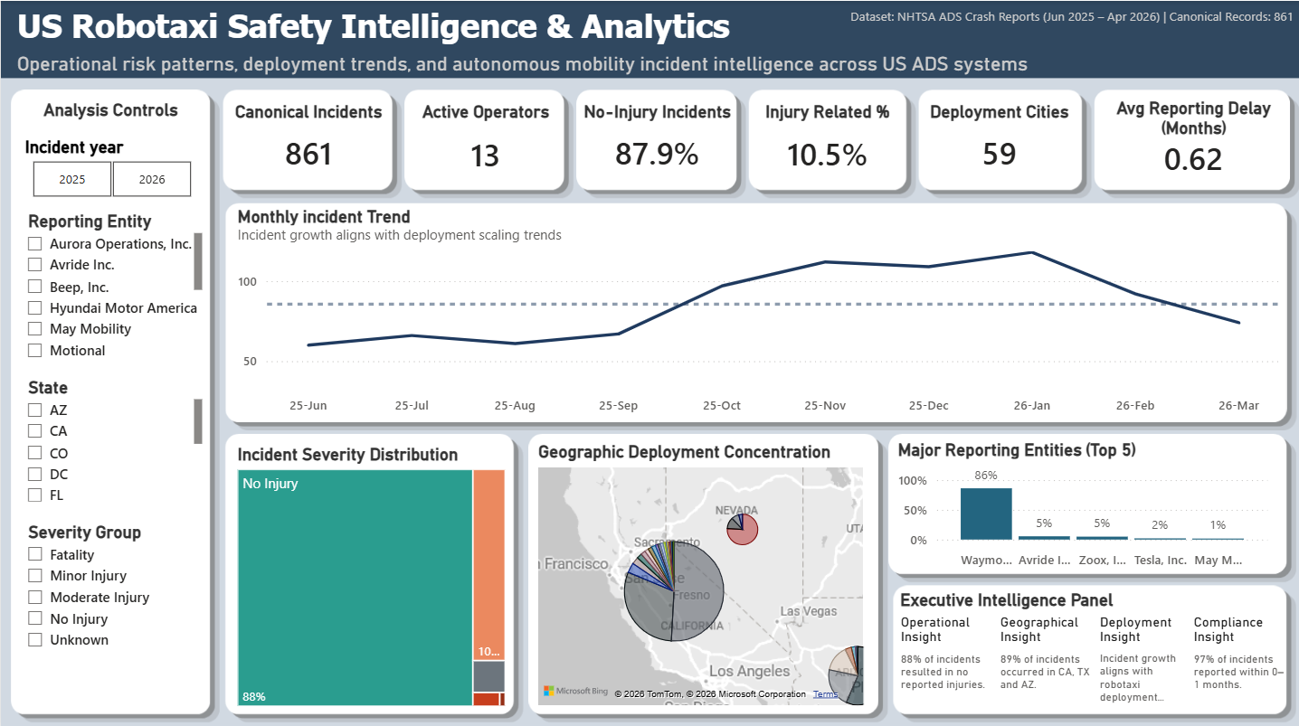

Strategic Recommendation
To progress from foundational volume-tracking to accurate safety performance measurement, the industry—and its regulators—must prioritize the integration of operational exposure metrics (e.g., Vehicle Miles Traveled, active operational hours). Without denominator data, incident counts remain a proxy for fleet size rather than a true measure of autonomous risk.

2. Methodology & Approach
This project executed a robust, end-to-end data processing pipeline designed to transform raw, unstructured regulatory disclosures into a structured analytical model suitable for business intelligence reporting. The methodology prioritizes data integrity, precise categorical normalization, and operational relevance over algorithmic complexity.

Data Sourcing and Scope Definition
The foundational dataset was acquired from the official NHTSA ADS Crash Dataset under Standing General Order 2021-01. The temporal scope spans January 2025 through April 2026, though robust data concentration exists primarily from June 2025 onward. The raw dataset contained 895 incident reports across 116 data dimensions.

Data Cleaning and Deduplication Pipeline
To combat reporting anomalies and data redundancy, a rigorous Python/pandas cleaning pipeline was deployed:
- Dimensionality Reduction: The 116 original columns contained high sparsity and irrelevant metadata. The dataset was reduced to 23 canonical columns focusing exclusively on core analytics (Reporting Entity, Incident/Submission Dates, Location, Interaction Context, Severity, and Narrative).
- Deduplication Strategy: Exact and fuzzy duplicate analysis identified overlapping submissions (e.g., iterative amendments or multi-entity reporting for a single event). 34 redundant records were successfully purged, yielding a final analytical dataset of 861 unique incidents.
- Datetime Parsing and Normalization: Native string dates were cast to structured pandas Datetime objects to enable reliable time-series aggregation and quarter-over-quarter comparisons.
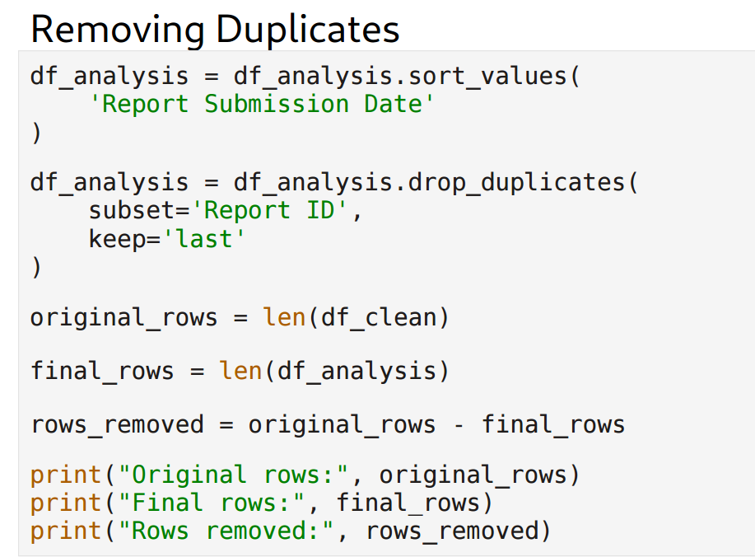
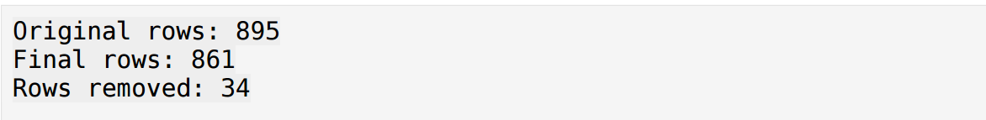

Feature Engineering for Operational Insights
Raw operational data rarely speaks directly to business metrics. To bridge this gap, several calculated fields were engineered:
- • Reporting Delay Months: Calculated by determining the delta between "Incident Date" and "Report Submission Date". This feature was vital for unlocking compliance reporting behaviors.
- • Severity Normalization: Highly granular severity text strings were mapped into a clean, hierarchical "Severity Group" categorization to allow for standardized Power BI visualizations.
- • Entity Grouping: Long-tail, low-volume operators were aggregated, keeping the analytical focus on major operators (Waymo, Tesla, Zoox, Avride).

Dashboard and Analytical Layering
The transformed dataset (robotaxi_cleaned.csv) was modeled within Power BI. Advanced DAX measures were constructed to support complex business logic, including "Same Month Reporting %" and "Long Delay %". Additionally, a specialized Tooltip strategy was developed to offer dynamic, multi-layered geographic and operator context without cluttering the primary executive views.

3. Exploratory Data Analysis (EDA)
Our exploration of the dataset unfolded as an investigation into the physical and operational realities of autonomous vehicles on public roads. Rather than merely tabulating accidents, the data reveals a compelling story about how, where, and when robotaxis interact with their environment.

The Scaling Footprint
Initial temporal analysis showed a clear trajectory: incident volumes scaled alongside fleet deployments. When analyzing geographic distributions, the data strongly anchors autonomous operations in specific Sunbelt environments—primarily California, Texas, and Nevada. Waymo’s overwhelming presence in the dataset emerged early in the EDA, but contextual analysis clarifies that this is an artifact of having the largest operational footprint in the ecosystem, not a signal of deficient safety protocols.
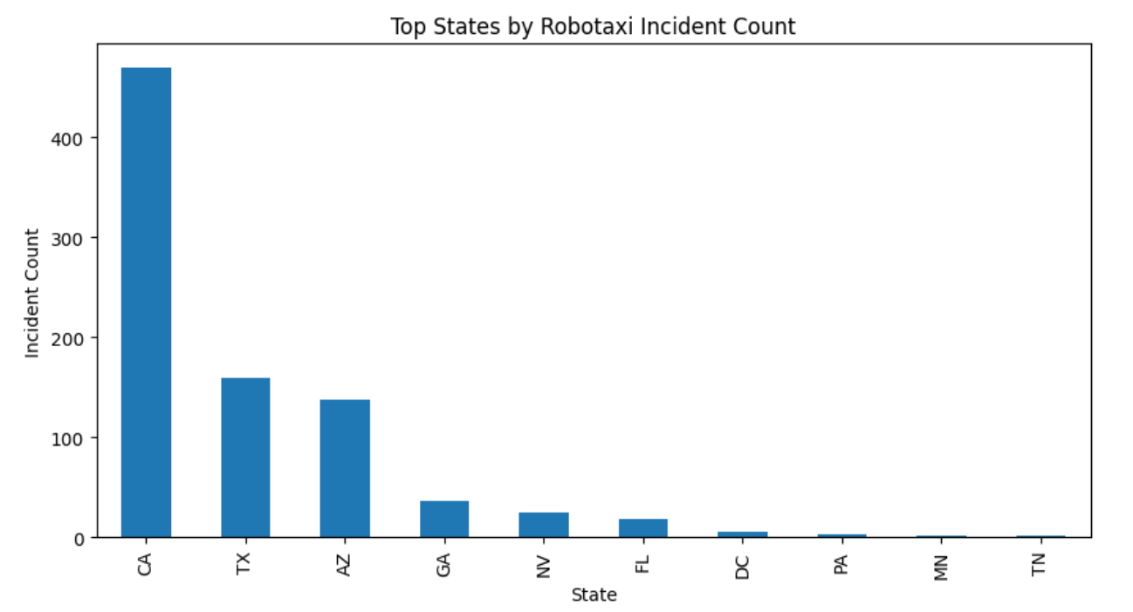
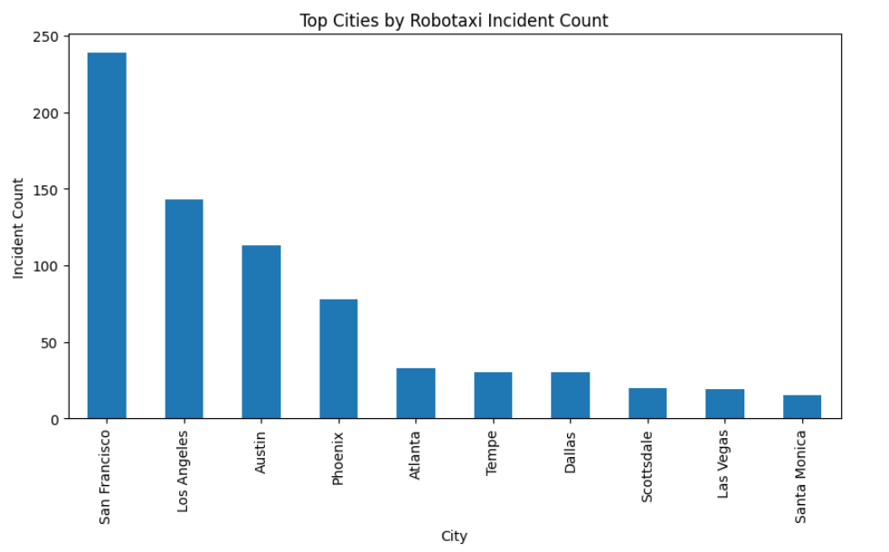

Environmental and Interaction Baselines
When examining the environmental conditions surrounding these incidents, the data challenges the notion of chaotic, unpredictable crashes. The overwhelming majority of recorded incidents occurred under "Clear" weather conditions on standard "Street" or "Intersection" roadway types. This points directly to the stringent Operational Design Domains (ODD) enforced by fleet operators, they are deploying where conditions are optimal.
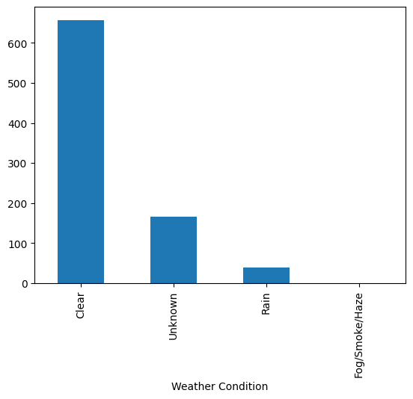
Furthermore, the "Crash Counterpart" analysis provided a fascinating look at the physics of these incidents. The data shows that autonomous vehicles are predominantly interacting with standard passenger vehicles. Paired with pre-crash movement data, the narrative emerges of autonomous vehicles often being the static or cautiously moving variable in environments where human-driven passenger cars are the dynamic, colliding factor.

The Severity Profile
As the exploration moved toward human impact, the severity metrics offered perhaps the most reassuring narrative of the dataset. Distributing incidents by severity group proved that the ecosystem is highly mature; the vast majority of incidents resulted in "Property Damage / No Injury", with severe outcomes remaining statistical outliers.
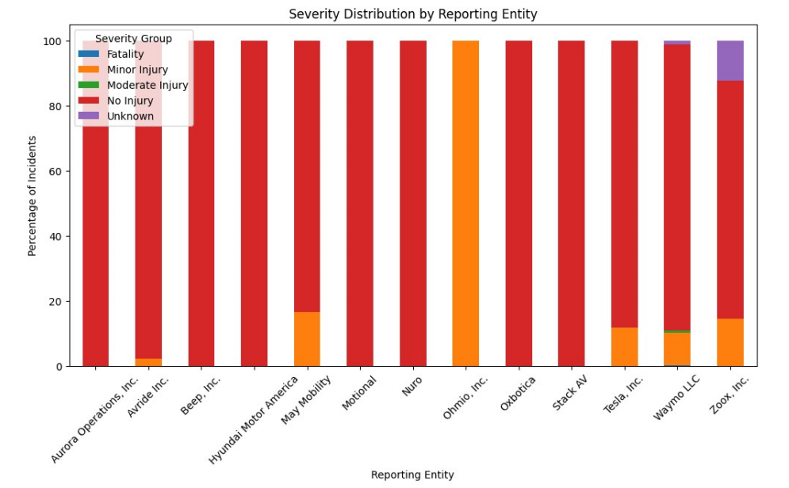

4. Key Findings & Limitations

Key Findings
Finding 1: Incident Volume is a Proxy for Operational Scale
Waymo commands the majority share of recorded incidents, but this correlates directly with its market-leading deployment density. In the absence of exposure data, raw counts merely map the geographic and temporal expansion of the fleet rather than highlighting inherent safety defects.
Finding 2: Exceptional ODD Adherence
A striking 98.9% of all documented incidents occurred while the autonomous systems were operating strictly within their designed operational domains. This indicates that geofencing and environmental lock-outs are functioning as intended at the software level.
Finding 3: High Concentration in Short-Lag Compliance
Over 97% of all incidents are reported within a 0–1 month window. Waymo and Zoox demonstrate highly standardized, predictable reporting cadences, reflecting mature internal operational compliance pipelines.
Finding 4: Uncoupling Delay and Severity
An anomalous reporting behavior analysis revealed that long-tail reporting delays (e.g., 4 to 8 months) are almost exclusively associated with "No Injury" or minor incidents. Distinctly, Tesla exhibited unusually long reporting-delay tails. Because these delays do not correlate with high-severity investigations, they strongly suggest the presence of administrative amendment workflows or de-redaction backlogs rather than evasive compliance failure.
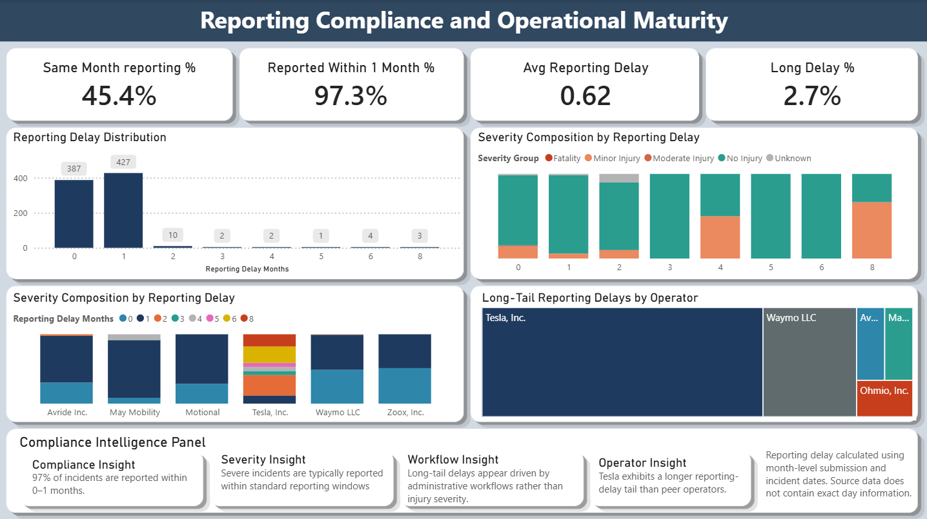

Limitations of the Analysis
While the findings are statistically robust within the confines of the dataset, absolute conclusions regarding comparative vehicle safety are mathematically invalid due to systemic data limitations:
- Lack of Exposure Metrics: The dataset contains no denominator data (Vehicle Miles Traveled, fleet size, or total active hours). It is impossible to calculate a true "crash rate per mile."
- Incomplete Chronology: The 2026 data cover a partial year (up to April), rendering annual trend forecasting incomplete.
- Reporting Bias: Self-reported metrics, particularly regarding subjective categorizations of "minor injury" or narrative descriptions, carry inherent corporate reporting bias. The amendment loops identified in the delay analysis highlight that the dataset is continually structurally evolving.

5. Recommendations
Based on the operational compliance and incident severity patterns isolated in this analysis, the following strategic actions are recommended to optimize ecosystem safety tracking and regulatory transparency.

1. Mandate Integration of Exposure Metrics
Stakeholder: Regulators (NHTSA, DMV)
Rationale: Analyzing absolute crash volumes penalizes operators with the highest operational success and largest fleets (e.g., Waymo).
Action: NHTSA should amend Standing General Order 2021-01 to require parallel submission of monthly Vehicle Miles Traveled (VMT) and operational hours per geofenced region.
Success Metric: The ability to transition the analytics dashboard from purely tracking "Incidents per Operator" to "Incident Rate per 100,000 Autonomous Miles."

2. Standardize Administrative Amendment Pipelines
Stakeholder: Autonomous Fleet Operators (Particularly Tesla, Inc.)
Rationale: The EDA identified long-tail reporting delays (4–8 months) that are overwhelmingly tied to non-severe incidents, suggesting inefficient internal review, data un-redaction, or staged re-submission workflows.
Action: Conduct an internal audit of the compliance data pipeline to automate the categorization and submission of low-severity "Property Damage Only" incidents, aligning with the 0–1 month cadence demonstrated by industry peers like Zoox.
Success Metric: Reduction of the "Long Delay %" KPI to under 1% of total monthly submissions.


3. Optimize Intersection-Specific Object Detection Models
Stakeholder: OEM Engineering & Operational Risk Teams
Rationale: Given the 98.9% adherence to optimal ODDs (clear weather, standard roads), the remaining operational risk is highly concentrated around intersection dynamics and passenger-vehicle interactions (often rear-end collisions by human drivers).
Action: Prioritize machine learning object-prediction models and defensive driving parameters specifically tuned for static-hold scenarios at complex intersections to mitigate human-driver counterpart collisions.
Success Metric: A quarter-over-quarter reduction in incidents categorized under "Intersection" roadway types involving "Passenger Vehicle" counterparts.

6. Appendix: Screenshot Placeholders Log
This log tracks the targeted visual assets required to finalize the business formatting of this report.
ID | Section | Required Screenshot Description
1 | Executive Summary | Power BI Dashboard Page 1 — Executive Overview showing high-level KPIs, severity donut chart, and geographic distribution
2 | Methodology & Approach | Python output of dataframe `.info()` or `.shape` comparison before and after the 34-row deduplication drop
3 | EDA | Python seaborn/matplotlib bar chart showing Incident Volumes by State/City or Major Operator
4 | EDA | Python bar chart showing Weather Condition distribution heavily skewed toward 'Clear'
5 | EDA | Python crosstab heatmap of Reporting Entity vs. Severity Group showing concentration in 'No Injury'
6 | Key Findings & Limitations | Power BI Dashboard Page 4 (Reporting Compliance) visual showing Reporting Delay Distribution and Severity Mix by Delay
7 | Recommendations | Power BI tooltip or custom visual showing the 'Long-Tail Delay Spotlight' by Operator

