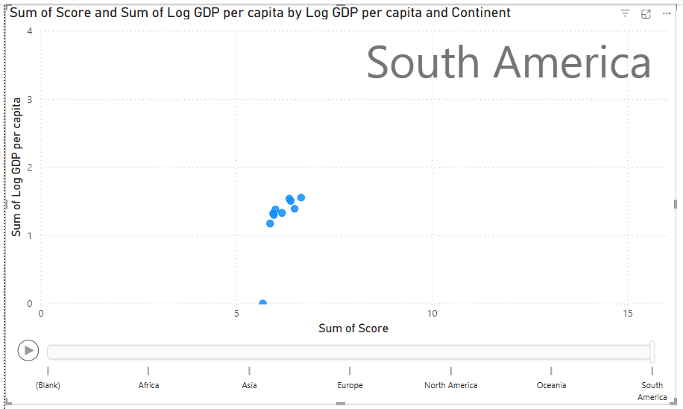

Play Axis

**Steps:**

* **In Report View Tab**

1. Visualizations tab ->Build Visual
2. Click on **Scatter Chart**

* **Data Tab**

1. **WHR** -> Select Column name according to the given question

* **Build Visual**

1. Values -> Log GDP per Capita
2. X-axis -> Sum of Score
3. Y-axis -> Sum of Log GDP per Capita
4. Play Axis -> Continent

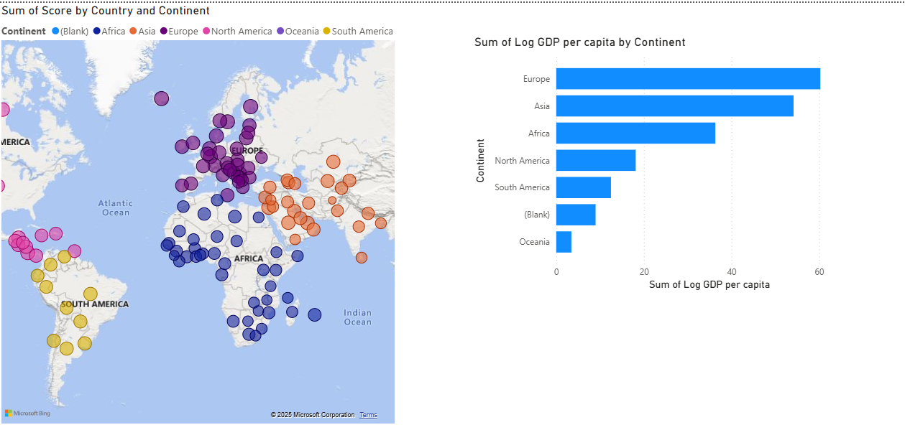

MAP

**Steps:**

* **In Report View Tab**

1. Visualizations tab ->Build Visual
2. Click on **MAP**

* **Data Tab**

1. **WHR** -> Select Column name according to the given question

* **Build Visual**

1. Location -> Country
2. Legend -> Continent
3. Bubble Size -> Sum of score

* **Format Visual**

1. Format Visual -> visual
2. Map Settings: Style -> Road (show labels)

* **Sum of Log GDP per capital by Continent**

**Steps:**

* **In Report View Tab**

1. Visualizations tab ->Build Visual
2. Click on **Stacked Bar Chart**

* **Data Tab**

1. **WHR** -> Select Column name according to the given question

* **Build Visual**

1. X-axis -> Continent

2. Y-axis -> Sum of Log GDP per capital

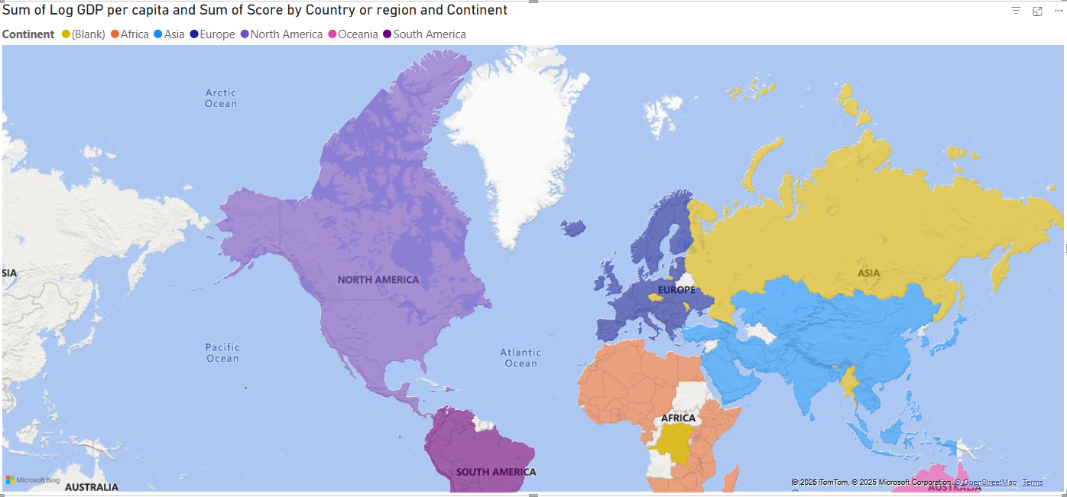

Filled Map

**Steps:**

* **In Report View Tab**

1. Visualizations tab ->Build Visual
2. Click on **Filled MAP**

* **Data Tab**

1. **WHR** -> Select Column name according to the given question

* **Build Visual**

1. Location -> Country or Region
2. Legend -> Continent
3. Tool Tip -> Sum of Log GDP per capital, Sum of score