Cybersecurity Suspicious Web Traffic Analysis
A Machine Learning & Cybersecurity Project
Prepared By: Premkumar
Mentor: Unified Mentor

Project Overview
This project analyzes AWS CloudWatch suspicious web traffic logs to identify potential anomalies, attacks, and malicious network behavior. Using Python, data preprocessing, data exploration, feature engineering, anomaly detection models, and classification techniques were applied. Visualizations were created to better understand threat patterns.

1. Importing the Dataset
• Loaded CloudWatch_Traffic_Web_Attack.csv using Pandas
• Verified dataset shape, columns, and datatypes
• Parsed timestamp columns (creation_time, end_time)

2. Data Cleaning
• Handled missing values and duplicates
• Converted timestamp columns into datetime format
• Standardized text fields (country codes)
• Converted numeric columns including bytes_in, bytes_out, dst_port

3. Exploratory Data Analysis (EDA)
• Generated descriptive statistics to understand dataset distribution
• Identified top countries generating suspicious traffic
• Analyzed protocol usage frequency
• Reviewed bytes_in / bytes_out distributions
• Visualized suspicious ports frequently targeted

4. Feature Engineering
• Created session_duration from creation_time and end_time
• Engineered avg_packet_size = (bytes_in + bytes_out) / session_duration
• Applied StandardScaler on numeric values
• Prepared model-ready dataset

5. Anomaly Detection (IsolationForest)
• Applied IsolationForest model with contamination=0.05
• Used features: bytes_in, bytes_out, session_duration, avg_packet_size
• Identified high-risk anomalous network interactions
• Visualized anomalies on scatter plots

6. Classification Modeling (RandomForest)
• Mapped detection_types into binary target is_waf_rule
• Performed train-test split (70-30)
• Trained RandomForest to classify suspicious vs normal traffic
• Generated accuracy score, classification report, confusion matrix

Visual Outputs & Screenshots
Chart: bytes_in_hist.png
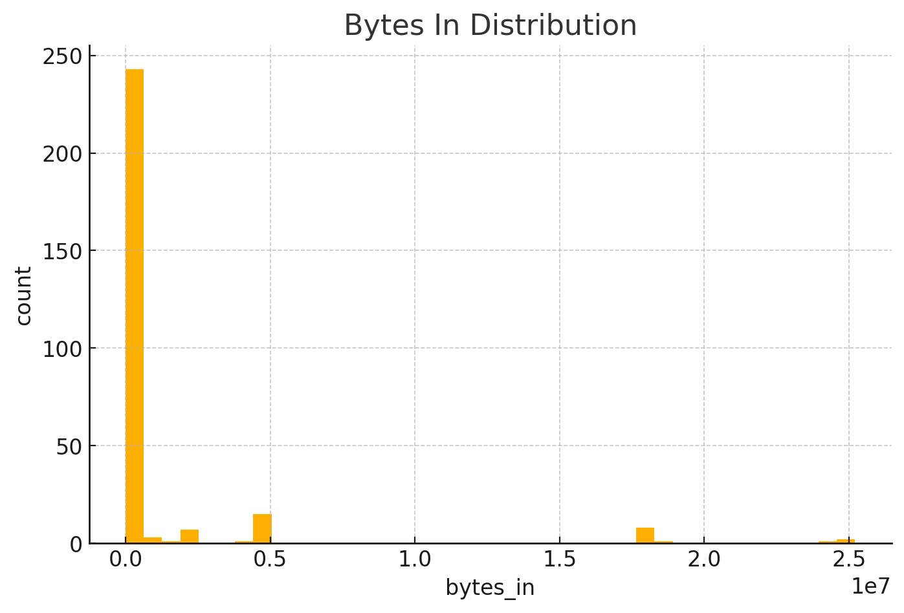

Chart: bytes_out_hist.png
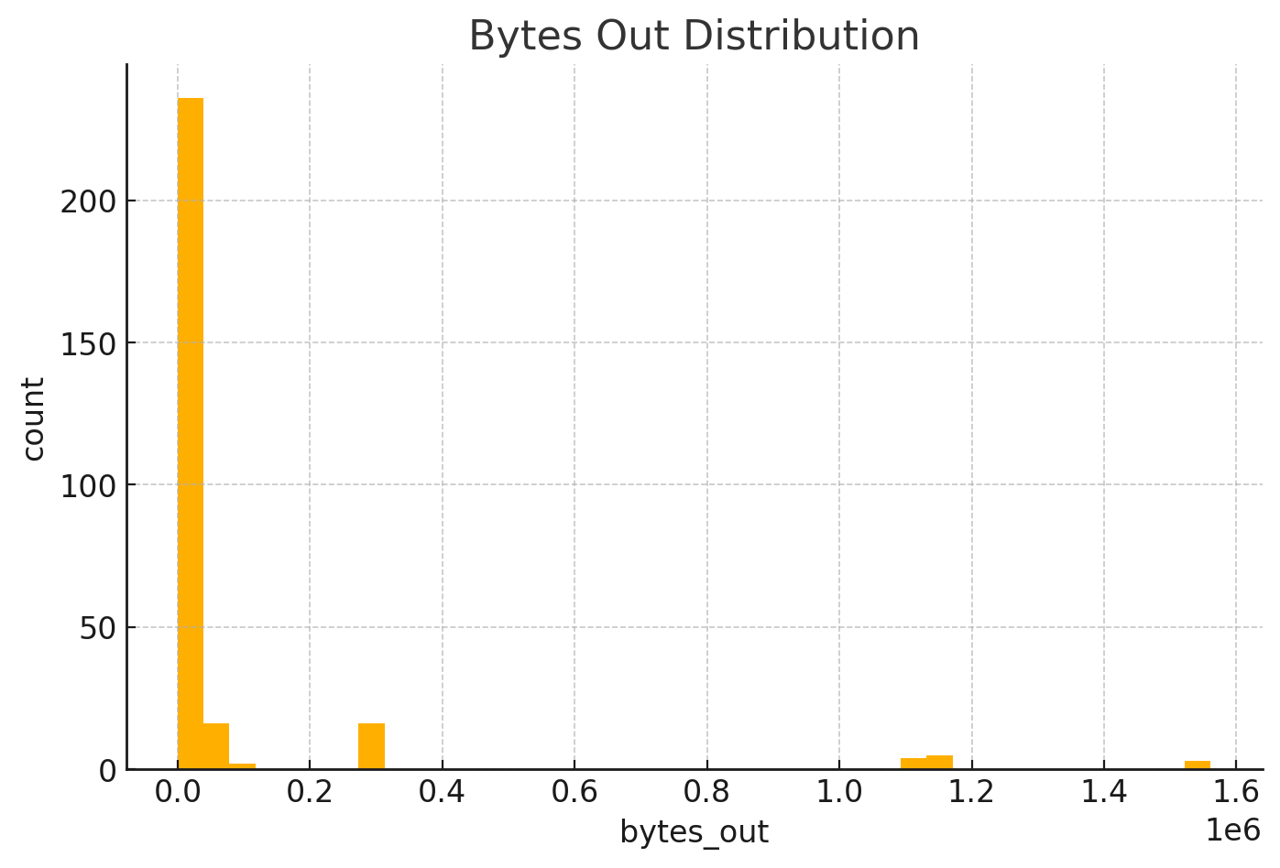

Chart: protocol_counts.png
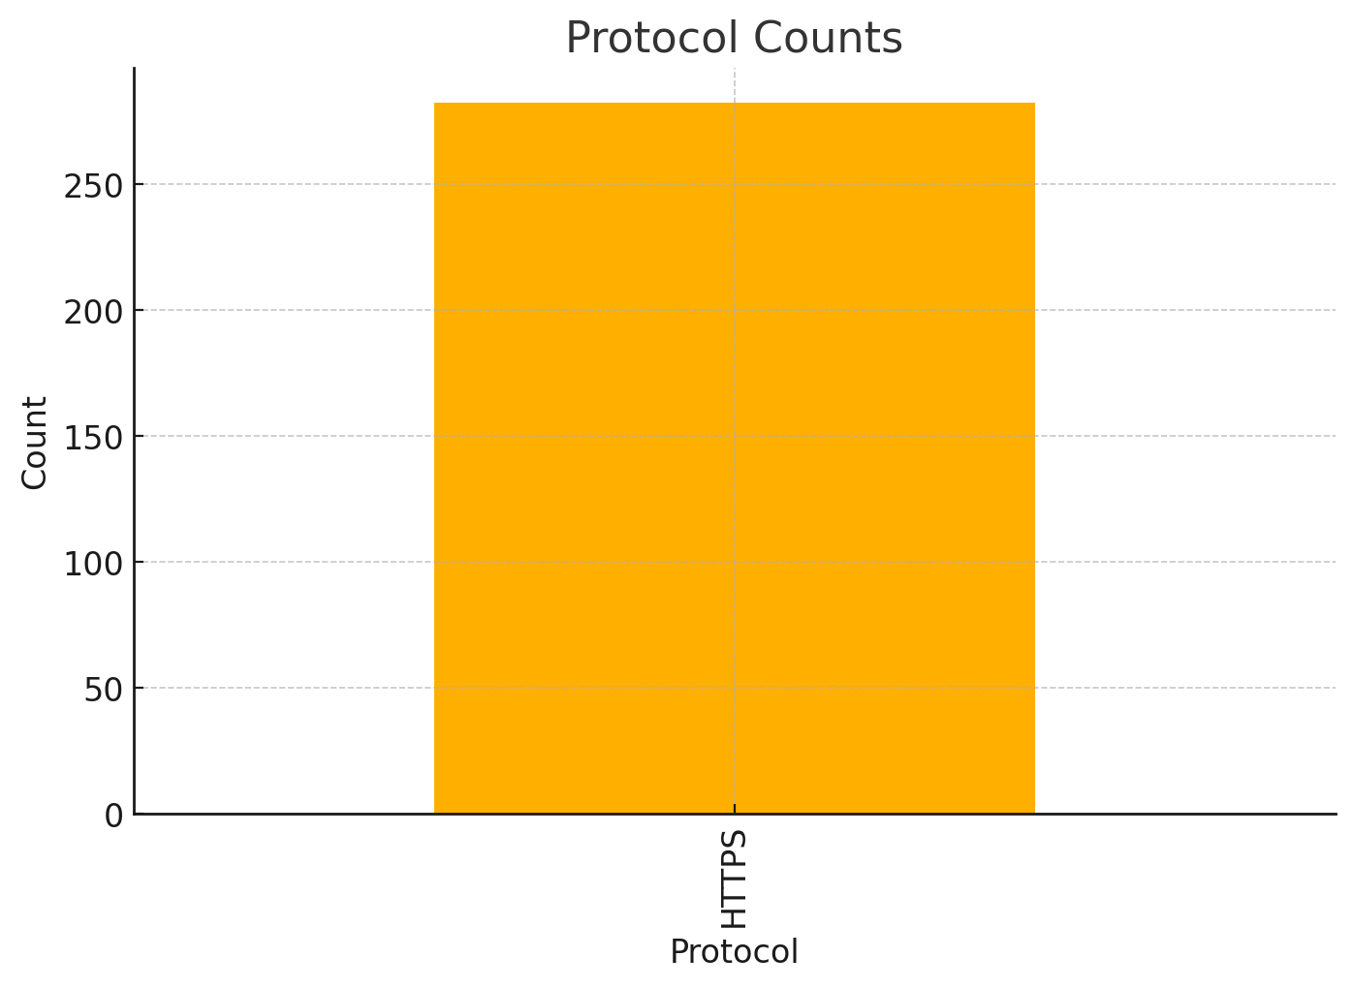

Chart: country_counts.png
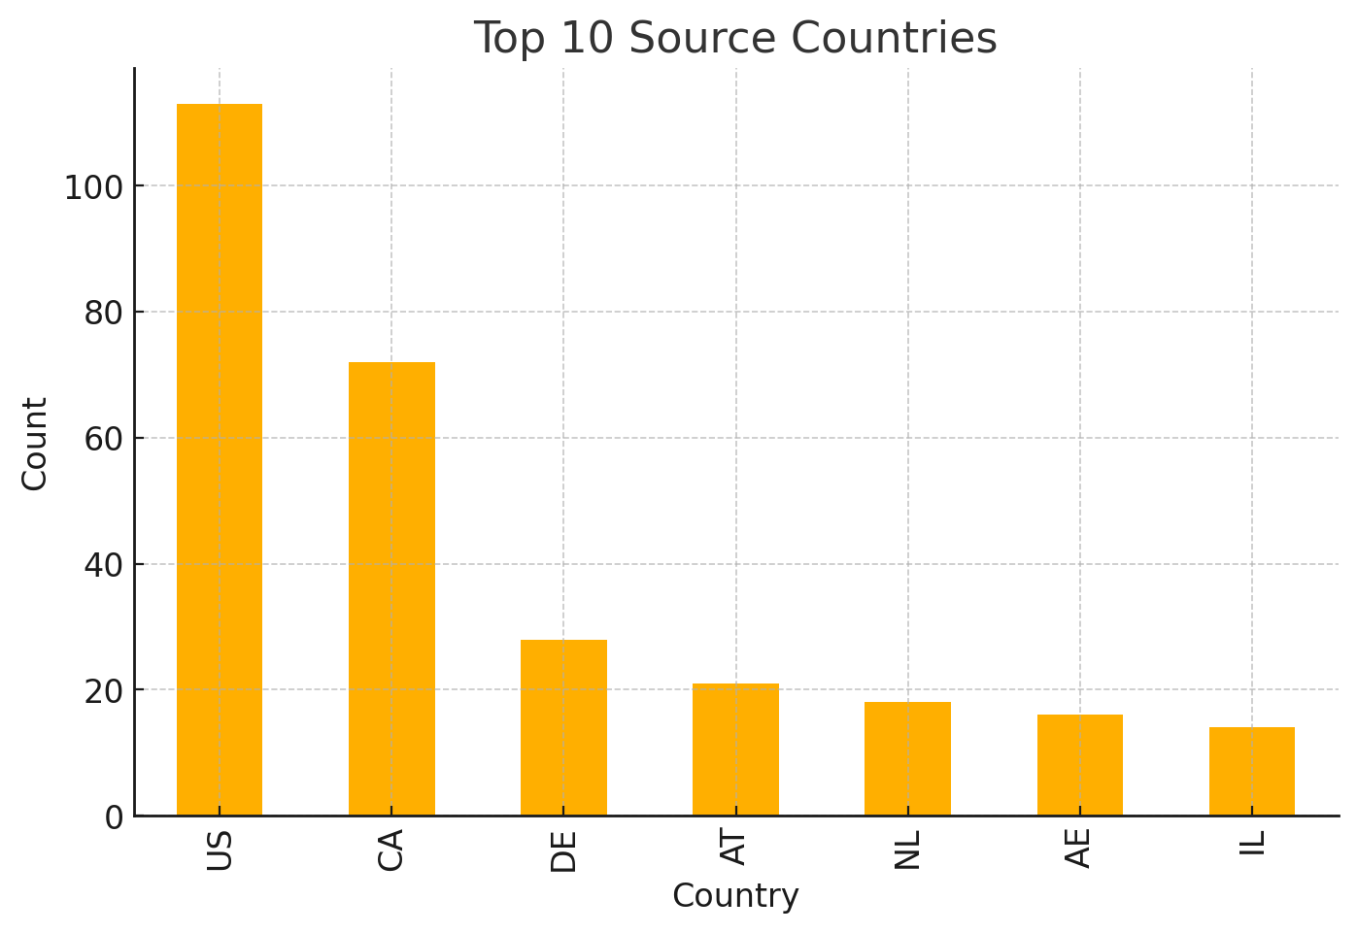

Chart: dst_port_top.png
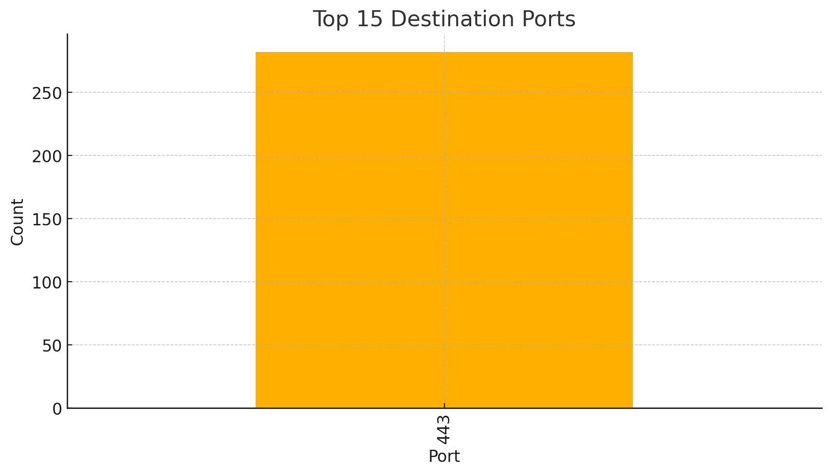

Chart: correlation_heatmap.png
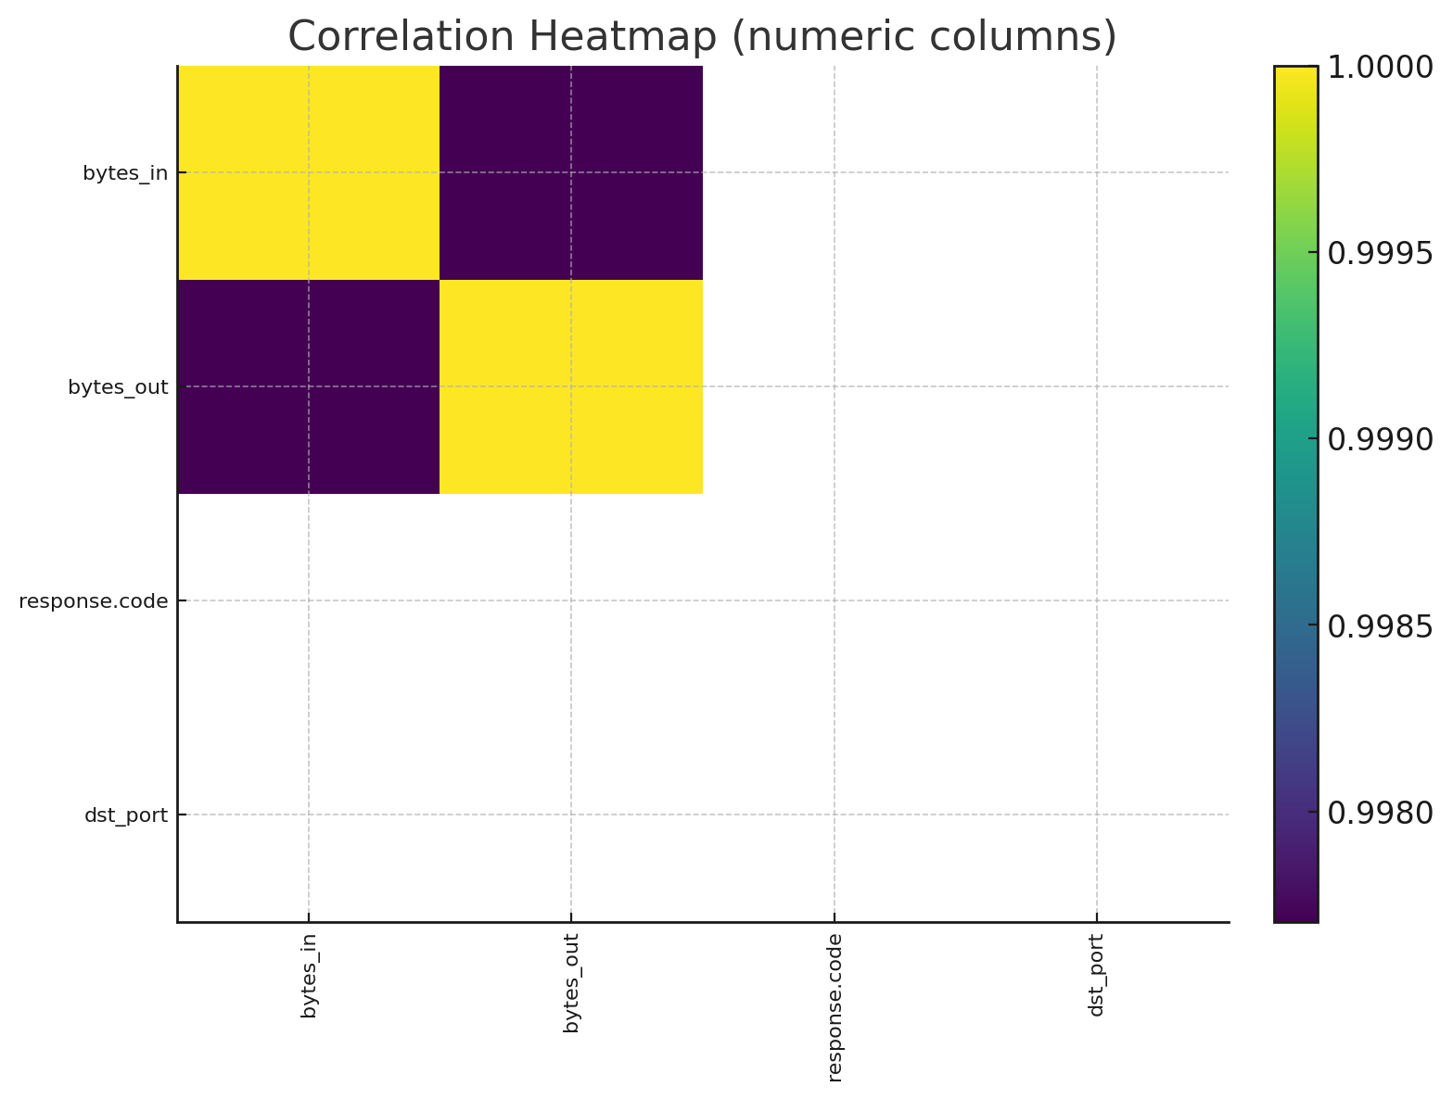

Chart: anomalies_scatter.png
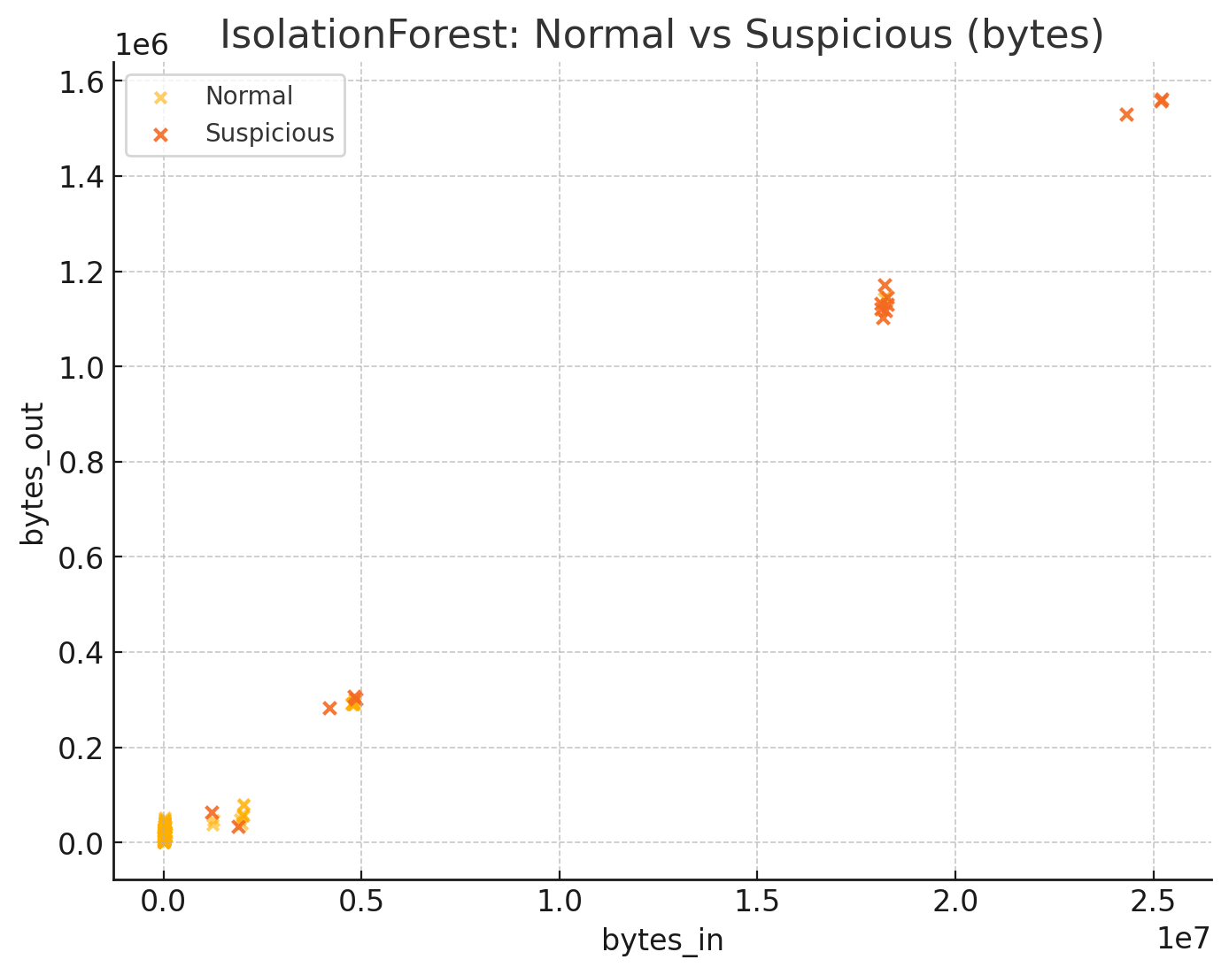

Conclusion
• The project successfully detected anomalies using IsolationForest.
• RandomForest classification provided additional threat labeling.
• Visualizations highlighted key malicious traffic patterns.
• Recommended enhancements include geolocation enrichment, IP reputation scoring,
• and near‑real‑time streaming threat detection.

