Colorado Motor Vehicle Sales Analysis

A Research Paper Style Technical Report

Abstract
This research paper presents a comprehensive analysis of motor vehicle sales across various counties in the state of Colorado. Using aggregated quarterly data, the study explores temporal sales patterns, county-level differences, and forecasting methods. The goal is to provide meaningful insights that support economic planning, policy development, and business decision‑making.

1. Introduction
Motor vehicle sales data serves as an essential indicator of regional economic activity. This study analyzes Colorado’s vehicle sales trends over multiple years, with the dataset containing information on year, quarter, county, and total sales figures. The analysis includes exploratory data analysis (EDA), visual trend evaluation, and forecasting methodologies.

2. Methodology
The methodology involves several key steps:
1. Data Cleaning – Ensuring consistent types and removing null values.
2. Feature Engineering – Constructing quarterly timestamps for trend analysis.
3. Aggregation – Summing sales for quarter-level analysis.
4. Visualization – Identifying trends and anomalies.
5. Forecasting – Evaluating SARIMAX, ETS, and baseline models.

3. Findings
The quarterly trend indicates clear seasonality across the years. The county-level breakdown reveals uneven distribution, with certain counties consistently dominating total sales.

3.1 Quarterly Trend Analysis
Figure 1 shows quarterly sales across the dataset period.
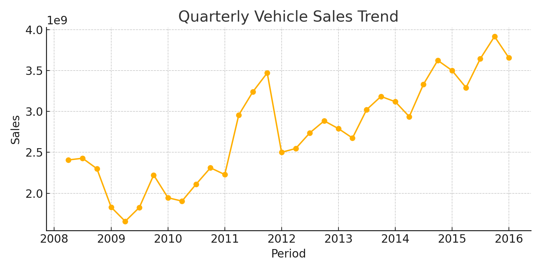

3.2 County-Level Distribution
Figure 2 visualizes the top contributing counties for the earliest available year.
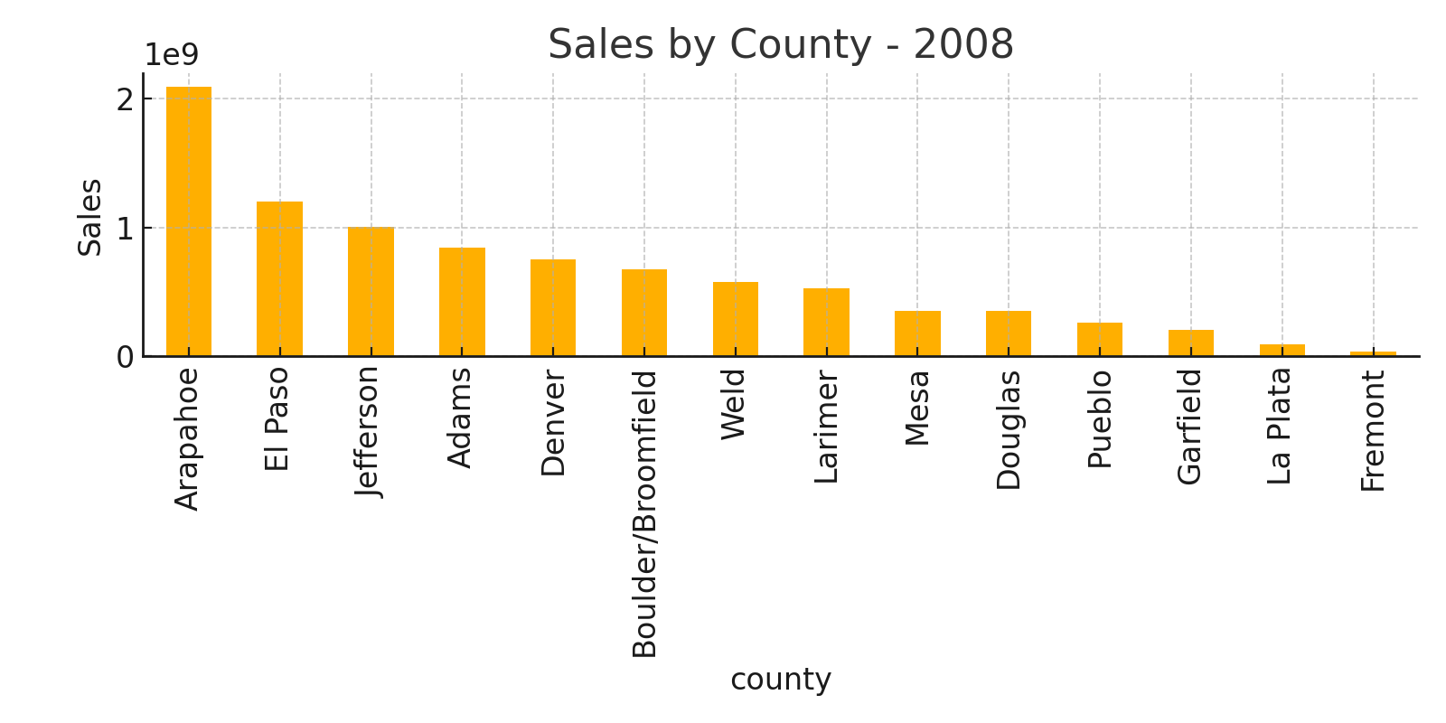

4. Forecasting Analysis
Given the strong quarter-based seasonal structure, SARIMAX models are appropriate choices for producing interpretable forecasts. Exponential Smoothing (ETS) serves as an alternative model for capturing seasonal patterns when data volume is limited.

5. Conclusion
The study concludes that Colorado’s motor vehicle sales follow a consistent seasonal pattern, with substantial regional disparities. Future work may involve advanced machine learning models, dashboard visualization, and predictive economic scenario modeling.

References
1. Colorado Motor Vehicle Sales Dataset
2. Statsmodels Documentation
3. Scikit-learn API Reference
4. Pandas Library Documentation

