

Technical Architecture

AP Supplier Portal

Prepared for: HighRadius Corporation
Prepared by: Metapointer Labs Pvt. Ltd.
Date: March 2026
Version: 3.3

Table of Contents
1. Architecture Overview 3
1.1 Five-Layer Architecture Stack 3
1.2 System Architecture Diagram 3
2. System Design 5
2.1 Application Architecture 5
2.2 End-to-End Process Flow 5
2.3 Microservice Domain Boundaries 7
3. Technology Stack 8
4. Integrations 10
5. Data Design 11
5.1 Multi-Tenancy Model 11
5.2 Core Data Entities 11
5.3 Database Strategy 11
6. Security Design 13
6.1 Authentication & Authorisation 13
6.2 Five-Layer Enforcement Chain 13
6.3 Encryption & Secrets Management 13
6.4 Screen-Level Permission Matrix (Key Screens) 14
7. DevOps & Environments 15
7.1 Environment Promotion Pipeline 15
7.2 CI/CD Pipeline 15
7.3 Rollback Strategy 15
7.4 Monitoring & Observability 16
8. Performance & Scalability 17
8.1 Performance Benchmarks 17
8.2 Scalability Design 17
9. Technical Risks 18

1. Architecture Overview
The AP Supplier Portal follows a modular, layered architecture designed to meet HighRadius’s non-functional requirements: sub-3-second API responses, 100% multi-tenant data isolation, containerised G4 deployment, and Keycloak-based authentication. Clear separation between presentation, API gateway, service, integration, and data layers ensures independent maintainability and scalability of each tier.

1.1 Five-Layer Architecture Stack
Layer | Technology | Components | Responsibility
Presentation | React 18.x + G4 DSL | 3 persona-specific SPAs sharing a common component library | Responsive UI, WCAG 2.0 AA, virtual scrolling (1,000+ rows), role-based route guards
API Gateway | Spring Cloud Gateway | JWT Validator, Rate Limiter, Tenant Injector, RBAC Middleware | Every request passes 4 sequential gates — no request reaches business logic without valid JWT + tenant context + role
Service | Spring Boot 3.x | 12 microservices across 4 domains (Onboarding, Compliance, PO, Invoice) | Stateless, horizontally scalable, independently deployable; 66 APIs total
Integration | Adapter Pattern | Circuit breaker, retry, dead-letter queues for all 7 external integrations | Fault-tolerant integration with HighRadius-owned and ERP services
Data | PostgreSQL + Redis | Schema-per-tenant DB; Redis cache; immutable audit log store | Multi-tenant isolation, caching of config/templates, 2-year audit log retention

1.2 System Architecture Diagram
The following diagram illustrates the five-layer system architecture and component relationships:
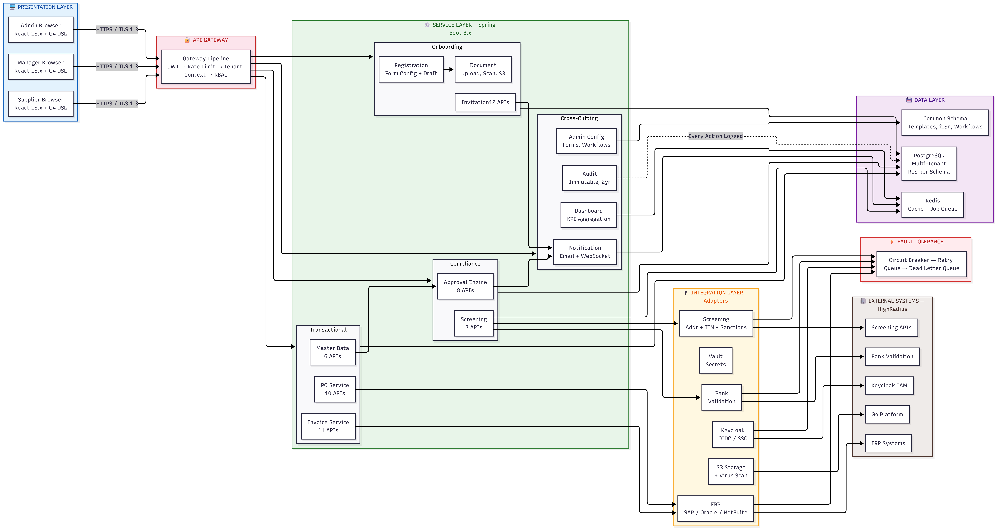
Figure 4: AP Supplier Portal — System Architecture (5-Layer Stack)

Architecture Design Principles
Stateless services for horizontal scaling — each microservice can scale independently. Zero-trust security: every request is authenticated, authorised, and tenant-scoped before any business logic executes. Fault tolerance at every integration boundary: circuit breakers prevent cascading failures from HighRadius-owned service outages.

2. System Design

2.1 Application Architecture
The application follows a microservices architecture with domain-driven boundaries. Each agent is implemented as an independently deployable service:
• Presentation Layer: React 18.x SPA with G4 DSL component library. Three persona-specific application shells sharing a common component library. Role-based routing enforced at the frontend layer. WCAG 2.0 AA compliance with ARIA tags and keyboard navigation. Virtual scrolling for grids with 1,000+ rows.
• API Gateway: Central entry point for all frontend requests. Performs JWT validation, tenant context injection (tenant_id from Keycloak claims), RBAC middleware check, and rate limiting before routing to backend services.
• Service Layer: Spring Boot 3.x microservices, one per agent domain plus cross-cutting services (audit, notifications, admin). Stateless design with horizontal scaling. Workflow-driven business logic for onboarding, approvals, and invoice processing.
• Integration Layer: Adapter pattern with circuit breaker, exponential retry, and dead-letter queues for all external system calls. No blocking calls to external services in the critical path.

2.2 End-to-End Process Flow
The complete supplier lifecycle from invitation through invoice processing and ERP synchronisation is illustrated below:
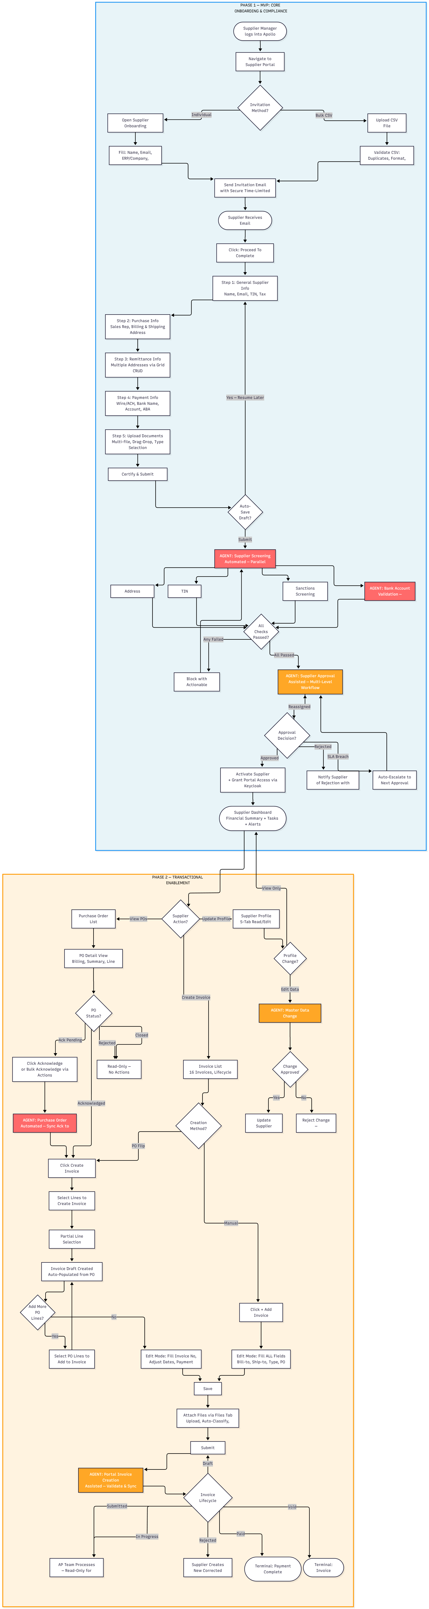
Figure 5: AP Supplier Portal — End-to-End Process Flow (Phase 1 + Phase 2)

2.3 Microservice Domain Boundaries
Domain | Services | APIs | Phase
Onboarding Domain | Invitation Service, Registration Service, Draft Management | 12 | Phase 1
Compliance Domain | Screening Orchestrator, Bank Validation Adapter | 10 | Phase 1
Approval Domain | Approval Workflow Engine, Master Data Change Service | 14 | Phase 1 + 2
PO Domain | PO Import Service, ERP Adapter (SAP/Oracle/NetSuite) | 10 | Phase 2
Invoice Domain | Invoice Creation Service, PO-Flip Engine, AP Sync Service | 11 | Phase 2
Cross-cutting | Audit Service, Notification Service, Admin Config Service | 9 | Phase 1
Total | — | 66 | —

3. Technology Stack
The technology stack is fully aligned with HighRadius engineering standards as specified in RFP Section 5. All technology choices are G4-native or G4-compatible:
Layer | Technology | Version | Details
Frontend UI | React + HighRadius G4 DSL | 18.x | Design System component library; WCAG 2.0 AA; virtual scrolling
API Gateway | Spring Cloud Gateway | 3.x | JWT validation, tenant injection, rate limiting, RBAC middleware
Backend Services | Spring Boot (Java) | 3.x / Java 17+ | Stateless microservices; horizontal scaling; workflow-driven logic
Database | PostgreSQL (OLAP) | Latest stable | Schema-per-tenant; row-level security; read replicas for analytics
Caching | Redis | Latest stable | Session management; form template cache; i18n label cache; job queues
Authentication | Keycloak IAM | HighRadius env | OIDC/JWT SSO; RBAC/ABAC; multi-tenant token claims (tenant_id)
Secrets Mgmt | HashiCorp Vault | HighRadius env | Dynamic secrets; credential rotation; API key management
Encryption | TLS 1.3 / AES-256 | — | TLS 1.3 in transit; AES-256 for data at rest
Containerisation | Docker + Kubernetes + Helm | Latest stable | Containerised deployment in HighRadius G4 environment
CI/CD | Per HighRadius practices | — | RFP Section 5 mandate; environment promotion: Dev → QA → UAT → Prod
Async Processing | Redis-backed Job Queue | — | Bulk imports, screening orchestration, long-running ERP sync
DB Migrations | Flyway | — | Tenant-aware schema versioning; rollback migration scripts
Observability | Prometheus / Grafana / ELK | — | Infrastructure metrics; structured logging; application performance
AI Tooling | Claude Opus AI | — | All 6 engineers; 1.10x–1.50x productivity on code, tests, docs

4. Integrations
The portal integrates with 7 external systems. All integrations use fault-tolerance patterns: circuit breaker, exponential retry, and dead-letter queues. Vendor responsibility is limited to integration layer only for HighRadius-owned services:
External System | Integration Method | Ownership | Fault Tolerance
Keycloak IAM | OIDC/SSO; JWT validation; RBAC | HighRadius-owned; vendor integrates | Token refresh; re-authentication on expiry
Screening Services (Addr/TIN/OFAC) | REST API; 4 parallel checks | HighRadius-owned; vendor builds orchestration layer | Retry on timeout; stub for dev; partial result display
Bank Validation Service | REST API; synchronous | HighRadius-owned; vendor builds adapter | Circuit breaker; mock for dev; re-trigger API
ERP Systems (SAP/Oracle/NetSuite) | REST API; PO import and invoice sync | Vendor builds adapter and orchestration | Bi-directional sync conflict detection; dead-letter queue; retry queue
Document Storage (S3-compatible) | S3 API; virus scanning on upload | Vendor builds integration; HR provides infra | Upload retry; virus scan failure handling; quarantine flow
HashiCorp Vault | Secrets management API | HighRadius-provided; vendor integrates | Credential rotation; fallback to environment variables in dev
Notification Service | Email via SMTP + WebSocket for real-time | Vendor builds | Async delivery; retry on failure; notification centre fallback

Integration Resilience Pattern
All 7 integrations implement the same resilience pattern: Circuit Breaker (prevents cascading failures from HR service outages) → Exponential Retry (handles transient failures with backoff) → Dead-Letter Queue (captures unprocessable messages for manual review). No integration failure can bring down the portal.

5. Data Design

5.1 Multi-Tenancy Model
The portal implements a schema-per-tenant multi-tenancy model, providing the strongest possible data isolation for a SaaS environment while sharing infrastructure cost:
• Schema-per-Tenant: Each HighRadius customer (tenant) gets a dedicated PostgreSQL schema. No data from one tenant can physically exist in another tenant's schema.
• Row-Level Security: PostgreSQL RLS policies act as a database-level safety net. Even if application middleware is bypassed, RLS prevents any cross-tenant data access.
• Tenant Resolution: Tenant ID is extracted from the Keycloak JWT (tenant_id claim) at the API Gateway layer. It is injected into the request context before any business logic executes.
• Query Enforcement: Every database query is automatically scoped with a tenant_id WHERE clause at the middleware layer. No query reaches the database without tenant scope.
• Common Schema: A shared common schema stores non-tenant-specific configuration: form templates, workflow definitions, and i18n labels. These are read-only for tenant services.

5.2 Core Data Entities
Entity | Schema | Key Attributes | Retention
Supplier | Tenant | supplier_id, tenant_id, status, created_at, activated_at, master_data fields | Indefinite (active records)
Invitation | Tenant | invitation_id, email, status, expiry, sent_at, completed_at | 2 years
Screening Result | Tenant | screening_id, supplier_id, check_type, status, result_payload, screened_at | 7 years (compliance)
Approval Workflow | Tenant | workflow_id, entity_id, step, approver, decision, decided_at, escalation_count | 7 years (compliance)
Purchase Order | Tenant | po_id, erp_id, supplier_id, status, line_items, acknowledged_at | 7 years (audit)
Invoice | Tenant | invoice_id, po_id, supplier_id, status, line_items, submitted_at, approved_at | 7 years (audit)
Document | Tenant | document_id, entity_id, type, s3_key, virus_scan_status, uploaded_at | 7 years (compliance)
Audit Log | Tenant | log_id, actor_id, action, entity_type, entity_id, timestamp, ip_address, outcome | 2 years minimum (RFP mandate)

5.3 Database Strategy
• PostgreSQL OLAP with read replicas for analytics and dashboard queries
• Redis caching layer for form templates, workflow definitions, and i18n labels — reduces DB read load for frequently-accessed configuration
• Flyway for schema versioning with tenant-aware migration strategy — each migration runs per tenant schema
• Immutable audit log — append-only table with no UPDATE or DELETE operations permitted; filterable and exportable
• Async job queue (Redis-backed) for bulk imports, screening orchestration, and long-running ERP sync operations

6. Security Design

6.1 Authentication & Authorisation
The portal implements a zero-trust security model. No request reaches business logic without passing all authentication, authorisation, and tenant-scoping checks:
• Authentication: Keycloak SSO with OIDC/JWT. No request bypasses authentication. Tokens validated at API Gateway on every request.
• RBAC: Roles assigned in Keycloak: Supplier, Supplier Manager, Approver, Admin. Role claims included in JWT and validated at API Gateway.
• ABAC: Runtime attribute-based checks at Service Layer for fine-grained control: record ownership, spend threshold, tenant scope, workflow status.
• Multi-Tenant: Tenant_id extracted from JWT and injected into all downstream service calls. No tenant can access another tenant's data at any layer.

6.2 Five-Layer Enforcement Chain
Layer | Enforcement Point | What It Checks | Failure Action
1. Frontend | Route guards + component visibility | Role → show/hide routes, buttons, tabs, modals | Hidden UI elements; redirect to dashboard
2. API Gateway | JWT validation + RBAC middleware | Token validity, role claim, tenant_id in claims | 401 Unauthorised / 403 Forbidden
3. Service Layer | ABAC checks | Ownership, tenant match, status, spend threshold, role actions | 403 Forbidden with reason code
4. Database | tenant_id WHERE clause + RLS policies | Every query scoped to tenant; RLS enforced at DB level | Query returns empty set — no cross-tenant leakage
5. Audit | All access decisions logged | Every allow/deny decision recorded with actor, action, entity | Immutable audit trail for compliance review

6.3 Encryption & Secrets Management
• In Transit: TLS 1.3 enforced on all API endpoints. No HTTP — all traffic is HTTPS. CSP headers enforced.
• At Rest: AES-256 encryption for sensitive data fields. Document storage encrypted at rest via S3-compatible storage.
• Secrets: HashiCorp Vault for all credentials, API keys, and certificates. Dynamic secrets with automatic rotation. No hardcoded credentials anywhere in the codebase.
• OWASP: SAST + DAST scanning of all vendor-built endpoints. OWASP Top 10 compliance validated before every production release.

6.4 Screen-Level Permission Matrix (Key Screens)
Screen / Area | Supplier | Supplier Manager | Approver | Admin
Supplier Dashboard | Full (Own) | None | None | None
Manager Dashboard | None | Full | View | View
Supplier Registration Form | Full (Own) | None | None | None
Supplier List / Worklist | Own | Full | View | View
Screening Dashboard | None | Full | View | View
Approval Worklist | None | View | Full | View
PO List & PO Detail | Full (Own) | View | None | None
Invoice List & Creation | Full (Own) | None | None | None
Form Builder | None | None | None | Config
Workflow Configuration | None | None | None | Config
User / Role Management | None | None | None | Full
Audit Trail | None | View | None | Full
Notification Centre | Full (Own) | Full (Own) | Full (Own) | Full

7. DevOps & Environments

7.1 Environment Promotion Pipeline
All deployments follow a linear environment promotion pipeline with manual gates at UAT and Production stages:
Environment | Trigger | Purpose | Sign-off Required
Development (Local) | Developer machine | Feature development and unit testing | None
QA | Auto on merge to QA branch | Integration testing, E2E automation, API validation | QA Engineer
UAT | Manual — QA sign-off | Client acceptance testing with HighRadius stakeholders | HighRadius Product + QA
Production | Manual — UAT sign-off | Live customer deployment via HighRadius G4 containerised environment | HighRadius Engineering + Infosec

7.2 CI/CD Pipeline
• Pipeline follows HighRadius engineering practices as mandated in RFP Section 5
• Deployment uses Docker containers with Helm charts for Kubernetes orchestration in the G4 environment
• Every merge to QA triggers: unit test run, SAST scan, container build, deployment, smoke test
• No merge permitted with critical/high SAST findings or failing unit tests
• Pre-deployment checklist: all automated tests passing, code review completed, security scan clean, documentation updated, stakeholder approval obtained, rollback plan documented

7.3 Rollback Strategy
Failure Type | Rollback Strategy | Estimated Recovery Time
Application bug (post-deploy) | Revert to previous container image via Helm rollback | < 5 minutes
Database migration failure | Execute pre-written rollback migration script (Flyway) | < 15 minutes
Integration failure (HR service) | Circuit breaker activates; fallback to cached/queued state | Automatic
Configuration error | Revert ConfigMap/Secret via version control | < 5 minutes
Full deployment failure | Automated rollback to last known good state | < 10 minutes

7.4 Monitoring & Observability
Observability Layer | Tools / Approach | What It Monitors
Application Performance | APM integration (G4 compatible) | API response times, error rates, throughput, slow queries
Structured Logging | Centralised log aggregation (ELK/Fluentd) | Application logs, audit events, integration call traces
Infrastructure Metrics | Kubernetes-native (Prometheus/Grafana) | CPU, memory, pod health, replica counts, network I/O
Business KPIs | Custom dashboards | Onboarding cycle time, screening pass rates, invoice SLA, approval queue depth
Real-Time Alerting | PagerDuty/OpsGenie integration | Technical incidents (P1/P2 auto-page), business anomalies
Health Checks | Kubernetes liveness + readiness probes | Every 5 minutes; auto-restart on failure; traffic routing on readiness

8. Performance & Scalability

8.1 Performance Benchmarks
The following performance targets are contractually committed and validated through automated performance testing before every production release:
Metric | Target | Validation Method
API Response Time (P95) | < 3 seconds | Artillery load test — 100–500 concurrent users
API Response Time (P99) | < 3 seconds | Artillery stress test — beyond expected capacity
Grid Load (1,000+ rows) | < 500 ms | Virtual scrolling stress test with synthetic data
Page Load Time | < 2 seconds | Lighthouse performance audit per sprint
Screening Execution (4 checks) | Real-time < 30s | E2E test: screening triggered → all 4 checks complete
File Upload/Download | < 5 seconds | Upload stress test with max file sizes
Concurrent Users | 1,000 | 8-hour soak test; sustained load with no memory leaks
Transactions per Hour | 10,000 | Month-end simulation test; peak invoice/PO volume

8.2 Scalability Design
• Frontend, backend, and integration layers scale independently via Kubernetes HPA (Horizontal Pod Autoscaler)
• Stateless microservices — any instance can handle any request; no session affinity required
• Schema-per-tenant database architecture allows new tenants to be onboarded without impacting existing tenants
• Multi-tenant automation absorbs acquisitions without proportional headcount increases
• Redis caching reduces database load for high-read configuration data (form templates, workflow definitions)
• Asynchronous processing via Redis job queue for bulk imports and long-running ERP sync operations
• Read replicas for PostgreSQL reduce primary database load for dashboard and analytics queries

9. Technical Risks
The following technical risks have been identified and mitigated through architecture decisions and delivery planning:
Risk | Probability | Impact | Architecture Mitigation
G4 DSL component gaps requiring custom builds | Medium | Medium | Sprint 0 G4 OOB component evaluation; custom components built only for identified gaps; component-per-screen mapping in sprint planning
ERP sync conflict resolution complexity | Medium | High | Bi-directional sync with conflict detection; dead-letter queue for unresolvable conflicts; synthetic test data in dev; real ERP validation in UAT
Multi-tenant isolation defect in production | Low | Critical | Schema-per-tenant + RLS as defence-in-depth; automated cross-tenant isolation tests every sprint; 5-layer enforcement chain; independent security pen test
HighRadius service API breaking changes | Low | High | Adapter pattern isolates integration logic; version-pinned API contracts; circuit breakers prevent cascading failures
Performance degradation at scale | Low | High | Redis caching for all high-read data; virtual scrolling for large grids; 8-hour soak test and month-end simulation before every go-live
HashiCorp Vault integration delay | Medium | Medium | Environment variables in dev; Vault integration completed pre-UAT; no secrets ever hardcoded in codebase or CI/CD config

