***Documentation***

**Name : M.ADITYA VENKAT NARASHIMA**

**Roll No: 234352**

**The Process**

**Git hub Django🡪 Docker container🡪docker hub**

*1****.Create a new folder:***

* 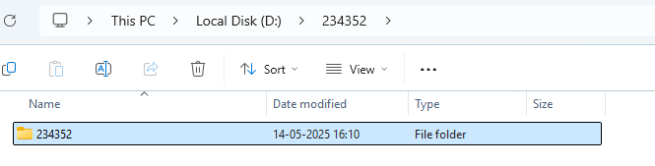Go to file explorer
* Select the location to create a new file
* Click on new
* Give a name to the file

***2.open git bash and check directory*:**

* 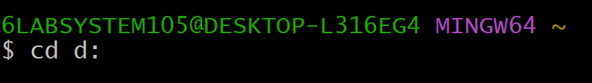Changing of directory to where the file is located
* Changing of directory to the file 234332

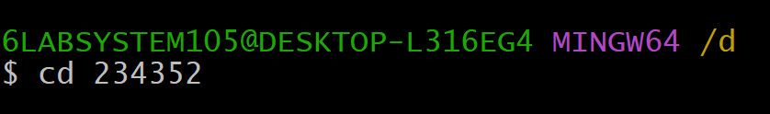

***3.Cloning of Git:***

* It is used to copy local copy to repository
* Git clone is the command in Git version
* SYNTAX:

git clone <https://github.com/username/repository.git>

EXAMPLE:

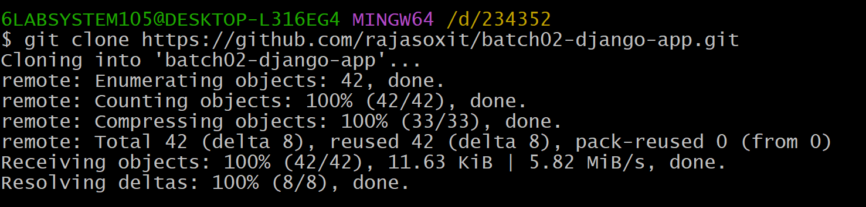

***4. Changing directory:***

* Changing of directory to the file located



***5.Docker ps:***

* It is used to show the running process
* EXAMPLE: docker ps



***6.Docker Build:***

* It is used to create an image that we are going to build
* It is used to create container image
* **EXAMPLE:** Docker build -t Django-app .
* **‘.**’ is used to bring all files in the folder to build
* It creates docker image in the dockerfile

**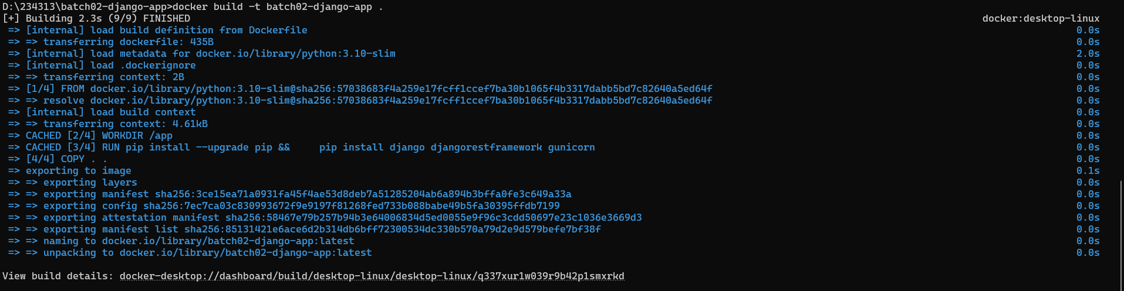*7.Docker Image:***

* Docker image is used to read-only template
* It servers as blueprint for creating a Docker container

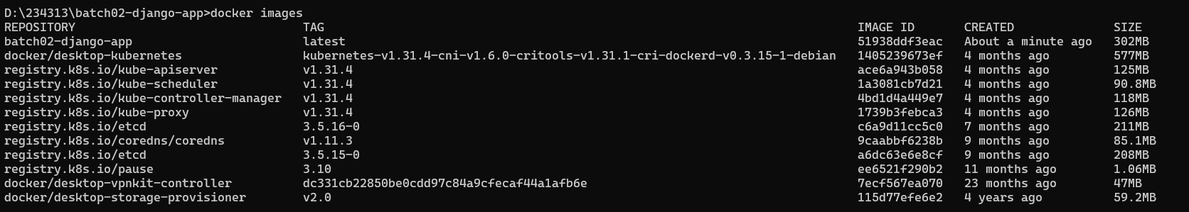***8.Docker Run:***

* It is used to Run the build image in the dockerfile
* Docker run is used in Docker file to execute and configure the docker image

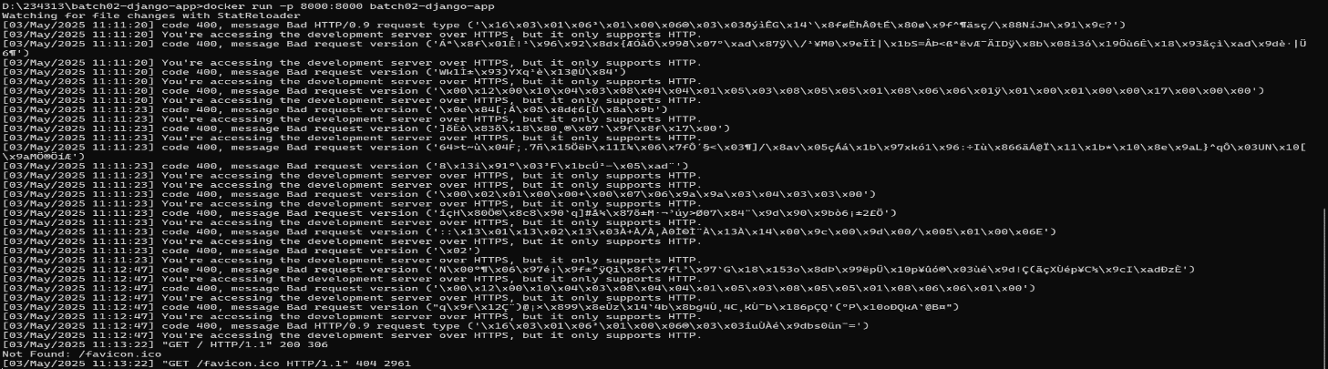***EXAMPLE:*** Docker run -p 8000:8000 django-app

***9.Opening of browser:***

* Open the browser <https://localhost:8000/> to see the image the was developed

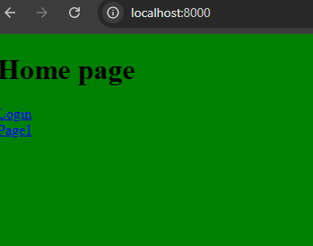

***10.Visual Studio Code:***

* Open VS code
* Open the with latest created folder
* Go to templates
* Select index.html
* It shows the code that we previously coded
* 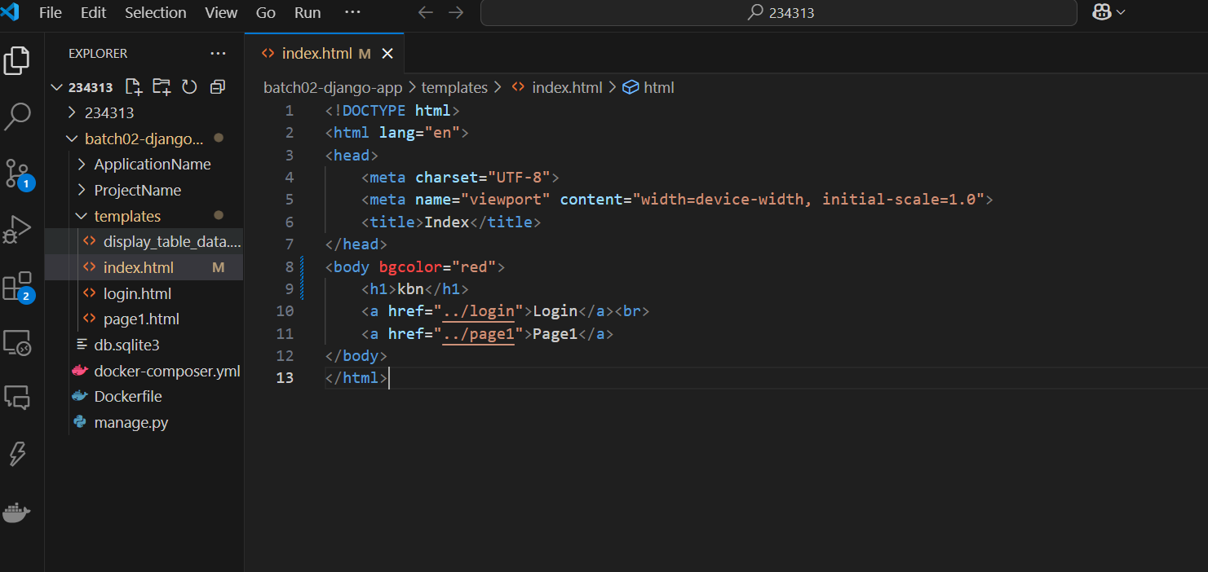Changing the “Home Page” to “TEST” and bgcolor “Green” to “purple”

***11.open browser:***

* To see the changed file

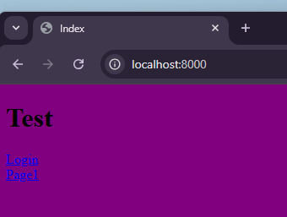

***12.Again build:***

* Build the changed image
* EXAMPLE: docker build -t Django-app

***13.Again run:***

* Run the image that we build previously
* 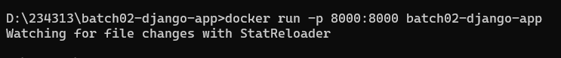EXAMPLE: docker run -p 8000:8000 django-app

***14.Docker hub:***

* Create a docker hub account
* Login to docker hub
* Create a Repository in the docker hub
* **EXAMPLE:**  batch01-django-app

**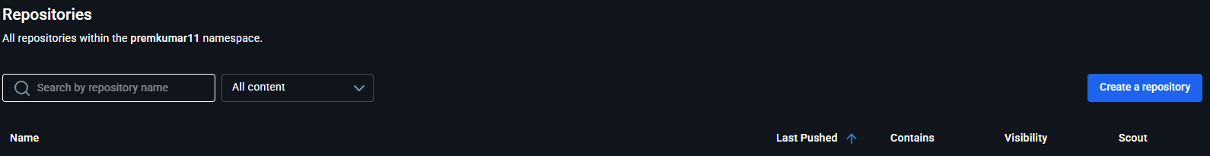*15.Docker tag:***

* It is used to create a tag to the docker image

SYNTAX:

docker tag SOURCE_IMAGE[:TAG] TARGET_IMAGE[:TAG]

* Source Image : the image that we have to create
* Target Image: the image for we have taken
* EXAMPLE: docker tag django-app rajasoxit/batch02-django-app

***16.Docker Login:***

* It is used to login into the docker
* It authenticating users to docker registers
* Pushing and pulling purpose
* 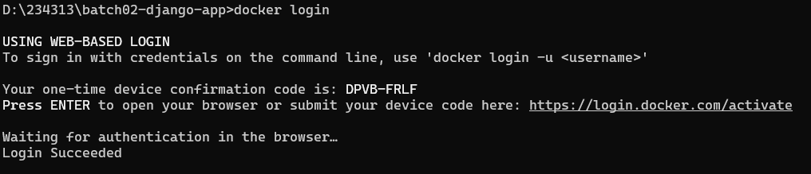Example: docker login

***17.Docker Push:***

* It is used to push the image to a registry
* Deploy them to different environments or to the others

Syntax: docker push NAME[:TAG]

EXAMPLE: docker push boyigowri/batch02-django-app

