CONTACT MANAGER

Introduction

Project Title : Contact Manager
Team ID: ( SWTID-2026-1778 )
Team Leader :
-Prem kumar D (premkumar151106@gmail.com )
Team Members :
- Mukesh R (mukeshon2005@gmail.com)

- Paveen Puran S (pavinpuran@gmail.com)

- Meshak Raj K (meshakm187@gmail.com)

PROJECT OVERVIEW

ConnectHub is a backend web application developed to solve the problem of scattered contact information across different platforms. People usually store their contacts in various places such as mobile phones, emails, spreadsheets, and social media platforms. Managing these contacts becomes difficult when they are not organized in one place.The ConnectHub system provides a centralized solution for storing, organizing, and searching contacts efficiently. It allows users to securely register, log in, and manage their contacts using a simple and structured interface.The application enables users to add, update, delete, and search contacts easily. It also allows categorization of concept through authentication mechanisms and stores the information in a MongoDB database.The ConnectHub is a backend web application designed to solve the common problem of scattered contact information across multiple platforms. It provides users with a centralized, organized system to store, search, and categorize their professional and personal contacts.

KEY OBJECTIVES
The key objectives of the ConnectHub project focus on providing a secure and efficient way to manage contact information. One of the main objectives is to provide secure user authentication using JWT tokens, which ensures that only authorized users can access their accounts and personal data.Another objective is to allow users to store and manage their contact information efficiently. The system provides a centralized platform where users can keep all their personal and professional contacts in one place.The project also aims to implement CRUD operations, which allow users to create, read, update, and delete contact details whenever necessary. This helps users maintain accurate and up-to-date contact information.In addition, ConnectHub allows users to organize contacts using tags such as work, family, or friends. This makes it easier to categorize and manage contacts based on different groups.
Finally, the system provides fast searching and filtering features, enabling users to quickly find specific contacts using name, email, or tags. These objectives help make the contact management process simple, secure, and efficient.

The main objectives of the ConnectHub project are:
- To provide secure user authentication using JWT tokens.
- To allow users to store and manage contact information efficiently.
- To implement CRUD operations for managing contacts.
- To organize contacts using tags for better categorization.
- To enable fast searching and filtering of contacts.
- To provide a scalable backend architecture using Node.js and MongoDB.

3. Scope of the Project
The ConnectHub application is designed for individuals and professionals who need a structured way to manage their contacts.
The scope of the project includes:
- Secure user registration and login system.
- Contact management features.
- Contact search functionality.
- Tag-based contact categorization.
- Database storage using MongoDB.
The system can be extended in the future to include mobile applications, cloud synchronization, and advanced analytics.

4. Target Users
The target users of the ConnectHub application are individuals and professionals who need an organized system to manage their contact information. In many situations, people store contact details in different places such as mobile phones, emails, spreadsheets, and social media platforms. This makes it difficult to find and manage contact information when needed. ConnectHub helps solve this problem by providing a centralized platform where users can store and organize all their contacts in one place.One of the main target users of this application is freelancers and consultants. They usually work with many clients and need to maintain contact information for communication and project coordination. ConnectHub allows them to store client details, categorize them using tags, and quickly search for the required contact information.Another group of users includes small business owners. Business owners often interact with customers, suppliers, and vendors. By using ConnectHub, they can maintain all these contact details in an organized way and easily update or retrieve the information whenever required.Students and young professionals are also important users of this system. They often build networks with classmates, teachers, mentors, and colleagues. ConnectHub helps them maintain these professional and personal contacts for future communication and career opportunities.In addition, event organizers can use ConnectHub to manage the contact information of attendees, volunteers, and staff members. This makes it easier to communicate with participants and coordinate events effectively.Overall, ConnectHub is useful for anyone who wants a simple, secure, and organized way to store and manage contact information. It helps users access their contacts quickly and improves the efficiency of contact management.

Freelancers
Freelancers can use the system to manage their client contacts and communication details.
Small Business Owners
Business owners can store vendor and customer information.
Students and Young Professionals
Students can maintain their academic or professional networking contacts.
Event Organizers
Organizers can track volunteers and attendees easily.
General Users
Anyone who wants to organize personal contacts securely can use this system.
PROJECT INSTRUCTION
The project instruction explains the steps required to set up and run the ConnectHub backend application. First, Node.js must be installed because it is used to run the backend server and execute JavaScript outside the browser. After installing Node.js, the installation can be verified using the commands node -v and npm -v.Next, a project folder is created for the backend. Inside this folder, a new directory called server is created to store all backend files. Then the Node.js project is initialized using the command npm init -y, which generates a package.json file to manage the project dependencies.After initialization, the required packages such as Express and Mongoose are installed. Express is used to build the server and handle API requests, while Mongoose helps connect the application to the MongoDB database and manage data models. Nodemon is also installed for development so that the server automatically restarts when changes are made in the code.Then a server file (server.js) is created to configure and start the backend application. The project is also configured to support ES modules by adding "type": "module" in the package.json file.Finally, the backend server is started using the command npm run dev or node server.js. When the server runs successfully, it can be accessed in the browser using http://localhost:5000, which shows that the backend application is running properly.The connectHUB project is developed by following a series of steps to set up the environment, build the application, and run the system successfully.First, the required software such as Node.js, database (MongoDB or MySQL), and a code editor like VS Code must be installed. These tools are necessary for writing, running, and managing the project code.Next, a project folder is created to organize all the files related to the application. The backend project is initialized using Node.js so that the required packages and dependencies can be installed.After that, important libraries and frameworks such as Express are installed. These packages help in creating the server, handling requests, and connecting the application to the database.Then the server file is created and configured to start the application. The database connection is also set up to store and retrieve the expense data.Finally, the application server is started and tested using tools like Postman or a web browser to ensure that all features such as adding expenses, updating records, and viewing data work correctly.

1️⃣ Install Node.js (If Not Installed)
Download and install Node.js from: https://nodejs.org/
After installation, verify:
node -v
npm -v

2️⃣ Create a Backend Project Folder
• Choose or create a directory where you want your backend.
• Open your terminal or command prompt.
• Navigate to the selected directory:
cd your-project-folder
• Create a new backend folder:
mkdir server
cd server
3️⃣ Initialize Node Project
Run: npm init -y
This will create a package.json file.
4️⃣ Install Required Dependencies
Install Express:
npm install express
npm install mongoose
For development (auto-restart server):
npm install nodemon --save-dev

5️⃣ Create Basic Server File
Inside the server folder:
• Create a file called: server.js
Add this code :
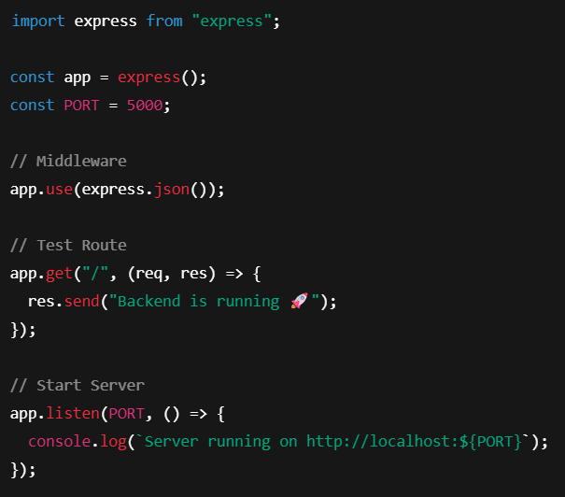

6️⃣ Enable ES Modules (Important)
Open package.json and add: "type": "module"
Example:
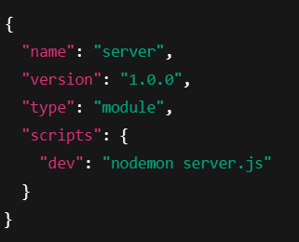
7️⃣ Start the Backend Server
Run: npm run dev
OR if not using nodemon: node server.js

8️⃣ Open in Browser
Open: http://localhost:5000
You should see: Backend is running
PRE-REQUISITES
The pre-requisites for the ConnectHub project are the basic software tools and technical knowledge required to develop and run the application.First, Node.js must be installed because it is used to run the backend server and execute JavaScript on the server side. A MongoDB database is required to store user details and contact information. The npm (Node Package Manager) is used to install the necessary libraries and dependencies needed for the project.A code editor such as Visual Studio Code is also required to write and manage the project files. Git can be used for version control to track the changes made during development.In addition to software tools, developers should have basic knowledge of JavaScript, Node.js, Express.js, MongoDB, and API development. Understanding JWT authentication and password hashing is also helpful for implementing secure user login and registration in the ConnectHub application.

Software Requirements
Software | Purpose
Node.js | JavaScript runtime for backend
MongoDB | NoSQL database for data storage
npm | Package manager
Git | Version control system
Code Editor | VS Code, WebStorm, or similar

Knowledge Requirements
• JavaScript ES6+ syntax and concepts
• Node.js and Express.js for RESTful API development
• MongoDB and Mongoose ODM
• JWT authentication and bcrypt password hashing
• Git version control workflow
PROJECT THUMBNAIL
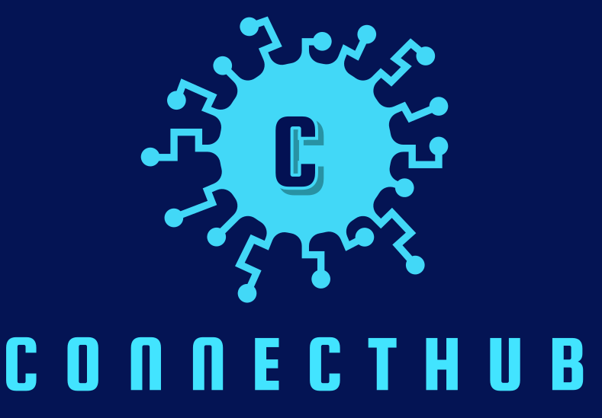

The high-level architecture of ConnectHub shows how the main components of the system interact with each other. The project follows a three-tier architecture, which includes the client layer, the backend server, and the database.
First, the client layer is where the user interacts with the application. The user sends requests such as login, add contact, update contact, or search contact through the interface.
Second, the backend layer is developed using Node.js and Express.js. This layer receives the user requests, processes them, and performs the required operations. It also handles important tasks such as authentication, validation, and API request handling.
Finally, the database layer uses MongoDB to store all the application data. It stores user details and contact information in collections. The backend communicates with the database using Mongoose, which helps manage and organize the data.
Overall, the high-level architecture ensures that the system works in an organized way by separating the user interface, application logic, and data storage. This improves the performance, security, and scalability of the ConnectHub application.

1.Create New Contact

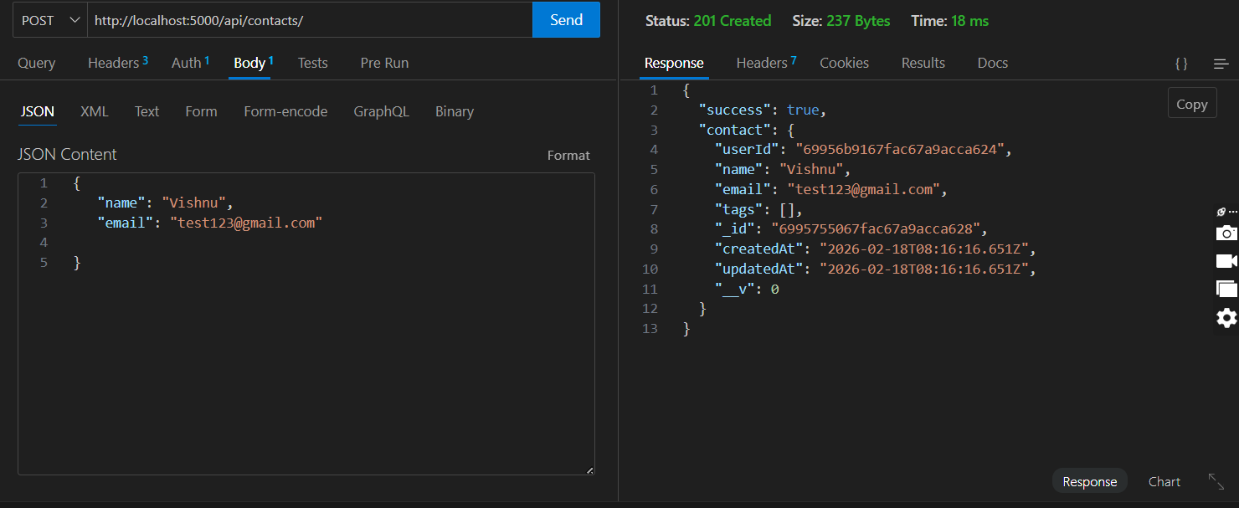

2.Update Contact

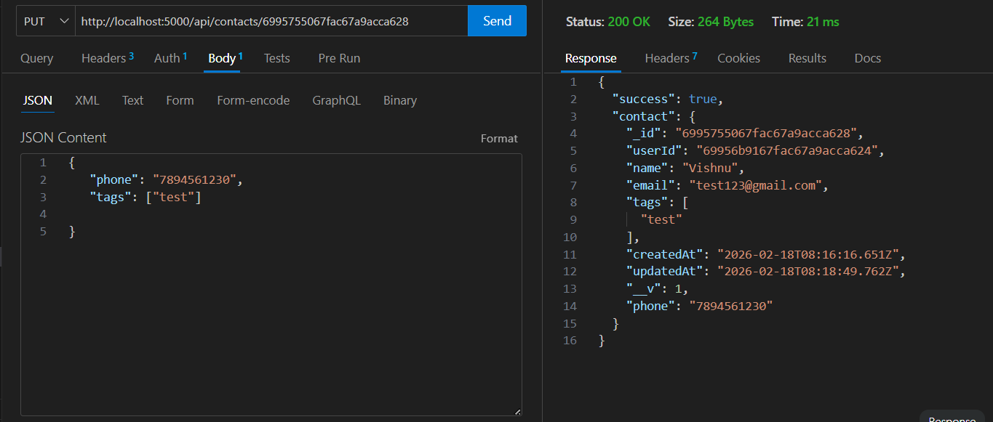

3.Delete Contact

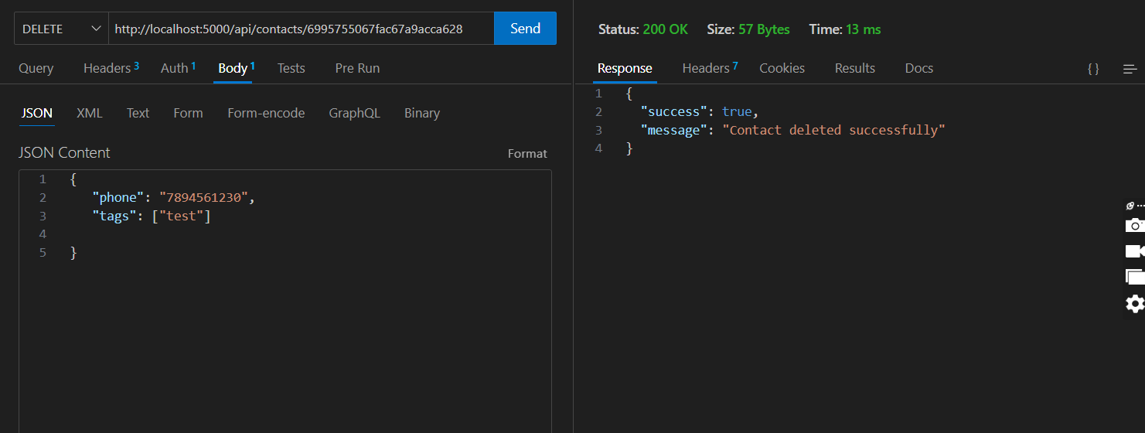

4.Search Contact

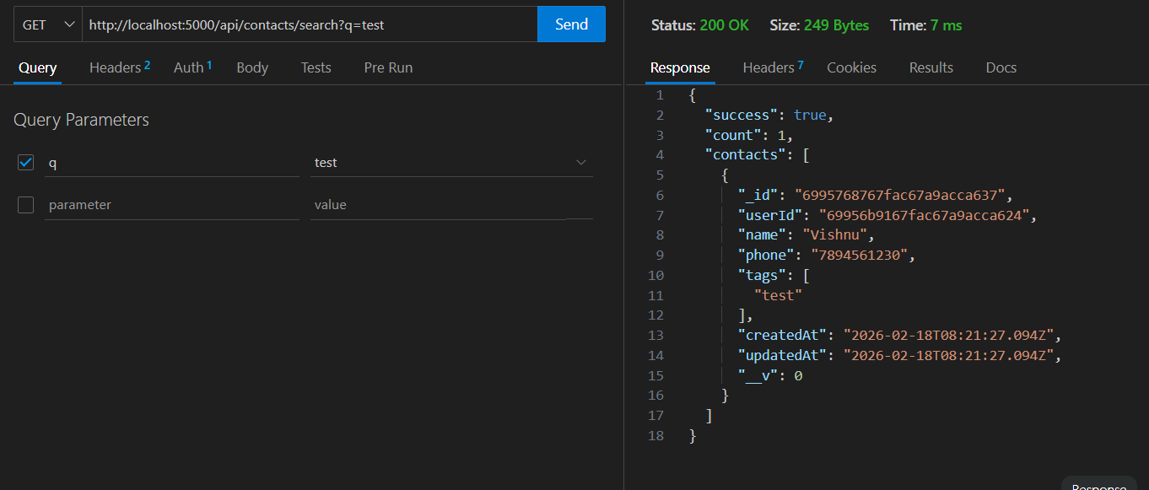

5.Get The Current User

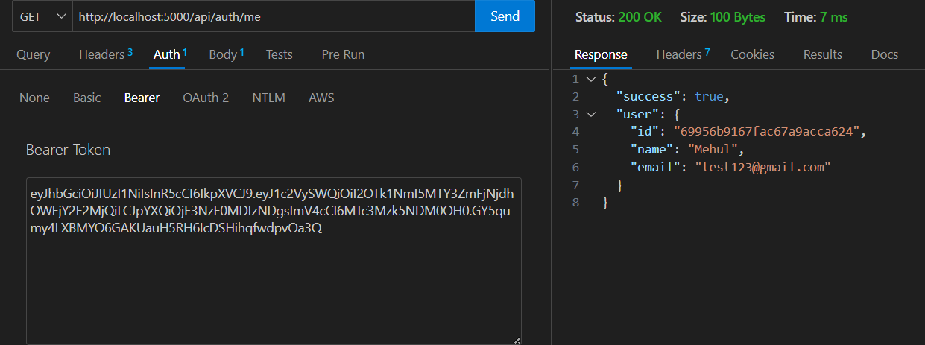

Project Demo
Contact Manager.webm

Code Link

Contact-Manager
TECHNICAL ARCHITECTURE
Backend Architecture (Node.js + Express)
• Controllers: Business logic for authentication and CRUD operations
• Models: Mongoose schemas defining data structure
• Routes: API endpoint definitions with HTTP methods
• Middleware: JWT verification, error handling, validation
• Configuration: Database connection and environment variables
Database Architecture (MongoDB)
• Users Collection: _id, name, email, password (hashed), timestamps
• Contacts Collection: _id, userId (FK), name, email, phone, notes, tags[], timestamps
• Relationships: Many-to-One (Contacts → User)
• Indexes: email (unique), userId, name, tags (for search)
ER DIAGRAM
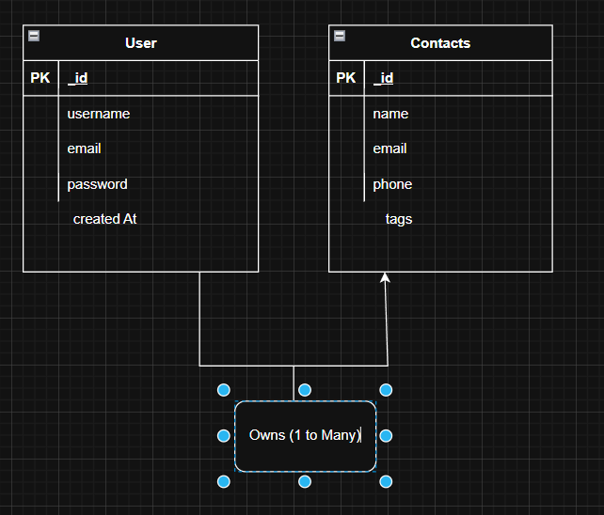
Features
Core Features

# | Feature | Description
1 | User Authentication | JWT-based registration, login, and session management with bcrypt password hashing
2 | Contact CRUD | Create, read, update, and delete contacts with full validation and error handling
3 | Tag Categorization | Organize contacts with multiple tags (Work, Family, Friends, etc.) and filter by category
4 | Real-time Search | Debounced search across name, email, and tags with instant results

Roles and Responsibility

- User -

- Registration - Register on the application using the name, email , password
- Login - Login on the application using the email and registered password
- Search - Search for a contact using name , email or tags
- Add Contact - Add new contact - name , email , phone , notes , tags
- Edit Contact - Edit the existing contact
- Delete Contact - Delete any contact

User Flow

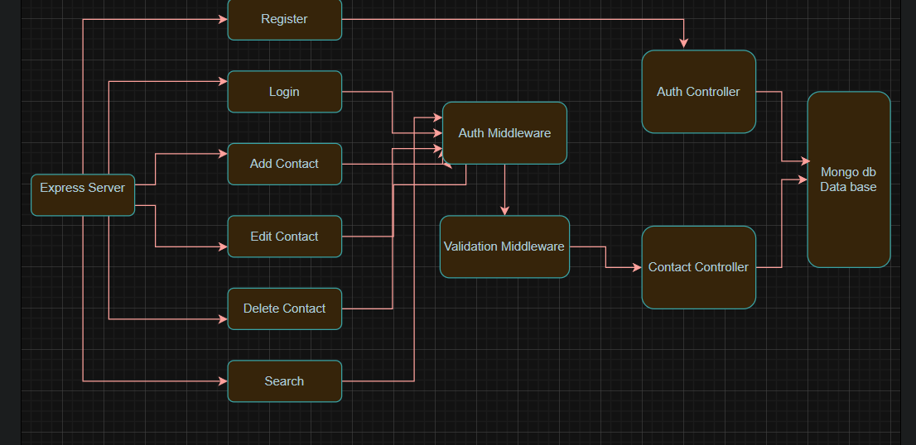

Project Setup and Configuration
The initial step in developing ConnectHub involves setting up the backend environment and configuring the required tools and dependencies. This process ensures that the project has a well-organized structure and that all necessary technologies are properly installed before development begins.
1. Creating the Project Directory
The first step is to create a dedicated folder for the ConnectHub backend project. This folder will contain all the source code, configuration files, and dependencies required for the application. Organizing the project in a structured directory helps maintain clean code and makes it easier to manage files as the project grows.
2. Initializing the Node.js Project
After creating the project folder, the backend project is initialized using Node.js. This generates a package.json file, which stores important information about the project such as the project name, version, scripts, and installed dependencies. The package.json file acts as the central configuration file for managing project packages.
3. Installing Required Dependencies
To build the backend functionality of ConnectHub, several essential packages are installed. These dependencies provide tools for server creation, routing, database interaction, and environment configuration. Commonly used packages include:
- Express.js – used to build the server and handle API routes.
- MongoDB / Mongoose – used for database management and data modeling.
- dotenv – used to store sensitive information such as database URLs and secret keys in environment variables.
- nodemon – used during development to automatically restart the server when code changes are made.
Installing these packages simplifies backend development and provides a solid foundation for building scalable APIs.
4. Creating the Basic Server Structure
Once dependencies are installed, the main server file (usually server.js or app.js) is created. This file is responsible for initializing the Express application, setting up middleware, and defining API routes. The server is configured to listen on a specific port so that it can handle incoming client requests.
5. Environment Configuration
To ensure security and flexibility, environment variables are used to store sensitive configuration details. A .env file is created to store values such as the server port, database connection string, and authentication secrets. The dotenv package loads these variables into the application at runtime.
6. Running the Development Server
After the setup is complete, the backend server is started using npm scripts. During development, nodemon is often used to automatically restart the server whenever code changes are detected. This improves development efficiency and speeds up testing.
7. Organizing the Project Structure
For better maintainability, the project is structured into different folders such as:
- routes – contains API route definitions
- controllers – contains the business logic for handling requests
- models – defines database schemas
- middlewares – contains custom middleware functions
- config – stores configuration files such as database connections
- This modular structure helps keep the code organized, scalable, and easier to maintain as the ConnectHub project evolves.
Folder Structure

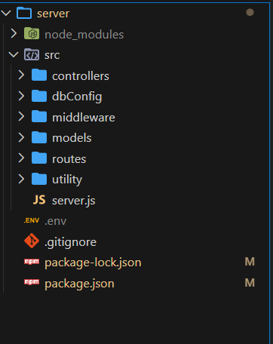

Project Setup

1. Install required tools and software:
Node.js.
MongoDB.
2. Create project folders and files:
Server folders.
3. Install Packages:
Backend npm Packages
Express.
Mongoose.
Cors.

Backend Development
Setup express server
Create index.js file in the server (backend folder).
Create a .env file and define port number to access it globally.
Configure the server by adding cors, body-parser.
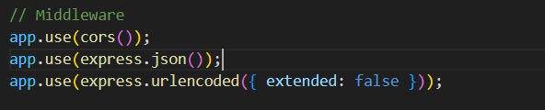
User Authentication:
• Create routes and middleware for user registration, login, and
• Set up authentication middleware to protect routes that require user authentication.
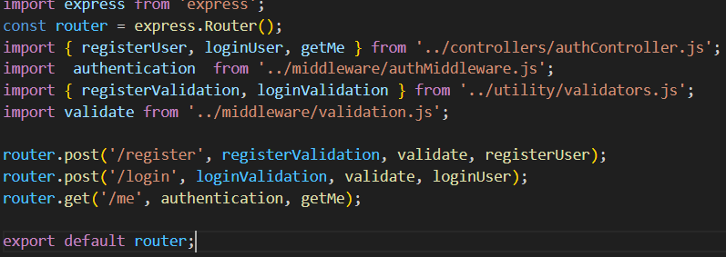 Define API Routes:
• Create separate route files for different API functionalities such as user authentication and crud operation for contacts
• Implement route handlers using Express.js to handle requests and interact with the database.
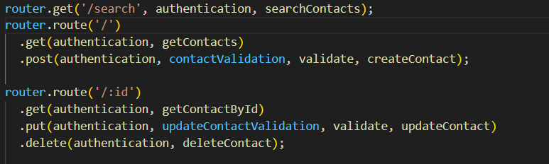
Implement Data Models:
• Define Mongoose schemas for the different data entities like user and contact
• Create corresponding Mongoose models to interact with the MongoDB database.
• Implement CRUD operations (Create, Read, Update, Delete) for each model to perform database operations. 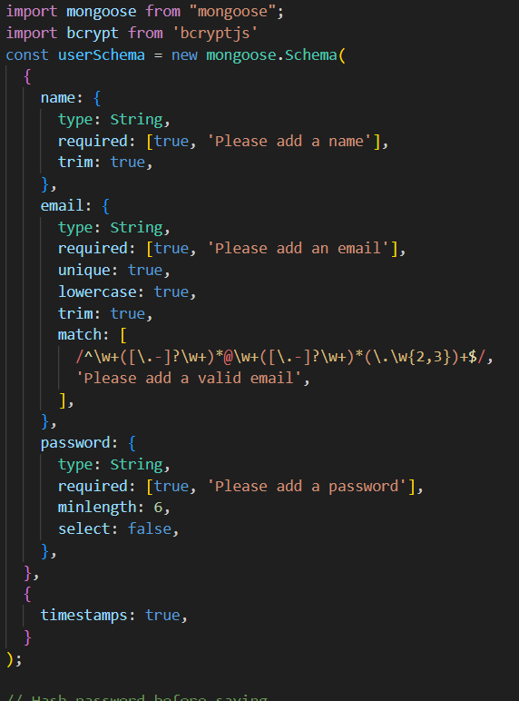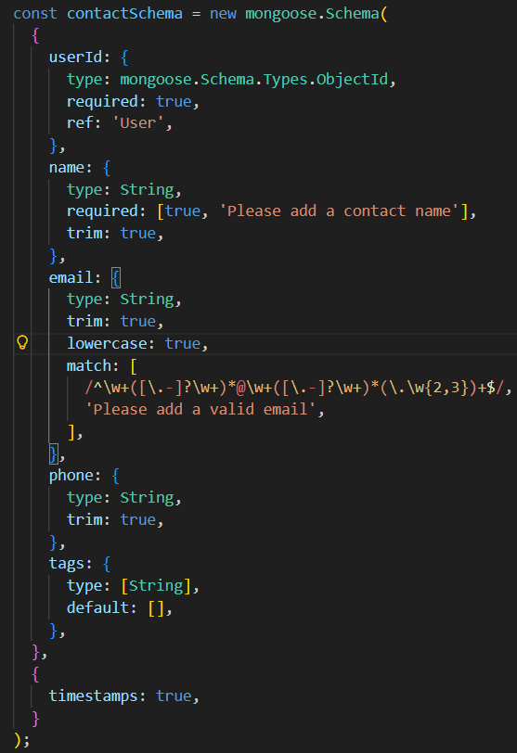
Error Handling:
• Implement error handling middleware to catch and handle any errors that occur during the API requests.
• Return appropriate error responses with relevant error messages and HTTP status codes.
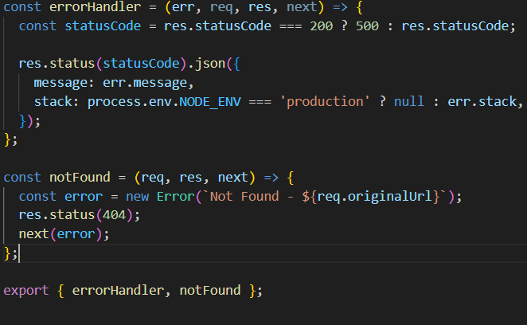

Database Configuration and Setup
1. Configure MongoDB:
Install Mongoose.
nnect database to backend:
Now, make sure the database is connected before performing any of the actions through the backend. The connection code looks similar to the one provided below.

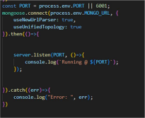

2. Configure Schema:
Firstly, configure the Schemas for MongoDB database, to store the data in such pattern. Use the data from the ER diagrams to create the schemas.
The schemas are looks like for the Application.
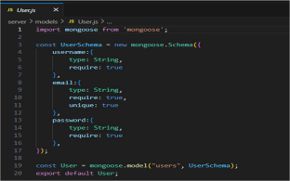

Project Execution

Execution Steps
- Open the project folder in the terminal
- Make sure you have a start script in the package.js file
- Use the command npm start to start the server
- You will the Running on PORT message on the successfully starting the server
- You will also see the database connected message if the database is connected successfully
- Use the Thunder client or Postman for using the created api’s

Output Screenshots

- Register
Api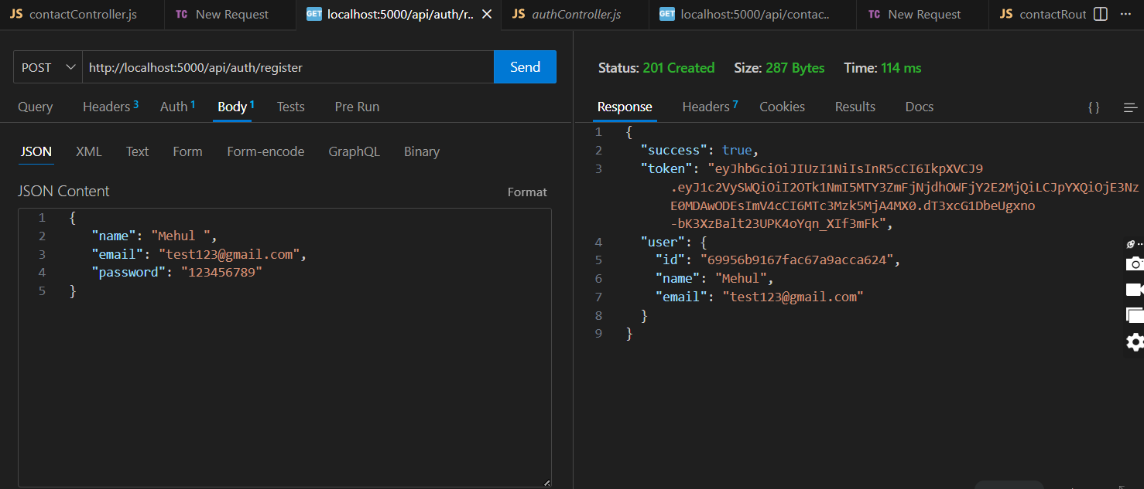
- Login Api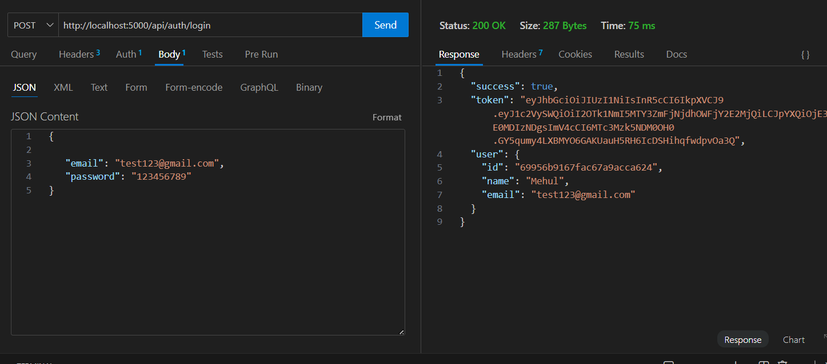

- Create New Contact


- Update Contact


- Delete Contact


- Search Contact


- Get The Current User


Conclusion

The ConnectHub Contact Manager is an efficient backend application that simplifies the process of storing and managing contacts. It provides a secure and organized system where users can maintain personal and professional contact information.By using modern technologies such as Node.js, Express.js, and MongoDB, the system ensures scalability, security, and flexibility. The project demonstrates practical implementation of RESTful API design, authentication mechanisms, and database management.The system can be further expanded with additional features to support real-world applications and larger user bases. The SpendWise project is a useful application designed to help users manage and track their daily expenses in a simple and organized way. It allows users to record their income and expenses, categorize transactions, and monitor their spending patterns. By using this system, users can clearly understand where their money is being spent and can plan their finances more effectively.The application improves financial awareness and helps users control unnecessary expenses. It provides a convenient and efficient way to maintain personal financial records. Overall, SpendWise is a practical solution for personal expense management and can be further improved by adding advanced features such as budget planning, data visualization, and mobile application support in the future.ConnectHub is a backend-focused project designed to demonstrate the core principles of modern web application development. Through this project, essential backend concepts such as server setup, API development, database integration, authentication, and data management are implemented using technologies like Node.js and Express.The project provides practical experience in building RESTful APIs and managing user-related data efficiently. By structuring the application with organized folders, middleware, and controllers, ConnectHub follows a scalable and maintainable backend architecture. This approach helps developers understand how real-world backend systems are designed and maintained.Overall, ConnectHub serves as a strong learning project for developers who want to improve their backend development skills. It lays the foundation for building more advanced full-stack applications and real-time communication platforms in the future. The knowledge gained from this project can be applied to larger systems, making it a valuable step in the journey of becoming a proficient backend developer.

