MYSQL VIEWS
Practical Examples and Student Exercises using MySQL Workbench

1.What is a View?
A View is a virtual table created from one or more existing tables.
- It does not store data itself.
- It stores only the SQL query.
- Whenever you query the view, MySQL retrieves the latest data from the underlying tables.

2. Setup: Employees and Departments Tables
Run this setup first. If these tables already exist with data, you may skip the setup.
CREATE DATABASE IF NOT EXISTS employeedb1;
USE employeedb1;
CREATE TABLE IF NOT EXISTS departments (
dept_id INT PRIMARY KEY,
dept_name VARCHAR(50)
);
CREATE TABLE IF NOT EXISTS employees (
emp_id INT PRIMARY KEY,
emp_name VARCHAR(50),
dept_id INT,
salary DECIMAL(10,2)
);
INSERT IGNORE INTO departments VALUES
(1,'CSE'),
(2,'ECE'),
(3,'EEE');
INSERT IGNORE INTO employees VALUES
(101,'Rahul',1,50000),
(102,'Priya',2,65000),
(103,'Anil',1,55000),
(104,'Sneha',3,70000),
(105,'Kiran',2,48000);

3. Verify the Tables
SHOW TABLES;
SELECT * FROM departments;
SELECT * FROM employees;

View 1 – Display All Employees
Question: Create a View named EmployeeView to display all columns from employees.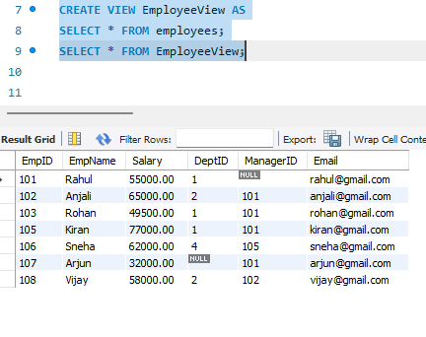

View 2 – Selected Columns
Question: Create a View showing employee ID, employee name and salary only.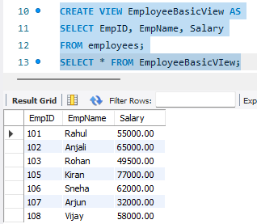

3 – High Salary Employees
Question: Create a View that displays employees earning more than 55000.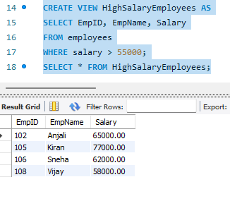

View 4 – Employee and Department using JOIN
Question: Create a View that displays employee name, department name and salary.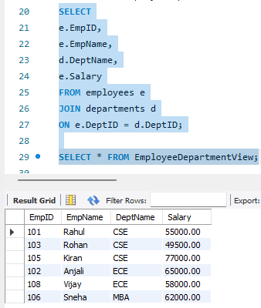

View 5 – Employees from a Particular Department
Question: Create a View that displays only CSE employees.

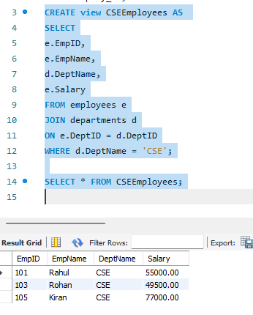

View 6 – Department-wise Average Salary
Question: Create a View using GROUP BY and AVG() to display department-wise average salary.

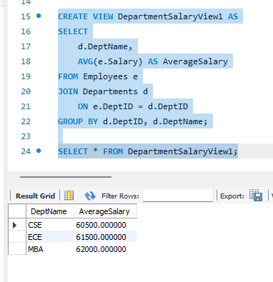

View 7 – Departments with Average Salary Above 55000
Question: Create a View that displays departments whose average salary is greater than 55000.

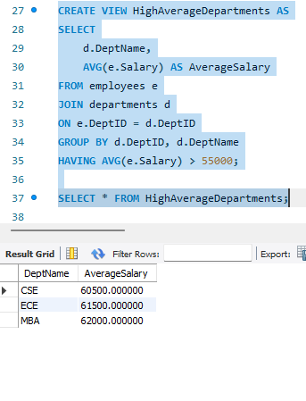

View 8 – Salary Range View
Qestion: Create a View that displays employees with salary between 50000 and 70000. 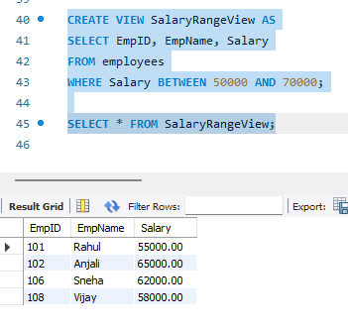

View 9 – View with Calculated Column
Question: Create a View that displays employee name, monthly salary and annual salary.

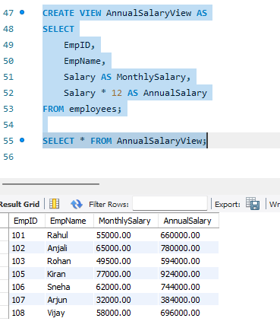

View 10 – Update Data Through a Simple View
Question: Create a simple single-table View and update an employee's salary through the View. 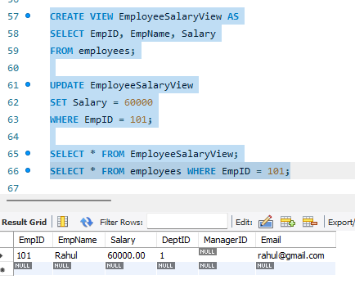

View 11 – CREATE OR REPLACE VIEW
Question: Modify an existing View so that it displays employee name and salary only.

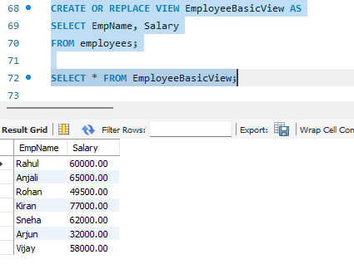

View 12 – View Definition
Question: Display the SQL statement used to create a View.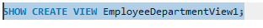

View 13 – List All Views
Question: Display all Views available in the current database. 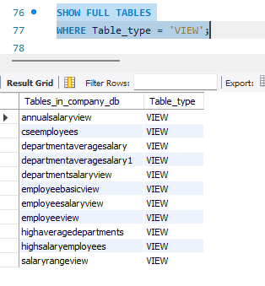

View 14 – Drop a View
Question: Remove an existing View from the database.



