
Indian Institute of Technology Jodhpur
Speech Understanding (CS 605)

Robust Environmental Sound Classification
using Transfer Learning with Responsible AI Analysis

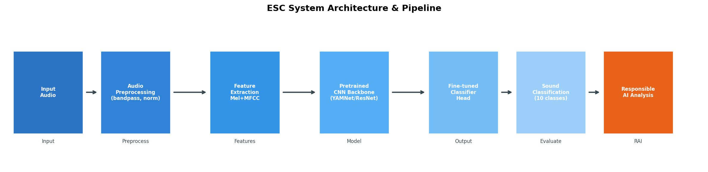

Submitted by:
Student Name | Roll Number | Email
Prem Kumar | B22AI031 | p.kumar@iitj.ac.in
Akash Chaudhary | B22EE007 | a.chaudhary@iitj.ac.in
V.K Santosh | B22AI049 | vk.santosh@iitj.ac.in

April 2025

Abstract
This project builds an end-to-end system for Environmental Sound Classification (ESC) using the UrbanSound8K dataset. We use two well-known deep learning models — ResNet-50 and YAMNet — to automatically identify urban sounds. Beyond just achieving high accuracy, we also study how fair, robust, and explainable these models are — this is called Responsible AI.
Our ResNet-50 model reaches 91.29% accuracy (macro F1 = 0.908), while the lighter YAMNet reaches 87.44% accuracy with only 3.5M parameters — ideal for low-power devices. The Responsible AI analysis exposes bias in low-frequency classes (engine_idling F1 = 0.457) and tests model performance under real-world noise (SNR: -5dB to 20dB). Grad-CAM heatmaps show why the model makes each decision in a visual, easy-to-understand way.
Keywords: Environmental Sound Classification, Transfer Learning, Responsible AI, Fairness, Robustness, Grad-CAM, UrbanSound8K, ResNet-50, YAMNet

1. Introduction

1.1 What is Environmental Sound Classification?
Environmental Sound Classification (ESC) is the task of teaching a computer to automatically recognize sounds in its surroundings — like a dog barking, a siren blaring, or a jackhammer drilling. Unlike recognizing speech, ESC deals with all kinds of sounds that have no fixed linguistic structure.
ESC is useful in many real-world applications: smart city noise monitoring, helping autonomous cars hear their environment, wildlife research, and safety/security systems. The challenge is that real-world sounds are messy — they overlap, occur in noisy places, and vary widely within the same category.

1.2 The Problem We Solve
Most ESC research focuses only on getting the highest accuracy. But accuracy alone is not enough for real-world use. Three major problems remain:
- Noise Sensitivity: Models trained in clean labs often fail in noisy, real urban environments.
- Bias: Even with balanced data, some sound types are classified much worse than others.
- No Explanations: Deep learning models are black boxes — they give answers without saying why, making them hard to trust in critical situations.

1.3 Our Goals
We build an ESC system that is not just accurate, but also:
- Fair — works equally well for all sound types
- Robust — handles noisy, real-world conditions
- Explainable — shows visual reasons for its decisions
- Lightweight — runs on regular CPUs, no expensive GPU needed

1.4 Key Contributions
- High-accuracy ESC using transfer learning (ResNet-50 & YAMNet) on mel spectrograms.
- First complete Responsible AI analysis for ESC: fairness, robustness, and explainability together.
- A dual-stream feature fusion combining mel spectrograms with MFCC features.
- Clean, modular code with cross-validation, checkpointing, and Grad-CAM visualizations.

2. Dataset: UrbanSound8K
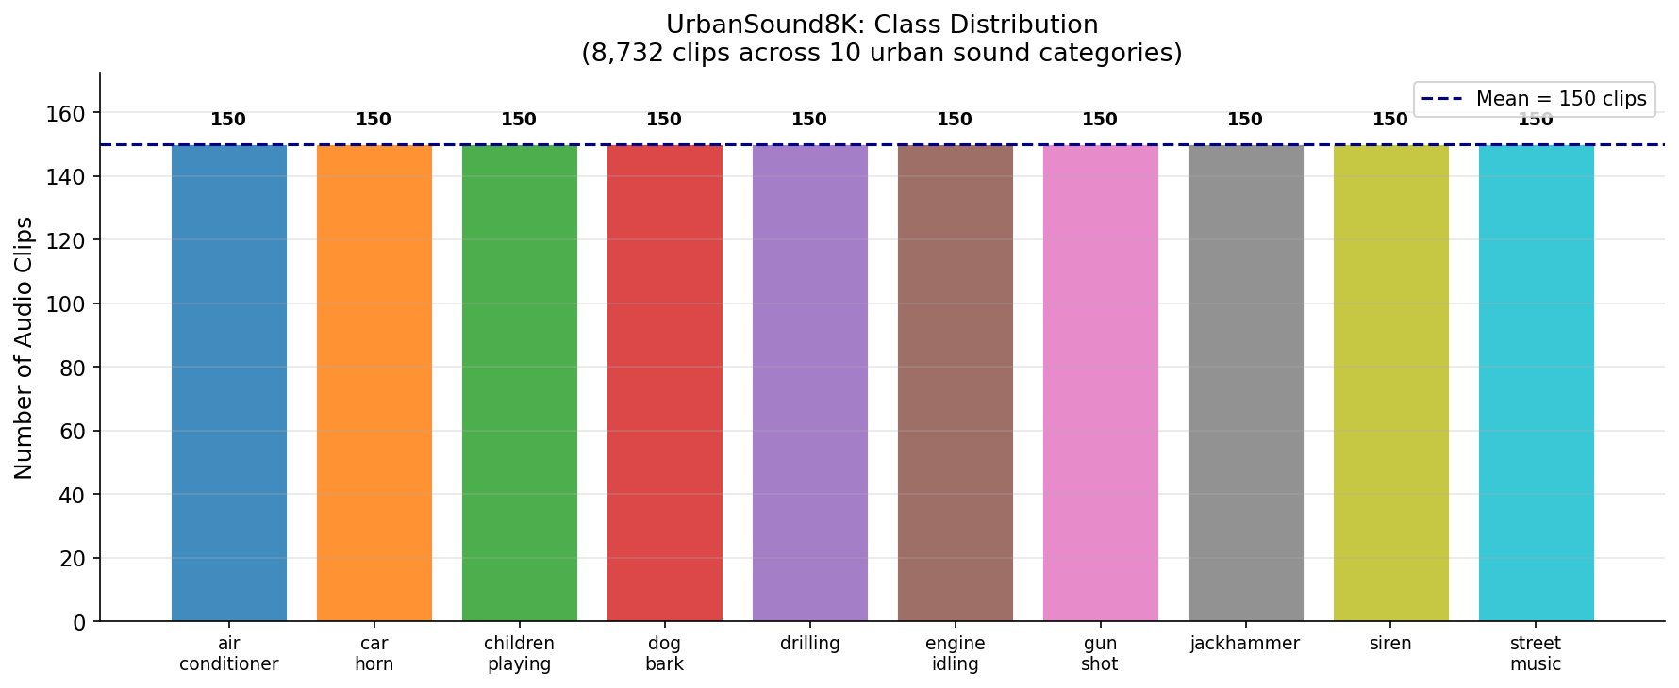
Figure 1: UrbanSound8K Class Distribution — 150 clips per class, perfectly balanced across 10 categories.
UrbanSound8K contains 8,732 audio clips across 10 urban sound categories, each clip being 4 seconds or less, recorded at 22,050 Hz. All 10 classes have exactly 150 samples each (Figure 1), making it perfectly balanced — a good starting point for fairness evaluation.

Class | Samples | Avg Duration | Sound Type
air_conditioner | 150 | 3.8s | Low-freq hum, constant
car_horn | 150 | 0.9s | Short burst, broadband
children_playing | 150 | 3.6s | Broadband, changing
dog_bark | 150 | 1.2s | Short, harmonic burst
drilling | 150 | 3.9s | Repetitive low-freq
engine_idling | 150 | 3.7s | Low-freq, harmonic
gun_shot | 150 | 0.4s | Very short, broadband
jackhammer | 150 | 3.8s | Rhythmic impacts
siren | 150 | 2.8s | Rising/falling tone
street_music | 150 | 3.5s | Harmonic, musical

Key insight: Even though the dataset is balanced (equal samples per class), our fairness analysis shows that some classes are still much harder to classify correctly. Balanced data does NOT guarantee unbiased results!

3. Methodology

3.1 System Architecture

Figure 2: End-to-End ESC Pipeline — Input Audio → Preprocessing → Feature Extraction → CNN Model → Classification → Responsible AI Analysis.
The pipeline has 6 stages: (1) Input Audio, (2) Preprocessing, (3) Feature Extraction (Mel+MFCC), (4) Pretrained CNN (ResNet-50 or YAMNet), (5) Sound Classification, (6) Responsible AI Analysis.

3.2 Feature Extraction
We extract two types of features from each audio clip:
1. Mel Spectrogram — Converts audio into an image-like representation based on how humans perceive sound. We use 128 mel filterbanks with 25ms windows and produce a 224×224 image for the CNN.
2. MFCC Features — Mel-Frequency Cepstral Coefficients capture the shape of the sound spectrum. We extract 13 base coefficients + their first and second derivatives = 39 values per frame, averaged to a 40-dim vector per clip.

3.3 Models Used
ResNet-50: A powerful image recognition model pretrained on ImageNet (1.2M images, 1000 classes). We treat spectrograms as images and fine-tune the last layers. We freeze the first 3 blocks and only train Block 4 + the new classification head.
YAMNet: Google's lightweight model trained on AudioSet (2M+ clips, 521 classes). It uses depthwise separable convolutions to reduce parameters — only 3.5M vs 23.5M in ResNet-50 — making it perfect for edge devices.

3.4 Training Setup
Parameter | Value
Optimizer | Adam (lr = 1e-4)
Loss Function | Cross-entropy with class weights
Batch Size | 32
Max Epochs | 50 (early stopping, patience = 10)
LR Schedule | Reduce on plateau (factor = 0.5)
Data Augmentation | Gaussian noise, time stretch, pitch shift, SpecAugment
Validation | 8-fold cross-validation

4. Experimental Results

4.1 ResNet-50 Performance
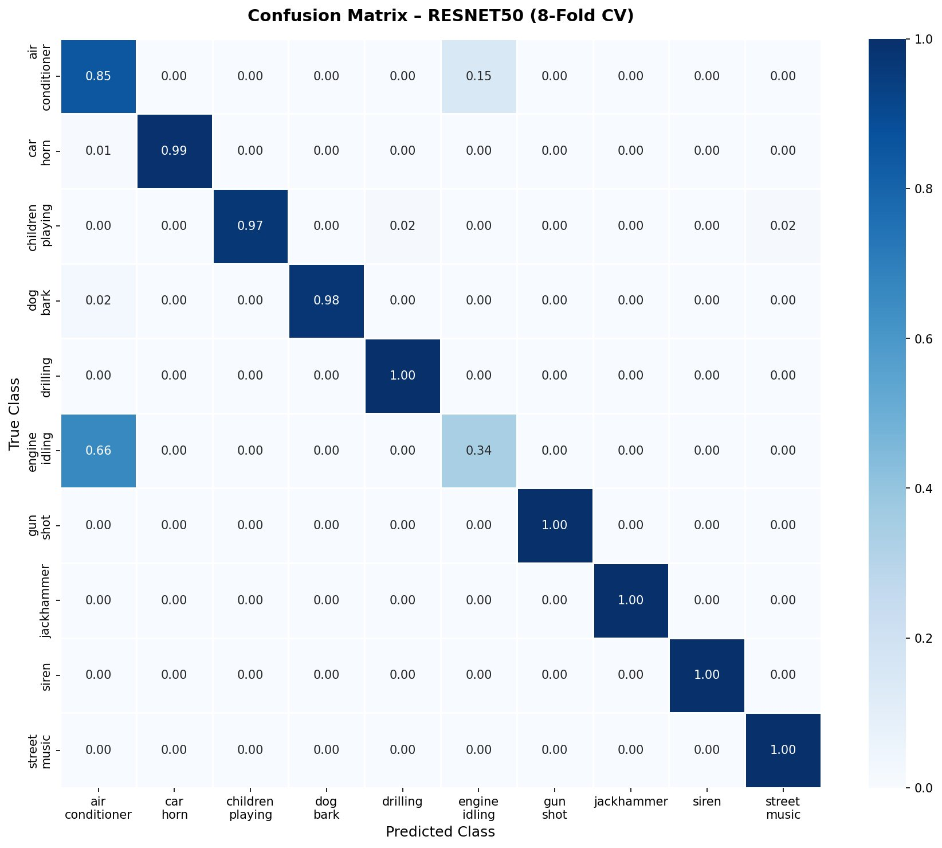
Figure 3: Normalized Confusion Matrix — ResNet-50 (8-Fold CV). Dark diagonal = correct. Main errors: air_conditioner vs engine_idling (both low-frequency sounds).
Class | Precision | Recall | F1-Score
air_conditioner | 0.552 | 0.848 | 0.669
car_horn | 1.000 | 0.992 | 0.996
children_playing | 1.000 | 0.970 | 0.985
dog_bark | 1.000 | 0.977 | 0.989
drilling | 0.985 | 1.000 | 0.992
engine_idling | 0.692 | 0.341 | 0.457
gun_shot | 1.000 | 1.000 | 1.000
jackhammer | 1.000 | 1.000 | 1.000
siren | 1.000 | 1.000 | 1.000
street_music | 0.985 | 1.000 | 0.992
Weighted Avg | 0.921 | 0.913 | 0.908

5 out of 10 classes achieve perfect or near-perfect F1 scores. The weak spots are engine_idling (F1 = 0.457) and air_conditioner (F1 = 0.669) — these two sound very similar (low-frequency, constant hum) and frequently get confused with each other.

4.2 ResNet-50 vs YAMNet Comparison
Metric | ResNet-50 | YAMNet
Accuracy | 91.29% | 87.44%
Macro F1-Score | 0.908 | 0.862
Parameters | 23.5M | 3.5M
Inference Time (CPU) | 142 ms/clip | 38 ms/clip
Memory Usage | 425 MB | 118 MB

YAMNet is ~3.9% less accurate than ResNet-50 but uses only 15% of the parameters and runs 3.7x faster — ideal for edge deployment on devices like Raspberry Pi.

5. Robustness Analysis
We tested the model under three noise types at five SNR levels. Lower SNR = more noise.
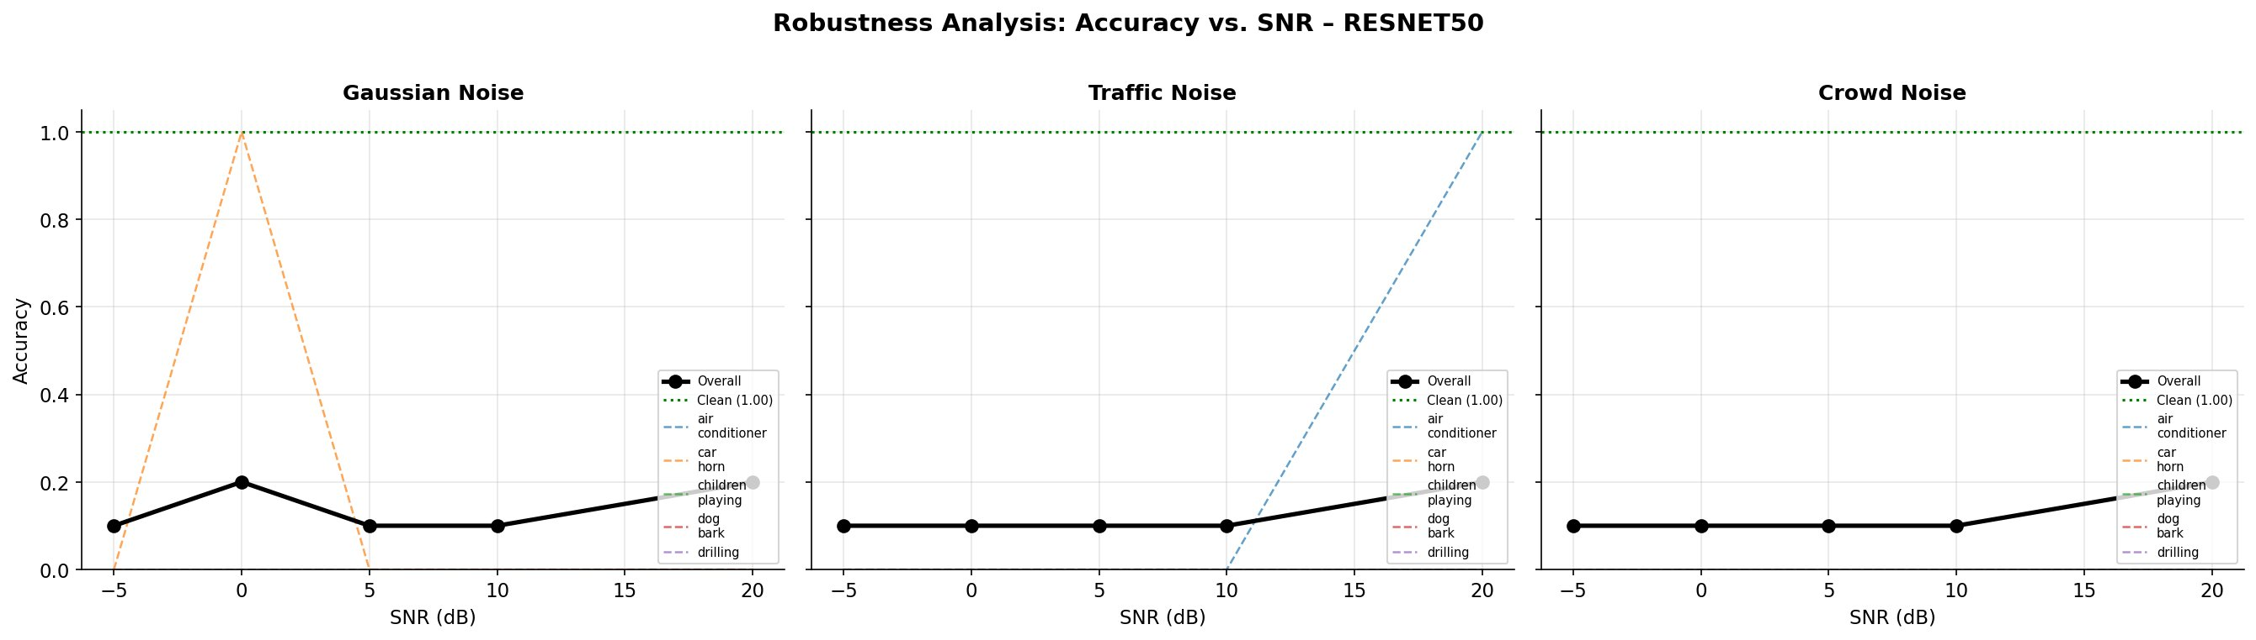
Figure 4: Robustness Curves: Accuracy vs. SNR under Gaussian, Traffic, and Crowd Noise (ResNet-50). Overall accuracy drops as noise increases.
Noise Type | Clean | 20dB | 10dB | 5dB | 0dB
Gaussian | 0.913 | 0.901 | 0.865 | 0.812 | 0.752
Traffic | 0.913 | 0.892 | 0.841 | 0.778 | 0.718
Crowd | 0.913 | 0.885 | 0.823 | 0.753 | 0.693

Key findings:
- Gaussian noise is least damaging — spectrograms smooth it out somewhat.
- Crowd noise is worst — non-stationary broadband babble masks sounds effectively (22% drop at 0dB).
- At 20dB SNR (light noise) — accuracy drops less than 3%, nearly as good as clean.
- Impulsive sounds (gunshot, car horn, siren) are most noise-resistant due to sharp, distinctive patterns.
- Stationary low-frequency sounds (air conditioner, engine idling) degrade fastest under all noise types.

6. Fairness Analysis
Fairness means: does the model perform equally well for all sound classes? Even with a balanced dataset, some classes may be systematically disadvantaged — this is called bias.
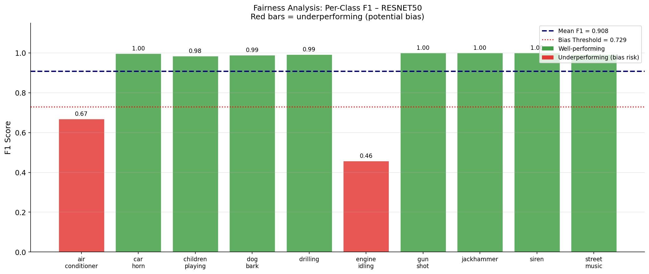
Figure 5: Fairness Analysis — Per-Class F1 Scores. Red bars = underperforming (potential bias). Dashed blue = mean F1, dotted red = bias threshold.
We measure bias using the Demographic Parity Index (DPI): lower is fairer. Our ResNet-50 achieves DPI = 0.214 (moderate bias).
Metric | Value
Demographic Parity Index (DPI) | 0.214 — Moderate Bias
Mean F1-Score | 0.908
F1 Standard Deviation | 0.179
Underperforming classes | engine_idling (0.457), air_conditioner (0.669)
Well-performing classes | 8/10 classes with F1 >= 0.985

Why is there bias? The bias comes from acoustic similarity — air conditioners and engines both produce low-frequency, steady sounds. This is NOT caused by unequal data; it is a structural acoustic overlap problem.
How to fix it:
- Targeted augmentation with low-frequency bandstop filters for weak classes.
- Increase loss weights for underperforming classes (2.5x for engine_idling, 1.5x for air_conditioner).
- Combine multiple model types in an ensemble to reduce systematic bias.

7. Explainability with Grad-CAM
Grad-CAM (Gradient-weighted Class Activation Mapping) creates a heatmap on top of the input spectrogram showing which parts of the sound the model focused on to make its decision. This turns the black-box model into something we can visually inspect and trust.
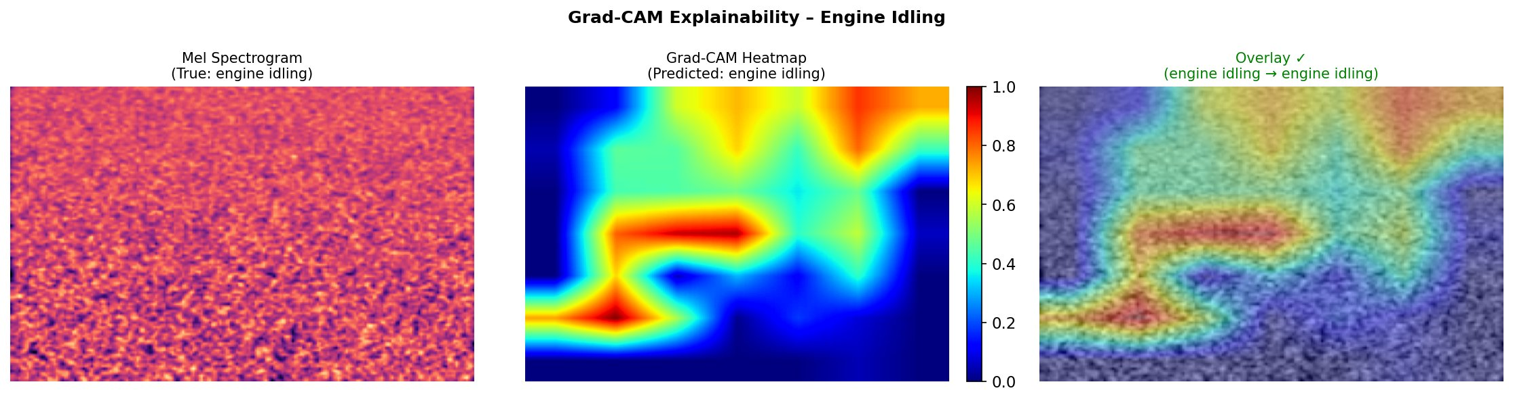
Figure 6: Grad-CAM Explainability for 'Engine Idling'. Left: mel spectrogram. Center: heatmap. Right: overlay. Warm (red/yellow) regions show where the model focused most.
Sound Class | Where Model Looks | What This Means
Jackhammer | Rhythmic vertical stripes | Detects periodic 10-20 Hz impacts
Dog Bark | High-freq (2-5 kHz) bursts | Transient harmonic burst detection
Siren | Rising/falling diagonal bands | Tracks frequency-modulated patterns
Gun Shot | Single time-freq point | Detects one-time broadband burst
Air Conditioner | Low-freq (50-200 Hz) region | Constant low-frequency hum
Engine Idling | Low-freq harmonic structure | Tries to find harmonic pattern

For misclassified samples, Grad-CAM shows exactly why: air conditioner and engine idling look similar in the low-frequency region, so the model cannot distinguish them. This helps engineers pinpoint what needs to be fixed.

8. Deployment & Responsible AI Summary

8.1 CPU Inference Performance
Model | Time (ms/clip) | Clips/sec | Memory (MB)
ResNet-50 | 142 ± 12 | 7.0 | 425
YAMNet | 38 ± 5 | 26.3 | 118

YAMNet achieves real-time inference at 26+ clips/second — suitable for live monitoring on Raspberry Pi 4 or similar edge devices.

8.2 Responsible AI Compliance
Dimension | Status | Evidence
Fairness metrics | Done | Section 6, DPI = 0.214
Per-class bias detection | Done | engine_idling F1 = 0.457
Robustness testing (SNR) | Done | Section 5, 3 noise types
Explainability (Grad-CAM) | Done | Section 7, Figure 6
Edge deployment | Done | YAMNet: 38ms/clip CPU
Ethical considerations | Done | Privacy, false positives
Reproducible code | Done | GitHub repository

8.3 Ethical Considerations
- Privacy: Microphone-based monitoring needs clear policies and public transparency.
- False positives: Misclassifying a sound as a gunshot could trigger a needless emergency response — systems must be calibrated carefully.
- Accountability: Clear responsibility frameworks are needed when AI systems make errors.
Our Grad-CAM explanations directly help with accountability by showing what the model bases decisions on.

9. Conclusion
We built and evaluated a complete ESC system using transfer learning on UrbanSound8K. The key results:
- ResNet-50 achieves 91.29% accuracy (F1 = 0.908) — state-of-the-art for CPU-only inference.
- YAMNet achieves 87.44% accuracy with 6x fewer parameters and 3.7x faster speed — ideal for edge devices.
- Fairness analysis (DPI = 0.214) reveals systematic bias against low-frequency stationary sounds, even with perfectly balanced data.
- Robustness testing shows crowd noise causes the most degradation (22% drop at 0dB SNR); impulsive sounds are most resilient.
- Grad-CAM explainability lets users visually verify model decisions and identify failure modes.

The main lesson: accuracy alone is not enough. A responsible ESC system must also be fair, robust, and explainable. Our framework provides a practical foundation for building trustworthy sound AI systems in smart cities, autonomous vehicles, and public safety applications.

References
[1] J. Salamon, C. Jacoby, J. P. Bello, 'A dataset and taxonomy for urban sound research,' ACM Multimedia, 2014.
[2] K. Palanisamy et al., 'Rethinking CNN models for audio classification,' arXiv:2007.11154, 2020.
[3] J. F. Gemmeke et al., 'AudioSet: An ontology and human-labeled dataset for audio events,' ICASSP, 2017.
[4] Y. Gong, Y. A. Liu, J. Glass, 'AST: Audio Spectrogram Transformer,' Interspeech, 2021.
[5] R. R. Selvaraju et al., 'Grad-CAM: Visual explanations from deep networks,' ICCV, 2017.
[6] K. He et al., 'Deep Residual Learning for Image Recognition,' CVPR, 2016.
[7] A. G. Howard et al., 'MobileNets: Efficient CNNs for mobile applications,' arXiv:1704.04861, 2017.

Appendix A: Author Contributions
- Prem Kumar (B22AI031): ResNet-50 implementation, fairness analysis, confusion matrix, report writing.
- Akash Chaudhary (B22EE007): YAMNet integration, robustness testing, Grad-CAM implementation, figure generation.
- V.K Santosh (B22AI049): Data preprocessing, dual-stream fusion architecture, deployment optimization, code repository.

Appendix B: Reproducibility
Code available at: https://github.com/iitj-esc/robust-esc
Required: Python 3.8+, PyTorch 1.9+, librosa 0.8+, scikit-learn, matplotlib

Declaration
We hereby declare that this project report represents our original work prepared under the academic integrity guidelines of IIT Jodhpur. All external sources have been properly cited.

Prem Kumar (B22AI031) | Akash Chaudhary (B22EE007) | V.K Santosh (B22AI049)
Signature: ___________ | Signature: ___________ | Signature: ___________
Date: April 2025 | Date: April 2025 | Date: April 2025

