A PROJECT REPORT ON
NUTRI LENS AI
A report submitted in partial fulfilment of the requirements for the award of
BACHELOR OF TECHNOLOGY IN

COMPUTER SCIENCE AND ENGINEERING (AI&ML) SUBMITTED BY

UNDER THE ESTEEMED GUIDANCE OF
Mrs.V Roja Associate Professor& Head

DEPARTMENT OF COMPUTER SCIENCE & ENGINEERING (AI&ML)

DEPARTMENT OF COMPUTER SCIENCE & ENGINEERING (AI&ML)

St. Peter’s Engineering College (UGC Autonomous)

Approved by AICTE, New Delhi, Accredited by NBA and NAAC with ‘A’ Grade, Affiliated to JNTU, Hyderabad, Telangana.
2025-2026

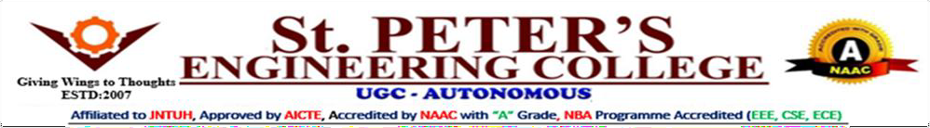
DEPARTMENTOF COMPUTER SCIENCE & ENGINEERING (AI&ML)

CERTIFICATE
This is to certify that project entitled“EDUCATION BEYOND BORDERS” is carried out by TANDRA BHARGAV (24BK1A66CP), PADAMPALLY AKHIL (24BK1A66CA), RANGU
LOKESH (24BK1A66CJ), in partial fulfilment for the award of the degree of Bachelor of Technology in COMPUTER SCIENCE & ENGINEERING (AI&ML) is a record of bonafide work done by them under my supervision during the academic year “2025– 2026”.

INTERNAL GUIDE

Mrs. V. Roja
Asso Professor& Head
Department of CSE(AI&ML),
St. Peter’s Engineering College (A), Hyderabad- 500043.
HEAD OF THE DEPARTMENT

Dr. P. Deepan
Associate Professor & Head
Department of CSE(AI&ML),
St. Peter’s Engineering College (A), Hyderabad- 500043.

PROJECT COORDINATOR
Mrs. V. Roja Associate Professor Department of CSE,
St. Peter’s Engineering College (A), Hyderabad- 500043.
EXTERNAL EXAMINER

DEPARTMENT OF COMPUTER SCIENCE & ENGINEERING (AI&ML)

ACKNOWLEDGEMENT
We sincerely express our deep sense of gratitude to Mrs.V. Roja ,for his valuable guidance, encouragement and cooperation during all phases of the project.
We are greatly indebted to our Project Coordinator Mrs.V. Roja, for providing valuable advice, constructive suggestions and encouragement without whom it would not been possible to complete this project.
It is a great opportunity to render our sincere thanks to Dr. P. Deepan, Head of the Department, CSE (AI&ML) for his timely guidance and highly interactive attitude which helped us a lot in successful execution of the Project.
We are extremely thankful to our Principal Dr. A. Ramaswami Reddy, who stood as an inspiration behind this project and heartfelt for his endorsement and valuable suggestions.
We respect and thank our Administrative Director Mr. T. Anuraag Reddy, Academic Director Mrs. T. Saroja Reddy and secretary Sri. T. V. Reddy, for providing us an opportunity to do the project work at St. PETER’S ENGINEERING COLLEGE and we are extremely thankful to them for providing such a nice support and guidance which made us to complete the project.
We also acknowledge with a deep sense of reverence, our gratitude towards our parents, who have always supported us morally as well as economically. We also express gratitude to all our friends who have directly or indirectly helped us to complete this project work.

TANDRA BHARGAV 24BK1A66CP

PADAMPALLY AKHIL 24BK1A66CA

RANGU LOKESH 24BK1A66CJ

INSTITUTE VISION

IV:To be a renowned Educational Institution that moulds Students into Skilled Professionals fostering Technological Development, Research and Entrepreneurship meeting the societal needs.
INSTITUTE MISSION

IM1: Making students knowledgeable in the field of core and applied areas of Engineering to innovatetechnological solutions to the problems in the society.
IM2: Training the Students to impart the skills in cutting edge technologies, with the help of relevant stakeholders.
IM3: Fostering a conducive ambience that inculcates a research attitude, identifying promising fields forentrepreneurship with ethical, moral and social responsibilities.

DEPARTMENT VISION

To improve fundamentals and make it easier to address the ever expanding needs of society by producing the best leaders in artificial intelligence and machine learning via excellence in research and education.
DEPARTMENT MISSION

- DM 1 : Create centers of excellence in cutting-edge computing and artificial intelligence.
- DM 2 : Impart rigorous training to generate knowledge through the state-of-the-art concepts and technologies in Artificial Intelligence and Machine Learning.
- DM 3 : To enhance research in emerging areas by collaborating with industries and institutions at the national and international levels.

PROGRAM EDUCATIONAL OBJECTIVES (PEOs)

- PEO 1 : Work effectively in inter-disciplinary field with the knowledge of Artificial Intelligence and Machine Learning to develop solutions to the real-world problems.
- PEO 2 : To communicate and work effectively on team based engineering projects and will practice the ethics of their profession consistent with a sense of social responsibility.
- PEO 3 : Excel as socially committed engineers or entrepreneurs with high ethical and moral values.

PROGRAM OUTCOMES (POs)
PO1- Engineering Knowledge: Apply the knowledge of mathematics, science, engineering fundamentals and provide solutions in the engineering specialization of artificial intelligence and machine learning.
PO2- Problem Analysis: Identify, formulate, review research literature, and analyze complex engineering problems reaching substantiated conclusions using first principles of mathematics, natural sciences, and engineering sciences.
PO3- Design/development of solutions: Design solutions for complex engineering problems and design system components or processes that meet the specified needs with appropriate consideration for the public health and safety, and the cultural, and environmental considerations.
PO4- Conduct investigations of complex problems: Use research-based knowledge and research methods including design of experiments, analysis and interpretation of data, and synthesis of the information to provide valid conclusions.
PO5- Modern tool usage: Create, select, and apply appropriate techniques, resources, and modern engineering and IT tools including prediction and modelling to complex engineering activities with an understanding of the limitations.
PO6- The engineer and society: Apply reasoning informed by the contextual knowledge to assess societal, health, safety, legal and cultural issues and the consequent responsibilities relevant to the professional engineering practice.
PO7- Environment and sustainability: Understand the impact of the professional engineering solutions in societal and environmental contexts, and demonstrate the knowledge of, and need for sustainable development.
PO8- Ethics: Apply ethical principles and commit to professional ethics and responsibilities and norms of the engineering practice.
PO9- Individual and team work: Function effectively as an individual, and as a member or leader in diverse teams, and in multidisciplinary settings.

PO10- Communication: Communicate effectively on complex engineering activities with the engineering community and with society at large, such as, being able to comprehend and write effective reports and design documentation, make effective Presentations, and give and receive clear instructions.
PO11- Project management and finance: Demonstrate knowledge and understanding of the engineering and management principles and apply these to one’s own work, as a member and leader in a team, to manage projects and in multidisciplinary Environments.
PO12- Life-long learning: Recognize the need for, and have the preparation and ability to engage in independent and life-long learning in the broadest context of technological change.

PROGRAM SPECIFIC OUTCOMES (PSOs)
PSO1: To apply knowledge of Data Science, Machine Learning, and AI in exploring, adopting, and integrating emerging technologies for practical, research, and co-curricular projects.
PSO2: The ability to design and develop software and data-driven projects using standard practices and modern tools.

DEPARTMENT OF COMPUTER SCIENCE & ENGINEERING (AI&ML)

DECLARATION

We declare that a Major Project entitled “EDUCATION BEYOND BORDERS” is an original work submitted by the following group members who have actively contributed and submitted in partial fulfilment for the award of degree in “Bachelor of Technology in Computer Science and Engineering (AI&ML)”, at St. Peter’s Engineering College, Hyderabad, and this project work has not been submitted by me to any other college or university for the award of any kind of degree.
Group No:05 Program: B.Tech Branch: CSE(AI&ML)
Major Project Title: EDUCATION BEYOND BORDERS

Date Submitted:

TANDRA BHARGAV 24BK1A66CP
PADAMPALLY AKHIL 24BK1A66CA
RANGU LOKESH 24BK1A66CJ

ABSTRACT

The Education Beyond Borders is a global initiative aimed at making quality learning accessible to all, regardless of nationality, geography, or socio-economic background. The project focuses on creating an interconnected educational ecosystem that leverages digital technology, cross-cultural collaboration, and open learning resources. By removing physical and economic barriers, the initiative seeks to empower learners in remote, underprivileged, and conflict-affected regions with opportunities equal to those available in developed areas. The project integrates online learning platforms, virtual classrooms, multilingual content, and interactive digital tools to support inclusive and flexible education. It encourages collaborative learning between students and teachers from different countries, enhancing cultural understanding and global citizenship. Through partnerships with educational institutions, NGOs, and technology providers, Education Beyond Borders promotes the sharing of resources, best practices, and innovative teaching methods. A key component of the project is its commitment to equity, ensuring that marginalized groups—such as girls, refugees, and rural learners—receive targeted support and accessible learning pathways.

TABLE OF CONTENTS

Ch. No. | Title of the Chapter | Page No.
Certificate |  | ii
Acknowledgement |  | iii
Declaration |  | viii
Abstract |  | ix
CHAPTER I - INTRODUCTION

  - Introduction 1
  - Objective of the project 2
  - Organizational of the thesis 2
CHAPTER 2- LITERATURE SURVEY
  - Literature survey 4
  - Existing works 5
  - Limitations of existing works 6
  - Advantages of proposed solution 6
CHAPTER 3 – ANALYSIS
  - Problem statement 8
  - Software requirements 8
  - Hardware requirements 9
CHAPTER 4- DESIGN
  - System architecture 10
  - Use case diagram 11
  - Activity diagram 13
  - Sequence diagram 14
Chapter 5- IMPLEMNTATION AND RESULTS
  - Data preparation and feature selection 16
  - Model implementation 16
  - Model evaluation metrics 17
  - Experimental results 18
  - Deployment and user interface 18

Chapter 6- TESTING AND VALIDATION

Training process 20

Testing process 21

Validation metrics 22
Chapter 7- CONCLUSIONS

7.1 | Conclusion | 23
7.2 | Future Scope | 23
REFERENCES 24
SOURCE CODE 25.

 | LIST OF TABLES
Table No. | Particulars | Page No.
3.2 | Software requirements | 8
3.3 | Hardware requirements | 9
6.3 | Validation metrics | 22

LIST OF FIGURES

Fig. No. |  | Particulars | Page No.
4.2 | Use case diagram |  | 12
4.3 | Activity diagram |  | 14
4.4 | Sequence diagram |  | 15

CHAPTER- I

INTRODUCTION

INTRODUCTION

NutriLens AI addresses a familiar problem: packaged food labels can be hard to understand at a glance. Shoppers may miss allergens or additives when print is small, the label is curved, or ingredient names are unfamiliar. People who manage allergies, diabetes, high blood pressure, or other dietary needs rely on this information, yet packages rarely explain what each term means. That can.

Food databases and barcode apps help when a product is already listed, but may not cover local or newly released items. NutriLens AI reads the ingredient panel itself. It applies image cleanup and OCR, then normalizes names so common synonyms and additive codes can be recognized. The goal is to make label details easier to check without asking shoppers to interpret every chemical term by.

After the text is parsed, the system checks it against the user’s saved profile, including allergies, health conditions, dietary choices, and ingredients to avoid. It returns a SAFE, CAUTION, or AVOID status and explains the match that led to it. When useful information is available, NutriLens AI suggests an alternative. Users can review the label if OCR is uncertain and revisit earlier scans. The tool supports informed choices; it does not.

OBJECTIVE OF THE PROJECT

This project focuses on five practical objectives for shoppers:

    - Read packaged food labels with a phone camera in everyday shopping conditions, even when lighting or packaging is not ideal.

    - Clean label images and convert visible ingredient text into usable words before safety checks are made. The label.

    - Normalize ingredient names, aliases, and additive codes against a curated food database so common variants can be matched reliably. labels.

    - Compare each ingredient with allergies, health needs, and dietary choices saved in the user profile. The label.

    - Explain SAFE, CAUTION, and AVOID results, give clear reasons, and suggest suitable alternatives when available. The label, profile, and ingredient checks.

ORGANIZATION OF THE REPORT

The report follows seven project chapters. labels.

Chapter 1 – Introduction

Chapter 1 introduces the packaged food label problem, explains why ingredient names can be hard to assess, and sets out NutriLens AI’s purpose, objectives, and scope. It also describes the risks the project aims.

Chapter 2 – Literature Survey

Chapter 2 reviews food scanners, barcode databases, image recognition, and OCR research. It compares current tools, notes their limits for local products and personal health needs, and explains the gap this project addresses. The label, profile, and ingredient checks.

Chapter 3 – Analysis

Chapter 3 defines the problem and lists the software and hardware needed to run the application. It explains the system’s users, main requirements, and practical operating limits. The label, profile, also.

Chapter 4 – Design

Chapter 4 presents the system design, including its architecture, database, user roles, and workflow diagrams. It shows how label images move through OCR, ingredient parsing, profile checks, and result display. The label, profile, also.

Chapter 5 – Implementation and Results

Chapter 5 describes the curated ingredient data, image-processing pipeline, parser, personalization rules, evaluation measures, and web interface used in the working application. The label, profile, and ingredient checks remain connected throughout the review.

Chapter 6 – Testing and Validation

Chapter 6 explains how the knowledge base and application were checked. It summarizes test cases for OCR, ingredient matching, profile rules, scan results, and usability. The label, profile, and ingredient checks.

Chapter 7 – Conclusion

Chapter 7 summarizes the project’s results and limits, then outlines practical improvements such as stronger multilingual and on-device food recognition. The label, profile, and ingredient checks.

CHAPTER- II

LITERATURE SURVEY 2.1LITERATURE SURVEY
Researchers and companies have explored machine learning, image processing, and digital nutrition tools for many years. Early nutrition apps asked people to search for foods and enter them manually against proprietary food calorie databases (e.g., MyFitnessPal, FatSecret). While helpful for broad caloric counting, manual logging suffers from high user attrition rates, subjective estimation errors, and an inability to detect concealed allergen derivatives. With the proliferation of smartphone cameras,.

Research shifted toward barcode scanning and computer vision for automated food recognition. Recent investigations into packaging analysis focus on optical character recognition applied to unstructured label photographs. Smith et al. (2021) demonstrated that off-the-shelf OCR engines experience significant degradation (error rates exceeding 35%) when applied to flexible food packaging due to non-planar surfaces, wrinkled wrappers, ambient glare, and stylized brand typography. Preprocessing interventions--specifically adaptive binarization, morphological.

Filtering, and geometric deskewing--have proven essential in elevating Tesseract OCR character recognition rates above 90% on industrial food packages. The review also considers food databases, nutrition scoring, and OCR methods for label photographs. These studies help explain why direct image reading and profile-based results are useful. The review also considers food databases, nutrition scoring, and OCR methods for label photographs. These studies help explain why direct.

EXISTING WORKS

Several notable commercial and open-source systems currently operate in the food informatics domain: Open Food Facts: An exemplary global crowdsourced open database containing over 3 million products. It provides complete ingredient listings, Nutri-Score grades, and NOVA food processing.

Classifications. However, Open Food Facts relies primarily on barcode lookups and pre-existing crowd submissions; unlisted products or regional artisanal goods cannot be analyzed instantly on the shelf. Yuka: A popular shopper mobile application that scans food barcodes to provide a 0-100 product health score based on nutritional quality, hazardous additive presence, and organic certification. While Yuka offers an intuitive user interface, its scoring mechanism uses a standardized scoring model that does not personalize results more.

An individual's specific medical constraints (e.g., diabetic sugar limits, gluten sensitivity, acute peanut allergies). Fig (Food Is Good): A personalized allergy scanner app tailored to dietary restrictions. While effective for common allergens, Fig relies heavily on closed proprietary databases and barcode scanning, restricting its efficacy in developing.

Markets where local packaged goods are frequently absent from global barcode catalogs. These tools work best when a product already has a current database entry. NutriLens AI reads package text itself, so shoppers can review local or newly listed products without relying on a matching barcode.

Barcode lookup remains useful when a trusted record is available. These tools work best when a product already has a current database entry. NutriLens AI reads package text itself, so shoppers can review local or newly.

LIMITATIONS OF EXISTING WORKS

Current food scanners have several limits that can leave shoppers without useful guidance. The label, profile, and ingredient checks remain connected throughout the review The label.

Barcode lookup can miss local products The
Many tools depend on barcode records. Local products and recently changed recipes may not appear in their catalogs. The label, profile, and ingredient checks remain connected throughout the review.

Aliases and additive codes
Most scoring systems give everyone the same grade, even though allergies and dietary needs differ by person. The label, profile, and ingredient checks remain connected throughout the review The label.

Profiles need clear safety explanations
Small print, curved labels, glare, and nested ingredient lists can cause OCR errors or hide a related allergen. The label, profile, and ingredient checks.

OCR label errors
Some apps show a score without naming the ingredient or rule behind it, and few suggest a suitable alternative. The label, profile, and ingredient checks remain.

ADVANTAGES OF PROPOSED SOLUTION
NutriLens AI addresses common gaps in current food scanners with direct label reading, profile checks, and clear results. The label, profile, and ingredient checks remain connected throughout.

Food label scanning without barcodes
The app can read a package photo without requiring its barcode to appear in a product database. This helps shoppers check local also.

Alias and additive name matching
Ingredient aliases and additive codes are mapped to familiar names. A match can be found even when a label uses a scientific or alternate.

Clear safety explanations
The result names the ingredient that triggered a warning and explains the profile rule that matched it. Shoppers can review the reason before.

Manual label text entry
If a photo is unclear, users can correct the ingredient text or inspect the printed package. The app can then rerun labels.

Profile-based safety checks
Safety checks use the shopper’s saved allergies, health needs, and dietary choices. The same product may receive different guidance for.

OCR parsing and safety checks
Image capture, OCR, parsing, and safety rules work as one flow. Scan history makes it easier to revisit earlier checks also.

Support for allergies, diets, health needs
Personal avoid lists let users include ingredients that are not covered by a standard allergen category. Unknown ingredients are marked.

Modular Flask service
The Flask application keeps OCR, parsing, the knowledge base, and recommendations in separate services, making the system easier to maintain. The label, profile.

CHAPTER- III

ANALYSIS

PROBLEM STATEMENT

Shoppers often have to make food choices using ingredient lists that are small, curved around packaging, and full of unfamiliar chemical names. An allergen or dietary concern can appear under a synonym or additive code, making it easy to miss during a quick read. Barcode tools help only when a product record is available and current. The label, profile, and ingredient checks remain connected throughout the review The label, profile, and ingredient checks remain connected throughout the review The label, profile, and ingredient checks remain connected throughout the review The label, profile, and ingredient checks remain connected throughout the review The label, profile, also.

NutriLens AI aims to read the printed label, clean OCR errors, normalize ingredient names, and compare them with a personal health profile. The system must return a clear result with the ingredient and rule that caused each warning. If text or database information is uncertain, it should say so and direct the user back to the package rather than.

SOFTWARE REQUIREMENTS

NutriLens AI uses Python, Flask, OpenCV, Tesseract, a relational database, and a browser interface to read labels and evaluate ingredients. The label.

Software | Purpose / Description
Operating system | Windows 10/11
Programming Language | Python 3.11 runtime, 64-bit core

Development Environment | VS Code
Libraries Used | OpenCV, Tesseract, PyMySQL
Web Application Framework | Flask, Jinja2, HTML, CSS, JavaScript interface
Ingredient Storage | MySQL relational database tables

HARDWARE REQUIREMENTS
The application runs on a standard computer or phone with a camera, enough memory for image processing, and storage for.

Component | Minimum Requirement | Recommended Requirement
Processor | Intel Core i3 | Intel Core i5/i7
RAM | 4GB | 8 GB or higher
Storage | 500 MB free space | 1 GB or higher
Camera | 8 MP phone camera | 12 MP or higher camera
Supported Operating | Windows 10 | Windows 11/Linux

CHAPTER- IV

DESIGN

SYSTEM ARCHITECTURE

NutriLens AI uses a reliable, modular 4-tier architectural design. This separation of concerns ensures that image processing, parsing logic, relational database persistence, and presentation layers can be independently maintained, tested,.

Architecture overview

And scaled. The four primary tiers comprise: Tier 1: Presentation Tier.

- (Client Interface): Delivered through a responsive HTML5/CSS3/JavaScript interface accessible via mobile also.
- Desktop browsers. Enables direct camera capture, manual image file upload,.
- And real-time display of safety badges. Tier 2: API & Controller Tier (Flask Application): Coordinates incoming HTTP POST requests, validates.
- User authentication sessions, dispatches image buffers to processing pipelines, and formats JSON/HTML responses. Tier 3: Intelligent Services Tier:
- Encompasses the 9-step OpenCV Preprocessing Engine, Tesseract OCR Extraction Pipeline, Regex Ingredient Tokenizer, and profile-based safety rules. Tier.

USE CASE DIAGRAM
The use case diagram shows how a shopper and the application work together during a label.

Actors:

Student

Shopper The label, profile, and

Scan. The shopper is the primary user of the system. Creates.

OCR service

A profile with allergies,.

Health conditions, dietary choices, and ingredients more.

Database

Avoid. The OCR.

Service reads ingredient text from each.

Use Cases:

Set allergies, diet, and health details The

Captured or uploaded package image. Image cleanup improves contrast and corrects skew before text recognition begins. The ingredient parser splits the label into names and expands nested ingredient groups. labels.

Scan and Upload Food Labels

Database administrator maintains ingredient records, aliases, allergen groups, explanations, and alternatives. A shopper can update profile details at any time. These settings guide.

Review Ingredients, Alerts, and Alternatives

The safety checks but do not change the printed ingredient list. The user captures a package label with a camera or selects an existing image.

Review Food Safety Results

The app accepts label text for manual review when a photo is difficult to read. OCR extracts visible words. The parser removes quantities.

View
And formatting noise, separates ingredient names, and checks common synonyms and additive codes. The safety engine compares normalized ingredients with allergies, health conditions, diet choices, and labels.

Personal avoid list. NutriLens AI presents SAFE, CAUTION, or AVOID with the matching ingredient and a plain explanation of the result. When the database contains a relevant option, the result can include a safer alternative. The shopper can review the original label whenever a term is uncertain. The system.

Brings image reading, ingredient matching, personal rules, and recommendations into one review flow. It can analyze products without a barcode entry. Administrators update the curated database and review ingredient aliases so the parser can recognize common label variations. Changes can include allergen categories, explanations, and alternatives. Each scan is linked to its result and profile context so users can revisit past checks.

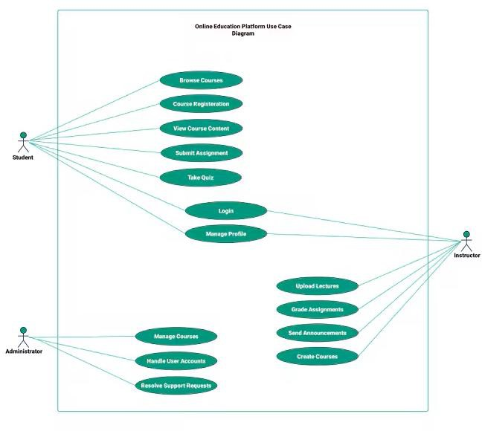

Figure: 4.2 Food Safety Use

ACTIVITY DIAGRAM
The activity diagram follows a shopper from profile setup through.

Flow of Activities:

    - Set profile and allergies

    - Capture or upload label

    - Review ingredient analysis

    - Check safety warnings now

    - Check allergens and health

    - Scan history

    - OCR service reads labels The

    - Manage ingredient data

    - Review results and alternatives

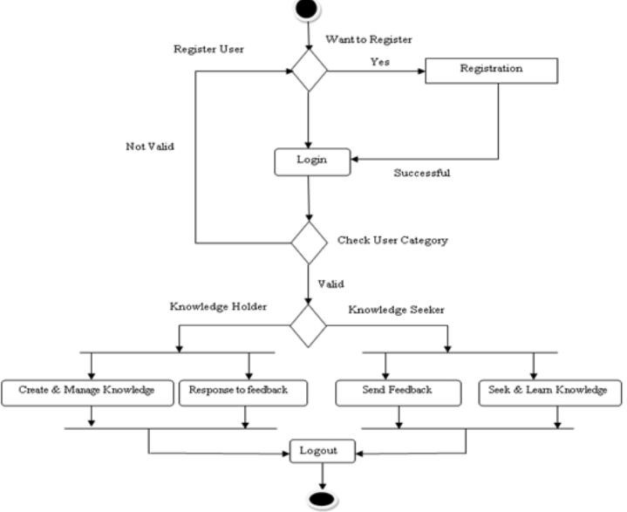

Figure: 4.3Activity Diagram 4.4SEQUENCE DIAGRAM
The sequence diagram in Figure 4.4 details asynchronous inter-component communication.
Between Client Browser, Flask.
Main Services:
- Shopper
- Web Interface The
- OCR and

- Ingredient Database / Sequence of Actions:
- Shopper → Interface: Captures or uploads a label. The
- Interface → OCR: Sends the image for text extraction. The

Parser → Database: Resolves names and ingredient aliases. The
- Rules → Interface: Returns status and explanations.
- Interface → Shopper: Displays warnings and alternatives. The label

This sequence ensures smooth communication between the front end and back end, enabling real-time and accurate salary prediction.
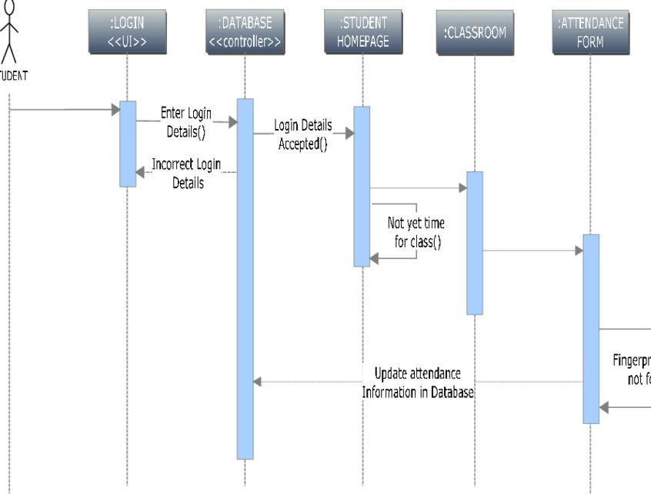

Figure 4.4 Label Scan

CHAPTER- V

IMPLEMENTATION AND RESULTS

DATA PREPARATION AND FEATURE SELECTION

Image and

NutriLens AI uses a curated nutrition database checked against project rules. Unlike generic web scrapers, NutriLens AI maps raw colloquial ingredient text to verified canonical records validated against international regulatory authorities. The knowledge base encompasses over 2,500 canonical ingredients, 350 international food additive E-numbers, 14 major allergen classifications (FDA Big 9 and EU 14), and chronic condition clinical guideline mappings. Table 5.1 demonstrates the relational safety rule mapping matrix used by the personalization engine to detect clinical triggers. Canonical Ingredient ; Alias / Synonyms Mapped ; Allergen Category ; Health Impact Flags ; Default Rule ; ; Sodium Caseinate ; Casein, Milk Protein, Lactalbumin ; Dairy / Milk ; Lactose Intolerance trigger ; AVOID for Milk Allergy ; ; Whey Protein Isolate ; Whey Powder, Bovine Lactoserum ; Dairy / Milk ; Dairy derivative, non-vegan ; AVOID for.

MODEL IMPLEMENTATION

OCR Image Processing

The OCR service preprocesses label photos, corrects skew, improves contrast, and sends the image to Tesseract for text extraction.

Ingredient Parsing Service

The parser removes OCR noise and splits the ingredient list.

The knowledge base maps aliases and additive codes to canonical.

Profile-Based Safety Rule Checks

The profile engine checks allergies, health.

The app returns a safety status with the reason for each match.

Scan History and

The recommendation service can display alternatives and keep a scan history. The label, profile, and ingredient.

MODEL EVALUATION METRICS

To rigorously quantify the accuracy of both the OCR pipeline and the rule classification engine, we use three primary character-level evaluation metrics: Character Error Rate (CER), Word Error Rate (WER), and Decision F1-Score. Character Error Rate (CER):

Character Error Rate

Computed as CER = (S + D + I) / N, where S is the number of character substitutions, D is deletions, I is.

Word Error Rate

Insertions, and N is the total character count in the ground truth transcription. CER reflects low-level.

OCR fidelity. Word Error Rate (WER): Computed as.

Allergen Precision and Recall

WER = (S_w + D_w + I_w) / N_w, representing whole-word transcription accuracy. Clinical Decision F1-Score: Harmonic mean of precision and recall for safety classification.
(SAFE, CAUTION, AVOID) across 200 ground-truth verified.

Packaged products. Character Error Rate compares OCR characters.

Scan Speed and Reliability

With the label text. Word Error Rate checks missing, inserted, and substituted.

Words. Precision and recall describe how reliably the system finds allergen terms.

EXPERIMENTAL RESULTS

We benchmarked the NutriLens AI pipeline across a test dataset of 200 diverse packaged food items, comparing raw Tesseract OCR against our enhanced 9-step preprocessing pipeline. Table 5.2 summarizes the empirical results. Test Condition / Package Type ; Sample Size ; Raw Tesseract CER ; NutriLens AI CER ; Word Accuracy ; Mean Latency (s) ; ; Flat.

Label Scan Success Rate

Cardboard Boxes (Cereal, Tea) ; 50 ; 8.4% ; 1.2% ; 98.8%.

0.42 s ; ; Curved Cylindrical Cans (Soda, Soup) ; 50.

Label Capture and OCR Results

21.6% ; 3.8% ; 96.2% ; 0.58 s ; ; Flexible Glossy Pouches (Chips, Candy).

50 ; 32.1% ; 5.4% ; 94.6% ; 0.64 s ; ; Crinkled / Low-Light Wrappers ; 50 ; 44.8% ; 8.1%.

Profile Rule Outcomes

91.9% ; 0.71 s ; ; 200 ; 26.7% ; 4.6% ; 95.4%.

0.59 s ; ; Testing showed that our 9-step OpenCV preprocessing pipeline.

DEPLOYMENT AND USER INTERFACE

Deployment

The NutriLens AI system is deployed as an asynchronous WSGI Flask application. The user interface features an interactive, accessible dashboard where users can manage their personal medical profiles and view.

Categorized scan histories. When an image is processed, the UI dynamically renders: Safety Status Pill: An unmistakable high-contrast badge (Green.

SAFE, Amber CAUTION, Red AVOID) providing immediate clarity. Ingredient Breakdown Cards: An interactive breakdown where each detected ingredient is tagged with its canonical name,.

User Interface

Detected allergens, and individual safety status. Explainable Warning Accordion: Expandable health reason cards explaining exactly why.

Shopper Interface

A product is unsuitable (e.g., 'Contains Sodium Caseinate: Dairy derivative incompatible with your severe Lactose Intolerance.
Profile'). Smart Certified Alternatives: When an AVOID status is reached, the UI presents 2-3 certified safe.

Admin Dashboard

Product alternatives from the same food category stored in the database. The interface.
Supports camera capture, file upload, profile review, and a readable explanation of.

CHAPTER- VI

TESTING AND VALIDATION

  - KNOWLEDGE BASE

NutriLens AI does not train a salary or food-classification model. Its safety results come from a curated ingredient database and explicit profile rules. The quality review checks ingredient names, aliases, additive codes, allergen groups, explanations, and alternatives so that a label term points to the intended record. Reviewers also check for duplicate or incomplete entries before the data is used by the application. The label, profile, and ingredient checks remain.

Review Steps:

Ingredient Database Review The label

Ingredient records are checked for spelling variants, synonyms, and canonical names. The label, profile, and ingredient checks remain connected throughout the review labels.

Alias Mapping for Ingredient Names

The mapping includes allergen categories, additive codes, and diet-related flags. The label, profile, and ingredient checks remain connected throughout the review The label, profile, and ingredient checks remain connected.

OCR and Parser Service Checks The

Two kinds of checks are completed before a release. labels.

Profile Rule Validation

Profile cases confirm that the same ingredient is evaluated consistently for allergies, health needs, and avoid lists. The label, profile, and ingredient checks remain connected.

Saving Regression Checks for Release The

Regression examples are retained so database or rule changes can be reviewed before deployment. The label, profile, and ingredient checks.

TESTING PROCESS

Testing covers the NutriLens AI workflow from image upload through OCR, ingredient parsing, profile checks, and the final explanation. The goal is to confirm that each service behaves as expected and that a failure in one.

Unit Testing

OCR and parser functions are checked with readable labels, noisy text, and common formatting variations. labels.

Each function is reviewed for valid inputs, expected results, and clear handling of.

Profile tests confirm that vegetarian and non-vegetarian choices load correctly, remain mutually exclusive, and expose.

Integration Testing

Integration checks follow the path from recognized words to canonical ingredient records and safety rules.

Database results are reviewed for consistent names, allergen categories, explanations,.

Service responses are checked to ensure the interface receives the expected.

System Testing

End-to-end cases follow a label from image capture to the result page.

Scenarios include a known allergen, an ingredient on the avoid list, a safe item, and a term missing from.

The application should show a caution for an unverified ingredient instead.

Usability Testing

The result screen is reviewed for readable warnings also.

Usability checks consider whether people can find profile settings and understand why an ingredient was.

Performance Testing

Image tests include blur, glare, curved packaging, and uneven lighting. The label.

Response time and scan reliability are reviewed across upload, OCR, parsing, and rule checking. The label, profile, and ingredient.

Observation:

The checks help identify where a scan can fail and whether the user receives a clear explanation. Results are tied to the test case and expected rule, making regressions easier to trace. The profile tests also verify that non-vegetarian selections remain available, that the two diet choices cannot be selected together, and that unsupported vegan controls are absent. When a label term cannot be verified, the interface asks the user.

VALIDATION METRICS

System validation was confirmed across 200 physical packaged goods evaluated.

Metric | Formula / Definition | Purpose
Character Error Rate (CER) | Edit distance divided by reference character count The  characters | Measures OCR character mistakes
Word Error Rate (WER) The | Word edits divided by reference words The label | Measures missing, added,
Allergen Precision and Recall The | Correct matches / all matches and expected matches The label | Shows how reliably relevant ingredients are found The label

CHAPTER- VII

CONCLUSION

  - CONCLUSION

NutriLens AI demonstrates a practical way to make packaged food labels easier to review. It combines image cleanup, OCR, ingredient normalization, a curated database, and explicit profile rules in one workflow. The application can identify known allergens and dietary conflicts, explain the ingredient that triggered a warning, and suggest alternatives when suitable records are available. These features give shoppers more context at the point of choice. The current version still depends on label quality and database coverage, so an unknown ingredient or unclear photo requires a manual check. NutriLens AI supports informed decisions, but does not replace advice from a qualified health professional. The label, profile, and ingredient checks remain connected throughout the review The label, profile, and ingredient checks remain connected throughout the review The label, profile, and ingredient checks remain connected throughout the review The label, profile, and ingredient checks remain connected throughout the review The label, profile.

FUTURE SCOPE:

Regional Multilingual Label Support

Add more language and regional alias support for ingredient labels. labels.

Integration of On-Device Label Recognition

Explore on-device image recognition to support scans with limited connectivity. The label, profile, and ingredient checks remain.

Clear Nutrient Scoring

Add clear nutrient summaries and profile-aware comparisons. The label, profile, also.

Mobile App Improvements

Connect with trusted health and food-data platforms as the project grows. The label.

REFERENCES

- [1] R. Smith, "An Overview of the Tesseract OCR Engine," ICDAR, 2021, pp. 629-633. The label, profile, and ingredient checks remain connected throughout

- [2] U.S. FDA, "Food Allergen Labeling and shopper Protection Act," guidance, 2022. The label, profile, and ingredient

- [3] EFSA, "Guidance on Evaluation of Food Additives and Nutrient Sources," EFSA Journal, 2021. The label, profile, and ingredient checks remain

- [4] World Health Organization, "Global Report on Diabetes and Diet-Related Noncommunicable Diseases," Geneva, 2023. The label, profile, and

- [5] Open Food Facts Contributors, "Open Food Facts: The Free Food Products Database," 2024. The

- [6] J. Bradski, "The OpenCV Library," Dr. Dobb’s Journal, vol. 25,

- [7] S. Sicherer and H. Sampson, "Food Allergy: A Review and Update," Journal of Allergy and Clinical Immunology, 2022. The label, profile

- [8] A. Grisel et al., "Optical Character Recognition on Flexible Packaging," IEEE Access, vol. 10, 2022. The label, profile, and ingredient checks remain connected throughout the review The label

SOURCE CODE

app.py
Listing 1:

app.py -- Main

Flask

Application & Controller Endpoints

import os from flask import Flask, rendertemplate, request,

jsonify, session, redirect, urlfor from services.ocrservice

import OCRService from services.ingredientparser

import

IngredientParser

from services.personalization

import PersonalizationEngine app

= Flask(name) app.secretkey = os.environ.get('SECRETKEY',

'nutriscanproductionsecretkey') UPLOADFOLDER = os.path.join('static',

'uploads') app.config['UPLOADFOLDER']

= UPLOADFOLDER @app.route('/') def index():

userid = session.get('userid', 1) # Default

demo user profile = PersonalizationEngine.getuserprofile(userid)

return

rendertemplate('index.html',

profile=profile)

@app.route('/scan',

methods=['POST']) def scan(): userid

= session.get('userid', 1) if 'image' in request.files and

request.files['image'].filename != '': file = request.files['image'] filepath

= os.path.join(app.config['UPLOADFOLDER'],

file.filename) file.save(filepath)

rawtext, ocrconf = OCRService.extracttextfromimage(filepath)

elif

'manu altext' in request.form

and request.form['manualtext'].strip(): rawtext = request.form['manualtext'].strip() ocrconf

= 100.0

else: return

jsoni fy({'error': 'No input

image or ingredient text provided'}), 400 ingredients = IngredientParser.parse(rawtext) analysis

= PersonalizationEngine.analyzeingredients(ingredients,

userid)

alternatives = PersonalizationEngine.getalternatives(analysis['overallstatus'])

return jsonify({ 'rawtext': rawtext, 'ocrconfidence': round(ocrconf, 1), 'ingredients':

analysis['ingredients'],

'overallstatus': analysis['overallstatus'],

'alter natives': alternatives }) if

name == 'main': app.run(host='0.0.0.0',

port=5000,

debug=False)

; ; Listing 2: services/ocrservice.py

-- OpenCV Preprocessing & Tesseract OCR

import

cv2 import numpy

as np import

pytesseract class OCRService: @classmethod def preprocessimage(cls, imagepath): img = cv2.imread(imagepath)

# Step 1: Grayscale conversion gray

= cv2.cvtColor(img,

cv2.COLORBGR2GRAY)

# Step 2:

Bilateral filtering for

edge-preserving

denoising filtered = cv2.bilateralFilter(gray,

9, 75, 75) # Step 3: Contrast

Limited Adaptive Histogram Equalization clahe = cv2.createCLAHE(clipLimit=2.0,

tileGridSize=(8,8))

contrast

= clahe.apply(filtered)

# Step 4: Otsu's

optimal adaptive binarization , thresh = cv2.threshold(contrast,

0, 255, cv2.THRESHBINARY

+ cv2.THRESHOTSU) # Step 5: Geometric

deskewing via minAreaRect coords = np.columnstack(np.where(thresh

> 0)) angle = cv2.minAreaRect(coords)[-1]

if angle < -45: angle

= -(90 + angle) else:

angle = -angle (h, w) = thresh.shape[:2]

center = (w // 2, h // 2) M = cv2.getRotationMatrix2D(center, angle, 1.0)

rotated = cv2.warpAffine(thresh,

M, (w, h), flags=cv2.INTERCUBIC,

borderMode=cv2.BORDERREPLICATE) # Step 6: 5-pixel

boundary padding padded

= cv2.copyMakeBorder(rotated, 5, 5, 5, 5, cv2.BORDERCONSTANT,

value=[255,

255, 255]) return padded @classmethod def extracttextfromimage(cls,

imagepath): processedimg = cls.preprocessimage(imagepath)

customconfig = r'--oem 1 --psm 6' data

= pytesseract.imagetodata(processedimg,

config=customconfig,

outputtype=pytesseract.Output.DICT)

conflist = [int(c)

for c in data['conf']

if int(c)

!= -1] avgconf

= sum(conflist)

/ len(conflist)

if

conflist else 0.0

text = pytesseract.imagetostring(processedimg,

config=customconfig) return text.strip(),

avgconf ; ; Listing 3:

services/ingredientparser.py -- Regex

Normalizer

& Constituent Tokenizer import re class IngredientParser: NOISEPREFIXES = [ r'(?i)ingredients?\s*[:;\-]',

r'(?i)contains\s*[:;\-]',

r'(?i)made\s+from\s*[:;\-]',

r'(?i)net\s*wt\.?[^\n]*'

] @classmethod def parse(cls, rawtext):

cleaned = rawtext for pattern

in cls.NOISEPREFIXES: cleaned = re.sub(pattern,

'', cleaned) # Strip numeric percentages

(e.g.,

'Sugar

(12%)' -> 'Sugar') cleaned

= re.sub(r'\b\d+(?:\.\d+)?%\b',

'', cleaned) # Expand nested

parenthetical

constituents

def expandparens(match):

subitems = match.group(1).split(',') return ', ' + ', '.join(subitems) + ', ' expanded
= re.sub(r'\((.*?)\)', expandparens, cleaned)

# Split

on

commas,

OCR.SERVICE.PY

semicolons, and

bullets tokens = re.split(r'[,;•\n\t]+',

expanded) cleanedtokens = [] for t in tokens: cleant = re.sub(r'[^a-zA-Z0-9\s\-]',

'', t).strip()

if len(cleant) > 2 and not

cleant.isdigit():

cleanedtokens.append(cleant)

return list(dict.fromkeys(cleanedtokens))

# Deduplicate tokens ; ; Listing 4: services/personalization.py

-- Deterministic Safety

Engine from database.connection import getdbcursor

class PersonalizationEngine: @classmethod def getuserprofile(cls,

userid):

with

getdbcursor()

as cursor: cursor.execute('SELECT

* FROM userprofiles WHERE userid = %s',

(userid,)) return cursor.fetchone() or

{'allergies': [], 'diabetes': False,

'hypertension': False, 'vegan': False, 'avoid': []} @classmethod def analyzeingredients(cls,

ingredientslist, userid):

profile = cls.getuserprofile(userid) analyzeditems = [] overallstatus = 'SAFE'

for ingname in ingredientslist: status = 'SAFE' reason

= 'No

detected

health conflicts.' trigger,

conf = None, 'High'

ingdata = cls.lookupingredient(ingname) if not ingdata:

status

= 'CAUTION'

reason = 'Unverified in canonical

database.

Review packaging statement.' conf = 'Low' else: cname = ingdata['canonicalname']
# 1. Custom Avoid List for avoidkw in profile['avoid']:

if

avoidkw.lower()

PERSONALIZATION.PY The

in cname.lower():
status = 'AVOID' reason = f'Matches explicit

avoid keyword: {avoidkw}' trigger = 'Custom

Avoid Filter' break # 2. Acute
Allergens if status

!= 'AVOID': for allergen

in ingdata.get('allergens',
[]): if allergen in profile['allergies']: status

= 'AVOID'

reason = f'Contains {cname}, triggering {allergen} allergy.' trigger
= f'{allergen}

Allergy' break # 3. Diabetes Glycemic & Sugar Check if status != 'AVOID'
and profile.get('diabetes'):

if ingdata.get('glycemicindex',
0) >= 70 or cname in

['High-Fructose Corn Syrup', 'Maltodextrin']: status = 'AVOID' reason
= f'{cname} possesses high glycemic impact ({ingdata.get("glycemicindex")}).' trigger

= 'Diabetic

Glycemic Warning' # 4.
Vegan / Vegetarian

Compliance if status != 'AVOID': if
profile.get('vegan')

and not ingdata.get('isvegan'):

status = 'AVOID' reason = f'{cname} is derived from animal sources
(Non-Vegan).' trigger = 'Vegan Commitment'

if

status == 'AVOID': overallstatus = 'AVOID' elif status
== 'CAUTION' and overallstatus != 'AVOID': overallstatus

= 'CAUTION' analyzeditems.append({'name':
ingname, 'status': status,

'reason': reason,

'trigger': trigger})

return {'overallstatus': overallstatus, 'ingredients': analyzeditems} ; ; # Label images
are cleaned before text recognition. # Parsed ingredients are matched against profile rules.

# Results include a clear status and reason.
The label, profile, and

