Skill - 1
Encapsulation Builder: Analyze the overhead introduced by protocol headers and determine how encapsulation affects network efficiency.

Aim: To capture network packets and understand how Ethernet, IP, and TCP/UDP headers are added during data transmission.

Whenever data travels through a computer network, each protocol layer adds its own header to the data. These headers introduce overhead. Using Wireshark, we will capture real network packets, examine Ethernet, IP and TCP/UDP headers, calculate the total overhead, and determine how efficiently the network carries application data.

Step 1: Install Wireshark

- Open the browser.
- Install Wireshark Wireshark • Go Deep | Download
- Install it using the default settings.
- Open Wireshark.

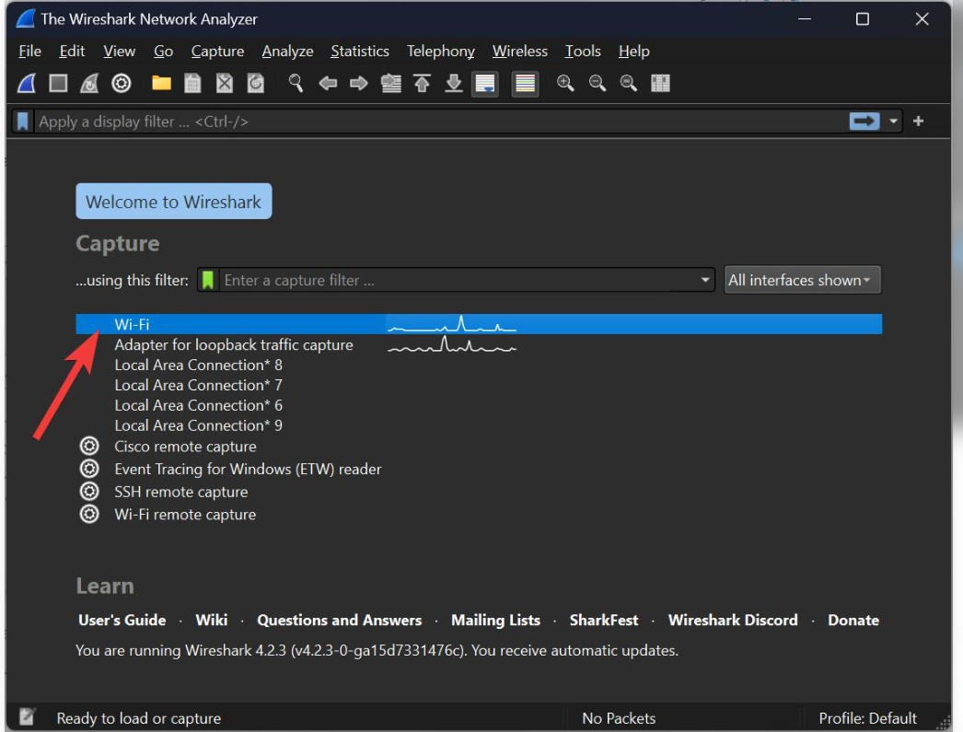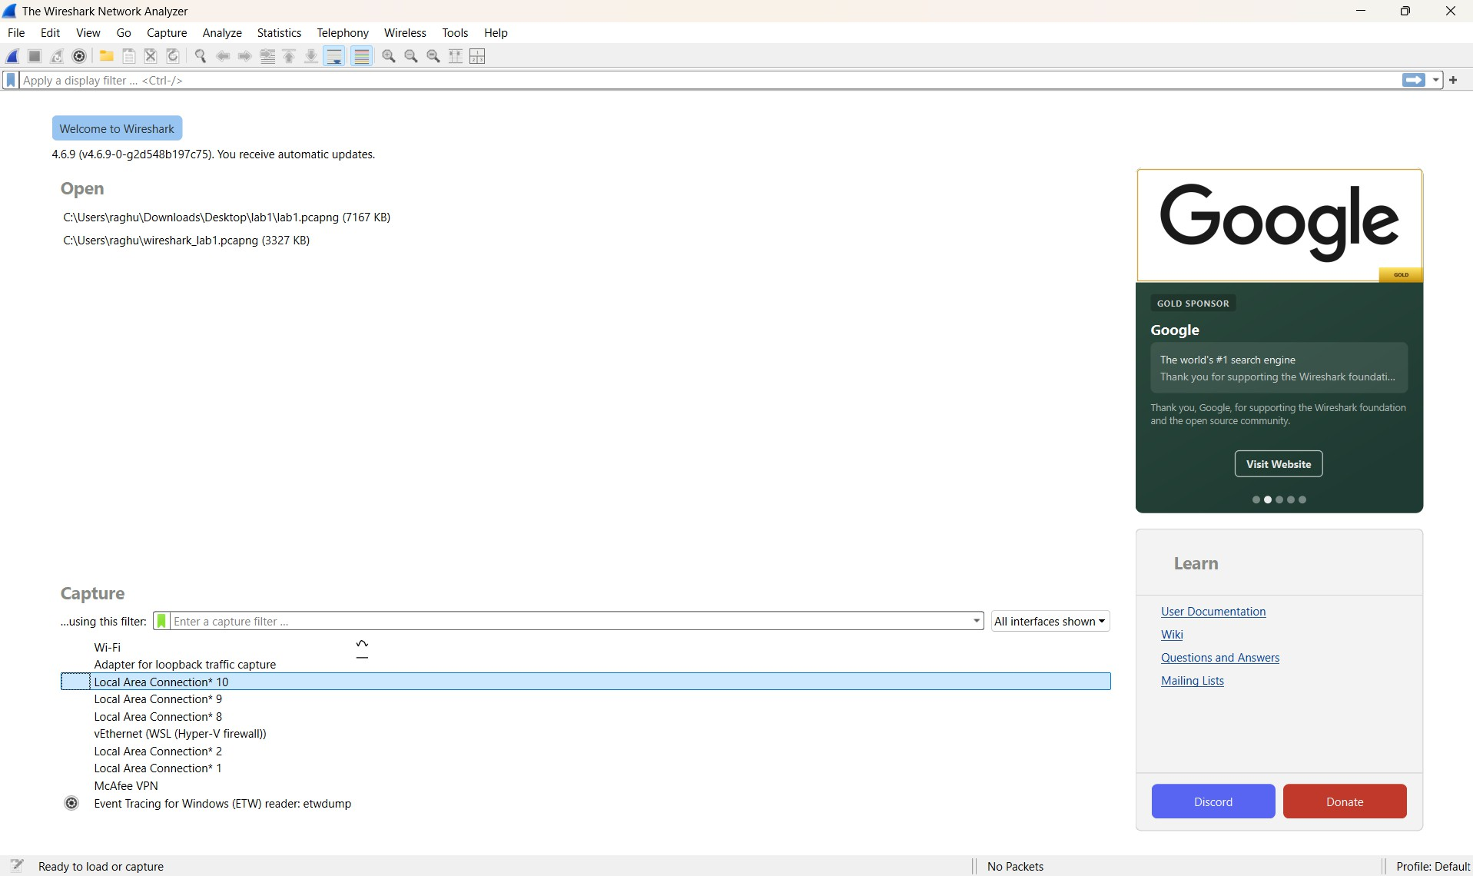

Step 2: Select your network interface
When Wireshark opens, you will see interfaces such as: Wi-Fi, Ethernet, Bluetooth
- If you are connected through Wi-Fi, select Wi-Fi.
- Double-click the Wi-Fi interface.
- Packet capture will start.

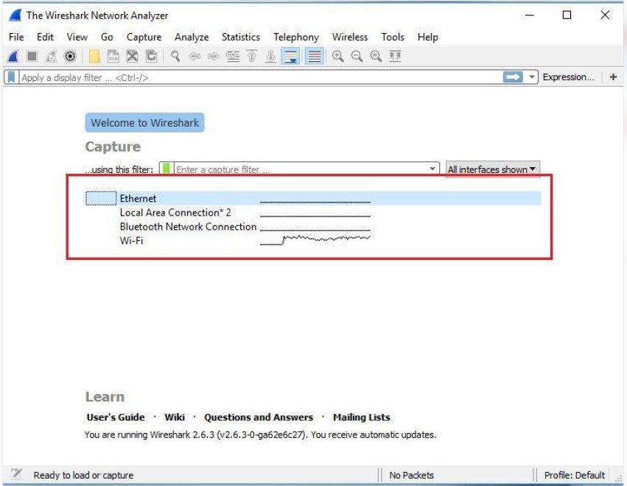

Step 3: Generate network traffic While Wireshark is capturing:
- Open a new browser tab.
- Visit a website such as https://www.google.com.
- Open two or three different websites.
- Wait for approximately 30 seconds.
- Return to Wireshark.
- Click the red Stop button.

You should now see captured packets.

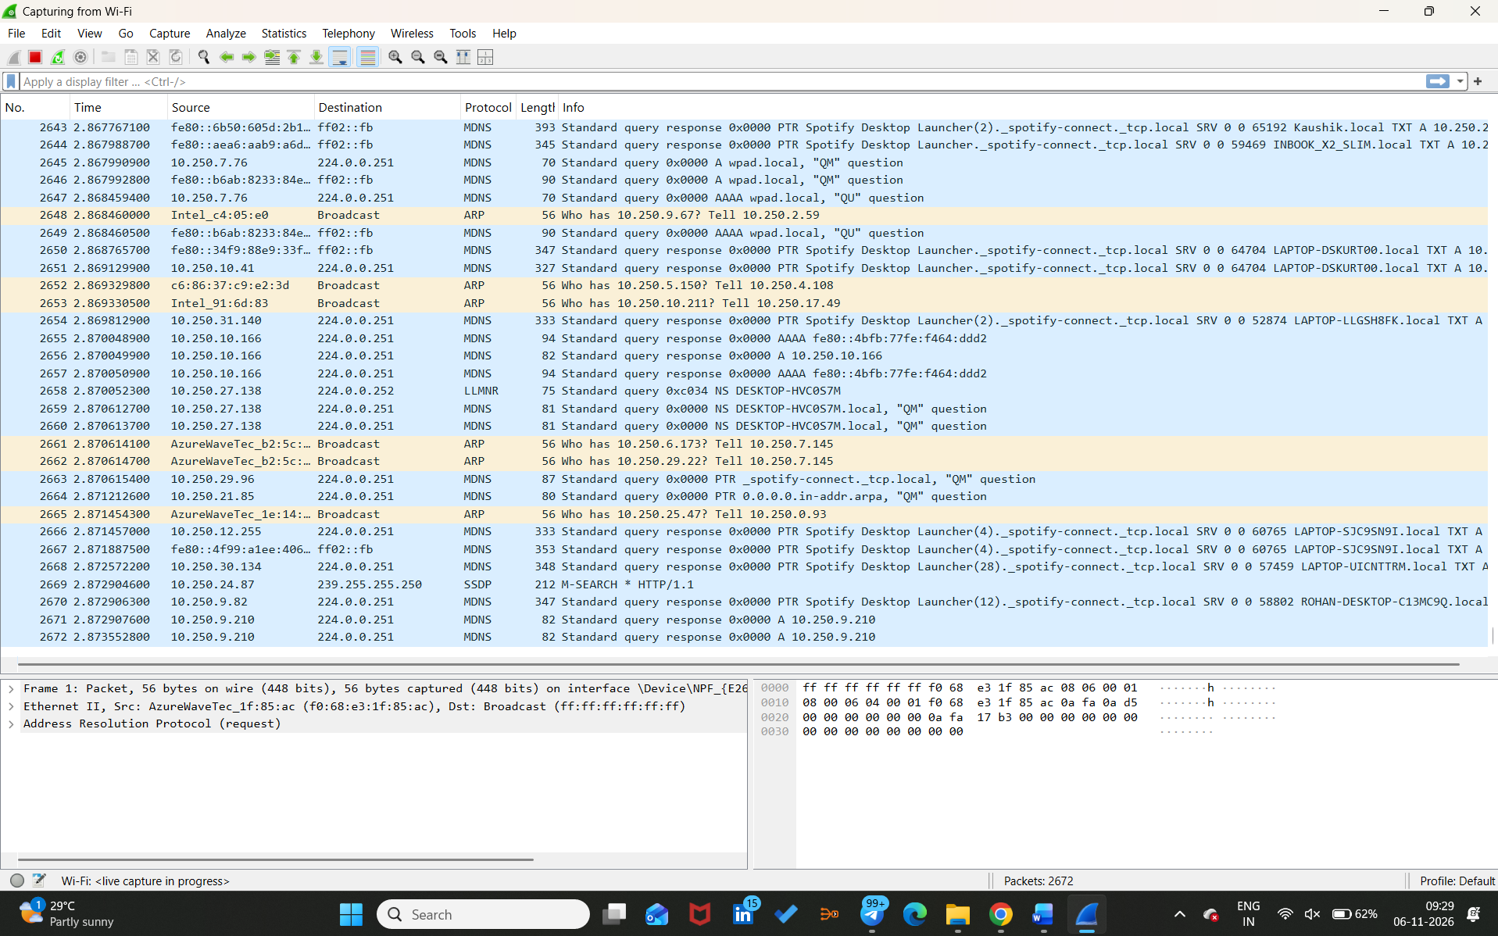

Step 4: Apply display filters
In the Wireshark filter bar, enter each filter separately and press Enter.

Filter | Purpose
tcp | Displays TCP packets
udp | Displays UDP packets
icmp | Displays ICMP packets
tcp.len > 0 | Displays TCP packets carrying data

First, enter: TCP
Observe the packets displayed. Then enter: UDP
Observe the UDP packets.

Step 5: Inspect packet headers
Select any TCP packet from the packet list.

In the packet details pane, expand these sections:
- Frame
- Ethernet II
- Internet Protocol Version 4
- Transmission Control Protocol
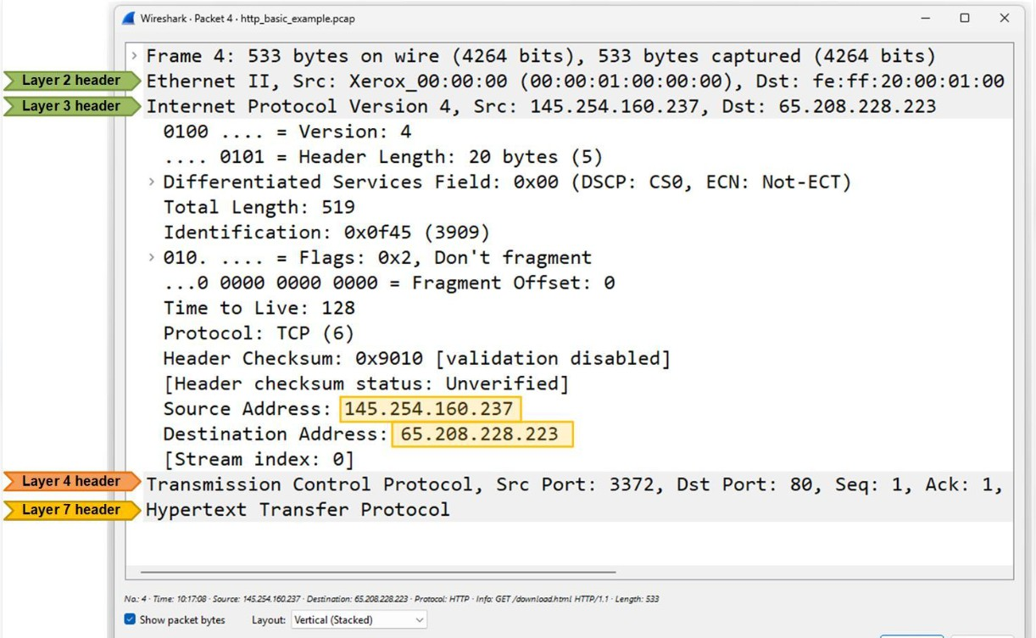
- 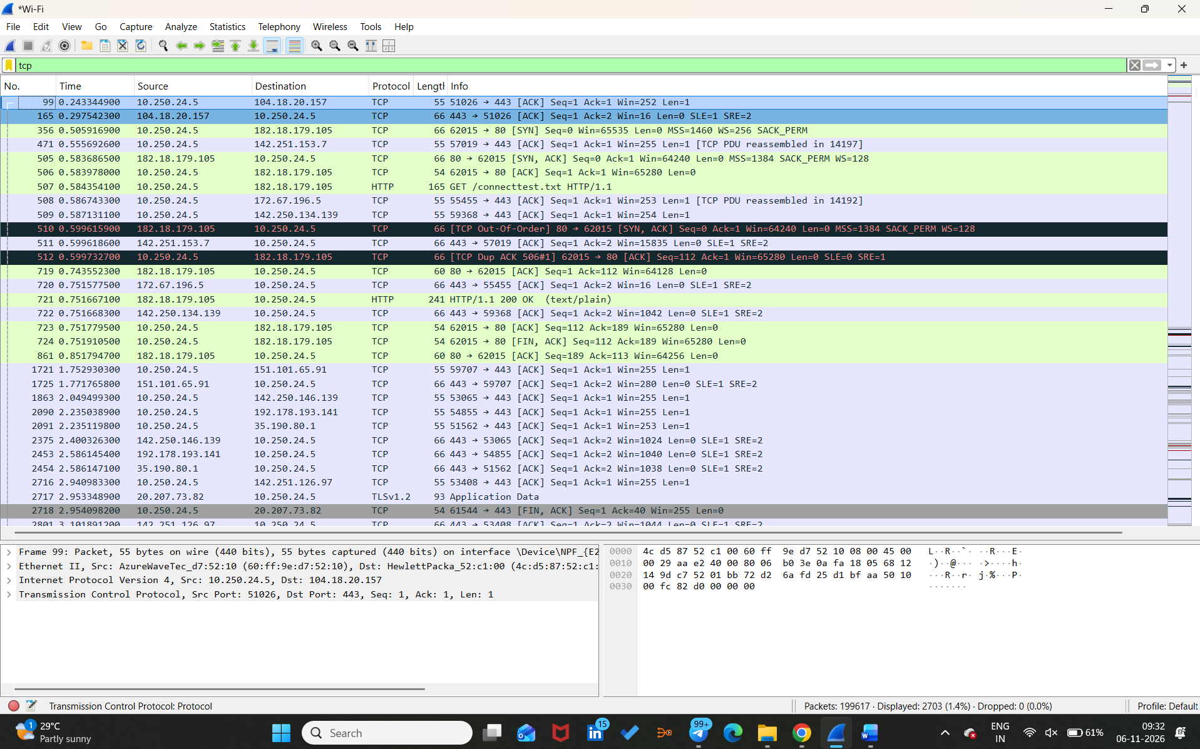

Record the following values:

Parameter | Where to find it
Frame length | Frame
Ethernet Header | Ethernet II
Source MAC Address | Ethernet II
Destination MAC Address | Ethernet II
IPv4 Header Length | Internet Protocol Version 4
IPv4 Total Length | Internet Protocol Version 4
TCP Header Length | Transmission Control Protocol
TCP Segment Length | Transmission Control Protocol

Repeat the process for one UDP packet. Observe the UDP header and its length field.

Step 6: Calculate header overhead
For a basic Ethernet + IPv4 + TCP packet without TCP options:
  - Ethernet header = 14 bytes
  - IPv4 header = 20 bytes
  - TCP header = 20 bytes
  - Application data = 1500 bytes
  - FCS = 4 bytes, if included in the frame representation Total size including FCS:

14 + 20 + 20 + 1500 + 4 = 1558𝑏𝑦𝑡𝑒𝑠
Total overhead:

14 + 20 + 20 + 4 = 58𝑏𝑦𝑡𝑒𝑠
Payload efficiency:
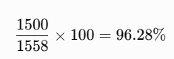

Note: Wireshark may not capture or display the Ethernet FCS. Use the actual captured packet fields when recording your observations.

Step 7:
Fill in your observation table

Record values from your own Wireshark capture.

Parameter | TCP Packet | UDP Packet
Frame Length
Ethernet Header Length
IP Header Length
Transport Header Length
IP Total Length
Transport Header Length
Payload Length

Steps to save a capture file

Step 1: Start capturing packets

- Open Wireshark.
- Select your Wi-Fi or Ethernet interface.
- Double-click the interface to start capturing packets.

Step 2: Stop the capture

Once you have generated sufficient network traffic:
- Click the red Stop button (top-left corner).
- Your captured packets will remain visible on the screen.
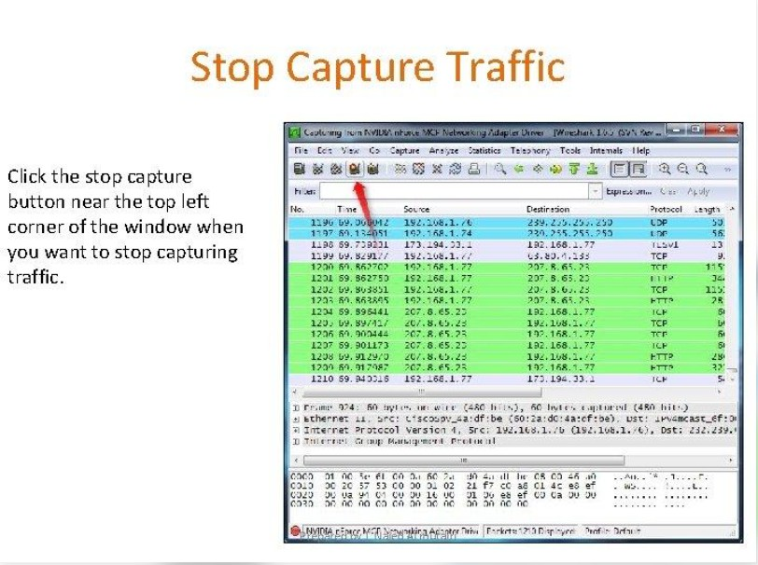

Step 3: Save the capture
  - Click File in the menu.
  - Select Save As.
  - Choose the folder where you want to save the file.
  - Enter a filename.
  - Keep the file format as pcapng.
  - Click Save.
For example: sender_capture.pcapng
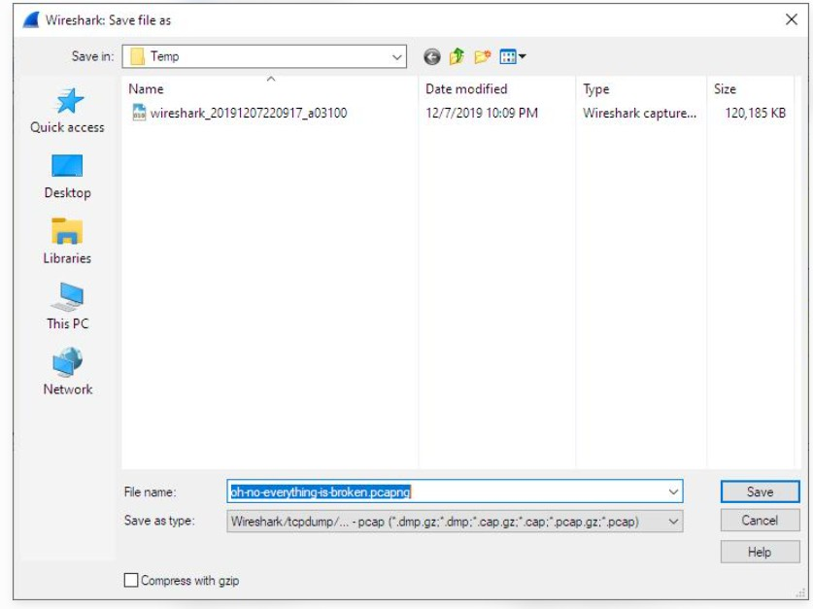

How to open a saved capture file
- Open Wireshark.
- Click File → Open.

- Select your .pcapng or .pcap file.
- Click Open.
- Enter icmp in the display filter bar to view ICMP packets.

Answer these questions
  - What is encapsulation?
  - What is the purpose of the Ethernet header?
  - What information is stored in the IP header?
  - What is the difference between TCP and UDP headers?
  - Why does each protocol add a header?
  - What is packet overhead?
  - How does header overhead affect network efficiency?

Skill–1: Encapsulation Builder

Answers to the Questions
- What is encapsulation?
Encapsulation is the process in which each network layer adds its own control information, usually in a header, to the data received from the layer above. For example, the transport layer adds a TCP or UDP header, the network layer adds an IP header, and the data-link layer adds an Ethernet header. The resulting data is transmitted as frames over the network.
- What is the purpose of the Ethernet header?
The Ethernet header helps deliver a frame across a local Ethernet network. It contains the destination MAC address, source MAC address, and a Type/Length field that identifies the payload protocol or its length.
- What information is stored in the IP header?
An IPv4 header contains information used to route a packet between networks. Important fields include the source and destination IP addresses, header length, total length, time to live (TTL), protocol number, identification, fragmentation flags and offset, and header checksum.
- What is the difference between TCP and UDP headers?

TCP header | UDP header
Minimum 20 bytes; may be longer when options are present. | Fixed 8 bytes.
Contains source/destination ports, sequence and acknowledgement numbers, flags, window size, checksum, and options. | Contains source/destination ports, length, and checksum.
Supports connection-oriented, reliable, ordered delivery using acknowledgements and retransmissions. | Connectionless; does not itself guarantee delivery, ordering, or retransmission.
- Why does each protocol add a header?
Each protocol adds a header because its layer has a different job. Ethernet provides local-link delivery using MAC addresses; IP provides logical addressing and routing; TCP or UDP provides transport information such as port numbers so data can be delivered to the correct application. Headers allow the receiving layers to interpret and process the data.
- What is packet overhead?
Packet overhead is the extra protocol and control information carried in addition to the application data. In the worksheet's example, the Ethernet header is 14 bytes, the IPv4 header is 20 bytes, the TCP header is 20 bytes, and the assumed FCS is 4 bytes. Therefore, overhead = 14 + 20 + 20 + 4 = 58 bytes.
- How does header overhead affect network efficiency?
Header overhead uses part of the transmitted frame for control information rather than application data. For a fixed total packet size, more overhead means a smaller proportion of useful application data and therefore lower payload efficiency. Larger application payloads generally make the overhead a smaller percentage of the total.

Calculation from Step 6 in the supplied worksheet
Total size including the assumed FCS = 14 + 20 + 20 + 1500 + 4 = 1558 bytes.
Total overhead = 14 + 20 + 20 + 4 = 58 bytes.
Payload efficiency = (1500 / 1558) × 100 = 96.28% (approximately).

Observation table – packet-specific values
The TCP and UDP observation values must be read from the user's own packet capture. They cannot be determined from the Wireshark welcome-screen screenshot supplied so far, so these cells are intentionally left for the actual capture rather than guessed.
Parameter | TCP Packet | UDP Packet
Frame Length | To be recorded | To be recorded
Ethernet Header Length | To be recorded | To be recorded
IP Header Length | To be recorded | To be recorded
Transport Header Length | To be recorded | To be recorded
IP Total Length | To be recorded | To be recorded
Payload Length | To be recorded | To be recorded

Note about the supplied screenshot: The Wireshark welcome-screen screenshot has been inserted into Step 2 of the original document. It shows the available interfaces but does not show captured packets. Upload the TCP and UDP packet-detail screenshots to complete the observation table with exact values.

