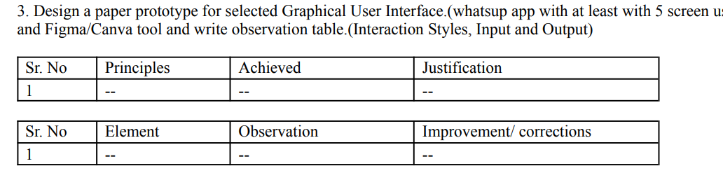
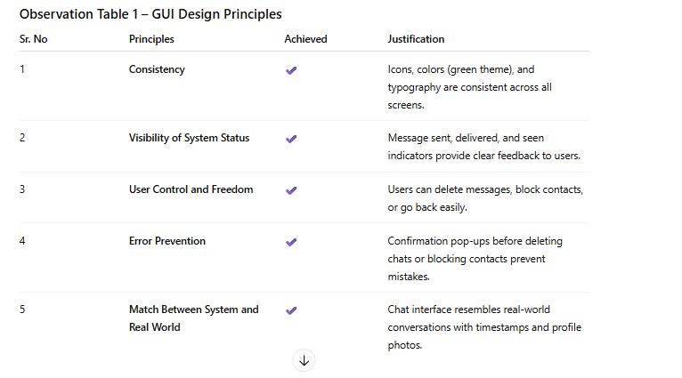
Sr. No | Element | Observation | Improvement/Corrections
1 | Chat List Screen | Displays recent chats, names, and profile pictures clearly. | Add unread message count for better visibility.
2 | Chat Window | Easy to read and send text, emoji, and media. | Include message reactions for better interaction.
3 | Status Screen | Allows users to view and upload status updates. | Add “mute” or “favorite” option for better control.
4 | Calls Screen | Displays call history and icons for audio/video calls. | Add quick access to frequently contacted users.
5 | Settings Screen | Well-organized with account, privacy, and notification options. | Group privacy settings under one category for simplicity.
