1. **What is jQuery?**

**Ans: -**jQuery is a fast, small, and feature-rich JavaScript library. It makes things like HTML document traversal and manipulation, event handling, and animation much simpler with an easy-to-use API that works across a multitude of browsers. jQuery is designed to simplify the client-side scripting of HTML.

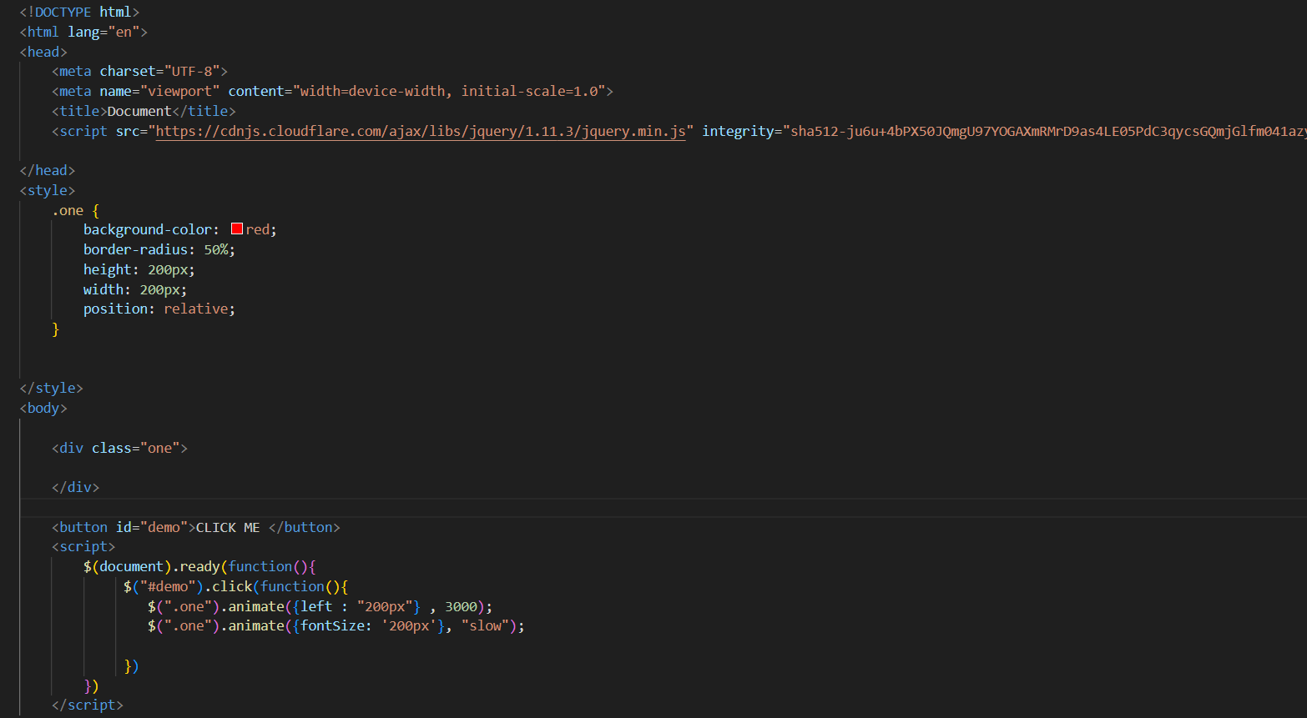

1. **How to Apply CSS Using JQuery, How to Add Class and Remove Class in Jquery , JQuery Animation?**

**Ans:- Apply css Using Jquery**

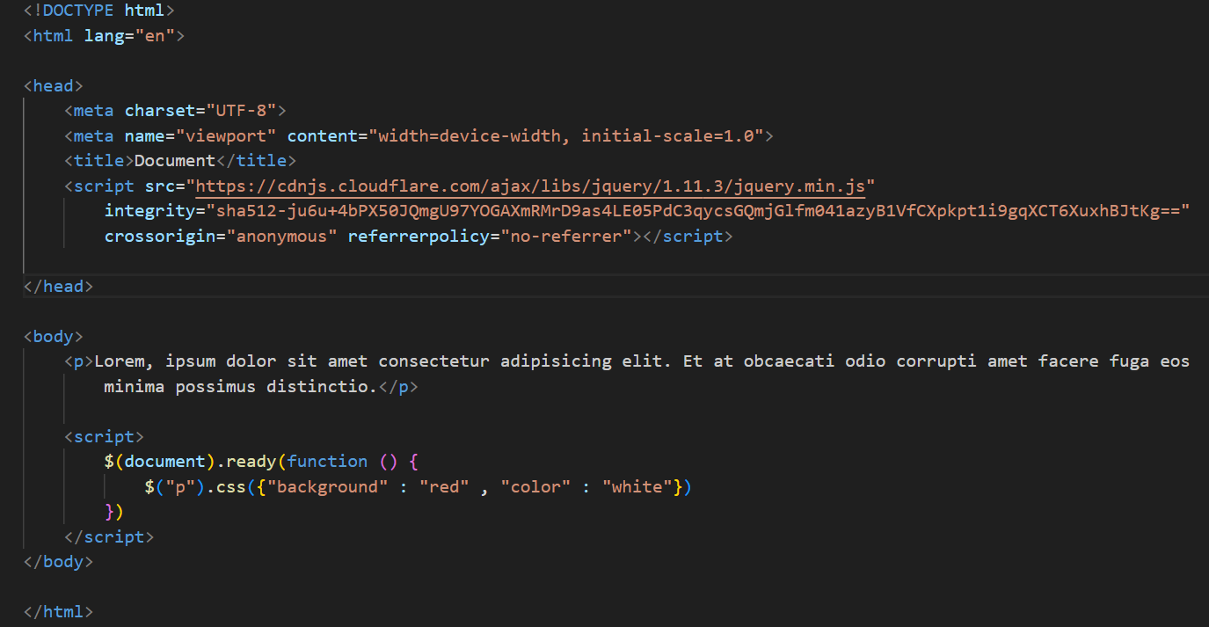

In this example, the $("p").css(...) method is used to set the background and color of the <p> element. You can pass an object with CSS property-value pairs to this method.

* **Adding and Removing Classes:-**

You can use the .addClass() and .removeClass() methods in jQuery to add and remove classes from elements. Here's an example:-

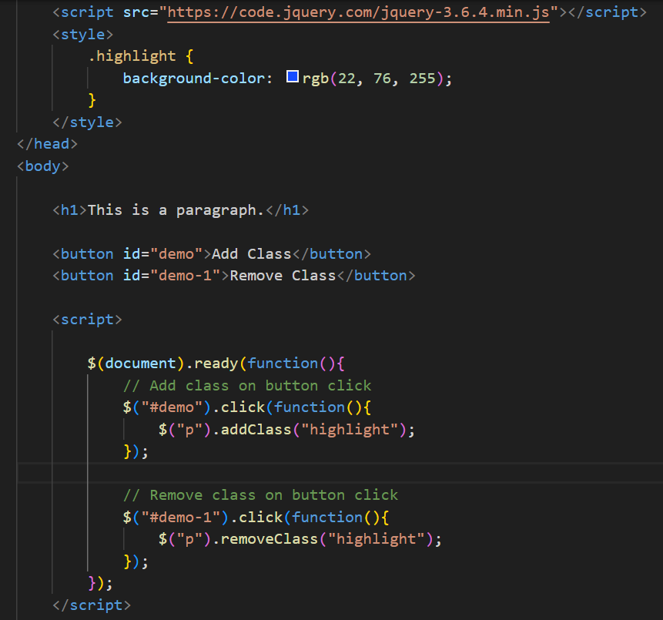

* **jQuery Animation:**jQuery provides methods to create simple animations. One of the commonly used methods is .animate(). Here's an example of a simple animation:

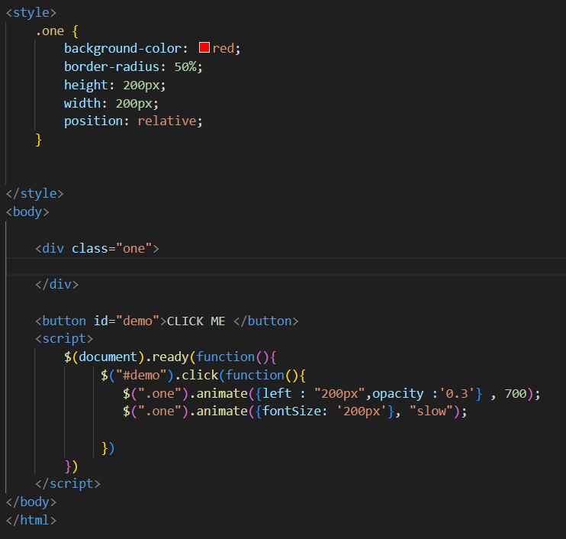

1. **How to create slider with animation?**

**Ans:-** Creating a slider with animation typically involves using HTML, CSS. Below is a simple example using HTML, CSS, and jQuery for the slider with animation.

