01.Are the HTML tags and elements the same thing?

Ans:- No. HTML elements are defined by a starting tag, may contain some content and a closing tag.

For example.

<h1>is a html element but just is a starting tag and is a closing tag.

Html tags:-

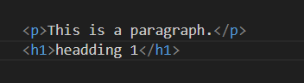

**HTML Elements:-**



02.What are tags and attributes in HTML?

Ans:- HTML tags are used to hold the HTML element. HTML element holds the content. HTML attributes are used to describe the characteristic of an HTML element in detail.

**HTML Tags: -**

HTML tags are enclosed in angle brackets ("<" and ">") and are used to define elements or components on a web page. Tags come in pairs: an opening tag and a closing tag. The opening tag marks the beginning of an element, and the closing tag marks the end of that element. Elements can contain other elements, creating a hierarchical structure.

Example :-

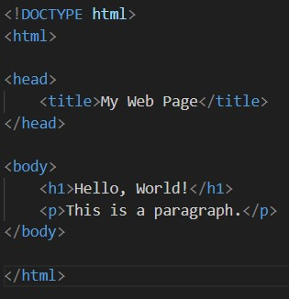

**HTML Attributes:-**

The Attributes provide additional information about HTML elements.

The are always included in the opening tag

Example:-



03.What are void elements in HTML?

Ans:-  Void elements in HTML are self-closing tags that don't require a closing tag and represent elements like images or line breaks**.**

Example**:-**

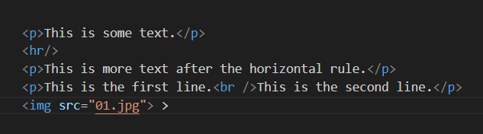

04.What are HTML Entities?

Ans:- HTML entities are special codes used to represent reserved characters and symbols in HTML, ensuring proper in web browsers.

Example:- 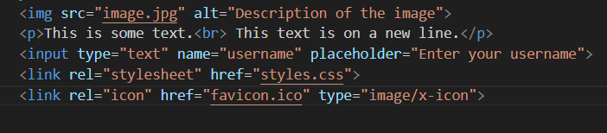

05.What are different types of lists in HTML?

Ans:- HTML Lists

1.**Ordered Lists (<ol>)** Ordered lists are used when you want to present a list of items in a specific sequence or order. Each list item is automatically numbered.

Example:-

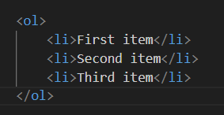

2.**Unordered Lists (<ul>)** Unordered lists are used for lists of items that don't require a specific order or sequence. Each list item is typically represented by a bullet point.

Example:-

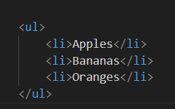

**3.Nested Lists:-** You can nest lists inside other lists to create hierarchical structures. For example, you can have an ordered list within an unordered list or vice versa.

Example:-

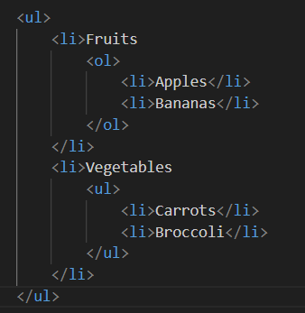

06.What is the ‘class’ attribute in HTML?

Ans:- The **class** attribute is used to assign one or more class names to an HTML element. This attribute is primarily used to apply CSS styles and JavaScript behaviors to specific elements.

Example:-

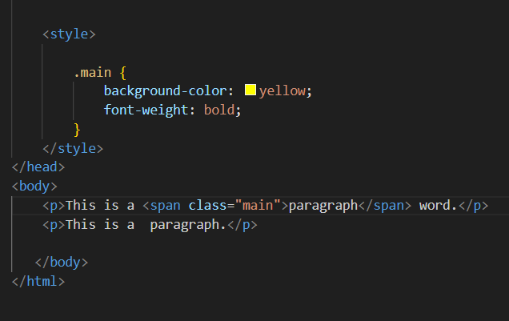

07. What is the difference between the ‘id’ attribute and the ‘class’ attribute of HTML elements?

Ans:- The difference between Class and Id. A Class name can be used by multiple HTML elements, while an ID name must only be used by one HTML element within the page.

ID attribute:-

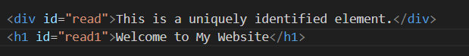

Class attribute:-

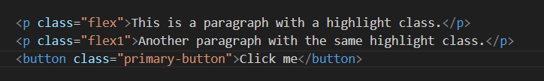

08.What are the various formatting tags in HTML?

Ans:- Different types of formatting tags are: <b> (bold), <i> (italic), <u> (underline), <strike> (strikethrough), and <sup> (superscript), among others.

Example:-

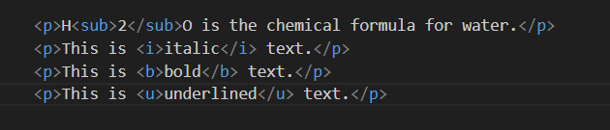

09. How is Cell Padding different from Cell Spacing?

Ans:- Cellpadding basically defines the space present between a table cell's border and the content present in it.

Example:-

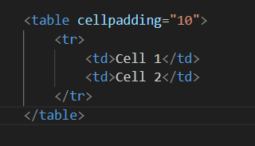

* Cellspacing basically defines the space present between individual adjacent cells.

Example:-

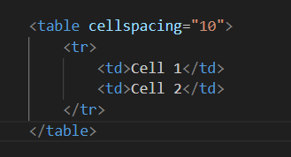

10. How can we club two or more rows or columns into a single row or column in an HTML table?

Ans:- It can be done by using the rowspan and colspan attribute in HTML.

The rowspan is used to merge or combine the number of cells in a row.

The colspan is used to merge column cells in a table.

Example:-

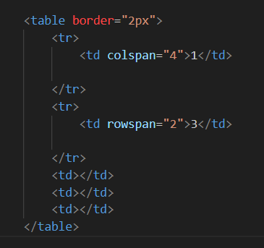

11. What is the difference between a block-level element and an inline element?

Ans:- The difference between a block-level element and an inline element

Block elements always start from a new line. Inline elements never start from a new line.

Block elements cover space from left to right as far as it can go.

Inline elements only cover the space as bounded by the tags in the HTML element.

Exapmle:-

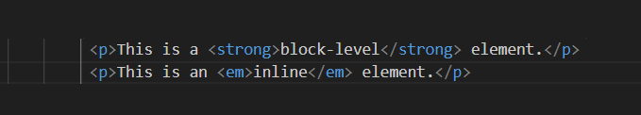

12. How to create a Hyperlink in HTML?

Ans:- you can create a hyperlink using the anchor (**<a>**) element. A hyperlink is used to link to another web page, a file, an email address, or another resource on the internet. Here's the basic syntax for creating a hyperlink in HTML:

Example:-

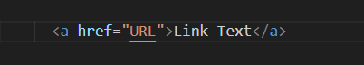

13. What is the use of an iframe tag?

Ans:- The <iframe> tag in HTML is used to embed another web page or content within the current web page.

Example:-

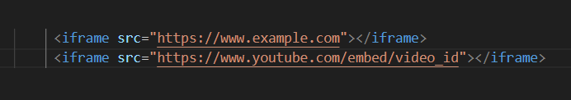

14. What is the use of a span tag? Explain with example?

Ans:- Span is Also a container used for other HTML Elements.

The tag is much like the element, but is a block-level element and is an inline element. It does not add any line breaks or create a new block-level element like a paragraph or a division (**<div>**) would. Instead, it is typically used to target and style individual words.

Example:- 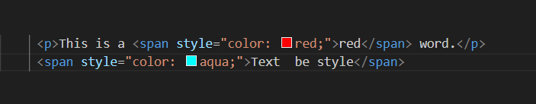

15. How to insert a picture into a background image of a web page?

Ans:- To set the background image of a webpage, use the CSS style.

Under the CSS <style> tag, add the property background-image. The property sets a graphic such as jpg, png, svg, gif, etc.

HTML5 do not support the background attribute, so CSS is used to change set background image.

Example:-

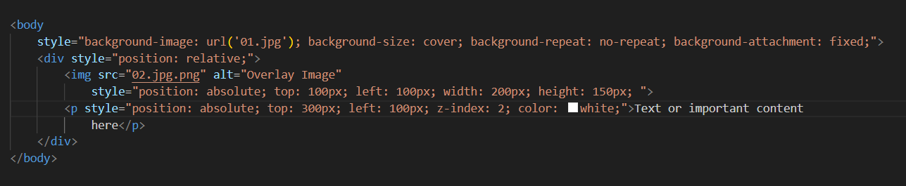

16.How are active links different from normal links?

Ans:- Active links different from normal links.

Normal links:- Normal links are links which are there on the page and have not been clicked yet.

Active links :- Active links are those links, which have just been clicked at that instant.

example:-

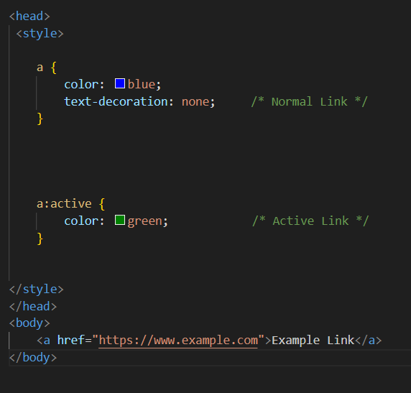

17. What are the different tags to separate sections of text?

Ans:- We separate a section of texts in HTML using the below tags: br tag – It is used to separate the line of text.

Example:-

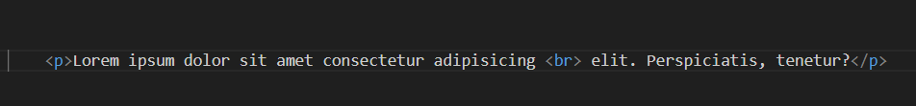

It breaks the current line and shifts the flow of the text to a new line. p tag–This tag is used to write a paragraph of text.

Example:-

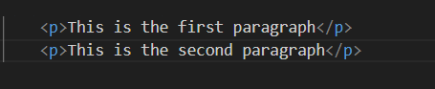

18. What is SVG?

Ans:- SVG stands for Scalable Vector Graphics, It's a popular XML-based vector image format used for displaying graphics and images on the web. SVG images are resolution-independent, which means they can be scaled to any size without loss of quality.

Example:-

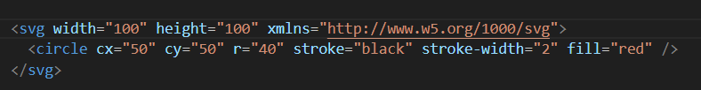

19. What is difference between HTML and XHTML?

Ans:- HTML

1.HTML tags are't extensible.

2.HTML tags are not case-sensitive.

Example:-

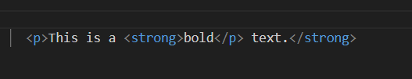

XHTML

1. XHTML tags are extensible.

2. XHTML only lowercase tags are allowed.

Example:-

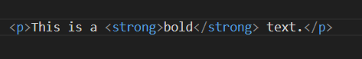

20. What are logical and physical tags in HTML?

Ans:- Physical and Logical tags are used in HTML for better visibility and understanding of the text by the user on the web page.

However, both tags differ from each other as suggested by their names. Logical Tags : Logical Tags are used in HTML to display the text according to the logical styles.

Logical tags:-<em>,<cite>,<code>,<strong>

Ex:-

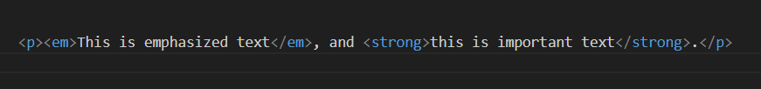

Physical tags:-<B>,<I>,<U>

Ex:-

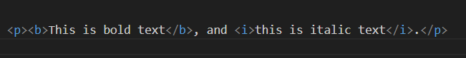

-------------------------------------------------------------Complete-------------------------------------------------