**Digital Marketing Strategies For Startups**

***ABSTRACT***

This project explores and outlines effective digital marketing strategies tailored specifically for startups, with a primary focus on leveraging a dynamic webpage as a central tool for online presence and customer engagement. In an era where establishing a robust digital footprint is critical for business success, startups often face unique challenges that require targeted and efficient strategies.

Through a user-centric design, responsive elements, and compelling content, the webpage serves as a hub for showcasing products/services and fostering meaningful connections. Emphasizing SEO, social media, and content marketing, the project aims to drive organic traffic and enhance brand visibility. Real-time analytics guide data-driven decision-making, enabling continuous optimization of the webpage for user interaction and feedback. The flexible framework ensures scalability and adaptability, providing startups with practical insights to navigate the digital landscape effectively. This concise guide empowers startups to establish a strong online footprint, connect with their target audience, and lay the groundwork for sustained success in the competitive digital arena.

**Introduction:**

In the ever-evolving landscape of business, startups face unique challenges in establishing a strong online presence and effectively engaging with their target audience. This project, titled "Digital Marketing Strategies for Startups: Web-Centric Approach," aims to provide startups with a comprehensive guide for navigating the complexities of the digital realm. Focused on leveraging a dynamic webpage as a central tool, the project emphasizes user-centric design principles, responsive elements, and compelling content strategies. By exploring the integration of various digital marketing techniques, including SEO, social media, and content marketing, this initiative seeks to empower startups to drive organic traffic, enhance brand visibility, and foster meaningful connections with their audience. Real-time analytics play a crucial role in guiding data-driven decision-making, enabling continuous optimization of the webpage for optimal user interaction and feedback. With a flexible and scalable framework, startups can adapt their strategies alongside their growth, ultimately laying the groundwork for sustained success in the competitive digital marketplace. This introduction sets the stage for a focused exploration of practical insights and actionable recommendations tailored specifically for startups seeking to thrive in the digital age.

**Problem Statement**:

Despite the digital era's vast opportunities, startups encounter distinct challenges in establishing a robust online presence and connecting effectively with their target audience. Many startups struggle to navigate the intricate landscape of digital marketing, often facing issues related to user engagement, organic traffic generation, and the effective utilization of online platforms. The lack of tailored strategies specifically designed for startups further complicates matters, leaving these ventures without a clear roadmap for success in the competitive digital marketplace. Additionally, the rapid evolution of digital trends requires startups to adapt swiftly, further intensifying the need for practical and scalable solutions. The absence of a cohesive approach that integrates user-centric webpage design with dynamic digital marketing strategies leaves startups at a disadvantage, hindering their ability to leverage the full potential of the online landscape. This project aims to address these challenges by providing startups with a comprehensive guide and practical insights into crafting effective digital marketing strategies centered around a dynamic webpage.

**Benefits of implementing the webpage for digital marketing strategies’ for startups:**

**Enhanced Online Visibility**: The dynamic webpage, optimized for search engines and user engagement, contributes to improved online visibility, ensuring that the startup's offerings are easily discoverable by the target audience.

**Increased User Engagement:** User-centric design principles and compelling content foster increased user engagement, encouraging visitors to explore the website, interact with its features, and potentially convert into customers or leads.

**Brand Building and Representation:** The webpage serves as a powerful tool for brand representation, allowing startups to convey their unique value proposition, showcase products or services, and establish a compelling brand identity in the digital space.

**Targeted Digital Marketing:** The integrated digital marketing strategies, including SEO, social media, and content marketing, enable startups to target their audience more effectively, driving organic traffic and increasing the likelihood of reaching potential customers.

**Data-Driven Decision Making:** Real-time analytics provided by the integrated database allow startups to gather valuable insights into user behavior, preferences, and interaction patterns. This data-driven approach facilitates informed decision-making and continuous optimization.

**Customer Relationship Management (CRM**): The database infrastructure supports the collection and management of customer data, enabling startups to build personalized relationships, tailor marketing campaigns, and enhance overall customer experience.

**Adaptability and Scalability:** The flexible framework ensures that the strategies and the webpage can adapt to the startup's evolving needs and growth. This adaptability is crucial for maintaining relevance in the ever-changing digital landscape.

**Cost-Effectiveness:** By focusing on a targeted and integrated approach, startups can optimize their digital marketing efforts, potentially reducing overall marketing costs while maximizing the impact on their audience.

**Competitive Edge:** Implementing a web-centric strategy provides startups with a competitive edge, allowing them to stand out in the crowded digital marketplace and compete effectively with more established players.

**Long-Term Sustainability**: The holistic approach to digital marketing, combining a dynamic webpage with strategic marketing efforts, sets the groundwork for long-term sustainability. Startups can establish a strong digital foundation for continued growth and success.

**REQUIREMENT SPECIFICATION**

**INTRODUCTION**:

The webpage must be responsive, ensuring optimal user experience across various devices, including desktops, tablets, and smartphones. Implement an intuitive and user-friendly interface that facilitates easy navigation, reducing bounce rates and encouraging prolonged user engagement.Develop high-quality, relevant, and engaging content that effectively communicates the startup's value proposition, products, or services.Employ SEO best practices to enhance the webpage's visibility on search engines, including keyword optimization, meta tags, and mobile-friendliness.Integrate social media sharing buttons and feeds to encourage seamless sharing of content, expanding the startup's reach and fostering social engagement.Implement a robust database system capable of capturing, storing, and managing user data, including preferences, behavior patterns, and interaction history.Integrate analytics tools to provide real-time insights into webpage performance, user behavior, and marketing campaign effectiveness for data-driven decision-making.

**HARDWARE REQUIREMENTS**:

The most common set of requirements defined by any operating system or software application is the physical computer resources, also known as hardware. A hardware requirements list is often accompanied by a hardware compatibility list (HCL), especially in case of operating systems. An HCL lists tested, compatibility and sometimes incompatible hardware devices for a particular operating system or application. The following sub-sections discuss the various aspects of hardware requirements.

**HARDWARE REQUIREMENTS FOR PRESENT PROJECT:**

PROCESSOR : Intel dual Core ,i3

RAM : 1 GB HARD DISK : 80 GB

**SOFTWARE REQUIREMENTS**:

Software Requirements deal with defining software resource requirements and pre-requisites that need to be installed on a computer to provide optimal functioning of an application. These requirements or pre-requisites are generally not included in the software installation package and need to be installed separately before the software is installed.

**SOFTWARE REQUIREMENTS FOR PRESENT PROJECT:** OPERATING SYSTEM : Windows 7/ XP/8

FRONT END : HTML, CSS, JAVA SCRIPT

DATABASE : MySQL

**SCHEMA:**

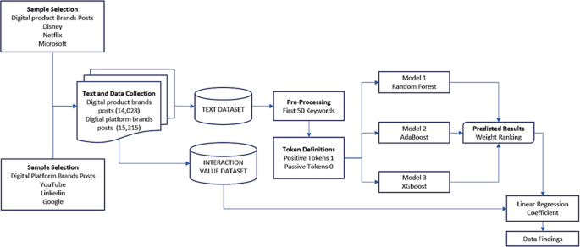

**SAMPLE OUTPUTS:**

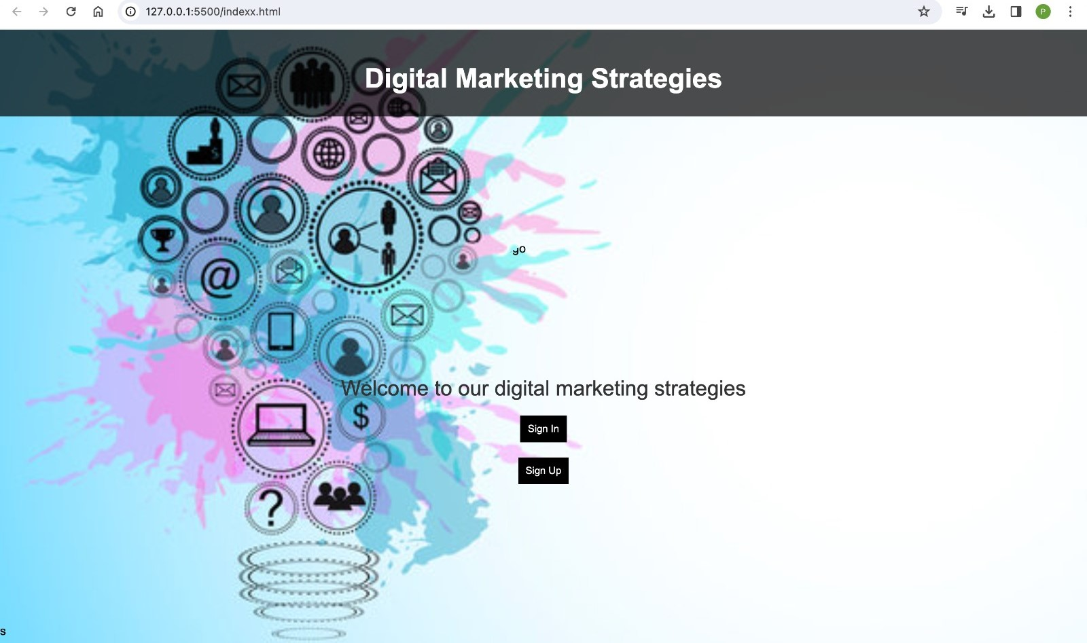

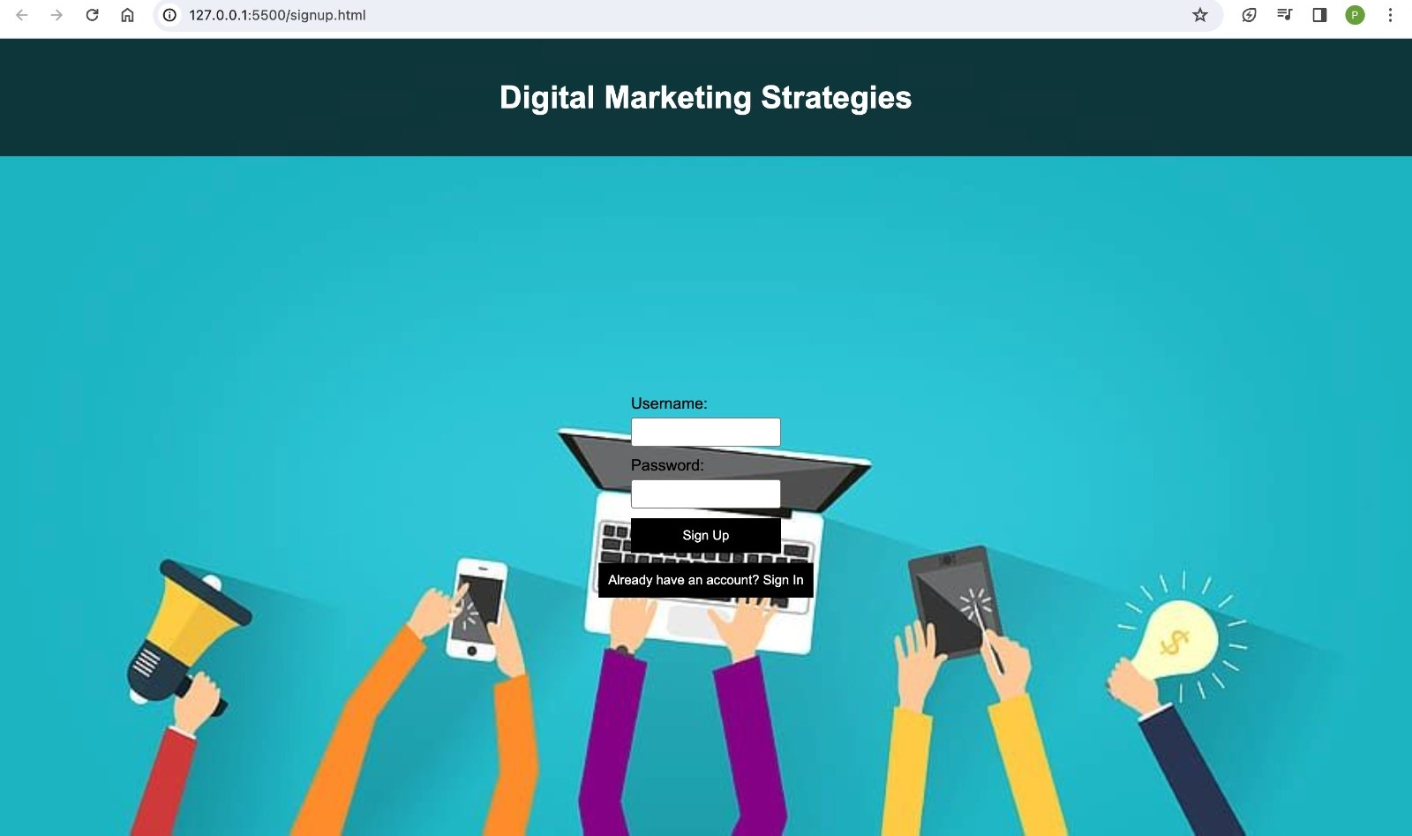

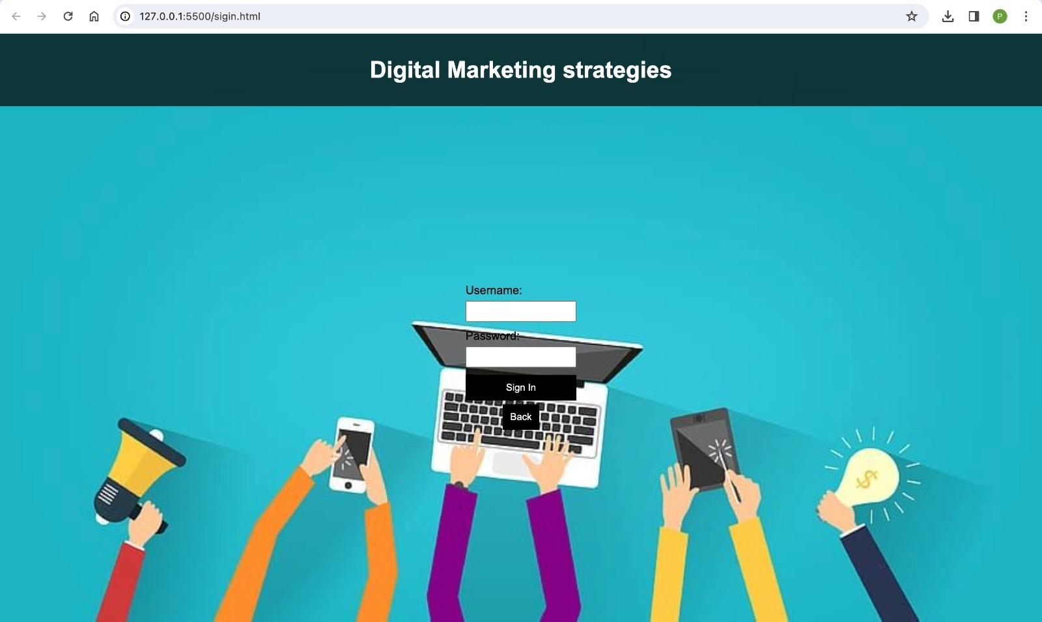

**Conclusion:**

the "Digital Marketing Strategies for Startups: Web-Centric Approach" project offers startups a holistic roadmap for success in the digital realm. By emphasizing a dynamic webpage, user-centric design, and integrated digital marketing strategies, startups can enhance their online visibility, engage effectively with their audience, and build a compelling brand presence. The project's focus on data-driven decision-making, scalability, and security ensures adaptability to evolving needs and sustained growth. Through this approach, startups can establish a strong foundation for success in the competitive digital landscape.

**Reference:**

Business Research Methodology, 2020 [Online] Available at: https://researchmethodology.net/research-methodology/research-approach/inductive-approach-2/

Accessed on 23 Oct 2020.

CB Insights, 2019 [online]. Available at https://www.cbinsights.com/research/startupfailure-reasons-top/ .( Accessed 9th Oct, 2020)

Chaffey, D., 2009. Internet Marketing. 4th ed. Harlow: Financial Times Prentice Hall.

Chaffey, D. Smart Insights (2020) [Online] Available at:

https://www.smartinsights.com/digital-marketing-strategy/digital-strategydevelopment/10-reasons-for-digital-marketing-strategy/ [Accessed 11 Jan 2021].

Cook, S., 2020, Startups [online]. Available at

https://webcache.googleusercontent.com/search?q=cache:AyqkcJ20ayAJ:https://startup

s.co.uk/analysis/what-is-a-startup/+&cd=22&hl=en&ct=clnk&gl=se (Accessed on 10th

Oct 2020)