SOCIALMIND
Social Media Engagement Agent
AI Agents That Learn Using Hindsight

Project in one sentence
SocialMind is a LinkedIn-focused AI social-media strategist that remembers what worked and what failed for a specific audience, uses Hindsight to recall those experiences before generating new content, and learns again from real post-performance feedback.

HackWithHyderabad 3.0 • Complete Project & Implementation Documentation

Table of Contents
- 1. Project Overview
- 2. Official Hackathon Problem Statement
- 3. Problem We Are Solving
- 4. Proposed Solution: SocialMind
- 5. Why Hindsight Is Essential
- 6. Target User, Persona and Value Proposition
- 7. What the System Does
- 8. Technology Stack
- 9. System Architecture
- 10. Data Responsibilities: MongoDB vs Hindsight
- 11. Hindsight Concepts Used
- 12. Complete Cognitive Pipeline
- 13. Step-by-Step Implementation
- 14. Backend Implementation
- 15. Hindsight Service Implementation
- 16. LLM Integration
- 17. Database Models
- 18. Seed Data and Historical Learning
- 19. API Design
- 20. Frontend Implementation
- 21. Screen-by-Screen Features
- 22. Performance Feedback and Learning
- 23. Learning Demonstration
- 24. Testing and Verification
- 25. Security
- 26. Project Folder Structure
- 27. End-to-End Example
- 28. Hackathon Demo Flow
- 29. What Makes SocialMind Different
- 30. Current Limitations and Responsible Learning
- 31. Final Summary

1. Project Overview
SocialMind is an AI-powered Social Media Engagement Agent designed for a brand, startup, founder, or marketing/social-media manager who wants to create better LinkedIn content using the history of their own audience.
The central idea is that generic AI can generate a post from a prompt, but it does not automatically know which content patterns have historically worked for a particular audience. SocialMind adds a persistent memory layer using Hindsight so that the agent can recall previous experiences, reason over successful and unsuccessful patterns, generate a personalized strategy, observe real performance, and retain the new learning for future content.
Core principle
The project is not primarily a post generator. The important capability is audience-specific learning over time.

2. Official Hackathon Problem Statement
The official HackWithHyderabad 3.0 problem statement is titled “AI Agents That Learn Using Hindsight.” It asks teams to build AI-powered applications using Hindsight, a memory system from Vectorize that allows agents to remember, recall and improve over time. The problem statement emphasizes persistent memory and learning from past interactions.
The official challenge requires Hindsight to be used in the project and encourages projects where memory is central to the value proposition, rather than a decorative feature. It also recommends demonstrating a visible learning curve: the agent should become more personalized as it accumulates experience.
- Required technology: Hindsight.
- Any LLM may be used; Groq was recommended by the challenge.
- The recommended Groq models in the challenge included openai/gpt-oss-120b and qwen/qwen3-32b.
- The project should solve a real business problem and demonstrate why persistent memory matters.
- The official Social Media Engagement Agent idea describes an agent that learns which post styles, topics and timing drive engagement for a specific audience.
- The challenge emphasizes a realistic demo, a clear before/after learning story, tight scope, and realistic data.
- Judging criteria: Innovation 30%, Hindsight Memory 25%, Technical Implementation 20%, User Experience 15%, Real-world Impact 10%.
Source note
This section is based on the uploaded official Hackathon Problem Statements PDF supplied for this project.

3. Problem We Are Solving
Social-media teams repeatedly face the same problem: they create content, publish it, inspect performance, and then manually try to remember what worked.
- A post may perform well because of its storytelling style, topic, hook, structure, timing, or call-to-action.
- Another post may underperform even though it was generated using generally accepted social-media advice.
- Different audiences respond differently, so generic best practices are not enough.
- The useful knowledge is cumulative: the team needs to remember outcomes across many posts.
- Without persistent memory, an LLM starts each content request with little or no experience specific to that audience.
SocialMind turns the repeated content cycle into a learning loop.

4. Proposed Solution: SocialMind
SocialMind combines structured application data, Hindsight long-term memory, and an LLM reasoning/generation layer.
Layer | Responsibility
React + Vite + Tailwind | User interface and visualization of the memory-driven workflow.
Express + Node.js | API layer, controllers, orchestration and secure server-side integration.
MongoDB + Mongoose | Structured posts, metrics, dates, and application records.
Hindsight Cloud | Long-term experiential memory: successful patterns, failed patterns, audience preferences, reflections and learning.
Groq + GPT-OSS 120B | Reasoning over recalled experience and generation of strategies/posts/reflections.
Axios | Frontend-to-backend HTTP communication.

5. Why Hindsight Is Essential
Hindsight is the core differentiator. MongoDB can store a metric such as “6.38% engagement,” but SocialMind needs to transform that event into reusable experience such as “a technical retrospective with a quantified result performed strongly for this audience.”
Without Long-Term Memory | With SocialMind + Hindsight
Prompt → generic post | Prompt → recall → reason → personalized strategy → post
The agent does not naturally remember prior outcomes | Past audience outcomes can influence future recommendations
Generic advice | Audience-specific patterns
Feedback stays isolated | Feedback becomes a retained experience
Repeated manual analysis | Accumulated learning

6. Target User, Persona and Value Proposition
Primary persona: a startup founder, marketing manager, or social-media manager responsible for one brand's LinkedIn presence.
- Platform scope: LinkedIn for the MVP.
- Workflow: content strategy → post generation → performance logging → learning.
- The system is intentionally not a multi-platform scheduler or publishing suite.
Value proposition
“An AI social-media strategist that remembers what your audience responded to and uses those experiences to make better content decisions.”

7. What the System Does
- Stores historical LinkedIn post information and performance.
- Converts meaningful post outcomes into experiences that can be retained by Hindsight.
- Recalls relevant experiences before generating a new strategy.
- Uses an LLM to reason over successful and unsuccessful patterns.
- Generates a tailored content strategy and LinkedIn post.
- Allows a user to log actual performance metrics.
- Computes engagement and compares it with the account benchmark.
- Uses LLM reflection to turn the new outcome into a meaningful learning statement.
- Retains that experience in Hindsight.
- Allows later content requests to recall the newly retained experience.

8. Technology Stack
Technology | Use in SocialMind
React | Frontend application and reusable UI components.
Vite | Frontend development/build tooling.
Tailwind CSS | Clean SaaS-style UI styling.
Axios | Frontend API client.
Node.js | Backend runtime.
Express.js | REST API and routing.
MongoDB Atlas | Structured persistent application data.
Mongoose | MongoDB schemas/models.
Hindsight Cloud | Persistent agent memory and recall/reflect operations.
@vectorize-io/hindsight-client | Backend integration with Hindsight.
Groq API | LLM inference.
openai/gpt-oss-120b | Configured LLM for reasoning and generation.
dotenv | Backend environment configuration.
cors | Backend cross-origin configuration.

9. System Architecture
USER
│
▼
React + Vite + Tailwind Frontend
│
│ Axios / REST
▼
Node.js + Express Backend
│
├──────────────► MongoDB Atlas
│ Structured data:
│ posts, metrics, dates, statistics
│
├──────────────► Hindsight Cloud
│ Long-term memory:
│ experiences, patterns, insights
│
└──────────────► Groq / GPT-OSS 120B
reasoning + generation
│
▼
Strategy / LinkedIn Post
│
▼
User publishes + records performance
│
▼
Analytics → LLM Reflection → Hindsight RETAIN
│
▼
Future Hindsight RECALL
│
└──────────────► Better future strategy

10. Data Responsibilities: MongoDB vs Hindsight
MongoDB Atlas | Hindsight Cloud
Structured application records | Long-term experiential memory
Post title/topic | What a result means strategically
Impressions, likes, comments, shares | Audience preference patterns
Engagement rate | Successful/failed content patterns
Dates and identifiers | Lessons and reflections
Historical post list | Recallable experiences

The distinction is deliberate. MongoDB is the source for structured application state. Hindsight is the source for memory that the agent can recall and reason over.

11. Hindsight Concepts Used
Operation | How SocialMind uses it
RETAIN | Stores a meaningful experience after historical seeding or new performance feedback.
RECALL | Retrieves memories relevant to the user's current content request.
REFLECT | Synthesizes multiple retained experiences into higher-level strategic principles.

Example
MongoDB event: “Post received 650 likes, 75 comments and 40 shares from 12,000 impressions.”
Hindsight experience: “A technical retrospective with a quantified result generated strong engagement for this audience.”

12. Complete Cognitive Pipeline
RETAIN → RECALL → REASON → GENERATE → FEEDBACK → RETAIN
1. RETAIN
Historical experiences are inserted into Hindsight.
2. RECALL
A new content request triggers a search for relevant experiences.
3. REASON
The LLM compares recalled successful and unsuccessful patterns.
4. GENERATE
SocialMind produces a recommended strategy and LinkedIn post.
5. FEEDBACK
The user enters actual performance metrics.
6. RETAIN
Analytics + LLM reflection turn the result into a meaningful experience
and store it in Hindsight for future recall.

13. Step-by-Step Implementation

Step 1 — Define the problem and scope
The project was restricted to one workflow, one persona and one platform: LinkedIn content strategy and learning for a specific audience.

Step 2 — Create the Hindsight memory bank
A Hindsight Cloud memory bank named “Social-Media-Agent” was created and an API key was configured on the backend.

Step 3 — Set up backend configuration
The backend environment contains the server port, MongoDB connection, Hindsight API key/bank ID, Hindsight base URL, Groq API key and LLM model configuration. Secrets remain backend-only.

Step 4 — Build the backend structure
Express routes, controllers, services and Mongoose models were organized so that application logic, memory operations, LLM operations and analytics are separated.

Step 5 — Integrate Hindsight
The Hindsight service was implemented with retain, recall, reflect and memory-list operations using the official Hindsight client.

Step 6 — Integrate Groq
The LLM service was configured for openai/gpt-oss-120b. It receives recalled experiences and is responsible for reasoning, strategy generation, post generation and performance reflection.

Step 7 — Create historical data
A historicalPosts.json seed dataset containing 20 realistic LinkedIn posts was created, representing successful and unsuccessful content patterns.

Step 8 — Build meaningful experiences
Seed records are converted into meaningful experience statements before they are retained in Hindsight. This avoids treating Hindsight as a raw metric table.

Step 9 — Implement strategy generation
The strategy controller receives a content idea, recalls relevant memories, sends the memory context to the LLM, and returns the strategy and generated post.

Step 10 — Implement performance logging
The performance controller accepts metrics, calculates engagement, persists the post/metrics, asks the LLM to reflect on the result, and retains the new learning in Hindsight.

Step 11 — Build the React frontend
The frontend was organized into Dashboard, Create Content, Strategy View, Content History, Performance Logger and Learned Insights screens.

Step 12 — Connect the UI to APIs
Axios functions were added for statistics, strategy generation, performance recording, posts, memory retrieval and reflection.

Step 13 — Verify the learning loop
The implementation was tested from initial recall through performance feedback and a follow-up recall that retrieved the newly retained experience.

Step 14 — Perform UI/demo QA
The application was visually reviewed to ensure the cognitive loop is understandable and the major workflow is usable for a hackathon demonstration.

14. Backend Implementation

14.1 Backend organization
backend/
├── config/db.js
├── models/
│ ├── User.js
│ ├── Brand.js
│ ├── Post.js
│ ├── PostMetric.js
│ └── AudienceInsight.js
├── services/
│ ├── hindsightService.js
│ ├── llmService.js
│ └── analyticsService.js
├── controllers/
│ ├── strategyController.js
│ ├── performanceController.js
│ └── postController.js
├── routes/
│ ├── strategyRoutes.js
│ ├── performanceRoutes.js
│ ├── postRoutes.js
│ └── memoryRoutes.js
├── data/seed/
│ ├── historicalPosts.json
│ └── seedDatabase.js
├── tests/
│ ├── testHindsightLive.js
│ ├── testRecallAfterSeed.js
│ └── testFullLearningLoop.js
├── .env.example
├── server.js
└── package.json

14.2 Backend responsibilities
- Routes expose the application API.
- Controllers orchestrate requests and call services.
- hindsightService.js isolates Hindsight-specific operations.
- llmService.js isolates Groq/LLM reasoning and generation.
- analyticsService.js handles performance calculations.
- Mongoose models represent structured MongoDB data.
- Seed scripts prepare historical experience data.
- Tests verify Hindsight connectivity, seeded recall and the full cognitive loop.

15. Hindsight Service Implementation
The dedicated Hindsight service contains the operations used throughout the application:
Function | Purpose
retainMemory() | Stores meaningful experience in the Social-Media-Agent bank.
recallMemory() | Retrieves experiences relevant to a query.
reflectMemory() | Synthesizes accumulated experience into strategic conclusions.
listMemories() | Retrieves retained episodic experiences for the UI.

A metadata validation issue was encountered during implementation because Hindsight rejected numeric metadata values with a 422 response. The service was corrected by stringifying metadata values before sending them.

16. LLM Integration
Groq is used as the inference provider. The configured model is openai/gpt-oss-120b. The LLM is not the memory system; it is the reasoning and generation layer that works over the memory returned by Hindsight.
- Strategy generation: recalled memories are provided as context for reasoning.
- Content generation: the model produces the recommended LinkedIn post after the strategy is formed.
- Performance reflection: metrics and context are used to produce a meaningful learning statement.
Important design rule
Hindsight supplies long-term experience. The LLM interprets that experience. MongoDB supplies structured application state.

17. Database Models
Model | Main purpose / fields
User | Application user information.
Brand | Brand-level context for the social-media workflow.
Post | LinkedIn content/topic, style, hook and structured post information.
PostMetric | Performance values such as impressions, likes, comments, shares and engagement.
AudienceInsight | Cached/derived statistical metrics; qualitative Hindsight memory is not stored here as a substitute for Hindsight.

18. Seed Data and Historical Learning
The project uses a realistic synthetic historical dataset containing 20 LinkedIn posts. The seed data represents different content patterns, including successful and underperforming examples.
- Historical posts are inserted into MongoDB.
- The seed process builds a meaningful experience statement from each record.
- Those experience statements are retained in Hindsight.
- The result is a memory bank that can be queried before generating new content.
Why this matters
If the seed process stored only “likes = 840,” the agent would have little strategic meaning to recall. The Experience Builder turns outcomes into reusable learning statements.

19. API Design
Method | Endpoint | Purpose
GET | /api/posts/stats | Dashboard statistics including post count, average engagement and top content style.
POST | /api/strategy/generate | Recall Hindsight memories, reason with the LLM, and generate strategy + LinkedIn post.
POST | /api/performance/record | Record metrics, calculate engagement, reflect, and retain new experience.
GET | /api/posts | Retrieve historical/live posts for Content History.
GET | /api/memory | Retrieve retained Hindsight experiences.
GET | /api/memory/reflect | Request a Hindsight reflection/synthesized strategic report.

20. Frontend Implementation
frontend/
├── src/
│ ├── components/layout/AppLayout.jsx
│ ├── pages/
│ │ ├── Dashboard.jsx
│ │ ├── ContentHistory.jsx
│ │ ├── CreateContent.jsx
│ │ ├── StrategyView.jsx
│ │ ├── PerformanceLogger.jsx
│ │ └── LearnedInsights.jsx
│ ├── services/api.js
│ ├── App.jsx
│ ├── index.css
│ └── main.jsx
├── index.html
├── tailwind.config.js
├── postcss.config.js
├── vite.config.js
└── package.json
The UI uses a clean light SaaS layout. The sidebar exposes the six core screens, while the application header shows the Hindsight bank and connection status.

21. Screen-by-Screen Features

21.1 Dashboard
- Total posts and average engagement from application data.
- Top performing style derived from real metrics.
- Audience learning status.
- Recent learning cards.
- A visible “SocialMind Difference” panel contrasting generic generation with memory-driven generation.
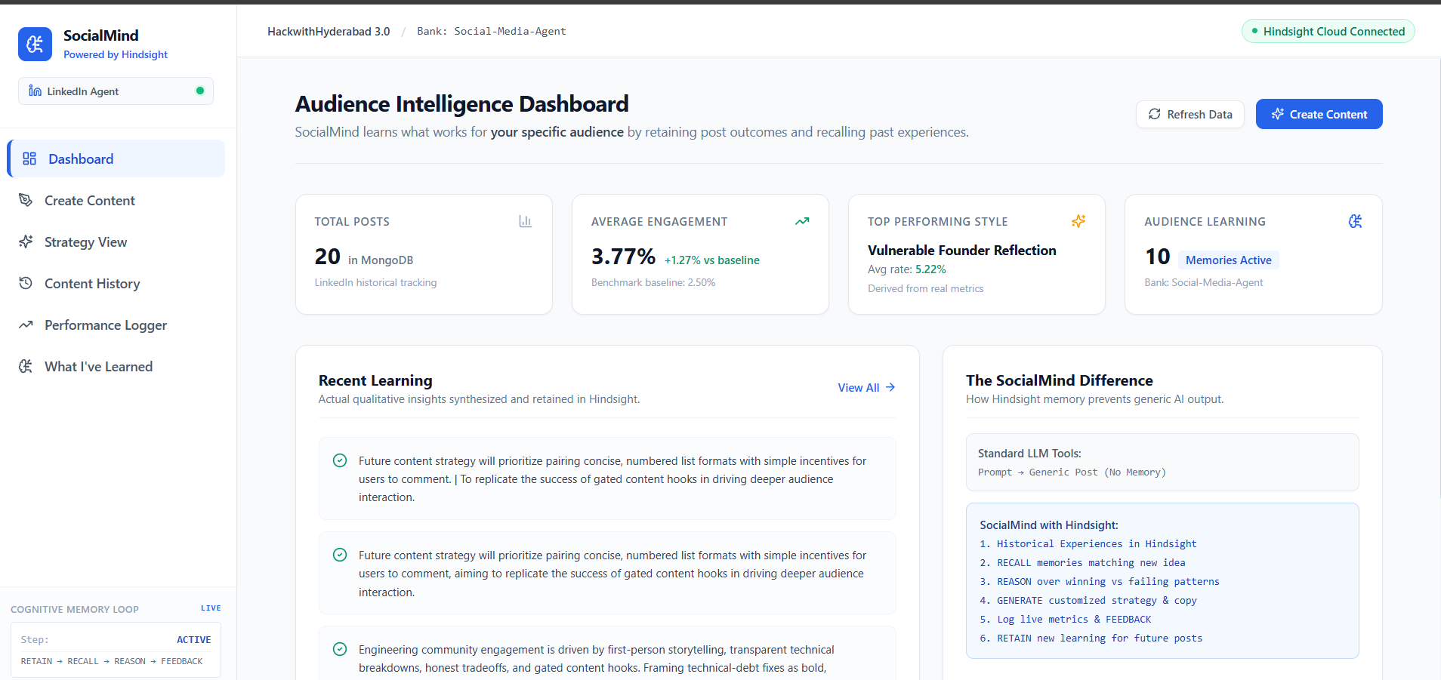
Figure 1 — SocialMind Dashboard.

21.2 Create Content
- User enters the content idea, primary goal and target audience.
- SocialMind recalls relevant memories before generation.
- Retrieved memories are displayed with relevance information.
- Recommended strategy includes content angle, hook, structure and things to avoid.
- Generated LinkedIn post is shown in a dedicated preview.
- A “Why This Strategy?” section explains how recalled memories affected the recommendation.
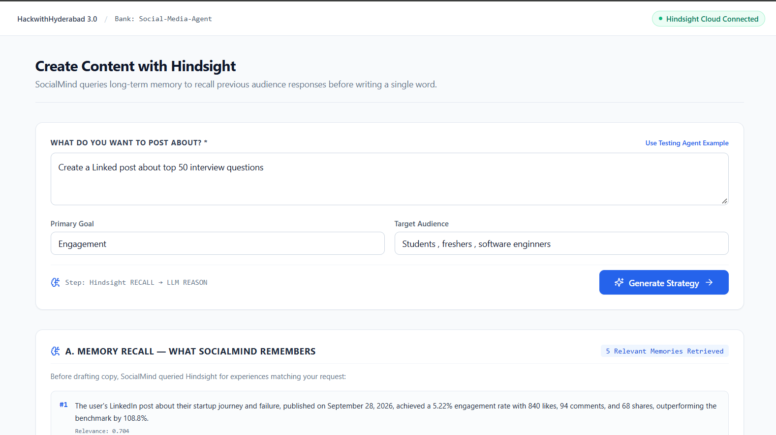
Figure 2 — Create Content input and workflow.

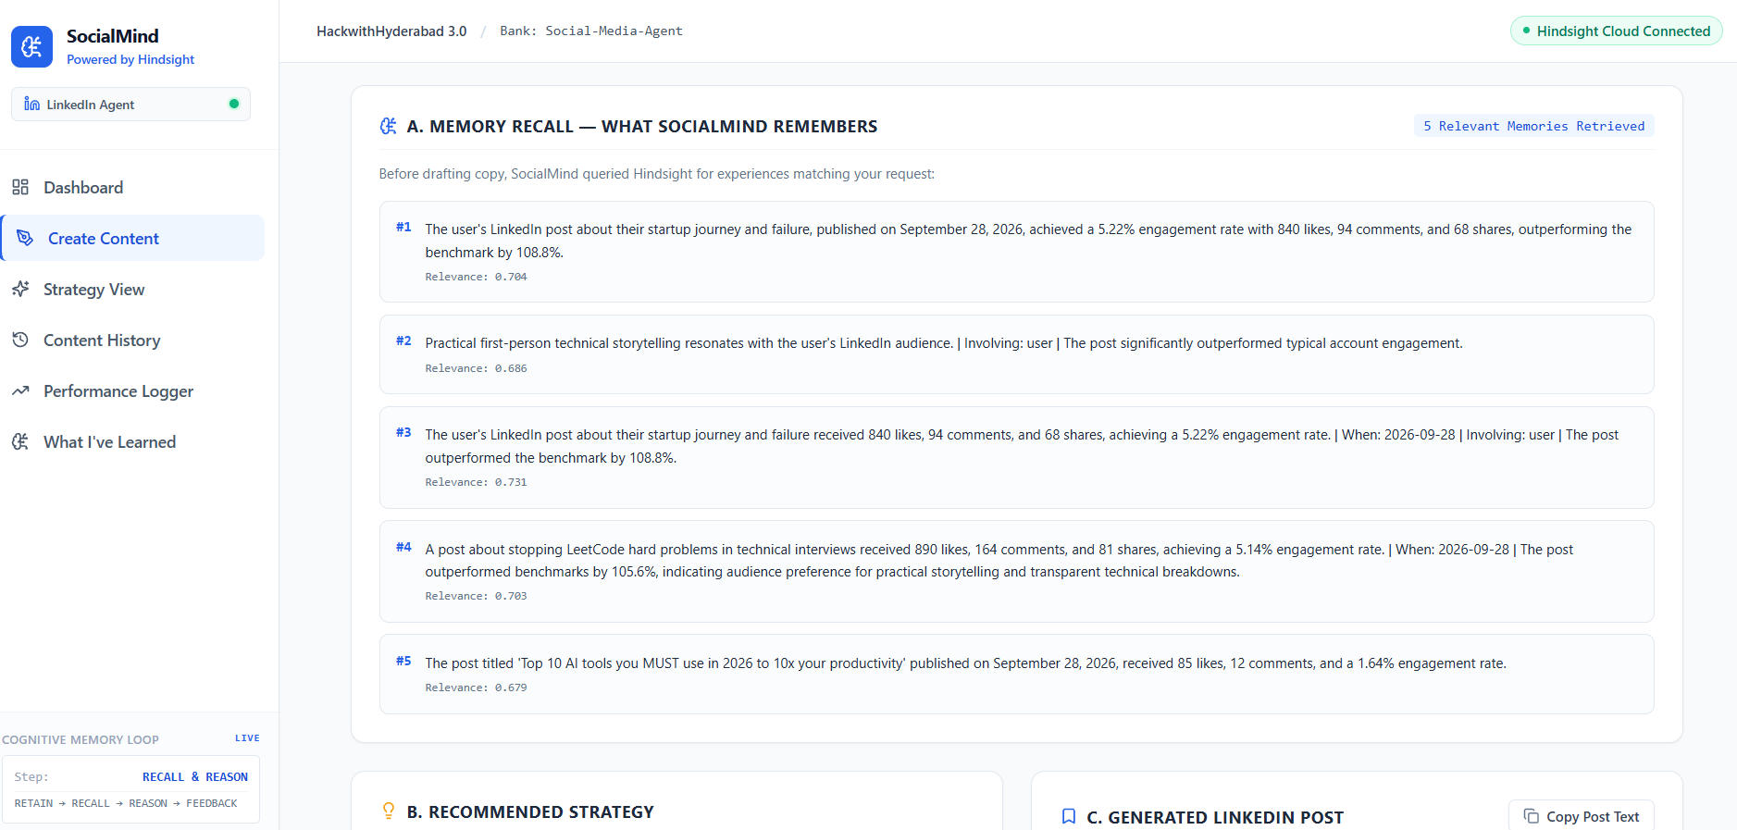
Figure 3 — Hindsight Memory Recall.

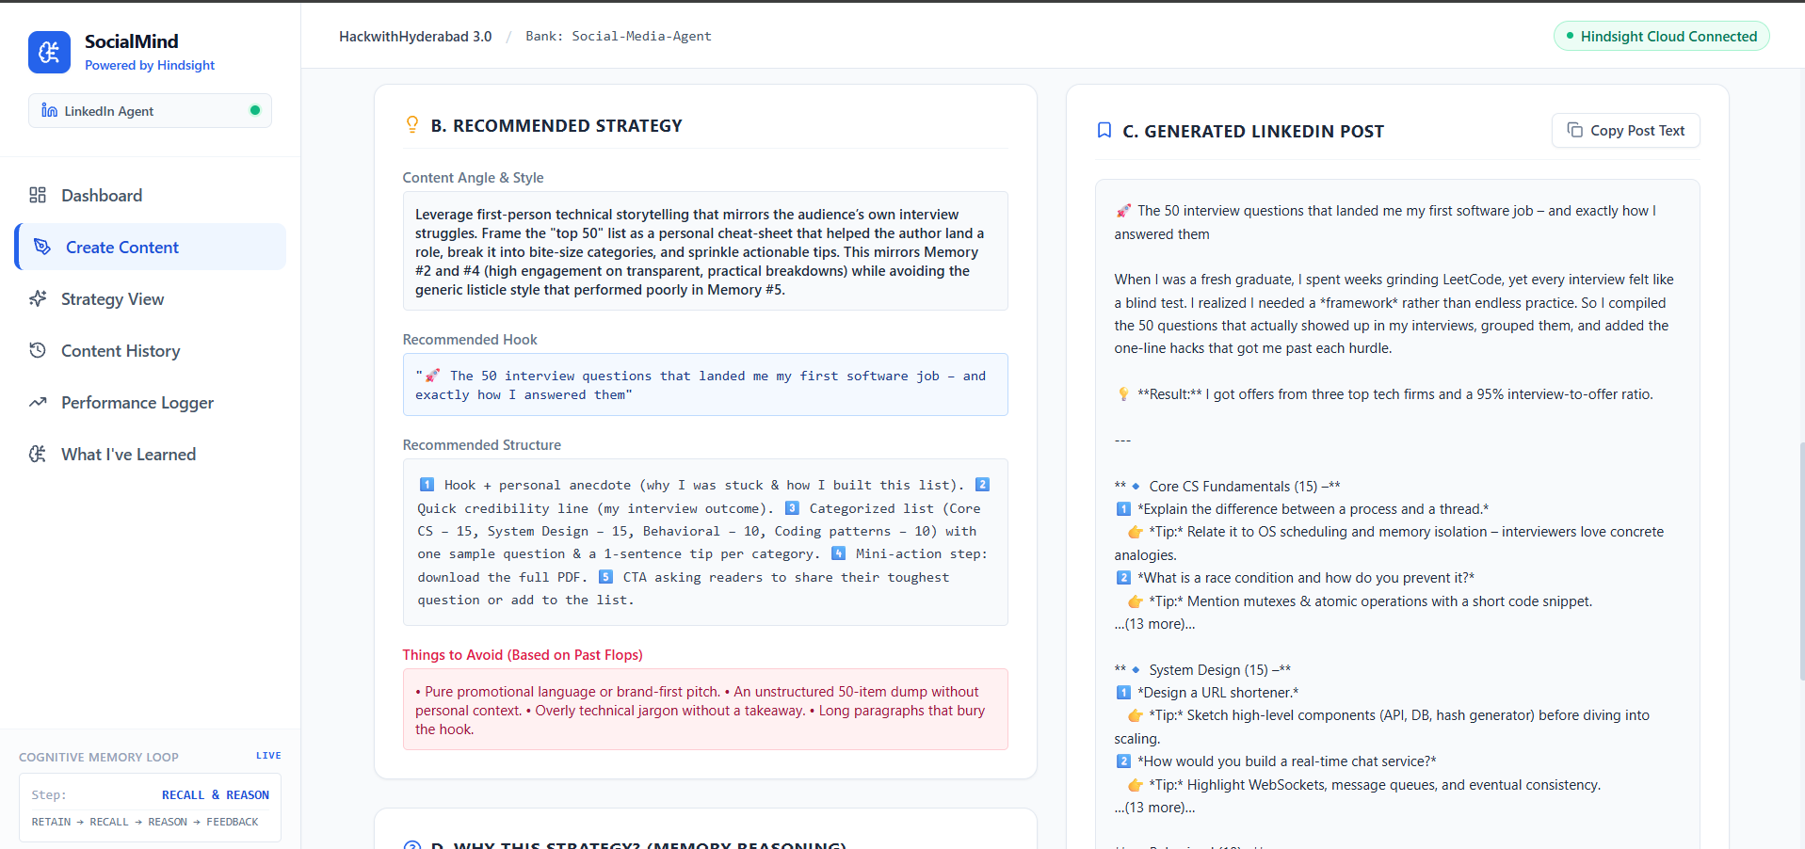
Figure 4 — Recommended Strategy and Generated LinkedIn Post.

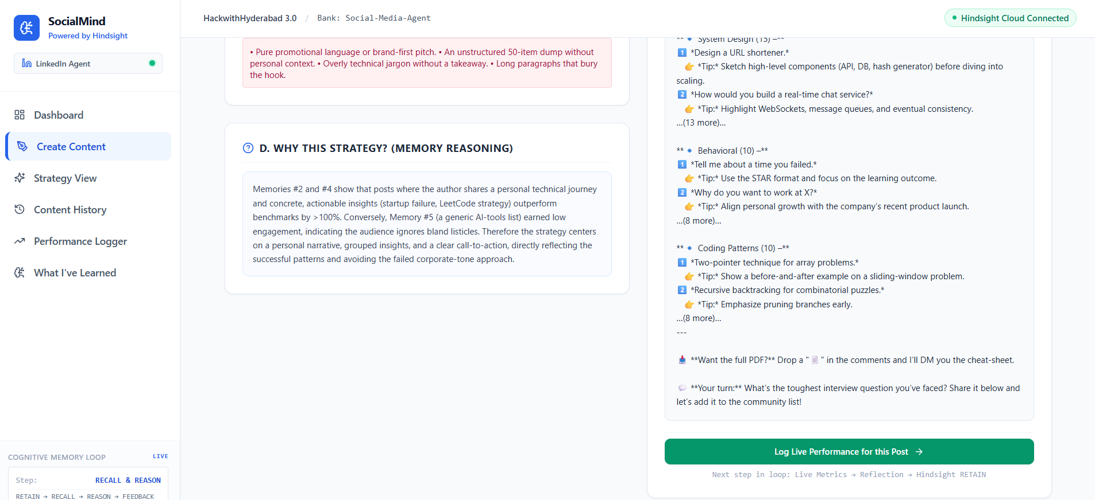
Figure 5 — Memory-based explanation and feedback transition.

21.3 Strategy View
- Persistent strategy breakdown for the generated content.
- Recalled memories and reasoning are visible to the user.
- Generated post can be copied for publishing.

21.4 Performance Logger
- User can select an existing post or enter custom post details.
- Metrics include impressions, likes, comments and shares.
- The pipeline is shown as Analytics → LLM Reflection → Hindsight RETAIN.
- After submission, the interface displays engagement, benchmark comparison and the new learning.
- The UI confirms that the new experience was retained in the Social-Media-Agent bank.
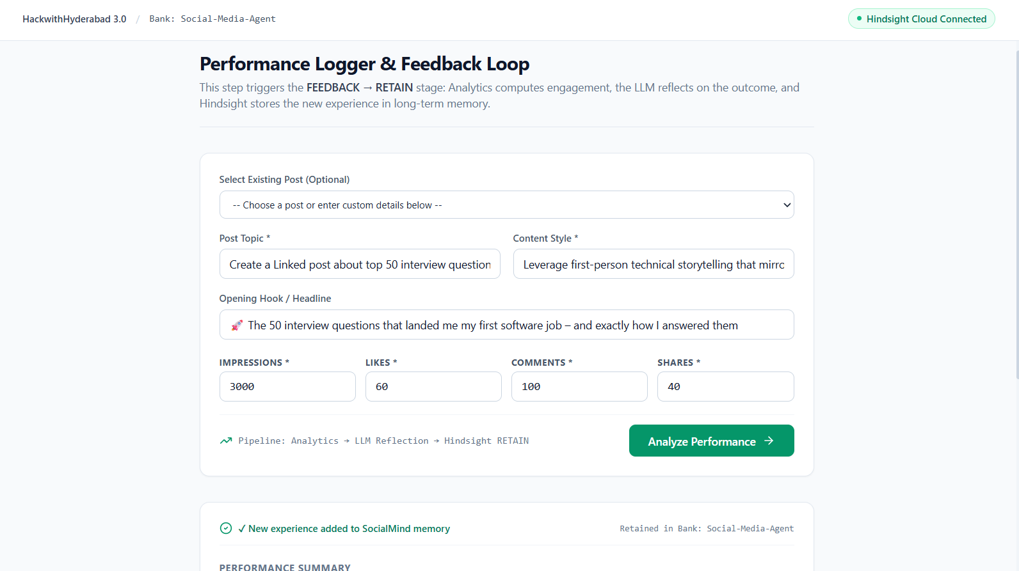
Figure 6 — Performance Logger.

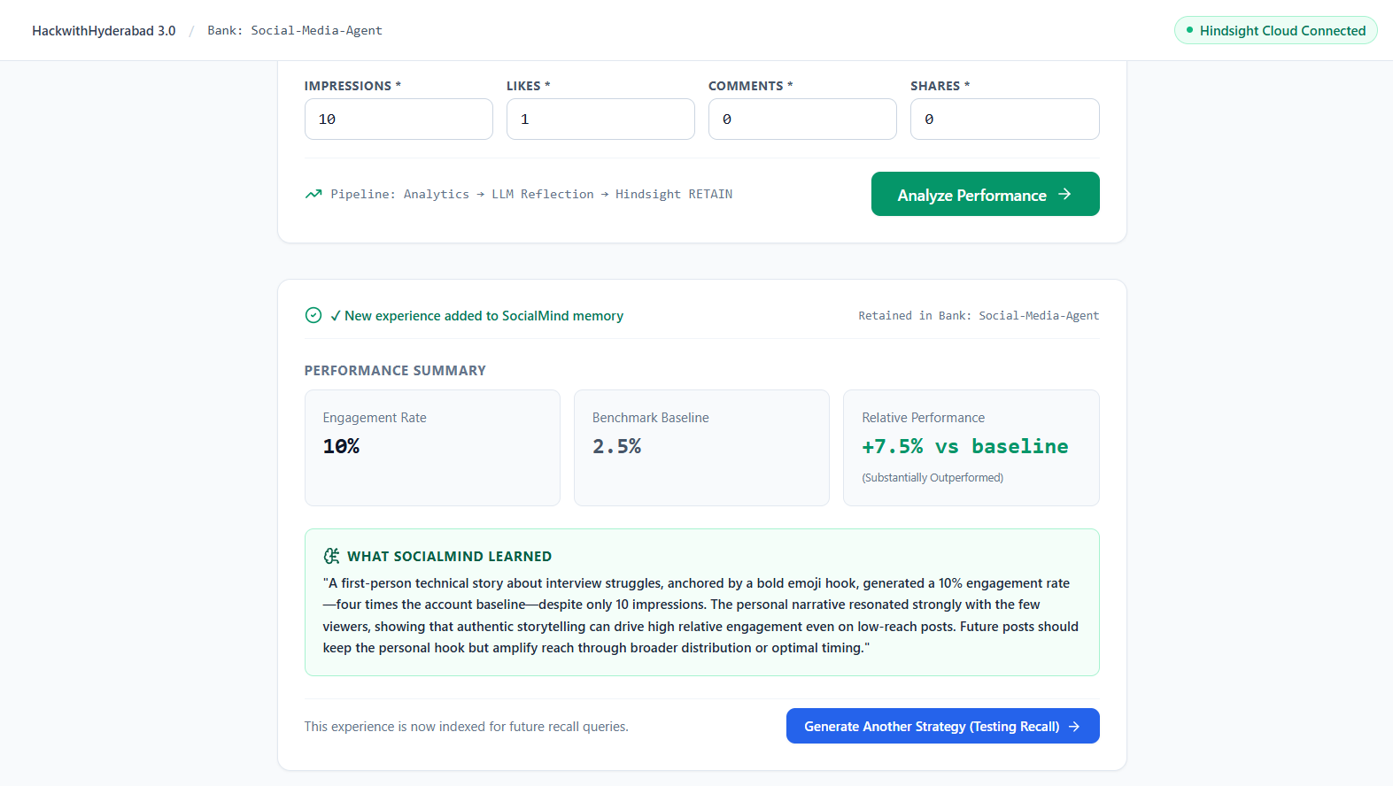
Figure 7 — Performance result, reflection and retained experience.

21.5 Content History
- Shows historical/live posts from MongoDB.
- Displays topic/hook, content style, interactions and engagement rate.
- Provides a detailed post view/modal.
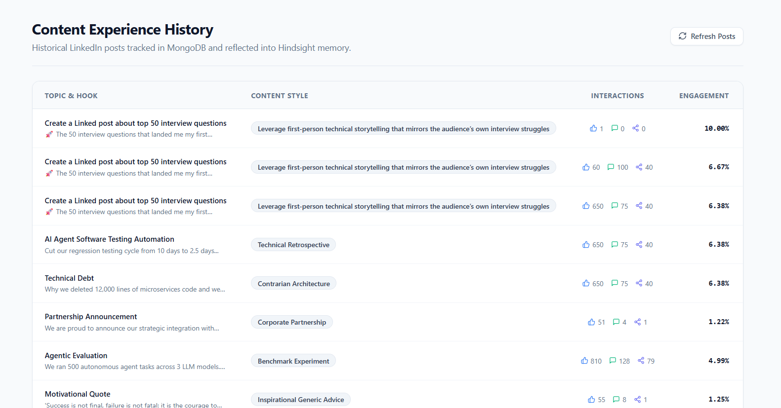
Figure 8 — Content Experience History.

21.6 What I've Learned / Learned Insights
- Displays retained episodic experiences from Hindsight.
- Provides a reflection-based strategic view of accumulated learning.
- Shows how individual performance events become reusable knowledge.
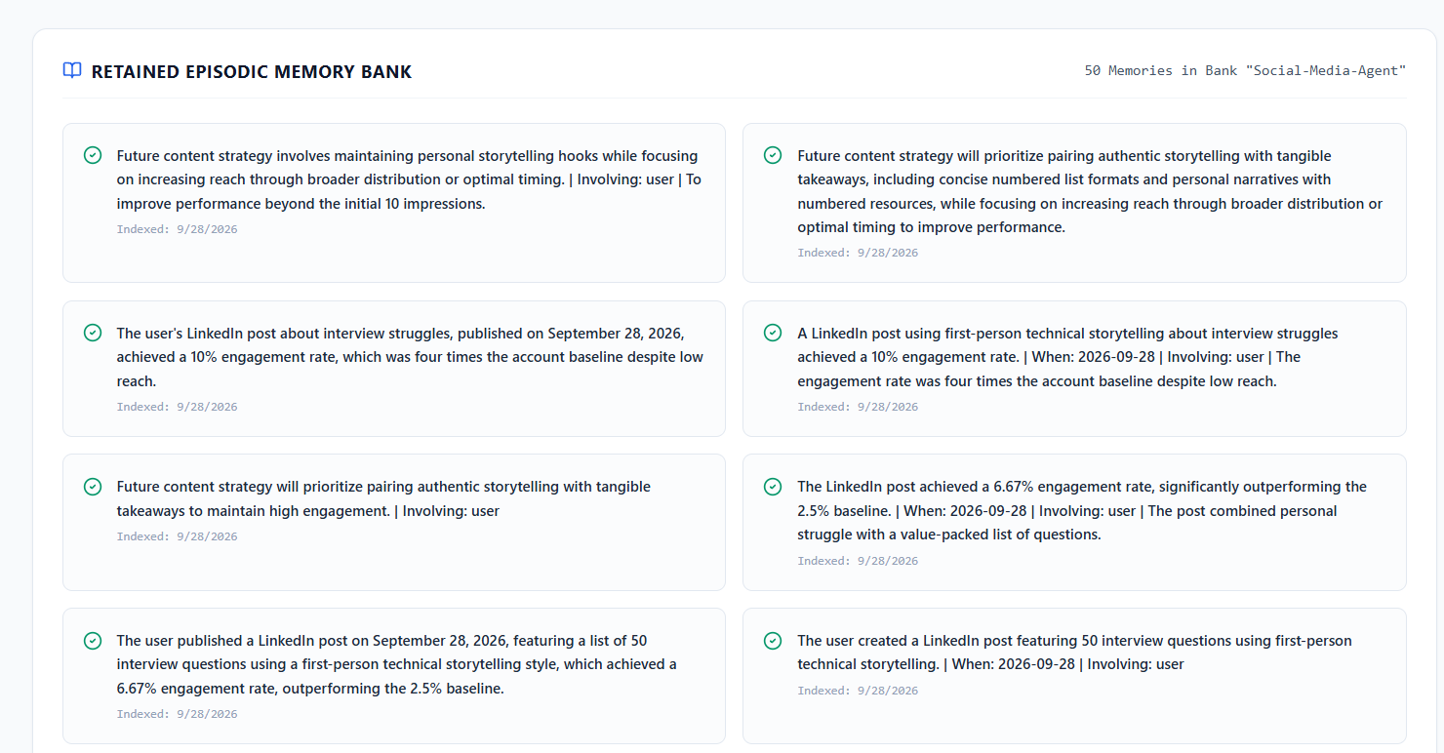
Figure 9 — Retained Episodic Memory Bank.

22. Performance Feedback and Learning
The feedback loop is what turns SocialMind from a one-shot content generator into a learning agent.
User enters:
Impressions = 12,000
Likes = 650
Comments = 75
Shares = 40
Engagement Rate
= (650 + 75 + 40) / 12,000 × 100
= 6.375%
≈ 6.38%
The analytics service computes the metric and compares it against the configured 2.5% benchmark used by the project. The LLM then converts the result into a qualitative experience, which is retained in Hindsight.
During implementation, the full-loop test confirmed that a newly retained performance experience could be retrieved by a subsequent strategy request.

23. Learning Demonstration
BEFORE NEW FEEDBACK
Historical Experiences
↓
Hindsight RECALL
↓
LLM REASONING
↓
Strategy + Post
USER PUBLISHES
↓
Performance Metrics
↓
Analytics
↓
LLM REFLECTION
↓
Hindsight RETAIN
↓
AFTER NEW FEEDBACK
Same/related request
↓
Hindsight RECALL
↓
New experience appears in relevant memories
↓
LLM uses the new evidence
↓
Improved / updated strategy
This is the core proof point for the hackathon: the agent's future behavior can be influenced by experience retained from previous outcomes.

24. Testing and Verification

24.1 Hindsight connectivity test
- testHindsightLive.js verifies live Retain, Recall and Reflect connectivity.
- The configured Hindsight Cloud endpoint and Social-Media-Agent bank were used.

24.2 Seed and recall test
- 20 historical posts were inserted into MongoDB.
- Historical experiences were retained in Hindsight.
- Recall queries returned relevant experiences such as technical storytelling and promotional underperformance patterns.

24.3 Full learning-loop test
- A content request triggered recall and generation.
- A simulated performance result was analyzed.
- LLM reflection produced a qualitative experience.
- The experience was retained in Hindsight.
- A follow-up recall retrieved the new experience.

24.4 Frontend build
cd frontend
npm run build
- The reported frontend production build passed with 0 errors.

24.5 Live integration
- Backend was reported running on port 5000.
- Vite frontend was reported running on port 5173.
- MongoDB Atlas and Hindsight Cloud were reported connected.
- The UI was then reviewed screen-by-screen using the live application.

25. Security
- Hindsight API key is stored on the backend.
- Groq API key is stored on the backend.
- MongoDB connection string is stored on the backend.
- Frontend does not receive these secrets.
- Environment variables are loaded through dotenv.
- The project should never commit real API keys to Git.
Rule
Only public configuration and API responses belong in the browser. Provider credentials must remain server-side.

26. Project Folder Structure
social-media-agent/
├── backend/
│ ├── config/
│ │ └── db.js
│ ├── models/
│ ├── services/
│ ├── controllers/
│ ├── routes/
│ ├── data/seed/
│ ├── tests/
│ ├── .env.example
│ ├── server.js
│ └── package.json
│
├── frontend/
│ ├── src/
│ │ ├── components/layout/
│ │ ├── pages/
│ │ ├── services/
│ │ ├── App.jsx
│ │ ├── index.css
│ │ └── main.jsx
│ ├── index.html
│ ├── tailwind.config.js
│ ├── postcss.config.js
│ ├── vite.config.js
│ └── package.json
│
├── .gitignore
├── README.md
└── SOCIAL MEDIA ENGAGEMENT AGENT.md

27. End-to-End Example

Scenario
A founder wants a LinkedIn post about an AI agent that automates software testing.
- The founder enters the idea in Create Content.
- Backend sends a recall query to Hindsight.
- Hindsight returns relevant technical storytelling and performance experiences.
- The LLM compares successful and unsuccessful patterns.
- SocialMind recommends a first-person technical narrative with a quantified outcome.
- The LLM generates a LinkedIn post following the strategy.
- The user publishes the post.
- The user later enters impressions, likes, comments and shares.
- Analytics calculates engagement.
- The LLM reflects on what the outcome means.
- The experience is retained in Hindsight.
- A later related content request recalls the new experience and can use it in reasoning.

28. Hackathon Demo Flow
A concise demonstration should focus on the learning story rather than showing every feature.
Time | Demo action | What to explain
0:00–0:30 | Dashboard | Introduce SocialMind and show that it already has audience experience.
0:30–1:30 | Create Content | Enter a new idea and show Hindsight Recall before generation.
1:30–2:15 | Strategy + Post | Show how successful/failed memories influence the strategy.
2:15–3:00 | Performance Logger | Enter a realistic performance outcome and show analytics/reflection.
3:00–3:45 | Learned Insights | Show that the experience has been retained.
3:45–4:30 | Generate another strategy | Show that the new experience can be recalled in a future request.

One sentence for judges
“The key difference is that SocialMind does not just generate content; it remembers how this audience responded, learns from the outcome, and uses that experience in the next decision.”

29. What Makes SocialMind Different
Generic AI Content Tool | SocialMind
One-shot generation | Persistent learning loop
General social-media advice | Audience-specific experience
Past results are separate | Results become recallable memory
Same prompt can produce generic advice | Relevant experience changes the strategy
Memory is not central | Hindsight is central to the workflow
Feedback is mostly manual analysis | Feedback is converted into retained experience

30. Current Limitations and Responsible Learning
The project is intentionally scoped as a hackathon MVP. It demonstrates the core learning architecture rather than a complete production social-media management platform.
- The MVP focuses on LinkedIn rather than multiple social networks.
- The project uses logged/synthetic performance data rather than direct platform scraping or automatic publishing.
- Historical seed data is realistic synthetic data used to bootstrap the memory bank.
- Small samples should be treated cautiously; a high engagement rate from extremely low impressions should not automatically become a strong audience rule.
- Generated content should not invent personal achievements, credentials or quantitative claims that the user did not provide.
- Future production versions could incorporate direct platform analytics, richer brand context, stronger authentication, and more sophisticated statistical confidence handling.
Important learning principle
A good memory agent should learn from evidence, not blindly memorize every noisy event. Strong conclusions should be supported by meaningful data.

31. Final Summary
SocialMind is a memory-driven LinkedIn social-media strategist built specifically around the HackWithHyderabad 3.0 requirement that AI agents should learn using Hindsight.
The implementation separates responsibilities clearly: MongoDB stores structured application state; Hindsight stores long-term experiences and enables Recall/Reflect/Retain; Groq with GPT-OSS 120B provides reasoning and generation; Express coordinates the backend; and React/Vite/Tailwind provides the user-facing product.
The most important feature is the closed learning loop. Historical posts create initial experience. A new request recalls relevant experience. The LLM reasons over it and generates a strategy. Actual performance becomes feedback. The result is reflected upon and retained in Hindsight. A later request can recall the newly learned experience.
Final architecture in one line
React UI → Express API → MongoDB + Hindsight → Groq LLM → Strategy/Post → Performance → Reflection → Hindsight RETAIN → Future RECALL

Appendix A — Key Configuration Concepts
PORT=5000
MONGO_URI=<MongoDB connection string>
HINDSIGHT_API_KEY=<Hindsight API key>
HINDSIGHT_BANK_ID=Social-Media-Agent
HINDSIGHT_BASE_URL=<Hindsight Cloud endpoint>
GROQ_API_KEY=<Groq API key>
LLM_MODEL=openai/gpt-oss-120b
Never place real secret values in shared documentation, GitHub, screenshots or frontend code.

Appendix B — Important Terms
Term | Meaning in this project
Agent | The application workflow that uses memory, reasoning, generation and feedback.
Memory | Long-term experiential information retained in Hindsight.
Recall | Retrieving memories relevant to the current task.
Retain | Adding a meaningful new experience to memory.
Reflect | Synthesizing multiple experiences into higher-level knowledge.
Reason | LLM interpretation of recalled experiences to choose a strategy.
Engagement Rate | (Likes + Comments + Shares) / Impressions × 100.
Benchmark | The baseline used by the project for comparing content performance.
Episodic Experience | A specific event/outcome retained in memory.
Strategic Insight | A broader lesson synthesized from accumulated experiences.

