**GLA UNIVERSITY MATHURA**



|  |  |
| --- | --- |
| Department | Computer Engineering and Application |
| Program | B. Tech CSE [AIML & IoT] |
| Section | CC |
| Project Name | 2-bit binary multiplier using logic gates |
| Subject Name | Computer Organization Lab |
| Subject Code | BCSC 0804 |

**Submitted To:** Dr. Ajit Debnath

**Submitted By:** Prem Narayan Sharma (36) – 2315510150

Priyanshu Sharma (38) – 2315510155

Priyam Srivastava (37) – 2315510153

Pradeep (34) – 23155101

Prashant Sagar (35) – 2315510147

**Objective :**

The objective is to design a combinational circuit that multiplies two 2-bit binary numbers using logic gates, producing a 4-bit product. It demonstrates binary arithmetic through partial product generation and addition while showcasing efficient use of basic logic gates for digital computation.

**Components Required :**

* **DC Trainer Kit:**  
  The kit should have built-in connections for input switches and output indicators, but ICs for logic gates will still be required to construct the actual multiplier circuit.
* **Logic Gate ICs:**
  + **AND Gate IC (e.g., 7408 IC):**  
    You’ll need 1 IC containing 4 AND gates to generate the partial products.  
    Connections: PP0 = A0 . B0, PP1 = A1 . B0, PP2 = A0 . B1, PP3 = A1 . B1.
  + **XOR Gate IC (e.g., 7486 IC):**  
    You’ll need 1 IC with 4 XOR gates. Use 2 XOR gates to handle the summation of partial products (for P1 and P2).  
    P1 = PP1 ⊕ PP2, P2 = PP3 ⊕ Carry.
  + **OR Gate IC (e.g., 7432 IC):**  
    You’ll need 1 OR gate IC (or just one OR gate from a kit) to manage carry outputs from XOR gates and ensure proper propagation of the carry during addition.
* **Input Switches:**  
  Toggle switches to represent binary inputs A1, A0, B1, B0.
* **Output Indicators:**  
  LEDs or 7-segment display to visualize the 4-bit output P3, P2, P1, P0.
* **Resistors:**  
  Current-limiting resistors (e.g., 220 Ω or 330 Ω) to protect the LEDs from high current.
* **Power Supply:**  
  A 5V DC power supply (typically included in a DC trainer kit).
* **Connecting Wires:**  
  For making connections between the ICs, input switches, and output indicators.
* **Breadboard (Optional):**  
  If you are not using a DC Trainer Kit that already has a breadboard, you may need one to physically assemble the circuit.
* gates.

**Theory :**

A 2-bit binary multiplier multiplies two 2-bit binary numbers to produce a 4-bit binary product. The multiplication is achieved through the use of logic gates to generate partial products and perform binary addition.

Components:

1. AND Gate IC (7408):  
   Generates partial products:  
   PP₀ = A₀ . B₀, PP₁ = A₁ . B₀, PP₂ = A₀ . B₁, PP₃ = A₁ . B₁.
2. XOR Gate IC (7486):  
   Sums the partial products to form intermediate product bits:  
   P₁ = PP₁ ⊕ PP₂, P₂ = PP₃ ⊕ Carry.
3. OR Gate IC (7432):  
   Handles carry propagation from the XOR gates.
4. Input Switches:  
   Provide the binary inputs A₁, A₀, B₁, B₀.
5. Output Indicators (LEDs/7-Segment):  
   Display the 4-bit product P₃, P₂, P₁, P₀.

Working:

1. The AND gates generate the partial products.
2. The XOR gates sum the partial products and handle intermediate results.
3. The OR gate manages carry propagation.
4. The result is displayed on LEDs or a 7-segment display.

**Circuit diagram & Explanation:**

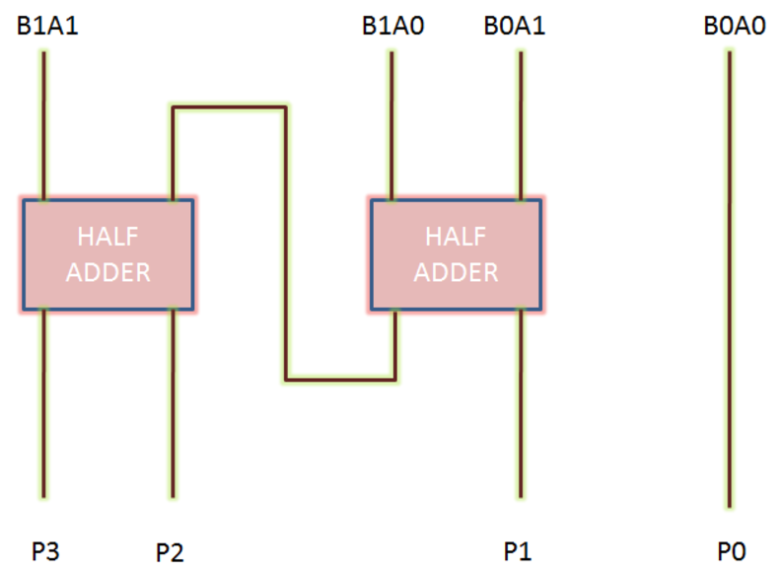

[AND] Gates (Multiplication):

These gates perform the binary multiplication for each pair of bits. The four AND gates generate the partial products of the 2-bit numbers:

* P0 = A0 ⋅ B0
* P1 = A1 ⋅ B0
* P2 = A0 ⋅ B1
* P3 = A1 ⋅ B1

[XOR] Gates (Addition):

The XOR gates are used to add the partial products together:

* XOR Gate 1 adds P1 and P2, generating an intermediate sum S1 and a carry C1.
* XOR Gate 2 adds C1 and P3, producing S2 and the final carry C2.

Half Adders:

The XOR gates here act as half adders because they perform the addition of two bits and generate both the sum and the carry.

Final Output:

* P0: The least significant bit (LSB) from the first AND gate.
* S1: The sum of P1 and P2, from the first XOR gate.
* S2: The final sum, considering carry C1 and P3, from the second XOR gate.
* P3: The most significant bit (MSB) from the last AND gate.

The carry bits C1 and C2 propagate the carry through the addition.

4-Bit Product:

The final 4-bit product of the 2-bit binary multiplier is:

Product = P3 S2 S1 P0

**Truth Table:**

For two 2-bit numbers A=A1A0A = A_1A_0A=A1​A0​ and B=B1B0B = B_1B_0B=B1​B0​, the resulting 4-bit product is given by P3P2P1P0P_3P_2P_1P_0P3​P2​P1​P0​.

| A1A_1A1​ | A0A_0A0​ | B1B_1B1​ | B0B_0B0​ | P3P_3P3​ | P2P_2P2​ | P1P_1P1​ | P0P_0P0​ |
| --- | --- | --- | --- | --- | --- | --- | --- |
| 0 | 0 | 0 | 0 | 0 | 0 | 0 | 0 |
| 0 | 0 | 0 | 1 | 0 | 0 | 0 | 0 |
| 0 | 0 | 1 | 0 | 0 | 0 | 0 | 0 |
| 0 | 0 | 1 | 1 | 0 | 0 | 1 | 0 |
| 0 | 1 | 0 | 0 | 0 | 0 | 0 | 0 |
| 0 | 1 | 0 | 1 | 0 | 0 | 1 | 1 |
| 0 | 1 | 1 | 0 | 0 | 1 | 1 | 0 |
| 0 | 1 | 1 | 1 | 0 | 1 | 1 | 1 |
| 1 | 0 | 0 | 0 | 0 | 0 | 0 | 0 |
| 1 | 0 | 0 | 1 | 0 | 1 | 0 | 1 |
| 1 | 0 | 1 | 0 | 0 | 1 | 0 | 0 |
| 1 | 0 | 1 | 1 | 0 | 1 | 1 | 1 |
| 1 | 1 | 0 | 0 | 0 | 1 | 1 | 0 |
| 1 | 1 | 0 | 1 | 0 | 1 | 1 | 1 |
| 1 | 1 | 1 | 0 | 1 | 0 | 1 | 0 |
| 1 | 1 | 1 | 1 | 1 | 0 | 1 | 1 |

**Applications of 2-Bit Binary Multiplier :**

1. **Basic Arithmetic Operations**:
   * A 2-bit binary multiplier is used as a fundamental building block for performing multiplication in digital systems. It can be extended to larger bit-width multipliers in computer processors for more complex arithmetic operations.
2. **Digital Signal Processing (DSP)**:
   * Multiplication operations are critical in DSP applications, such as convolution, filtering, and Fourier transforms. A 2-bit multiplier is often used in simpler DSP systems for basic signal operations.
3. **Embedded Systems**:
   * In embedded systems where low power consumption and efficient processing are important, a 2-bit binary multiplier can be used to optimize certain hardware designs that require multiplication of small numbers.
4. **Microprocessor Design**:
   * Multiplier circuits like the 2-bit binary multiplier are essential components in microprocessor arithmetic units. They form the foundation of multiplication operations in processors.
5. **Control Systems**:
   * 2-bit multipliers can be used in control systems for performing various calculations such as adjusting outputs based on input values, especially in simpler or specialized applications.
6. **Hardware Simulation**:
   * They are used in educational tools and simulation software to help understand how multiplication works at the binary level and how binary systems operate in hardware.
7. **Digital Multiplexers**:
   * In some digital multiplexing systems, a 2-bit binary multiplier is used to help control the switching mechanism and manage multiple inputs and outputs efficiently.
8. **Cryptographic Applications**:
   * Binary multipliers can play a role in cryptography, especially in algorithms that require multiplication of small numbers as part of encryption or hashing processes.
9. **Arithmetic Logic Units (ALU)**:
   * A 2-bit binary multiplier is a key component in an ALU, used to perform multiplication operations in basic computer processors and embedded systems.

**Conclusions:**

1. Basic Binary Multiplication: The 2-bit binary multiplier effectively demonstrates binary multiplication using basic AND and XOR gates.
2. Foundation for Larger Systems: This simple design serves as a foundation for creating larger multipliers in digital systems like microprocessors.
3. Educational Value: It offers a hands-on learning opportunity to understand how binary multiplication works in digital circuits.
4. Practical Applications: The circuit is used in embedded systems and simple processors for arithmetic operations.