IBM SkillsBuild Data Analytics with AI Internship 2026
BharatCares in association with AICTE
Restaurant Sales
Executive Decision Dashboard
Project Report
Submitted by: [YOUR NAME HERE]
College / Institution: [YOUR COLLEGE HERE]
GitHub repository: [YOUR GITHUB LINK HERE]
Date: September 2026

1. Introduction and Problem Statement
A restaurant chain produces thousands of sales records, but a CEO does not need rows of data. A CEO needs to know whether the business is healthy, what is driving it, what could go wrong, and what to do next. This project applies Business Intelligence practice to the sales records of a five-city restaurant chain covering 7 November to 29 December 2022 (53 trading days, 254 sales records).
The guiding framework is the BI chain Data → Information → Insight → Decision → Action. The analysis is organised as a five-level decision dashboard: KPIs (what is happening), trends (how it is changing), drivers (why), risks (what could go wrong) and actions (what to do).
Problem statement: Given raw sales records that contain data-quality problems, produce a decision-ready analysis for senior leadership: clean and validate the data, select KPIs that can be defended, identify the drivers and risks in revenue, recommend actions, and test how an AI assistant can support this work when it is given only verified data.

1.1 Objectives
- Clean and validate the raw data and document every assumption.
- Select three above-the-fold KPIs and justify each one against a business purpose.
- Analyse trends and drivers of revenue by product, city, channel and weekday.
- Identify risks and opportunities and convert them into specific management actions.
- Use Gemini as an executive analyst on verified metrics only, and validate its output against the data.

2. Dataset Description
The dataset is a restaurant sales file from Kaggle with 254 rows and 9 columns. It contains no missing values and no duplicate rows, but it has several quality problems described in Section 3. Source link:
[ADD YOUR KAGGLE DATASET LINK HERE]
Column | Description | Note
Order ID | Unique identifier of each sales record | 8 IDs missing from the sequence
Date | Date of sale, stored as dd-mm-yyyy text | Converted to a date type
Product | Menu category: Burgers, Fries, Chicken Sandwiches, Beverages, Sides & Other | 5 categories
Price | Unit price of the product | 2 invalid values found
Quantity | Units sold in the record | Decimal values (see limitations)
Purchase Type | Sales channel: Online, In-store, Drive-thru | Trailing space in every row
Payment Method | Credit Card, Cash, Gift Card | Trailing space in every row
Manager | Manager responsible for the record | 14 spellings for 5 people
City | London, Lisbon, Madrid, Berlin, Paris | Each manager runs one city

Derived columns created in the notebook: Standard Price (the product's menu price), Price Anomaly (flag), Revenue Raw (original price × quantity), Revenue (standard price × quantity) and Week Ending (Sunday of each week).

3. Data Cleaning and Preparation
Quality checks were run before any analysis. Each problem, the treatment applied and its impact are listed below so that every assumption is visible.
Issue found | Treatment | Impact
Stray spaces in text. Purchase Type and Payment Method had a trailing space in all 254 rows (for example "Online "). Manager names had extra internal spaces: 14 spellings for 5 people. | Trimmed edges and collapsed internal spaces in all text columns. | Categories group correctly; filters like == "Online" now work.
Dates stored as text in dd-mm-yyyy format. | Parsed with an explicit format string to avoid day/month swaps. | Enables weekly and weekday analysis.
Price anomalies. 2 rows: Fries at 25.50 (menu price 3.49) and Chicken Sandwiches at 29.05 (menu price 9.95). | Replaced with the product's most frequent price. The original is kept as Revenue Raw. | Revenue reduced by 17,714 (2.3% of raw revenue).
Missing Order IDs. 8 gaps in the ID sequence. | Flagged, not imputed. | Possible cancelled or unrecorded orders; recommended for audit.
Decimal quantities such as 573.07 that repeat by product. | Kept as given and interpreted as aggregated sales records. | Documented as a limitation.
Checks passed: no missing values, no duplicate rows, no duplicate Order IDs. | None needed. | None.

Total revenue is calculated as Standard Price × Quantity. Using raw prices it would be 769,516; after correction it is 751,802, which is the figure used throughout.

4. Methodology and KPI Framework

4.1 Dashboard hierarchy
Level | Question | What is measured
1. KPI | What is happening? | Total Revenue, Growth %, Average Order Value
2. Trends | How is it changing? | Weekly revenue, weekday pattern
3. Drivers | Why? | Revenue by product, city, channel; product × city mix
4. Risk | What could go wrong? | Concentration by product, city and channel; data-quality issues
5. Action | What should we do? | Risk → Opportunity → Action recommendations

4.2 KPI selection: top three above the fold
The rule applied is that every KPI must have a business purpose; a KPI that cannot be justified is removed. The CEO question is “is the business healthy?” and the three KPIs below answer it in five seconds.
KPI | Above the fold? | Business purpose
Total Revenue | Yes | Size of the business: how much was sold.
Growth % | Yes | Direction of the business. Measured from the first full week to the last full week.
Average Order Value | Yes | Quality of revenue. It also exposes the dependence on burgers found later.
Orders | No (Page 2) | A driver of revenue rather than a health check on its own.
Profit | Not available | The dataset has no cost data, so profit cannot be calculated.
Customers | Not available | There is no customer ID, so unique customers cannot be counted.

Definitions. Revenue = corrected unit price × quantity. Weeks end on Sunday. The final week contains only four trading days, so it is excluded from Growth % and shown separately as a daily run-rate. Growth % = (last full week − first full week) ÷ first full week.

5. Analysis and Findings

5.1 Page 1: Executive Overview
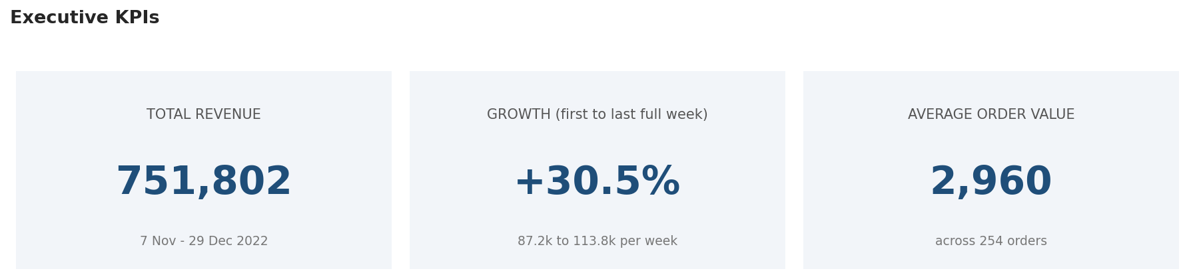
Figure 1: Executive KPIs
The business generated 751,802 in revenue across 254 orders, an average order value of 2,960. Weekly revenue grew +30.5% from 87,200 in the first full week to 113,800 in the last full week. On revenue, the business is healthy and growing.
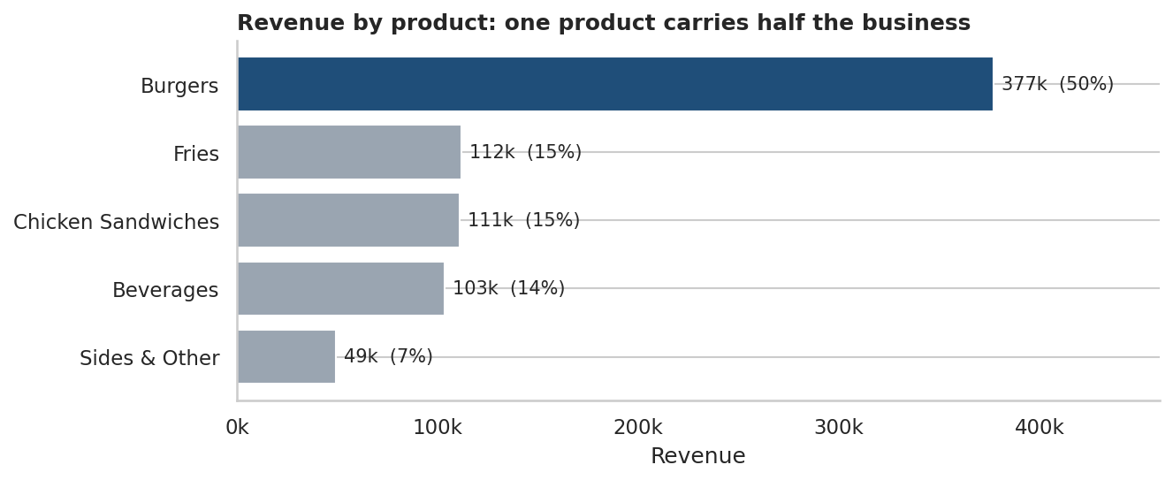
Figure 2: Revenue by product
Burgers generate 50% of total revenue from about one fifth of the orders. A burger order is worth 7,250 on average, compared with 1,855 for all other products combined. This explains why average order value looks high and is the first sign of concentration risk.

5.2 Page 2: Sales and Product Analysis
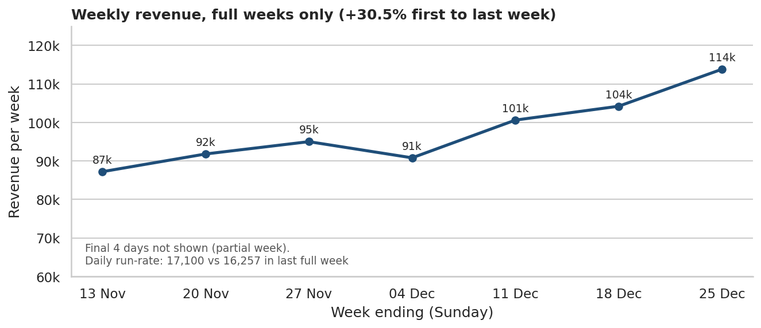
Figure 3: Weekly revenue (full weeks only)
Revenue rose in 5 of 6 week-on-week comparisons, an average of +4.7% per week. The final 4 days (a partial week) ran at 17,100 per day against 16,257 in the last full week, so the momentum continued. Caution: seven weeks that include the December holiday period cannot separate a genuine trend from seasonality.
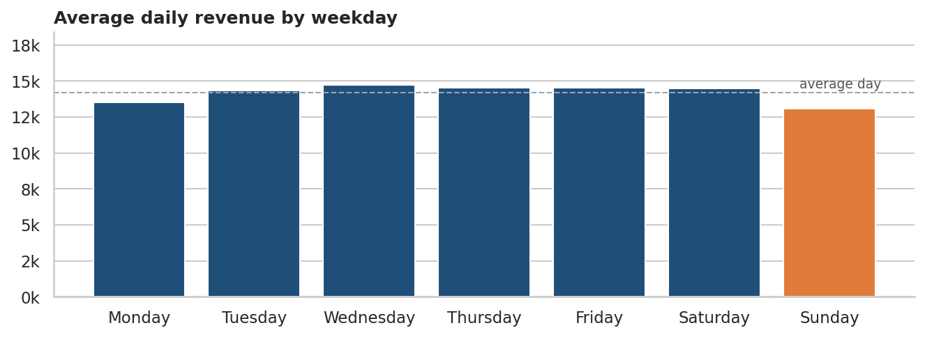
Figure 4: Average daily revenue by weekday
Sunday is the weakest day, 8% below the average day (14,185). The gap is small and based on seven Sundays, so it is treated as a low-priority opportunity.
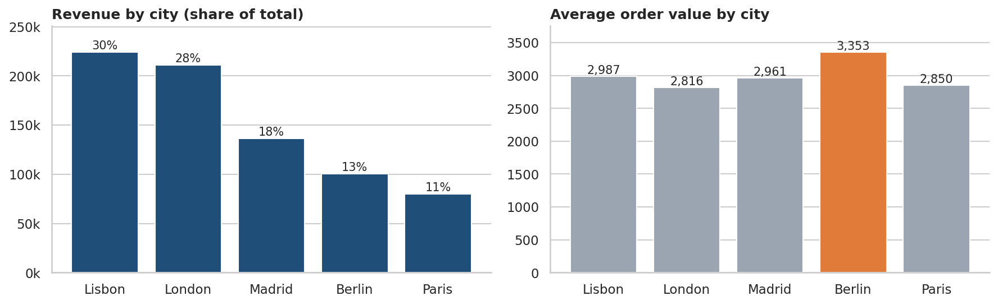
Figure 5: Revenue share and average order value by city
Lisbon and London produce 58% of revenue. Berlin has the highest average order value (3,353) but a smaller share of revenue, because it has fewer orders.
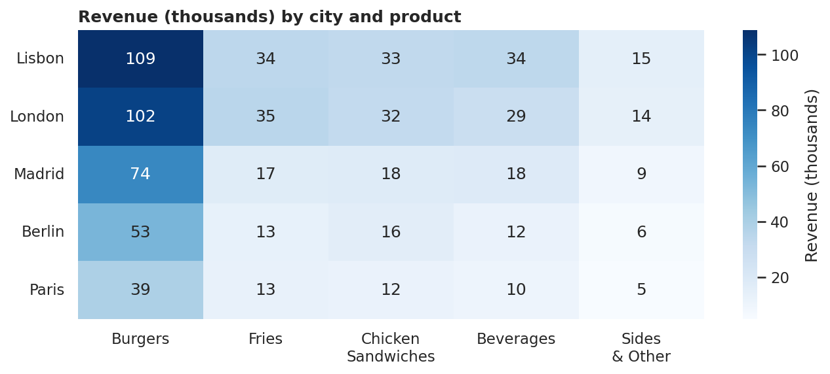
Figure 6: Revenue by city and product (thousands)
Burgers are the top product in every city, so the burger dependence is a chain-wide pattern and not the result of one unusual market.
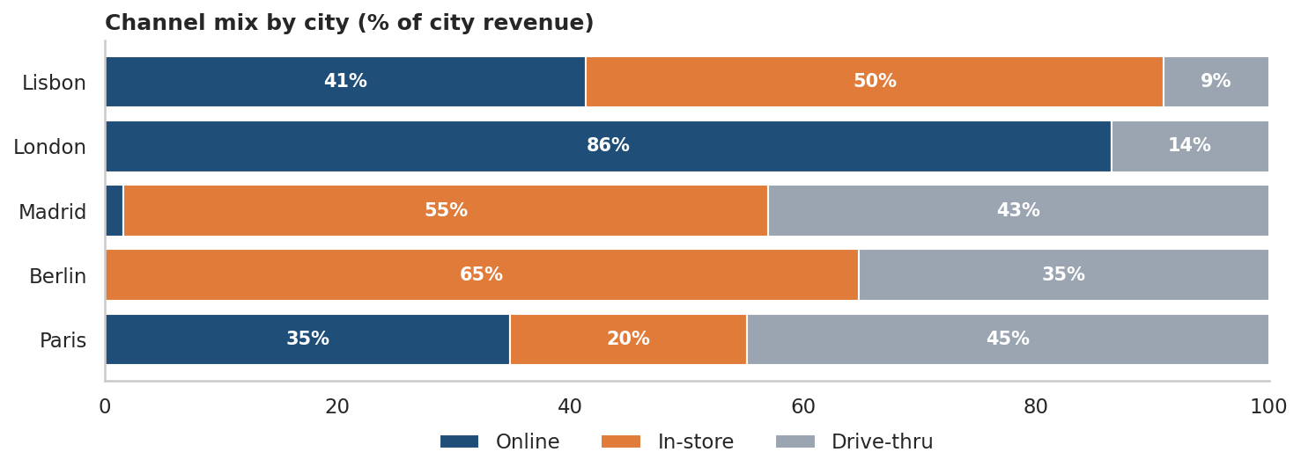
Figure 7: Channel mix by city (% of city revenue)
Online is the largest channel (41% of revenue). The mix differs sharply by city: London earns 86% of its revenue online and records no in-store sales, while Berlin has no online revenue at all and Madrid only 1.6%.

5.3 Page 3: Customer and Risk Analysis
The dataset has no customer ID, so repeat purchase, churn and lifetime value cannot be measured. Channel and payment method are used as the closest available view of how customers buy.
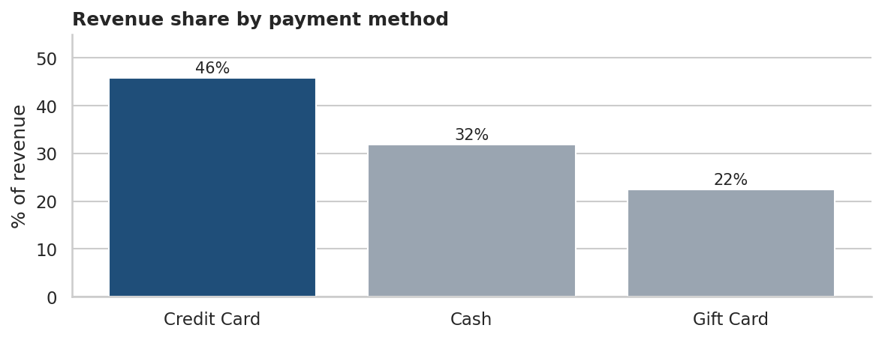
Figure 8: Revenue share by payment method
Credit cards account for 46% of revenue, cash for 32% and gift cards for 22%. No payment method dominates to a degree that creates risk.

Risk scorecard
Risk area | Measure | Value
Product concentration | Burgers share of revenue | 50%
City concentration | Lisbon + London share of revenue | 58%
Channel dependence | London revenue from online | 86%
Channel gap | Berlin online revenue / Madrid online share | 0 / 1.6%
Data quality | Raw revenue affected by price anomalies | 2.3%
Data quality | Missing Order IDs in the sequence | 8

6. Risk, Opportunity and Action
Each recommendation is built from a number computed in the analysis, so it can be traced to a chart above. Priority is a suggested ordering based on the size of the exposure or opportunity.
Type | Finding (evidence) | Recommended action | Priority
Risk | Burgers generate 50% of revenue and are the top product in every city. One supply, price or quality problem would hit half the business. | Secure burgers supply and pricing; track burgers share monthly with an alert if it moves sharply. | High
Risk | Lisbon and London produce 58% of revenue, and London earns 86% of its revenue online with no in-store sales. | Set up a contingency plan for the two anchor cities, including online platform uptime and delivery capacity in London. | Medium
Opportunity | Online is the largest channel (41% of revenue), yet Berlin has no online revenue and Madrid only 1.6%. Berlin has the highest order value (3,353). | Pilot online ordering in Berlin and Madrid; measure new online revenue after 4 weeks against the in-store baseline. | High
Opportunity | Sides & Other is only 7% of revenue at 1,000 per order, the lowest of all products. | Bundle Sides & Other and Fries with Burgers in combo offers to raise order value. | Medium
Opportunity | Weekly revenue grew +30.5% and the final partial week has the highest daily run-rate (17,100/day). Sunday is the weakest weekday (8% below average). | Run a targeted Sunday promotion; re-check growth once January and later data is available to separate trend from holiday season. | Low
Action (data) | 2 rows had invalid prices (about 2.3% of raw revenue) and 8 Order IDs are missing. | Add price validation at order entry and audit the missing Order IDs (possible cancelled or unrecorded orders). | Medium

7. AI as Executive Analyst (Gemini)
The masterclass rules for using AI in analysis are: give the AI only verified metrics, and always validate its conclusions against the dashboard. This section follows both.

7.1 Process
- The notebook prints a prompt that contains only numbers computed and verified in the analysis (listed below). No raw data was given to the AI.
- The prompt asks for 5 key findings, 3 risks, 3 opportunities and 5 recommended actions.
- Every claim in the AI response is checked against the charts and tables in Section 5 and marked Confirmed, Rejected or Unsupported.

7.2 Verified metrics supplied to Gemini
- Total revenue: 751,802 from 254 sales records; average order value 2,960
- Weekly revenue grew +30.5% from first to last full week (87,200 to 113,800); revenue rose in 5 of 6 weekly comparisons
- Products by revenue share: Burgers 50%, Fries 15%, Chicken Sandwiches 15%, Beverages 14%, Sides & Other 7%
- Average order value by product: Burgers 7,250, Fries 2,192, Chicken Sandwiches 2,131, Beverages 2,064, Sides & Other 1,000
- Cities by revenue share: Lisbon 30%, London 28%, Madrid 18%, Berlin 13%, Paris 11%
- Average order value by city: Lisbon 2,987, London 2,816, Madrid 2,961, Berlin 3,353, Paris 2,850
- Channel share of revenue: Online 41%, In-store 36%, Drive-thru 24%
- London earns 86% of its revenue online; Berlin online revenue = 0; Madrid online share = 1.6%
- Payment share: Credit Card 46%, Cash 32%, Gift Card 22%
- Weakest weekday: Sunday (8% below the average day)
- Limitations: no profit or cost data, no customer IDs, only 53 days of data

7.3 Gemini response
[PASTE GEMINI'S FULL RESPONSE HERE: 5 findings, 3 risks, 3 opportunities, 5 actions]

7.4 Validation against the dashboard
# | AI claim (short) | Verdict | Evidence from this analysis
1 | [CLAIM HERE] | [CONFIRMED / REJECTED / UNSUPPORTED HERE] | [EVIDENCE HERE]
2 | [CLAIM HERE] | [CONFIRMED / REJECTED / UNSUPPORTED HERE] | [EVIDENCE HERE]
3 | [CLAIM HERE] | [CONFIRMED / REJECTED / UNSUPPORTED HERE] | [EVIDENCE HERE]
4 | [CLAIM HERE] | [CONFIRMED / REJECTED / UNSUPPORTED HERE] | [EVIDENCE HERE]
5 | [CLAIM HERE] | [CONFIRMED / REJECTED / UNSUPPORTED HERE] | [EVIDENCE HERE]

7.5 Reflection
[WRITE 2-3 SENTENCES HERE: what the AI got right, what it overstated or invented, and what this shows about using AI for analysis]

8. Limitations
- No profit or cost data. Profit cannot be calculated, so “healthy” means healthy on revenue, not on margin.
- No customer ID. Customer count, retention and churn cannot be measured; channel and payment method are used as proxies.
- Short period. 53 days including the December holiday season, so the growth figure may partly reflect seasonality.
- Records are probably aggregated. Quantities are decimal and repeat by product, so an “order” here is a sales record and not a single customer transaction. Average order value should be read as revenue per sales record.
- Two prices corrected by assumption. The effect is quantified (2.3% of raw revenue) and the original values are retained.
- Manager and City are the same dimension. Each manager runs exactly one city, so no separate manager-performance conclusions are drawn.

9. Conclusion
The business is healthy and growing on revenue: 751,802 in total, with weekly revenue up 30.5% over seven full weeks. It is also concentrated. Half of revenue comes from one product, 58% from two cities, and London depends almost entirely on the online channel.
The clearest growth opportunity is extending online ordering to Berlin and Madrid, where the largest channel is almost absent. The clearest low-cost lever is raising order value through burger combos that include sides and fries. Both should be tested as small pilots before scaling.
Two further steps would strengthen the analysis: obtaining cost data so that profit and margin can be analysed, and repeating the trend analysis on a full year of data to separate growth from holiday seasonality.

Appendix: Tools and Files
- Python 3.10+ with pandas and NumPy (analysis), Matplotlib and Seaborn (charts), Jupyter Notebook.
- Gemini for the AI-assisted executive summary, validated against the data.
- Files submitted: analysis notebook (.ipynb), requirements.txt, this report (.docx) and README.md, all in the GitHub repository.

