BANK MARKETING DATA ANALYSIS
PROJECT REPORT
Using Python and Microsoft Power BI
Data Analytics Project

Table of Contents
1. Introduction
2. Problem Statement
3. Dataset Description
4. Data Cleaning and Preparation
5. Exploratory Data Analysis
6. Power BI Dashboard
7. Key Findings
8. Conclusion

1. Introduction
This project focuses on the analysis of bank marketing data to understand customer characteristics and patterns related to term-deposit subscription. The project uses data analysis techniques and Microsoft Power BI to transform customer and marketing campaign data into meaningful visual insights.
The analysis covers customer demographics, communication methods, campaign activity, and previous campaign outcomes. An interactive Power BI dashboard was created to present the results in a clear and easy-to-understand format.

2. Problem Statement
The objective of this project is to analyze customer information and marketing campaign data to understand patterns associated with term-deposit subscription.
The analysis examines customer groups, communication methods, campaign contacts, and previous campaign outcomes in relation to subscription.

3. Dataset Description
The project uses a cleaned bank marketing CSV dataset containing customer demographic information and marketing campaign-related attributes.
Item | Value
Total Customers | 41,176
Subscription Rate | 11.27%
Subscribed Customers | 4,639
Target Variable | y
Subscribed Value | 1
Not Subscribed Value | 0
The target variable y represents whether a customer subscribed to the term deposit. In the Power BI dataset, a value of 1 represents a subscription and a value of 0 represents no subscription.

4. Data Cleaning and Preparation
Before analysis, the dataset was checked and prepared for reliable analysis and visualization.
- Checked the dataset structure and column information.
- Checked for missing or problematic values.
- Checked for duplicate records.
- Reviewed and prepared data types for analysis.
- Prepared the target variable y for subscription analysis.

5. Exploratory Data Analysis
Exploratory Data Analysis (EDA) was performed to understand the main characteristics of customers and marketing campaigns.
- Customer job distribution
- Customer contact method
- Customer education
- Customer marital status
- Average age by subscription status
- Number of campaign contacts
- Previous campaign outcome
- Subscription status

6. Power BI Dashboard
Microsoft Power BI was used to create an interactive dashboard from the cleaned bank marketing dataset. The dashboard was organized into two pages: Main Dashboard and Customer Analysis.

6.1 Main Dashboard
The Main Dashboard contains summary cards and key charts for quickly understanding overall customer and subscription information.
- Total Customers
- Subscription Rate
- Subscribed Customers
- Subscription Status
- Customers by Contact Method
- Subscription Rate by Campaign Contacts
- Subscription Rate by Previous Campaign Outcome
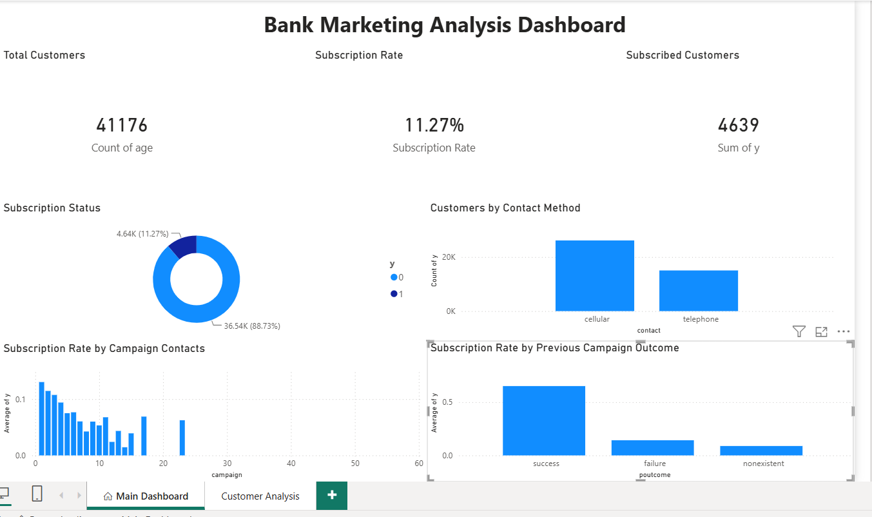

6.2 Customer Analysis
The Customer Analysis page provides additional views of customer characteristics and demographic patterns.
- Customers by Job
- Average Age by Subscription Status
- Customers by Marital Status
- Customers by Education
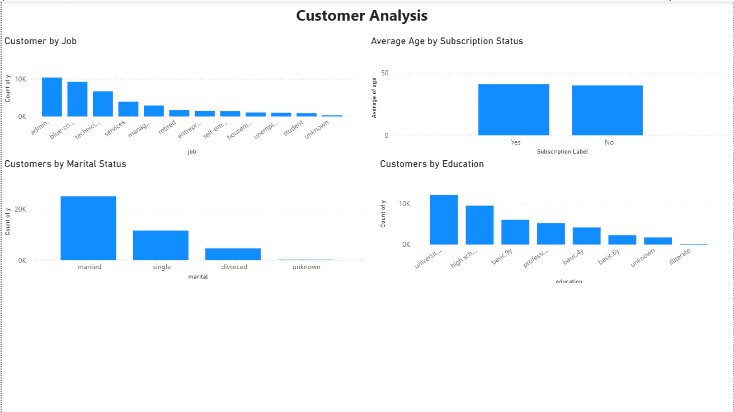

7. Key Findings
Based on the completed Power BI dashboard, the dataset contains 41,176 customers. The calculated subscription rate is 11.27%, and 4,639 customers are recorded as having subscribed.
- The dashboard provides a clear view of subscription status across the customer dataset.
- Customer job, education, marital status, and age can be explored through separate visualizations.
- The contact method analysis shows how customers were contacted during the marketing activity.
- Campaign contact analysis shows the relationship between the number of contacts and subscription rate.
- Previous campaign outcome provides an additional view of customer subscription patterns.

8. Conclusion
This project demonstrates the use of data cleaning, exploratory data analysis, and Power BI visualization for a bank marketing dataset. The analysis converts customer and campaign data into an interactive dashboard that makes important patterns easier to understand.
The project also provided practical experience in preparing data, creating calculated measures, building visualizations, and presenting analytical results in a professional dashboard format.

