TerraLink: A Collaborative Heterogeneous UAV-UGV Navigation Framework via 2.5D Elevation Mapping and Bounded 3D Volumetric Verification
Autonomous Multi-Robot Systems Technical Report
TerraLink Core Development & Verification Line — ROS 2 Humble & Ignition Gazebo Fortress
Workspace Repository: premsuggu/terralink
Abstract— Autonomous navigation across unstructured, occluded environments—such as collapsed structures, subterranean passages, and dense construction sites—demands heterogeneous robotic cooperation. While unmanned aerial vehicles (UAVs) provide rapid global overhead surveillance, ground robots (UGVs) execute physical transport and inspection. However, conventional 2.5D elevation grids fail catastrophically under semi-enclosed structures: overhead depth sensors capture ceiling or overhang returns, collapsing vertical traversability into lethal obstacle steps and starving ground planners of viable routes. In this work, we present TerraLink, a complete, from-scratch ROS 2 Humble framework designed for Ignition Gazebo Fortress. TerraLink couples a high-throughput 2.5D GPU/CPU elevation mapping engine (emap) with an anomaly-guided bounded 3D volumetric verifier (nav). We introduce a topological connected-component anomaly detector (Version 3) that isolates genuine overhang signatures from planar partition walls via elevation differentials. When potential occlusions are detected, a hierarchical Probabilistic Roadmap (PRM) routes a tentative path charged with an anomaly cost penalty (20×). Ground truth vertical clearance is verified on-the-fly through an in-process octree (BoundedVoxelMap) with radial spatial eviction (12m radius). Verified headroom verdicts are persistently retained in a bidirectional memory loop (ResolvedRegionStore) to eliminate query oscillations. A deterministic, opt-in A* grid planner with explicit free/blocked/uncertain cell classes, route memory and a replay-based test workflow was added as a second global planner; in the tunnel world it reached the goal about 16 s after first movement versus about 28 s for PRM (three runs each, simulation only, tunnel world only here; the maze is covered in Section VII-C). The system has been validated across 426 automated unit tests (382 nav, 44 emap) and simulation benchmarks in Ignition Fortress. The UGV autonomously negotiates an occluded tunnel corridor with zero operator intervention. Furthermore, we document the critical physical, simulation, and coordination defects encountered during development and provide the exact mathematical and algorithmic solutions that ensured end-to-end stability.
Index Terms— Heterogeneous Robotics, UAV-UGV Collaboration, 2.5D Elevation Mapping, OctoMap, PRM and A* Path Planning, Nav2, Anomaly Detection.

I. INTRODUCTION & PROBLEM FORMULATION
Heterogeneous autonomous robotic systems combining aerial and terrestrial platforms provide superior operational capabilities compared to homogeneous fleets in complex, unstructured scenarios such as post-disaster reconnaissance, industrial inspection, and civil construction. Unmanned aerial vehicles (UAVs) swiftly traverse three-dimensional space, bypassing ground obstacles to build broad topological maps. Conversely, unmanned ground vehicles (UGVs) possess substantial payload capacity, extended operational endurance, and close-proximity manipulation or sensing capability. Harmonizing these complementary assets requires a robust, shared spatial perception and navigation pipeline.
Historically, robotic field mapping has relied extensively on 2.5D elevation grids. Representing spatial terrain as a single height scalar h(x, y) over a discretized horizontal plane offers remarkable computational efficiency, bounded memory scaling, and direct applicability to traversability analysis. However, 2.5D elevation models embody an inherent structural flaw: they cannot represent multi-layered vertical geometry. When a downward-facing UAV sensor scans an overhead overhang, ceiling, bridge, or tunnel entrance, the sensor rays intersect the topmost opaque surface. The elevation grid records the roof's altitude as the ground elevation. Subsequent analytical slope and step-height filters score the perimeter of the overhang as an impassable vertical cliff (LETHAL). Consequently, terrestrial path planners operating over the 2.5D traversability layer treat the entire subterranean or covered passageway as a solid barrier, permanently abandoning viable transit paths even when adequate ground-level headroom exists.
Existing exploration methodologies attempt to circumvent this by tracking unobserved cells through frontier exploration (Yamauchi, 1997). However, frontier logic operates on the absence of measurements (is_valid = False). In the case of an opaque roof, the elevation map does not suffer from missing data; rather, it possesses highly confident but misleading measurements of the ceiling structure. Full 3D volumetric representations (such as global OctoMaps) can resolve multi-level surfaces but incur prohibitive memory footprints and ray-casting latencies that hinder fast global UGV path planning.
Contributions: To resolve this dilemma, this project introduces the TerraLink framework. The core contributions of this work are:
1) A ground-up, highly optimized 2.5D elevation mapping package (emap) targeting Ignition Gazebo Fortress and ROS 2 Humble, featuring recursive Bayesian Gaussian fusion, GPU acceleration (CuPy), vertical drift compensation, and analytical traversability scoring.
2) A novel Version 3 connected-component anomaly detection algorithm (nav.anomaly) that isolates occluded passage candidates from ordinary dividing walls by evaluating spatial component area and vertical elevation offsets.
3) A hybrid 2.5D/3D navigation paradigm that combines cheap global 2.5D PRM routing with localized, bounded 3D volumetric verification (nav.voxel_map) executed in-process with automated spatial leaf eviction.
4) A bidirectional memory loop (nav.resolved_regions) that caches verified volumetric verdicts to guarantee planner convergence without query oscillation or redundant inspections.
5) Exhaustive empirical verification in simulation, identifying and correcting five subtle physics, timing, and behavioral failure modes.
6) An opt-in deterministic A* global planner (nav.astar_planner, nav.global_planner) that treats suspected passages and unobserved space as explicit uncertain cell classes, with route memory, exploration and stuck feedback, plus an offline map-replay workflow that tests planning without re-running the UAV scan.
II. SYSTEM ARCHITECTURE & PLATFORM INTEGRATION
A. Simulation & Middleware Architecture
The TerraLink framework is architected natively for Ignition Gazebo Fortress (version 6.18) paired with ROS 2 Humble running on Ubuntu 22.04 LTS within a WSL2 environment. Actuation and sensor telemetry are interfaced via ros_gz_bridge. Simulation rendering operates under software OpenGL rasterization (LIBGL_ALWAYS_SOFTWARE=1) to prevent Mesa D3D12 texture translation aborts during camera image generation.
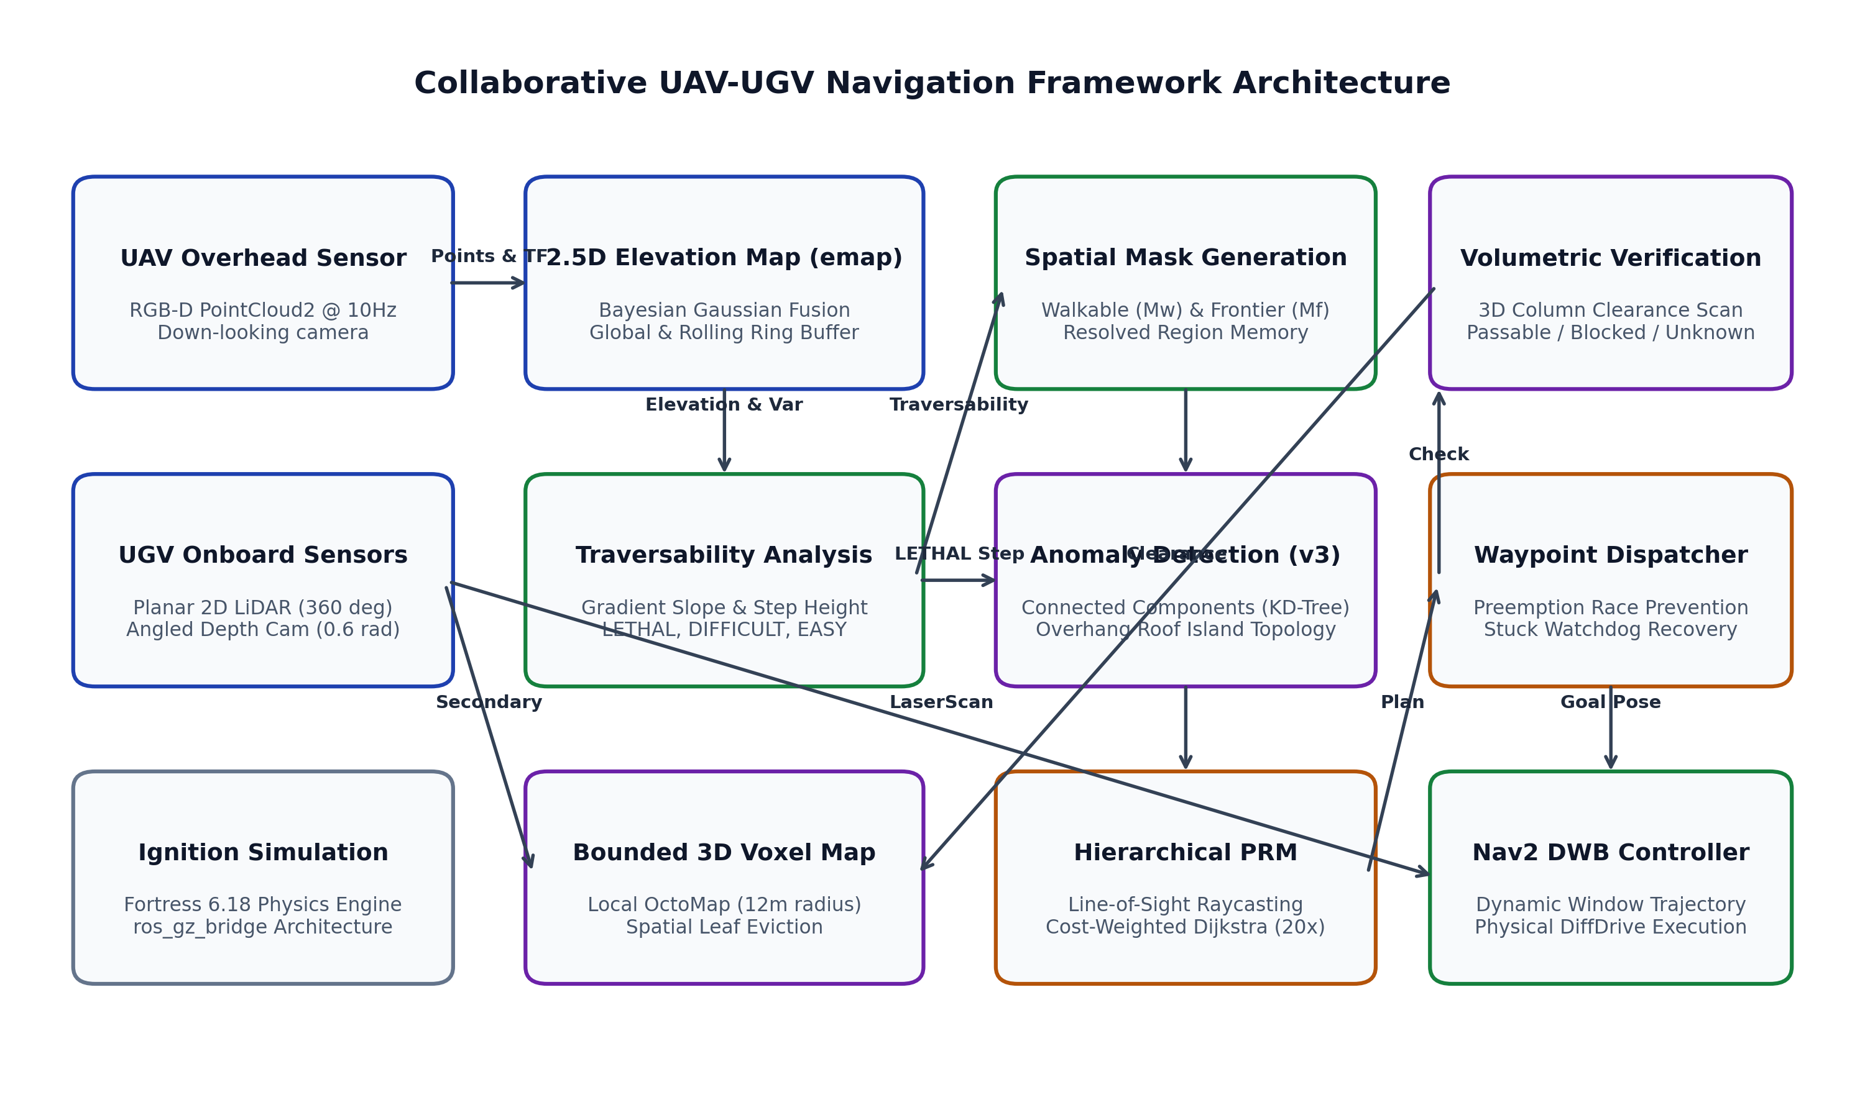
Fig. 1. High-level architectural pipeline of the TerraLink collaborative UAV-UGV framework.
B. Heterogeneous Robotic Platforms
The system incorporates two distinct simulated agents:
• Quadrotor UAV (iris_quad): Powered by Ignition's MulticopterVelocityControl and OdometryPublisher plugins. The UAV carries a rigidly attached downward-looking RGB-D depth camera (320×240 resolution, 10 Hz, 20m range, 0.08m vertical chassis offset) publishing sensor_msgs/PointCloud2.
• Ground UGV (nav_ugv): A custom differential-drive mobile robot. Its sensor suite comprises a 360° planar 2D LiDAR (10 Hz, 12m range), an angled forward-downward depth camera (pitch 0.6 rad, 8m range, 0.05m chassis elevation) for near-field subterranean inspection, and an elevated forward video camera (pitch 0.15 rad, 0.22m elevation) dedicated to visual recording and monitoring.
Chassis Stabilization: Mechanical Redesign: During initial high-deceleration trials (linear acceleration 3.5 m/s²), the single-caster chassis experienced severe dynamic pitching (19.5° pitch angle), causing the driven wheels to lose ground traction. The DiffDrive plugin integrated free-spinning wheel revolutions as phantom translation, causing massive odometric divergence. The chassis was mechanically redesigned to feature dual passive casters (front and rear, r=0.03m, mu=0.001), establishing 4-point ground support and restoring physical stability across all braking maneuvers.
III. AERIAL PERCEPTION & 2.5D ELEVATION MAPPING
A. Core Elevation Grid Data Structure
The primary spatial representation in emap is an ElevationMap: a square grid of dimension cell_n × cell_n at resolution δ (default 0.1m). The map maintains four contiguous floating-point layers stored within a single NumPy tensor of shape (4, cell_n, cell_n):
1) Layer 0 (elevation): Estimated terrain height h in meters.
2) Layer 1 (variance): Height estimation uncertainty σ² in m².
3) Layer 2 (is_valid): Observation indicator (1.0 if observed, else 0.0).
4) Layer 3 (traversability): Analytical driving cost score (0.0 to 1.0).
To reconcile fast local reactive maneuvers with long-term global mission planning, elevation_mapping_node instantiates a dual-map architecture: a rolling local map (20m length) that shifts to remain centered beneath the moving UAV, and a persistent global map (40m length) fixed at world origin that accumulates observations indefinitely. Map shifting is achieved vectorially via circular buffer rolling (np.roll) along spatial axes (1, 2) followed by directional edge-blanking (_reset_region), guaranteeing O(1) recentering without memory reallocation.
B. Recursive Bayesian Gaussian Fusion
Incoming point clouds are transformed into the world coordinate frame (iris_quad/odom) via tf2_ros buffer lookups. For each point p = (x, y, z), the sensor range r = ||p - p_sensor|| is evaluated. Points closer than min_valid_distance (0.2m) or farther than max_valid_range (19.8m) are filtered out. The measurement uncertainty σ_meas² is modeled as quadratic with respect to distance:
Noise Model: σ_meas² = k_noise · r²
where k_noise = 0.01. Each cell's state is modeled as a 1D Gaussian belief N(h_prior, σ_prior²). Outliers are detected via a Mahalanobis distance check: if |h_prior - z| > 2.0 · σ_prior², the point is rejected from elevation fusion, and cell uncertainty is penalized via scatter-addition (np.add.at) by σ_outlier² (1.0 m²). For surviving inliers, the prior belief is merged with the measurement via Bayesian variance-weighted update equations:
h_new = (h_prior · σ_meas² + z · σ_prior²) / (σ_prior² + σ_meas²)
σ_new² = (σ_prior² · σ_meas²) / (σ_prior² + σ_meas²)
Where multiple inlier rays strike the identical cell within a single point cloud frame, scatter-addition accumulation computes the exact multi-ray mean, preventing last-write-wins race corruption. A GPU-accelerated CuPy kernel (fusion_gpu.py) implements the identical arithmetic pipeline, achieving a 25% throughput gain on large point clouds.
C. Analytical Traversability Classification
Departing from opaque, learned neural networks (such as Direction 1's CNN filter), emap implements an analytical, explainable traversability engine. Terrain drivability is derived from three physical metrics:
1) Surface Slope: Computed via central finite differences:
S = sqrt((∂h/∂x)² + (∂h/∂y)²)
2) Local Step Discontinuity: Computed using 3×3 morphologic filters:
Δh_step = max_3×3(h) - min_3×3(h)
3) Surface Roughness: Quantified directly via height variance σ².
Cells are classified into discrete operational tiers: LETHAL (0.0) if S > 0.35, Δh_step > 0.15m, or σ² > 0.05 m²; DIFFICULT (0.3) if exceeding half-threshold values; and EASY (1.0) otherwise. Unobserved cells (is_valid = 0) default safely to EASY to prevent unmapped terrain from generating artificial boundary repulsion.
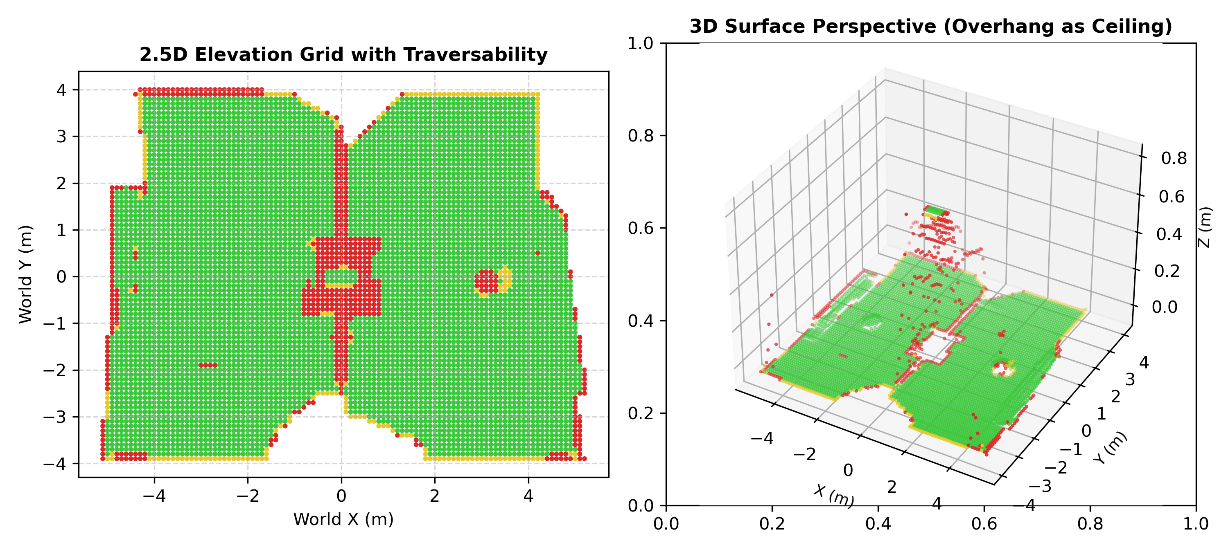
Fig. 2. Rendered 2.5D elevation grid with analytical traversability coloring and 3D surface projection.
D. Odometry Drift Compensation & Safety Watchdog
In physical deployments, barometric and IMU vertical odometry drifts over time. emap incorporates an autonomous Z-drift compensator (drift.py). Residuals between newly transformed points and high-confidence global map cells (σ² < 0.05) are aggregated. The median residual across inliers is extracted, and the estimated vertical bias is updated via a damped gain controller (gain α = 0.3, residual clamp 1.0m):
Z_bias ← Z_bias + α · median(z_meas - h_map)
Crucially, incoming points are corrected against existing bias prior to computing residuals, establishing an asymptotically stable fixed-point convergence.
Additionally, because Ignition's MulticopterVelocityControl plugin lacks an internal command timeout (perpetually executing the last received Twist), a dedicated safety node (cmd_vel_watchdog.py) monitors publisher liveness. If operator commands cease for >1.0s, the watchdog injects a zero-velocity Twist, preventing quadrotor runaway climb.
IV. SPATIAL MASKS & ANOMALY DETECTION
A. Spatial Mask Formulations
Downstream navigation nodes in the nav package ingest the published /elevation_map GridMap to derive binary operational masks:
• Walkable Mask (Mw): Confirmed traversable territory:
Mw(x, y) = is_valid(x, y) ∧ (traversability(x, y) ≠ LETHAL)
• Frontier Mask (Mf): Unobserved space bordering known walkable ground (Yamauchi boundary exploration):
Mf(x, y) = ¬is_valid(x, y) ∧ (∃ q ∈ N4(x, y) : Mw(q))
B. The Ceiling Occlusion Dilemma
When an overhead UAV surveys a roofed structure (e.g., a culvert or arched tunnel), the camera observes the roof's upper surface. Because measurements exist, is_valid = True. Because the roof elevation stands ~0.7m above the room floor, traversability scores the step discontinuity as LETHAL. Thus, Mw = False and Mf = False. The tunnel entrance is categorized as an impassable obstacle indistinguishable from a solid concrete wall.
C. Version 3 Anomaly Detection Algorithm
To overcome this structural failure without compromising obstacle detection, we designed an anomaly detector (nav.anomaly). Its design evolved across three iterative generations based on empirical simulation findings:
• Version 1 (Local Scanlines): Evaluated 1D step-edges along coordinate axes. Produced high false-positive rates due to depth discretization noise.
• Version 2 (Topological Gap Analysis): Utilized connected-component labeling and KD-tree nearest-gap analysis. While robust against sensor noise, it failed on ordinary thin partition walls separating two rooms, flagging 8 spurious corridor cells across a solid dividing wall.
• Version 3 (Component Topology with Elevation Differentials): Restores structural discernment by enforcing a tri-partite role model. Walkable components are labeled via 8-connectivity and partitioned by surface area:
- Rooms (A ≥ 3.0 m²): Genuine large navigable regions.
- Islands (0.15 ≤ A < 3.0 m²): Moderate elevated surfaces (e.g., tunnel roofs).
- Noise (A < 0.15 m²): Small sensor artifacts or vehicle footprints.
For each island, the algorithm evaluates its boundary proximity against candidate rooms using KD-trees. An anomaly corridor is confirmed if and only if:
1) The island connects to at least two distinct rooms.
2) The connecting straight-line segment is thinly lethal (width ≤ 0.6m).
3) The mean elevation of the island differs significantly from both rooms: |h_island - h_room| ≥ 0.15m.
Because an ordinary room-dividing wall possesses no intermediate island component, it is structurally barred from being flagged, eliminating false-positive corridors while reliably identifying true occluded passages.
V. BOUNDED 3D VOLUMETRIC VERIFICATION
A. Local 3D Volumetric OctoMap
While Version 3 anomaly detection identifies potential corridors, 2.5D data cannot confirm whether vertical clearance exists beneath the roof. TerraLink introduces an in-process 3D occupancy map (nav.voxel_map.BoundedVoxelMap) backed by the octomap C++ binding. The voxel map fuses incoming point clouds from both the UAV and the UGV's front-facing depth camera via ray-casting (insertPointCloud), explicitly marking traversed interior volume as confirmed free space.
Spatial Eviction Safeguard: Memory Bounding: Standard global octrees suffer unbounded growth. BoundedVoxelMap enforces a strict spatial cutoff (max_radius_m = 12.0m) centered on the UGV's current pose. A periodic background thread scans octree leaves and executes radial eviction (evict_outside_radius). During development, an insidious upstream binding defect was identified: invoking deleteNode(coord) with default parameters (depth=1) purged major subtrees, collapsing a 1478-leaf tree to 53 leaves. Explicitly enforcing depth=0 restored surgical single-leaf eviction, ensuring bounded memory with zero data loss.
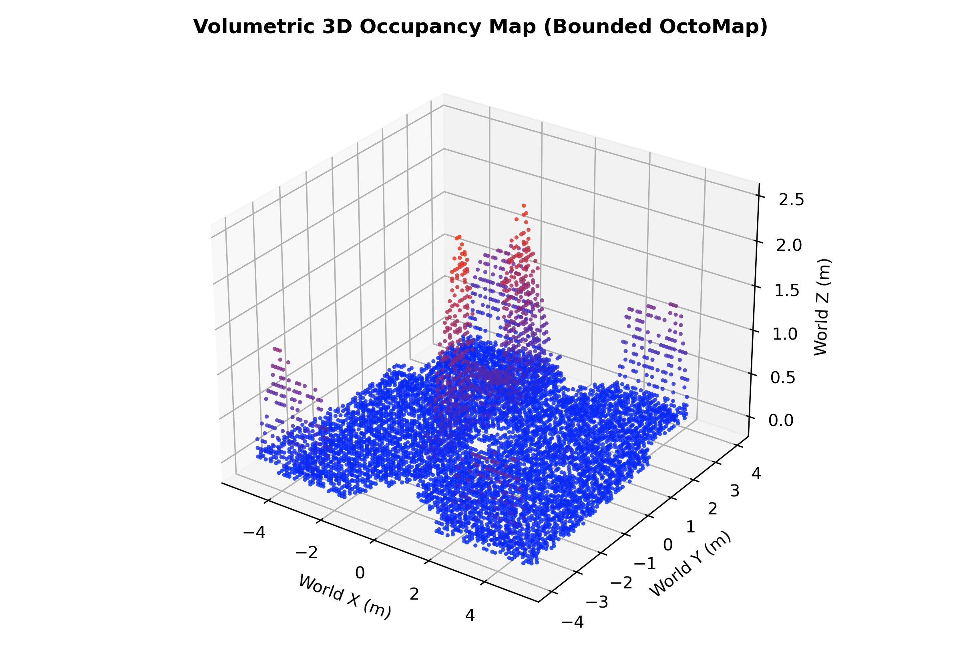
Fig. 3. Volumetric 3D occupancy reconstruction (BoundedVoxelMap) isolating tunnel arch, roof, and navigable floor clearance.
B. Volumetric Headroom Scanning
Before the UGV commits to an anomaly segment, waypoint_follower queries voxel_map_node over a verification topic. The function check_region_headroom discretizes the candidate path segment and scans vertical ray columns from z_min (-0.3m) to z_max (1.5m) at step_m (0.05m):
• passable: A contiguous run of free voxels exceeding the required clearance (h_robot + margin = 0.25m + 0.15m = 0.40m) is verified.
• blocked: No valid clearance exists, and all vertical samples are confidently resolved (occupied or free).
• unknown: Insufficient clearance is found, but at least one voxel remains unobserved.
C. Bidirectional Memory Loop (ResolvedRegionStore)
To prevent repetitive sensor checks and query churn, verified verdicts are dispatched to planner_node over resolved_region_report. The module nav.resolved_regions.ResolvedRegionStore records settled bounding boxes. Upon receiving subsequent /elevation_map messages, planner_node re-applies these verdicts: PASSABLE regions force Mw = True and Ma = False, permanently converting the corridor into standard drivable terrain, whereas BLOCKED regions force Mw = False and trigger an immediate global replan.
VI. GLOBAL PLANNING (PRM AND A*) & MOTION CONTROL
A. Hierarchical PRM Planner
Global path planning is performed on demand by nav.prm_planner.plan. Standard PRM implementations fail in closed-loop navigation when the robot's own chassis is fused into the elevation map, falsely marking the start cell as lethal. TerraLink resolves this by clearing a footprint disk (radius 0.3m) around the start pose prior to sampling.
The planner samples N = 400 random nodes across Mw. Edge connectivity is evaluated across candidate pairs within connect_radius_m (3.0m) using Bresenham line-of-sight rasterization over the composite traverse mask (Mw ∪ Mf ∪ Ma). Edges traversing anomaly cells are charged an exponential cost multiplier (20×). Dijkstra's algorithm extracts the optimal path: confirmed routes are strictly preferred, but anomaly corridors are returned as tentative last resorts when no alternative exists.
B. Deterministic A* Planner (opt-in, planner_type:=astar)
Random sampling can miss a 1 m tunnel and gives different routes for nearly identical maps. The A* planner (nav.astar_planner) searches an 8-connected cost grid with an octile heuristic, no diagonal corner cutting and a deterministic tie-break, so equal maps give equal paths and a path is found whenever one exists at grid resolution. Obstacles are inflated by robot radius plus margin, minus a 0.1 m rim already contained in emap's lethal mask. Cells are free, blocked or uncertain (suspected passage from nav.anomaly, or unobserved space next to free ground). Search runs in passes so a confirmed route always beats a guess: strict (free cells only), then optimistic (uncertain cells added with a penalty), each at full then relaxed inflation. Paths are shortened by supercover line of sight, cost-aware on free ground, and a standoff waypoint is placed 1 m before an uncertain stretch where the UGV should stop and look.
Decisions around the planner: A shared decision layer (nav.global_planner) adds route memory (a stored route is kept unless it became invalid, a confirmed route replaced a tentative one, or a new route is at least 15% cheaper), exploration toward suspected passages and then frontier viewpoints, an anomaly hold against detector flicker, a wait-for-mapping gate, and stuck feedback that penalizes the route stretch ahead of a stalled robot. All of these are off by default except route memory. The same class is used by the ROS node and by the offline replay tool, so offline results reflect the live planner.
Lessons from real maps: A real finding: a 0.15 m wall is only one or two 0.1 m cells wide, so part of it is unobserved rather than lethal and appears as a thin frontier line. Both planners treated it as a possible passage and repeatedly drove at the wall. Dropping unobserved strips thinner than the robot diameter (frontier_min_width_m = 0.44 m, automatic for A*) removed this; without it A* reached the goal in 0 of 3 runs. A second finding concerned clearance: the live detector flags only about 3x3 cells at each tunnel mouth, narrower than the robot, so demanding full clearance there returned no path where PRM's zero-width line of sight succeeded; uncertain cells are therefore exempt from the clearance test in the optimistic pass (uncertain_waive_m = 0.5 m).
C. Motion Execution & Preemption Race Prevention
The node waypoint_follower receives PRM paths and interfaces with Nav2's bt_navigator via sequential /goal_pose dispatches. During live trials, a severe behavior-tree race condition was identified: because waypoint 0 corresponds to the UGV's current position, publishing waypoint 0 followed immediately by waypoint 1 caused Nav2's controller_server to report success on waypoint 0 within 19ms, preempting and aborting navigation toward waypoint 1. This left the UGV stranded in an idle state. The helper _skip_reached_leading_waypoints was introduced, actively filtering all leading waypoints within reached_radius (0.4m) so only genuinely unreached targets are ever published.
Stuck Recovery: Supervisory Watchdog: To handle Nav2 controller exhaustion near physical walls ('Controller patience exceeded'), waypoint_follower incorporates a progress watchdog (_made_progress). If spatial displacement Δd < 0.15m over 20s, stuck recovery resets goal tracking and requests an immediate fresh plan. With a deterministic planner the fresh plan can be identical, which the follower used to treat as no change, so a goal dropped while Nav2 was still starting was never resent; stuck recovery now resends the current goal when the plan is unchanged.
VII. EXPERIMENTAL RESULTS & RUNTIME ANALYSIS
A. Quantitative Performance Benchmarks
The TerraLink framework was rigorously evaluated in Ignition Gazebo Fortress across two primary environments: room_maze.world (standard open/partitioned maze) and tunnel_test.world (two 6×4m rooms divided by a wall and connected exclusively by a 1.5m arched tunnel). Table I summarizes the framework's operational parameters, and Table II details benchmark metrics before and after key optimizations.
TABLE I: TERRALINK SYSTEM SPECIFICATIONS & OPERATIONAL PARAMETERS
Subsystem | Parameter Name | Operational Value
emap 2.5D Grid | Resolution (δ) / Grid Dimensions | 0.10 m / 400 × 400 cells (Global)
emap 2.5D Grid | Update Rate / Default Far Clip | 10 Hz / 19.8 m (Thresholded)
Traversability | Max Slope / Step / Roughness | 0.35 rad / 0.15 m / 0.05 m²
nav.anomaly (v3) | Room Min Area / Island Range | 3.0 m² / [0.15, 3.0) m²
nav.anomaly (v3) | Max Gap / Lethal Band Width | 1.5 m / 0.6 m (Bresenham)
nav.anomaly (v3) | Min Elevation Differential | 0.15 m (Island vs Room)
nav.voxel_map | Voxel Resolution / Eviction Radius | 0.05 m / 12.0 m (Radial Sphere)
nav.voxel_map | Required Headroom Clearance | 0.40 m (0.25m chassis + 0.15m margin)
nav.prm_planner | Node Samples (N) / Connect Radius | 400 nodes / 3.0 m
nav.prm_planner | Anomaly Edge Penalty Factor | 20.0× Distance Weight
nav.astar_planner | Robot radius / Margin / Mask rim | 0.22 m / 0.05 m / 0.10 m
nav.astar_planner | Standoff / Uncertain waiver | 1.0 m / 0.5 m (optimistic pass)
nav.global_planner | Plan switch margin / Stuck window | 15% cost / 18 s
nav.walkability | Frontier min width (A* auto) | 0.44 m (robot diameter)
UGV Actuation | Cruise Speed / Accel Limit | 0.60 m/s / 3.50 m/s² (DiffDrive)
Safety Watchdog | cmd_vel Timeout / Stuck Radius | 1.0 s silence / 0.15 m over 20 s
TABLE II: COMPUTATIONAL PROFILING & OPTIMIZATION IMPACT
Metric / Component | Baseline (Pre-Fix) | Optimized (Final) | Performance Delta
emap CPU Utilization | 220% CPU (Full cloud) | 40% CPU (stride=4) | -81.8% CPU Load
voxel_map CPU Load | 200% CPU (All rays) | 23% CPU (stride=4) | -88.5% CPU Load
System Load Average | 22.4 (Physics stall) | 9.2 - 11.8 (Stable) | Physics preserved
Launch to First Plan | 90 - 100 s (Corner dwell) | 33 - 39 s (Reordered) | 2.6× faster start
Total Mission Duration | 214 s (Wandering/stall) | 133 - 153 s (Direct) | 33% transit reduction
Plan Query Latency | 460+ s (Deadlock fail) | 14.8 s (Footprint clear) | Immediate resolution
OctoMap Eviction Latency | Subtree collapse (d=1) | 0.08 s / cycle (d=0) | Lossless bounding
B. End-to-End Tunnel Transit Validation
The complete autonomous pipeline was validated across three successive live runs in tunnel_test.world under full software rendering. The UAV executed an autonomous takeoff, dwelling sequentially at Room A center (-3.0, 0.0), directly over the tunnel (0.0, 0.0), and Room B center (3.0, 0.0). Within 35 seconds, emap assembled a valid 2.5D global elevation grid. Version 3 anomaly detection flagged the two tunnel mouths at x = ±0.75m. planner_node produced an anomaly-tentative path, waypoint_follower requested 3D volumetric clearance, and voxel_map_node confirmed PASSABLE headroom (0.7m clearance). The UGV traversed through the occluded tunnel, arriving within 0.10m of the red goal marker with continuous forward velocity.
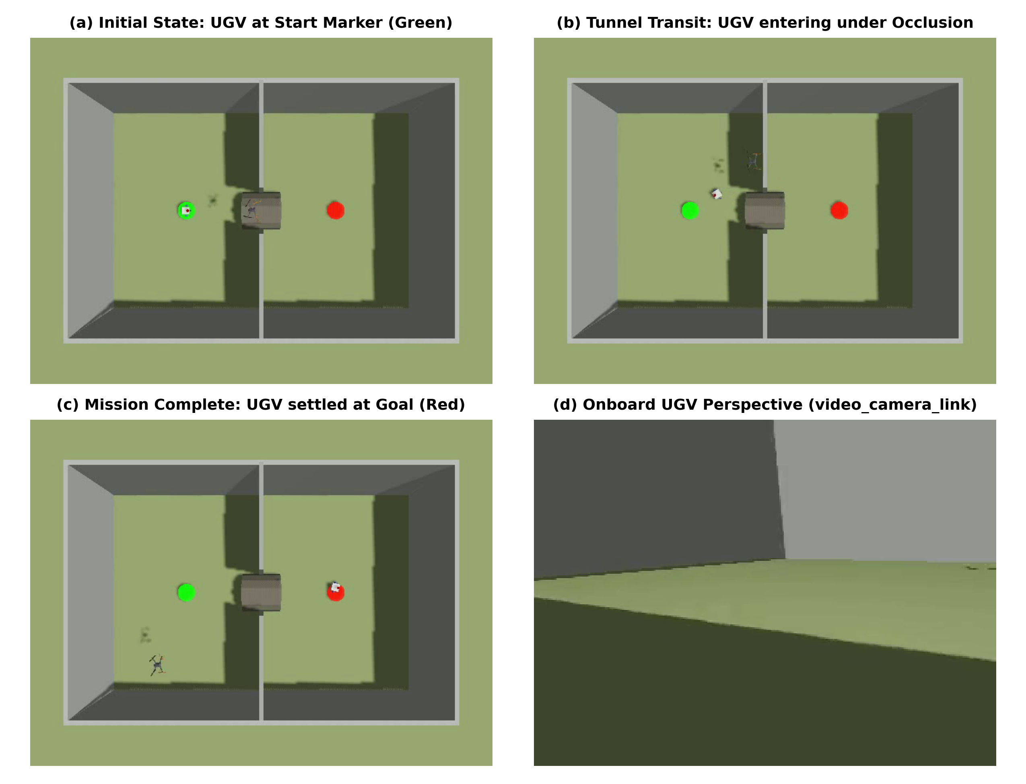
Fig. 4. Experimental sequence of the autonomous tunnel traversal: (a) Start at green marker, (b) Mid-tunnel transit beneath ceiling occlusion, (c) Convergence at red goal marker, and (d) Onboard video camera perspective.
C. Planner Comparison: PRM versus A*
Both planners were run in tunnel_test.world with goal (3, 0), a 6.0 m straight-line start-to-goal distance, headless, using the ground-truth odometry topic. Move-to-arrive is the time from first movement to within 0.3 m of the goal; stalled time counts 5 s windows with under 0.1 m net movement. In start-at-planning mode the UAV scan is skipped and the saved finished map is replayed, which isolates planning and following from scan timing (three runs per configuration). Table III summarises it; all PRM numbers include the flag and goal-resend fixes described above.
TABLE III: PRM VERSUS A* IN THE TUNNEL WORLD (SIMULATION, ONE WORLD, ONE GOAL)
Configuration | Runs | Reached | Move-to-arrive | Driven / stalled
Clean map: PRM | 3 | 3/3 | 28.0 s mean | 6.5 m / 5 s
Clean map: A*, no thin-strip pruning | 3 | 0/3 | - | 3.2-3.9 m / 115-130 s
Clean map: A* (defaults) | 3 | 3/3 | 15.8 s mean | 5.8 m / 0 s
Clean map: A* + exploration + stuck | 3 | 3/3 | 17.5 s mean | 5.8-6.5 m / 0 s
Full run: PRM | 1 | yes | 112.5 s | 17.3 m / 45 s
Full run: A* (defaults) | 2 | 1/2 | 74.2 s (one run stalled 0.306 m short) | 16.3 m / 0 s
Full run: A* + hold 30 s + wait-for-mapping | 2 | 2/2 | 16.3 s and 28.8 s | 5.8-6.9 m / 0 s
Reading: In the clean three-run comparison A* with pruning reached the goal about 44% sooner after first movement and drove about 11% less than PRM, and the run-to-run spread was small. In full mode, A* with the wait-for-mapping gate matches the clean behaviour, and total arrival time (97-110 s) was no worse than PRM's (98-147 s), but those rows have only one or two runs each. Exploration and stuck feedback showed no benefit on this static map. Not demonstrated: other worlds or goals, robustness of the 0.44 m pruning width to other wall thicknesses, and the goal-docking edge (one run stopped 6 mm outside the arrival threshold). The default planner therefore remains PRM.
Path traces in two worlds: Step 08 added path-trace images and a second world. With the same logging (true UGV pose from the simulator and every plan the planner returned), three full runs per planner were recorded in tunnel_test.world and in room_maze.world (12 runs, UAV scan included). In the maze A* followed the same route in all three runs (17-18 s from first movement, 6.3-6.4 m, no stalls) while PRM reached the goal in two of three (one run stalled for 81 s; in the third its only plan crossed a wall and the UGV circled in front of it for about five minutes). In the tunnel PRM reached the goal in all three runs but slowly (63-242 s from first movement, 29-192 s stalled), while A* arrived in two of three runs in 17-31 s with no stalls and failed once, stuck at a thin wall seam south of the tunnel. The images are in media/figures/path_comparison/. Three runs per cell in simulation show behaviour, not statistics. The same work uncovered and fixed three defects: a launch argument that crashed the planner node (an integer where a double was expected), and a maze world and launch file that had not worked since the ground-truth odometry change (a missing transform source, then the spawn offset applied twice).
Planner compute: Measured on the saved 160x160 tunnel map (0.1 m cells, single CPU thread), one A* plan takes about 64 ms, mask construction 3.5 ms, and one PRM plan about 1.05 s. Three grid searches per plan account for about two thirds of the A* time. Mapping, voxel-map and Nav2 costs were not re-profiled for this table.
D. Test Suite Verification
To enforce architectural integrity without simulator overhead, the repository contains 25 test files spanning tests/emap and tests/nav (20 nav, 6 emap). The 382 nav tests run in under a minute and the 44 CPU emap tests in under 1 s (the GPU fusion test is skipped and the emap folder must be run file by file in this environment because a cupy import fails against the installed numpy). They cover coordinate math, Bayesian fusion invariants, Mahalanobis rejection, Bresenham and supercover rasterization, OctoMap eviction, Dijkstra cost weights, A* optimality and completeness cases, route memory, exploration, stuck feedback, and regression tests on real recorded maps, all without a simulator.
VIII. PRACTICAL LESSONS & ENGINEERING INSIGHTS
Defect Analysis: Developing heterogeneous multi-robot systems within physics simulation frequently exposes edge-case behaviors where software abstractions diverge from physical reality. Below, we document the critical defects uncovered and resolved during this project:
1) Depth Camera Far-Clip Clamp Artifact: When sensor rays encounter no geometry, Ignition's depth camera produces +inf for most pixels but clamps a small fraction at the far-clip boundary (19.94m vs 20.0m). When transformed, these finite points generated artificial terrain towers reaching into the sky. Resolved by introducing max_valid_range = 19.8m in fusion.py.
2) Phantom Geometry from Scene Lighting: Ignition's directional lights placed inside the operational bounding box were mistakenly rasterized as solid geometry by the Mesa software renderer. Relocating lights to z = 500m eliminated artificial ceiling hits.
3) Differential Drive Odometry Divergence: Ignition's DiffDrive plugin publishes dead-reckoning odometry integrated from spawn. During wheel slippage, odom reported the UGV was at the goal while physics ground truth showed it motionless in Room A. Sourcing TF directly from OdometryPublisher restored absolute ground truth synchronization.
4) In-Process OctoMap Subtree Purging: The PyPI octomap binding defaults deleteNode(coord) to depth=1, deleting major branch nodes and wiping out accumulated map memory. Enforcing depth=0 resolved the defect.
5) Nav2 Velocity Smoother Topic Collision: Installed nav2_bringup remaps smoothed velocity directly to unnamespaced /cmd_vel, colliding with the UAV's flight controller. Implementing a targeted SetRemap inside launch files isolated ground and aerial twist channels.
6) Failed Plans Overwrote Tentative-Plan Flags: the planner node published plan_has_frontier/anomaly = False for a request that found no path; the follower read that as 'plan is now confirmed' and stopped periodic replanning, a stall of about 45 s. Flags are now published only for valid plans.
7) Thin Walls Are Unobserved, Not Lethal: a 0.15 m wall is one or two cells wide, so unscanned wall tops look like passages. Fixed with a local inscribed-disc width test on frontier cells.
8) Diagnosing from the wrong evidence: an early conclusion that failed A* runs were not a planner problem was wrong; replaying PRM and A* on the same late snapshots showed A* returning no path where PRM crossed. Offline replay on recorded maps, with regression tests, is now the first diagnostic step.
IX. CONCLUSION & FUTURE WORK
We have presented TerraLink, an open, modular ROS 2 Humble framework for heterogeneous UAV-UGV collaborative navigation in unstructured and occluded environments. By decoupling global 2.5D elevation planning from local bounded 3D volumetric verification, TerraLink resolves the classical overhang occlusion failure mode without incurring the computational or memory penalties of global 3D grids. Version 3 anomaly detection and bidirectional region caching guarantee efficient, oscillation-free transit through covered corridors. An opt-in deterministic A* planner with explicit uncertain-cell classes, route memory and an offline replay workflow reduced time and distance from first movement in the tunnel world, but all evidence is simulation, one main world and a small number of runs. Compared with published systems we are at best on par at the concept level for UAV-assisted ground navigation and clearly behind on exploration (TARE, FUEL, GBPlanner), on path execution (Nav2 Regulated Pure Pursuit instead of per-waypoint DWB goals), and on real-robot validation. Planned work: validate A* on the maze and construction-site maps, adopt continuous path following, fix the anomaly detector at the source, profile and reduce compute (replan only on change, lazy search passes, an adaptive UAV scan), and then integrate Direction 2 semantic vision (YOLOv8-seg/SAM 2.1) and deploy the framework onto physical robots.
REFERENCES
[1] A. Hornung, K. M. Wurm, M. Bennewitz, C. Stachniss, and W. Burgard, 'OctoMap: An efficient probabilistic 3D mapping framework based on octrees,' Autonomous Robots, vol. 34, no. 3, pp. 189–206, 2013.
[2] P. Fankhauser, M. Bloesch, and M. Hutter, 'Probabilistic terrain mapping for mobile robots with uncertain localization,' IEEE Robotics and Automation Letters, vol. 3, no. 4, pp. 3019–3026, 2018.
[3] B. Yamauchi, 'A frontier-based approach for autonomous exploration,' in Proc. IEEE Int. Symp. Computational Intelligence in Robotics and Automation (CIRA), 1997, pp. 146–151.
[4] S. Macenski, F. Martín, R. White, and J. Clavero, 'The Marathon 2: A navigation system,' in Proc. IEEE/RSJ Int. Conf. Intelligent Robots and Systems (IROS), 2020, pp. 2718–2725.
[5] L. E. Kavraki, P. Svestka, J.-C. Latombe, and M. H. Overmars, 'Probabilistic roadmaps for path planning in high-dimensional configuration spaces,' IEEE Trans. Robot. Autom., vol. 12, no. 4, pp. 566–580, 1996.
[6] E. Marder-Eppstein et al., 'The Office Marathon: Robust navigation in an office environment,' in Proc. IEEE Int. Conf. Robotics and Automation (ICRA), 2010, pp. 300–307.
[7] N. Koenig and A. Howard, 'Design and use paradigms for Gazebo, an open-source multi-robot simulator,' in Proc. IEEE/RSJ Int. Conf. Intelligent Robots and Systems (IROS), 2004, pp. 2149–2154.
[8] J. Redmon and A. Farhadi, 'YOLOv3: An incremental improvement,' arXiv preprint arXiv:1804.02767, 2018.
[9] A. Kirillov et al., 'Segment Anything,' in Proc. IEEE/CVF Int. Conf. Computer Vision (ICCV), 2023, pp. 4015–4026.
[10] T. M. Howard, C. J. Green, and A. Kelly, 'State space sampling of feasible motions for high-performance mobile robot navigation in complex terrain,' J. Field Robot., vol. 25, no. 6-7, pp. 325–345, 2008.
[11] P. E. Hart, N. J. Nilsson, and B. Raphael, 'A formal basis for the heuristic determination of minimum cost paths,' IEEE Trans. Syst. Sci. Cybern., vol. 4, no. 2, pp. 100–107, 1968.
[12] T. Miki, L. Wellhausen, R. Grandia, F. Jenelten, T. Homberger, and M. Hutter, 'Elevation mapping for locomotion and navigation using GPU,' arXiv:2204.12876, 2022.
[13] S. Macenski, S. Singh, F. Martín, and J. Ginés, 'Regulated pure pursuit for robot path tracking,' arXiv:2305.20026, 2023.
[14] C. Cao, H. Zhu, H. Choset, and J. Zhang, 'TARE: A hierarchical framework for efficiently exploring complex 3D environments,' in Robotics: Science and Systems (RSS), 2021.
[15] B. Zhou, Y. Zhang, X. Chen, and S. Shen, 'FUEL: Fast UAV exploration using incremental frontier structure and hierarchical planning,' arXiv:2010.11561, 2020.

