**Flow Diagram**

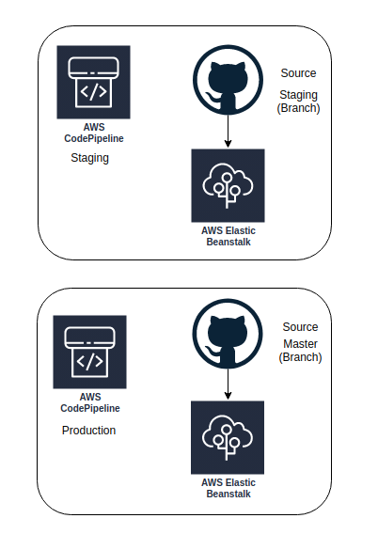

**Approach**

1. Creating two CodePipeline (Staging and Prod)
2. Using Github as Source for both Pipeline. (Github Token)
3. Using Elastic Beanstalk as Destination.
4. Create Cloudwatch event rules for any failure in the process.
5. Configuring Status Check on Github to ensure succeeded Staging branch only can be merged with Master.
6. [Optional] Codebuild for any source code compilation
7. [Optional] Approval stage for Production (SNS Topic)

**Cloudformation Template**

Description: CI/CD for EBS Application

Parameters:

GitHubOwner:

Type: String

Description: Github Username

GithubToken:

Type: String

NoEcho: true

Branch:

Type: String

AllowedValues:

- staging

- master

Description: Branch Name

NodeApplication:

Type: String

Description: EBS Node Application

NodeEnvironment:

Type: String

Description: EBS Node Environment

SnsTopicArn:

Type: String

Description: SNS Topic ARN for Notification

Resources:

EbsCodePipelineRole:

Type: "AWS::IAM::Role"

Properties:

RoleName: EbsCodepipelineRole

AssumeRolePolicyDocument:

Version: "2012-10-17"

Statement:

- Effect: "Allow"

Principal:

Service:

- "codepipeline.amazonaws.com"

- "elasticbeanstalk.amazonaws.com"

Action:

- "sts:AssumeRole"

Path: /

Policies:

- PolicyName: EbsCodepipelinePolicy

PolicyDocument:

Version: "2012-10-17"

Statement:

- Effect: "Allow"

Action:

- "s3:GetObject"

- "s3:GetObjectVersion"

- "s3:ListBucket"

- "s3:PutObject"

- "s3:GetBucketPolicy"

Resource:

- arn:aws:s3:::EbsNodeArtifactBucket

- arn:aws:s3:::EbsNodeArtifactBucket/*

- arn:aws:s3:::CodepipelineArtifactBucket

- arn:aws:s3:::CodepipelineArtifactBucket/*

- Effect: "Allow"

Action: "elasticbeanstalk:*"

Resource: !Sub "arn:aws:elasticbeanstalk:${AWS::Region}:${AWS::Region}:*/${NodeApplication}"

EbsCodePipeline:

Type: "AWS::CodePipeline::Pipeline"

DeletionPolicy: Retain

Properties:

Name: EBS-Node-Codepipeline

RoleArn:

Fn::GetAtt: [ EbsCodepipelineRole, Arn ]

Stages:

- Name: SrcCheckout

Actions:

- Name: Source

ActionTypeId:

Category: Source

Owner: ThirdParty

Version: 1

Provider: GitHub

OutputArtifacts:

- Name: EbsNodeArtifactBucket

Configuration:

Owner: !Ref GitHubOwner

Repo: node-hello

Branch: !Ref Branch

OAuthToken: !Ref GithubToken

PollForSourceChanges: true

RunOrder: 1

- Name: Deploy

Actions:

- Name: DeployAction

InputArtifacts:

- Name: EbsNodeArtifactBucket

ActionTypeId:

Category: Deploy

Owner: AWS

Version: 1

Provider: ElasticBeanstalk

Configuration:

ApplicationName: !Ref NodeApplication

EnvironmentName: !Ref NodeEnvironment

RunOrder: 1

ArtifactStore:

Type: S3

Location: CodepipelineArtifactBucket

EventRule:

Type: "AWS::Events::Rule"

Properties:

Description: "EventRule for Codepipeline Failure"

EventPattern:

source:

- aws.codepipeline

detail-type:

- CodePipeline Pipeline Execution State Change

- CodePipeline Stage Execution State Change

- CodePipeline Action Execution State Change

detail:

state:

- FAILED

pipeline:

- Ref: EbsCodePipeline

State: "ENABLED"

Targets:

-

Arn:

Ref: SnsTopicArn

Id: "OpsTopic"

InputTransformer:

InputTemplate:

Fn::Sub: '"The Pipeline <pipeline> has <state>. For More Details Go to https://console.aws.amazon.com/codepipeline/home?region=${AWS::Region}#/view/"'

InputPathsMap:

pipeline: "$.detail.pipeline"

state: "$.detail.state"