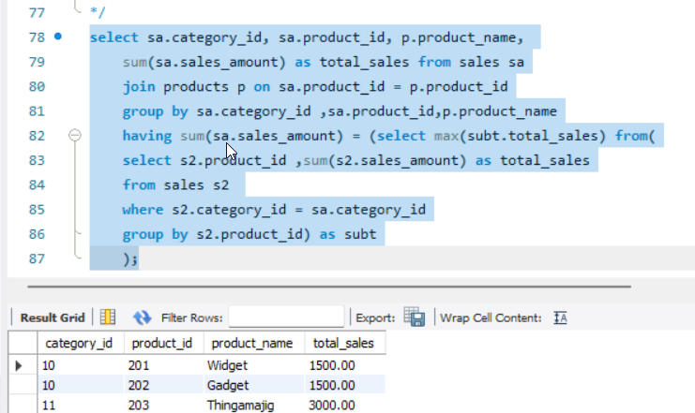 Q1 Top-Selling Product in Each Category

Q2: List Department with the Highest Average Salary

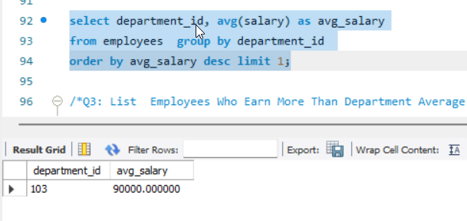

Q3: List Employees Who Earn More Than Department Average

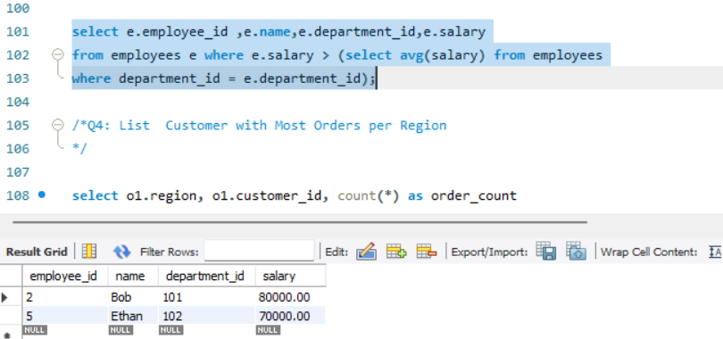

4

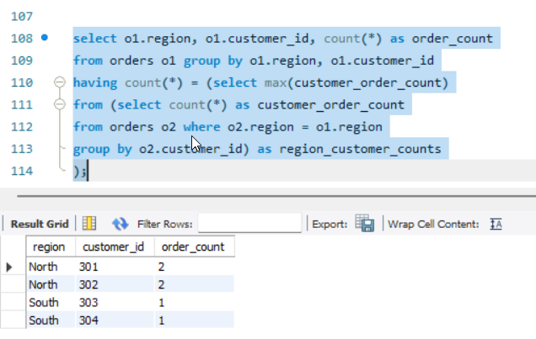

5,

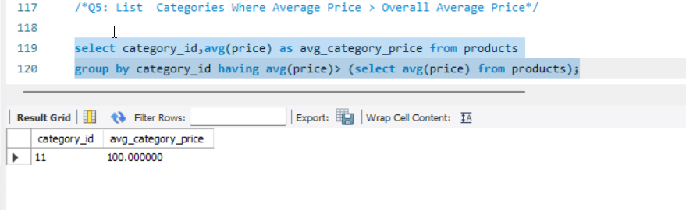

6,

