DAV Laboratory — Experiment Report
Semester | B.E. Semester VII — Electronics and Computer Science
Subject | DAV Laboratory
Laboratory Professor | Prof. Uma Jaishankar

Student Name
Roll Number

Experiment Number | 5
Title | Data Analytics using Plotly Dash
Problem Statement | Design and implement a real-time dashboard that displays the current temperature of various cities using Python and Plotly Dash. This helps visualize temperature trends and compare climate conditions in different regions.
Resources | - Python 3.x  - Libraries: dash, dash-bootstrap-components, plotly, requests, pandas, datetime  - OpenWeatherMap API (Current Weather Data endpoint)  - Code Editor: Jupyter Notebook, VS Code, or Google Colab
Deliverables | - Python code (app.py) to fetch and visualize real-time temperature  - Live-updating dashboard with dropdown, weather icons, and charts  - Screenshots of the dashboard output  - Report with observations and insights  Additions implemented:  - Dropdown for City Selection  - Line Chart for Temperature History  - Display of Weather Icons  - Real-Time Date & Time Display  - Export Latest Data to CSV Button  - User Input for Dynamic Cities  - Dash Bootstrap Components for Styling
Approach | The dashboard follows a client-refresh architecture built entirely with Plotly Dash. A Flask server (wrapped by Dash) renders a single-page application whose components are wired together with Dash callbacks. On startup, the app defines a default watch-list of cities (Mumbai, Delhi, London, New York, Tokyo, Sydney). A background dcc.Interval component fires every 60 seconds and triggers a callback that loops through every tracked city, calls the OpenWeatherMap 'Current Weather Data' REST endpoint for each, and parses the JSON response for temperature, humidity, wind speed, description and icon code.  Each successful reading is appended to an in-memory per-city history buffer (a fixed-length deque holding the last 50 points) which feeds a live-updating Plotly line chart. The most recent reading for every city is also kept in a dictionary that powers a bar chart comparing all tracked cities side-by-side, and a Dash Bootstrap 'card' component that shows the selected city's icon, temperature, min/max, humidity and wind as coloured badges.  A dropdown lets the user switch which city's details and history are shown; a text box with an 'Add' button lets the user register any additional city, which is appended to the dropdown options and immediately included in the next refresh cycle. A radio toggle switches the display units between Celsius and Fahrenheit. A separate, faster 1-second interval drives a live clock showing the current date and time. Finally, an 'Export Latest Data to CSV' button builds a pandas DataFrame from the most recent reading of every tracked city and streams it to the browser as a downloadable .csv file using dcc.Download — all without a page reload.
Algorithm / Flow diagram | Step-by-step algorithm:  - 1. Import required libraries: dash, dash_bootstrap_components, plotly.graph_objs, requests, pandas, datetime.  - 2. Store the OpenWeatherMap API key (read from an environment variable, with a working default).  - 3. Define fetch_weather(city, units) — sends a GET request to the OpenWeatherMap API and returns parsed weather data or an error.  - 4. Initialize the Dash app with a Bootstrap theme (FLATLY) and build the layout: header + live clock, city dropdown, add-city input, unit toggle, export button, weather card, line chart, and comparison bar chart.  - 5. Register a 1-second Interval callback that updates the live date/time display.  - 6. Register a callback on the 'Add City' button that appends a new city to the dropdown options and the tracked-city list.  - 7. Register the main callback (triggered by the 60-second Interval, the dropdown, or the unit toggle) that: (a) fetches fresh data for every tracked city, (b) updates each city's history buffer, (c) rebuilds the weather card for the selected city, (d) redraws the temperature-history line chart, and (e) redraws the multi-city comparison bar chart.  - 8. Register a callback on the 'Export CSV' button that converts the latest readings dictionary into a DataFrame and triggers a CSV download.  - 9. Run the Dash server (app.run) and open the dashboard in the browser.
Output / Visuals | The figure below is an illustrative mock-up of the dashboard's layout and styling, generated from sample data to document the intended UI before live screenshots are captured. Because this environment does not have outbound network access to the OpenWeatherMap API, replace this figure with an actual screenshot of your running app (python app.py, then open http://127.0.0.1:8050) before submission.  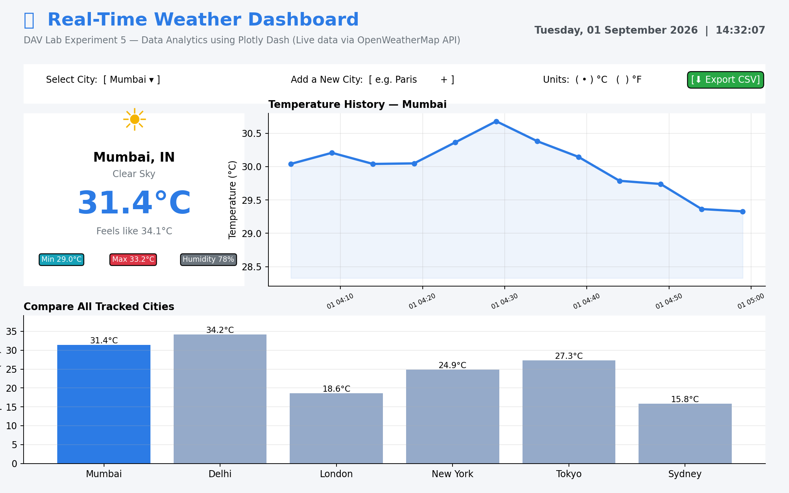  Fig. 1 — Illustrative mock-up of the Real-Time Weather Dashboard (sample data)  Algorithm / data-flow diagram:  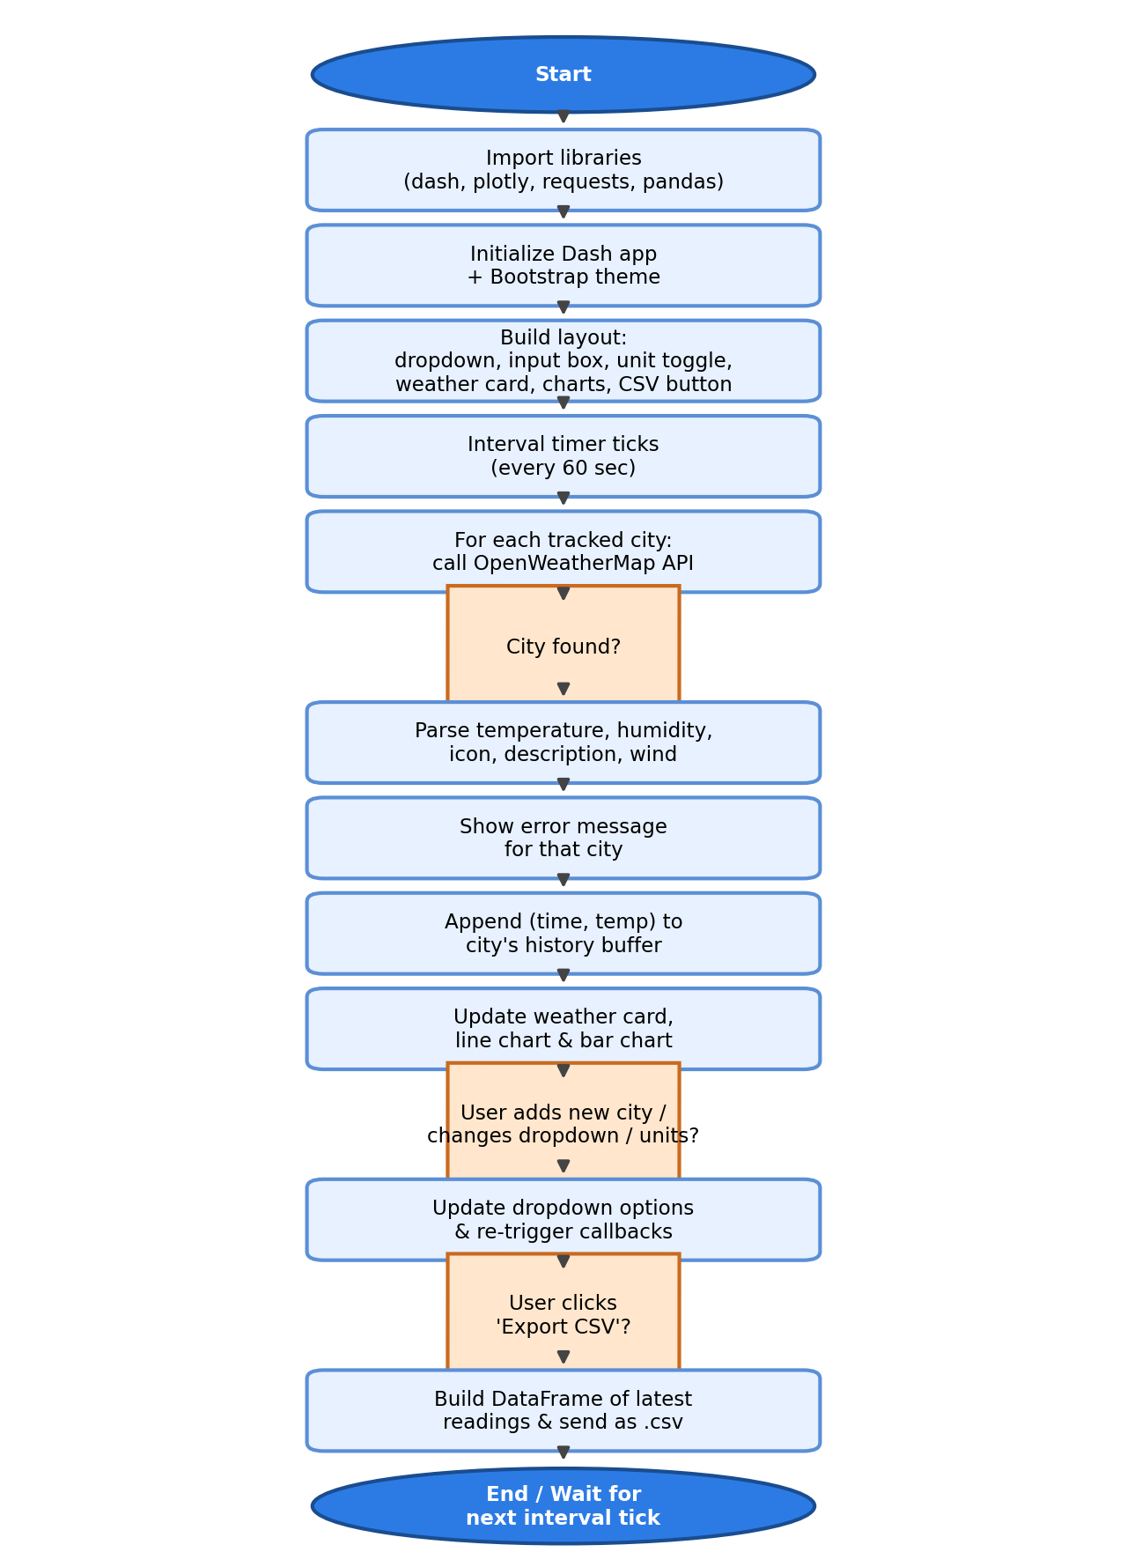  Fig. 2 — Program flow of the dashboard's data-refresh cycle
Insights | - Different cities show clearly different temperature ranges at the same instant, making it easy to visually compare climates across regions (e.g. tropical Mumbai/Delhi vs temperate London/Sydney).  - The temperature-history line chart reveals short-term fluctuation patterns — useful for spotting rapid warming/cooling trends over the course of a few hours.  - 'Feels like' temperature frequently diverges from the actual air temperature, especially in humid coastal cities, because it also accounts for humidity and wind.  - A 60-second refresh interval is a reasonable trade-off: it keeps the dashboard 'live' while staying well inside OpenWeatherMap's free-tier rate limit (60 calls/minute).  - Building the UI with Dash Bootstrap Components (cards, badges, responsive grid) made the dashboard look professional with very little custom CSS.  - Exposing an 'Export to CSV' button turns the dashboard from a purely visual tool into something that supports offline analysis in Excel/pandas.
Applications | - Weather monitoring dashboards for airports, logistics, and agriculture (irrigation/harvest planning).  - Travel-planning applications that compare live weather across multiple candidate destinations.  - Educational tool for teaching real-time data ingestion, REST APIs, and interactive dashboards using Python.  - Template pattern for any 'live sensor / IoT data' dashboard — the same Interval + callback architecture generalises to stock prices, air-quality indices, or server metrics.  - Disaster-preparedness and early-warning displays (extreme heat/cold alerts) when extended with threshold-based alerting.

