## INDIRA GANDHI NATIONAL OPEN UNIVERSITY

### Proforma for Approval of Project Proposal duly filled and signed by both the student and the Project Guide with date.

1. **Bio-data of the project guide with her/his signature and date.**

### Synopsis of the project proposal.

**II.**

**PROFORMA OF BCA PROJECT PROPOSAL (BCSP-064)**

**(Project Title and Guide’s Details)**

**Enrolment No:** 2250731044 **Regional Centre Code:** 49 **Study Centre:** 1632

1. **Name of Student :** Prem Vinod W Sequeira
2. **Address of the Student :** Padmavati CHS Ltd, C-310, Sector 7, Plot No 18, Kamothe,

Navi Mumbai -410209.

**3.(a) E-mail:** premsequeira@gmail.com **3.(b) Telephone/ Mobile No.:** 98190 71542

1. **Title of the Project :** Customer Re-KYC Monitoring Application
2. **Name of the Project Guide:** Mr. J. Chandrakant **5.(b) Designation of the Project Guide:** Project Manager
3. **Address of Project Guide:** IDBI Intech Ltd. IDBI Building Plot No 39-41, Sector No 11 CBD Belapur, Navi

Mumbai - 400 614.



1. **Qualification of the Guide\***

(Attach bio-data of the Guide)

**Ph.D. M. Tech. B. Tech. MCA Any other** M.S.E.

***\*Note:*** *i. All the above mentioned Degrees must have been awarded in Computer Science/IT only*

*ii. A Guide should not guide more than 8 students of BCA at any point of time.*

1. **Industrial / Teaching experience of the Guide (in Years)** 10+
2. **Software Used for this Project:** Oracle 19c for Database, Oracle Apex for application development, Core Java 1.8 for Backend data processing, CSS for font and front end designing, JavaScript for client side Input validation.

***Note: 1.*** *Use of Visual Basic and MS-Access as Front End and Back End respectively is forbidden.*

*But, you are permitted to use Visual Basic with other Software. Also, you can use MS-Access with other software.*

***2.*** *The use of C or C++ programming languages is strictly prohibited for projects associated with database management.*



Signature of the Student Signature of the Guide

Date: 19-06-2023 Date: 19-06-2023

**Important:**

1. Attach this Proforma along with Guide‟s Biodata and Project Synopsis in the Project Report.
2. Not more than one student is permitted to work on aproject.
3. Complete project as per the comments of Synopsis evaluator, then only submit your Project Report.

**For Office Use Only**

…………………………………… Signature, Designation, Stamp of the Project Proposal Evaluator

Approved Not approved Date: ……………………

**INDIA GANDHI NATIONAL OPEN UNIVERSITY**

**BIO-DATA OF PROJECT GUIDE**

**Name :** Mr. Chandrakant Jagtap

**Date of Birth :** 19th Sep 1970.

**Present Designation/ Profession:** Project Manager

**Residential Address** : A-1 704 Arihant Aloki, Bhise goan Karjat Dist Raigad.

**Phone Number :** +91 91673 81018 **Email address:** [chand1970@gmail.com](mailto:chand1970@gmail.com)

### Academic Qualification

|  |  |  |  |  |
| --- | --- | --- | --- | --- |
| **Degree** | **Branch/Specialization** | **University/Board** | **Year of Passing** | **Percentage of marks** |
| M.S.E.  (*Master in Software Engineering*) | Information  Technologies | Pune University |  | Grade B+ |

**Teaching/Industry Experience**:

|  |  |  |
| --- | --- | --- |
| **Position/ Designation** | **University/ Institution** | **Period From - To** |
| Project Manager | IDBI Intech Ltd. | Jan-2011 till Today |



### (Signature of the Guide)

**BCSP-064 Synopsis**

**BACHELOR OF COMPUTER APPLICATIONS**

**Customer Re-KYC Monitoring System**



Submitted By

# <Prem Waghela>

**Enrollment No.: 2003584323**

Under the guidance of

# <Mohit Sawant >

**Table of Contents**

Content Page No

1. Title of the Project 3
2. Introduction and Objectives of the Project 4
3. Project Category 6
4. Analysis 7
5. A complete structure 17
6. Tools / Platform, Hardware and Software Requirement specifications 21
7. Are you doing this project for any Industry/Client? Mention Yes/No. If Yes, Mention the Name and 23
8. Future scope and further enhancement of the project 23

### Title of the Project:

**Customer Re-KYC Monitoring System**

### Introduction and Objectives of the Project

**Introduction**:

As per RBI Master Direction : “Periodic data updating shall be carried out at least once in every 2 year for high risk customer, once in every 8 year for Medium risk customer, and once in every 10 years for low risk customer for the date of Account opening / last KYC updating date”.

Further RBI has asked ED’s to ensure that their internal KYC policy and processes on updating / periodic updating of KYC are transparent and adverse actions against the customer should be avoided, unless warranted by specific regulatory requirements.

Despite repeated communications through SMS, Notices, emails customer had failed to update KYC for which Bank is forced to take necessary action by freezing the accounts.

The Bank is taking necessary action by freezing the accounts manually for those customers who failed to update periodic KYC as per their respective risk. This manual process is lead to delay in freeze of accounts thereby whole process is defeated. The automated process will be save the time and efforts of the Bank official and would also ensure timely freezing of accounts of the KYC non-compliant customers.

Hence it is proposed to freeze the accounts with freeze code as below.

|  |  |
| --- | --- |
| Ref Code | Reference Code Description |
| NRKYC | Re-KYC Pending - DCCT |

### Objectives:

1. **Efficiency**: Our primary objective is to aim on streamline the dining experience, reducing wait times, and ensuring that customers can enjoy their meals without unnecessary delays.
2. **Transparency**: The Customer Re-KYC Monitoring System is committed to transparency in Account freezing, and availability ensuring that bank user have all the information they need to make informed choices.
3. **Sustainability**: We are committed to sustainable practices, including reducing food waste and promoting eco-friendly options in our restaurant.

The left-over food is donated to poor people on everyday basis so there’s no wastage for left-over and goes to right hands instead of getting wasted

1. **Convenience**: A key objective of The Customer Re-KYC Monitoring System is mark freeze customer account on right time and generate required reports to the bank user as well as various dashboard to Executive directors committee all times.
2. **Customer Satisfaction**: Ultimately, our goal is to create user friendly web base application through that bank user can communicate or solved the end user queries related Re-KYC.
3. **Accessibility**: The Customer Re-KYC Monitoring System is accessible to all Bank user over the PAN India over the intranet not internet.

### Project Category

### (RDBMS/OOPS/Networking/Multimedia/Artificial Intelligence/Expert Systems etc.)

Web Application Development or Website Development

### Analysis (DFDs at least up to second level , ER Diagrams/ Class Diagrams/ Database Design etc. as per the project requirements).

**DFDs (Data Flow Diagrams):**

DFDs illustrate the flow of data within the system, showcasing the processes, data sources, data stores, and external entities involved. At a high level, a DFD for Form finite could include the following components:

1. External entities: End Users and administrators
2. Processes: Data Uploaded by EDW Department, Data Upload Authorization by APU Department, Start Data backend process, fetch data from table and send to CBS for Flag Updating, get response from CBS and update respective record in local table.
3. Data sources: Data uploaded by EDW Department user.
4. Data stores: Store response received from web API in local table, record store in local table as data uploaded by EDW Department user

Data Flow Diagram (DFD) for The Customer Re-KYC Monitoring System

Level 0 DFD:

Level 1 DFD:

Chart

Reports

Executive Dash Board

Customer Re-KYC Monitoring System

Level 1 DFD:

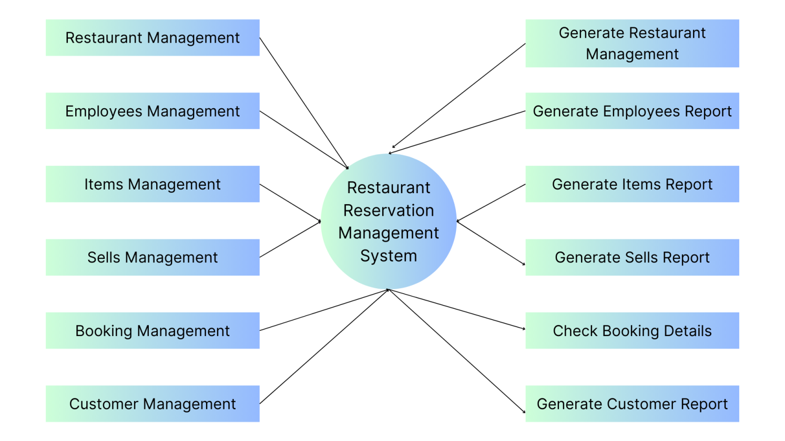

Level 3 DFD:

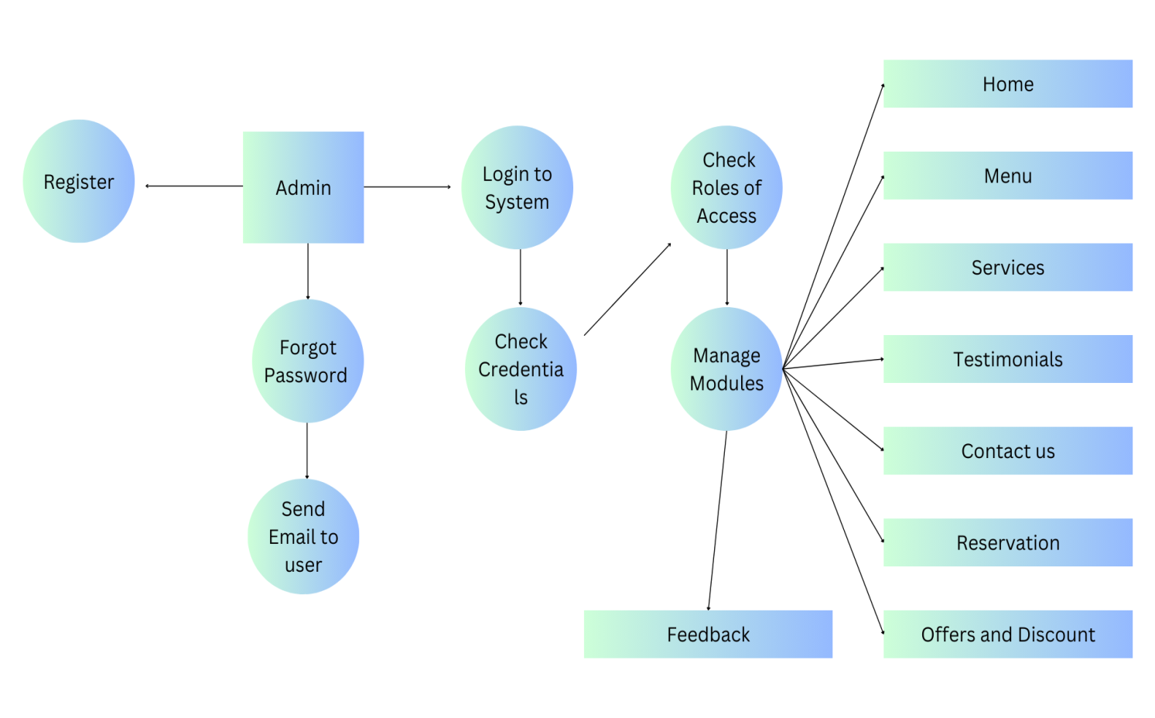

In this DFD, at Level 0, the EDW Department entity interacts with Customer Re-KYC Monitoring System.

At Level 1, there are two mainly 2 different types of users: 1. Admin User who Managing all the users creation, modification or deletion activity.

At Level 2, Customer Re-KYC Monitoring System manages all the overall system. It responsible to send data to CBS as well as update the received response from CBS and also maintain the status of request for generating reports. This helps in getting the process more similar and completes the cycle from end to end points request.

The User Login and Registration are linked with the database and as per user profile menu will be visible to end user.

At Level 3, The Admin user as well bank user flows with the Login and connecting with the databases, validate the user credentials.

It checks all the credentials from the database and the user is logged in. The main module is linked with the Home Page, Menu Page, Report Modules to generate the various reports and Inquiry.

### ER Diagrams (Entity-Relationship Diagrams):

ER diagrams help model the entities, relationships, and attributes within a system. Customer Re-KYC Monitoring System, entities are such as Bank Normal user, and Admin User. This defines all the relationships between these entities and their attributes to create a comprehensive ER diagram.

Entities: as branch_master, master_data, rekyc_data_edw, rekyc_error_desc.

The relationship between the entities are as follows:

1. Master_data: Its store master data.

**Attributes**: ID (*Primary Key*), Description, rcre_id, rcre_time.

1. User_master : It Represents user information with department ID, Role and Profile ID.

**Attributes**: user_id (*Primary Key*), sol (*Foreign Key with Branch master table*), Full name, email_address, grade and status.

1. User_master_hst: Represents the audit/history record for a user.

**Attributes**: user_id (*Foreign Key with user_master table*), sol_id (*check validate not Null*).

1. Branch_master: Represents list of all Branches with district, state, and region name

**Attributes**: sol_id (*Primary Key*), branch_name, dist_name, state_name, regn_name, zone_name, status.

1. process_control_management: Represents the data processing is start or stop by whom and when.

**Attributes**: user_id (*Foreign Key with user_master table*), user_location, status.

Entity Relationship Diagram 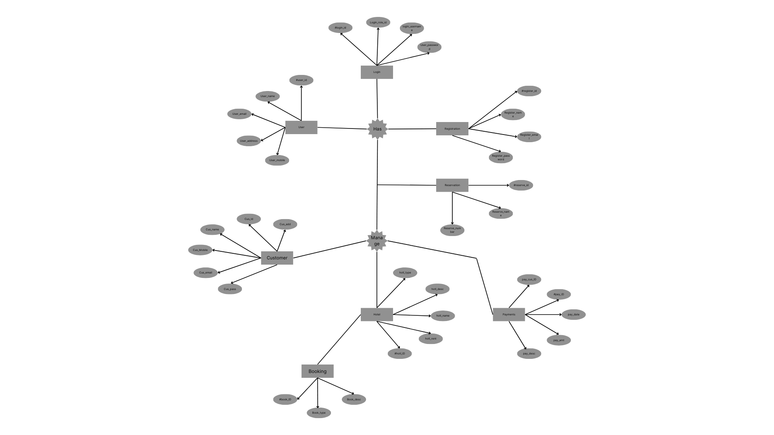

Entity Relationship Diagram for **Customer Re-KYC Monitoring System**

**Database Design:**

Table: **master_data**

|  |  |  |  |  |
| --- | --- | --- | --- | --- |
| **Field** | **Data Type** | **Size** | **Constraint** | **Description** |
| ID | VARCHAR2 | 4 | Primary Key | This column has value of ID |
| DESCRIPTION | VARCHAR2 | 200 |  | This column has value of Description |
| RCRE_ID | VARCHAR2 | 8 |  | This column has value of record created user ID |
| RCRE_TIME | TIMESTAMP | 6 | This column has value of record created Date with time |
| LCHG_ID | VARCHAR2 | 8 | This column has value of last changed record user ID |
| LCHG_TIME | TIMESTAMP | 6 |  | This column has value of last changed record Date with time |
| FREE_TEX1 | VARCHAR2 | 10 |  | Additional field for future |
| Status | CHAR | 1 |  | This column has value of record status  Default ‘A’ for Active |

Table: **process_control_management**

|  |  |  |  |  |
| --- | --- | --- | --- | --- |
| **Field** | **Data Type** | **Size** | **Constraint** | **Description** |
| USER_ID | VARCHAR2 | 8 | Foreign Key with user_master table | This column has value of login User ID |
| SESSION_ID | VARCHAR2 | 200 |  | This column has value of user Session ID |
| START_TIME | TIMESTAMP | 6 |  | This column has value of process start Date with time |
| STOP_TIME | TIMESTAMP | 6 |  | This column has value of process stop Date with time |
| USER_LOCATION | VARCHAR2 | 20 |  | This column has value of login user IP address |
| Status | CHAR | 1 |  | This column has value of record status  Default ‘A’ for Active |

Table: **rekyc_error_desc**

|  |  |  |  |  |
| --- | --- | --- | --- | --- |
| **Fields Name** | **Type** | **Size** | **Constraint** | **Description** |
| ERROR_CODE | VARCHAR2 | 10 | Primary Key | This column has Error Code No |
| ERROR_DESC | VARCHAR2 | 50 |  | This column has value Error Code details description |
| FREE_TEXT | VARCHAR2 | 10 |  | Additional Field for future. |
| FREE_TEXT1 | VARCHAR2 | 10 |  | Additional Field for future. |
| STATUS | Character | 1 |  | Status of record. |

Table: **user_master**

|  |  |  |  |  |
| --- | --- | --- | --- | --- |
| **Field** | **Data Type** | **Size** | **Constraint** | **Description** |
| USER_ID | VARCHAR2 | 8 | Primary Key | This column has value or User ID |
| SOL_ID | VARCHAR2 | 4 | Foreign Key with branch_master table | This column has value of User Sol ID |
| DEPT_ID | VARCHAR2 | 4 | Foreign Key with master_data table | This column has value of User Department ID as per Master Data Table. |
| PROF_ID | VARCHAR2 | 4 | This column has value of User Profile ID as per Master Data Table. |
| ROLE_ID | VARCHAR2 | 4 | This column has value of User Role ID as per Master Data Table. |
| REPORTING1 | VARCHAR2 | 8 |  | This column has value of User Reporting EIN as per Oracle HRMS as on date. |
| REPORTING2 | VARCHAR2 | 8 |  | This column has value of User Next Reporting EIN as per Oracle HRMS as on date. |
| ZONE | VARCHAR2 | 50 |  | This column has value of User Sol Zone Name |

Table: **user_master_history**

|  |  |  |  |  |
| --- | --- | --- | --- | --- |
| **Fields Name** | **Type** | **Size** | **Constraint** | **Description** |
| USER_ID | VARCHAR2 | 8 | Index Key without Null value | This column has value or User ID |
| SOL_ID | VARCHAR2 | 4 |  | This column has value of User Sol ID |
| DEPT_ID | VARCHAR2 | 4 |  | This column has value of User Department ID as per Master Data Table. |
| PROF_ID | VARCHAR2 | 4 |  | This column has value of User Profile ID as per Master Data Table. |
| ROLE_ID | VARCHAR2 | 4 |  | This column has value of User Role ID as per Master Data Table. |
| REPORTING1 | VARCHAR2 | 8 |  | This column has value of User Reporting Officer. |
| REPORTING2 | VARCHAR2 | 8 |  | This column has value of User Second Reporting Officer |
| RCRE_ID | VARCHAR2 | 8 |  | This column has value Record created User EIN |
| RCRE_TIME | Time | 6 |  | Record created Time. Default value will be Current Timestamp |
| LCHG_ID | VARCHAR2 | 8 |  | This column has value Last change User EIN |
| LCHG_TIME | Time | 6 |  | Record Last Changed Date with Time. |
| INSERT_TIME | Time | 6 |  | Record Inserted Date with Time. |
| STATUS | Character | 1 |  | Status of record. |

Table Name: **rekyc_data_edw**

|  |  |  |  |  |
| --- | --- | --- | --- | --- |
| **Fields Name** | **Type** | **Size** | **Constraint** | **Description** |
| REPORT_DATE | DATE |  | Primary Key | This column has value of data for the month. |
| KYC_DUE_DATE | DATE |  |  | This column has value customer KYC due date |
| SOL_ID | VARCHAR2 | 4 | Foreign key refered with branch_master table | Customer Account Branch ID. |
| CUSTOMER_ID | VARCHAR2 | 9 |  | Customer ID |
| ACCT_NO | VARCHAR2 | 16 |  | Customer Account Number |
| CUSTOMER_NAME | VARCHAR2 | 100 |  | Customer Account Name |
| SCHM_CODE | VARCHAR2 | 5 |  | Account Scheme Code |
| SCHM_TYPE | VARCHAR2 | 5 |  | Account Scheme Type |
| SCHM_DESC | VARCHAR2 | 100 |  | Account Scheme Description |
| ACCT_OPN_DATE | DATE |  |  | Account Open Date |
| RISK_CAT | VARCHAR2 | 6 |  | Account Risk Category |
| PROCESS_FLG | CHAR | 1 |  | Record process Flag |
| PROCESS_STATUS | CHAR | 1 |  | Request process Status |
| RCRE_TIME | TIMESTAMP | 6 |  | Record Created Time |

Table Name: **rekyc_data_hst**

|  |  |  |  |  |
| --- | --- | --- | --- | --- |
| **Fields Name** | **Type** | **Size** | **Constraint** | **Description** |
| UPLOAD_DATE | DATE |  | Primary Key | This column has value of data for the month. |
| KYC_DUE_DATE | DATE |  |  | This column has value customer KYC due date |
| REQ_NO | VARCHAR2 | 14 |  | Unique Serial No Generate by Application |
| REQ_DATE | TIMESTAMP | 6 |  | Request Time - send to CBS |
| RES_DATE | TIMESTAMP |  |  | Response Time - received from CBS |
| SOL_ID | VARCHAR2 | 4 |  | Customer Account Branch ID. |
| CUSTOMER_ID | VARCHAR2 | 9 |  | Customer ID |
| ACCT_NO | VARCHAR2 | 16 |  | Customer Account Number |
| PROCESS_FLG | CHAR | 1 |  | Record process Flag |
| PROCESS_STATUS | CHAR | 1 |  | Request process Status |
| RCRE_TIME | TIMESTAMP | 6 |  | Record Created Time |

Table Name: **branch_master**

|  |  |  |  |  |
| --- | --- | --- | --- | --- |
| **Fields Name** | **Type** | **Size** | **Constraint** | **Description** |
| SOL_ID | VARCHAR2 | 4 | Primary Key | This column has value of Branch ID. |
| BRAN_NAME | VARCHAR2 | 100 |  | This column has value Branch Name |
| DISTRICT | VARCHAR2 | 30 |  | District Name |
| STATE | VARCHAR2 | 30 |  | State Name |
| REGION | VARCHAR2 | 30 |  | Region Name |
| ZONE | VARCHAR2 | 30 |  | Zone Name |
| RCRE_ID | VARCHAR2 | 8 |  | Record Created user ID |
| RCRE_TIME | TIMESTAMP | 6 |  | Record Created Time |
| LCHG_ID | VARCHAR2 | 8 |  | Record last changed user ID |
| LCHG_TIME | TIMESTAMP | 6 |  | Record last changed Time |
| STATUS | CHAR | 1 |  | Record Status |

### 5. A complete structure which includes: Number of modules and their description to provide an estimation of the student’s effort on the project. Data Structures as per the project requirements for all the modules. Process Logic of each module.

**Testing process to be used. Reports generation (Mention tentative content of report)**

Designing a complete structure for **Customer Re-KYC Monitoring**, including modules, data structures, process logic, testing process, and report generation, is a complex task. Below, I'll provide a high-level outline to help you get started, but keep in mind that the actual implementation can vary based on the specific requirements and scale of your project.

1. Number of Modules and Their Description:

1. **User Registration and Authentication**: It allows users to register, log in, and manage their profiles. Also, it runs on user profiles, authentication, JSON web tokens. The process logic behind the user’s registration follows the flow of login password, reset password, and managing user profiles.
2. **Restaurant Listings and Details**: It displays all the list of menu details and rating of the food and provides details of all different items. The Prem’s Kitchen is located at Borivali in Mumbai has a great varieties of menu from starters till the desserts and also reserve tables according to user’s need. It will fetch details from the Api’s and would be displaying all he restaurant data and show all the available slots.
3. **Reservation Management**: It enables users to record reservation and keep records of all bookings and get updated via notifications half an hour ago as a reminder. Users can create reservations allowed to modify all the reservation details and if they wish to cancel the reservation according to their perceptions.
4. **Menu and Ordering**: It allows users to browse restaurants menus and place orders for dine in or for takeout. It also allows users to view menus and order online by adding details for delivery information. User’s gets notification about the order is it under preparation or prepared or is it out for delivery.
5. **Payment and Checkout**: It handles payment processing for orders and reservations. With all the payments records with the transaction details with complete history and checkout details. It secures all the payment handling and checkout process with complete transaction history.
6. **Admin Dashboard**: The website owner manages all the owners and orders history and manages all the reservations and restaurant details. The admin user profiles and fetches all the user profiles and manages the upcoming order status. The Dashboard manages the reservation tables and analyzes the restaurant settings

2. The Reservation Logic Steps:

1. User selects a restaurant and a desired reservation date and time.
2. The system checks for table availability at the specified time.
3. If a table is available, the user is prompted to confirm the reservation.
4. User confirms the reservation, and a confirmation email is sent.

3. Testing Process:

1. **Unit Testing**: Test individual functions and methods within modules.
2. **Integration Testing**: Test how different modules interact with each other.
3. **User Acceptance Testing**: Involve real users to ensure the system meets their needs.
4. **Performance Testing**: Assess the system's response time and scalability.
5. **Security Testing**: Evaluate the system's security, including authentication and data protection.

4. Reports Details:

1. Reservation confirmations and details.
2. Order confirmations and receipts.
3. Profile and account information.
4. Admin Reports:
5. Reservation reports: reservations, cancellations.
6. User reports: user data and activity.
7. Menu reports: popular items, sales trends.
8. User Feedback Reports:
9. Summarize user feedback and suggestions
10. Feedbacks from the customers regarding reviews.

### Tools / Platform, Hardware and Software Requirement specifications

Tools/Platform/Services:

For the development of The Prem’s Kitchen, the following tools and platforms can be considered:

1. React: A widely used front-end framework for building front-end web applications.
2. HTML/CSS/JavaScript: These are the three core technologies used in web development. HTML is the backbone which gives structure and content to webpage. CSS is used for styling and formatting content. JavaScript is dynamic and high-level programming language.
3. TypeScript: A superset of JavaScript that adds static typing and other features to improve the development of large-scale and complex applications.
4. Node.js: It is an open-source, cross-platform runtime environment that allows developers to execute JavaScript code outside of a web browser.
5. Express.js: A web application framework for Node.js that helps in building scalable web applications through APIs.
6. MongoDB: MongoDB is a popular open-source NoSQL database management system known for its flexibility, scalability, and ease of use.
7. Git: A version control system for tracking changes in source code during software development.
8. Visual Studio Code/Sublime text or Atom any other preferred code editor: To write and edit the code.
9. Bootstrap: It is used for styling, open source front-end development framework for he creation of websites and web apps.

Hardware Requirements:

The most common set of requirements defined by any operating system or software application is the physical computer resources also known as hardware. It should be generally checked for testing and development purpose:

1. Processor: Intel Core i3 or equivalent.
2. RAM: 4GB or higher.
3. Storage: At least 256GB SSD or 500GB HARDDRIVE.
4. Display: 1280x800 resolution or higher/lower mobile screens.

Software Requirements:

The software requirements deals with defining software resource requirements and prerequisites that needs to be installed on a computer to provide optimal functioning of an application. Here are the key requirements for making software application:

1. Operating System : Windows, macOS, or Linux.
2. Oracle 19c or above : Oracle 19c or above version must be installed on remote database server for data storage purpose.
3. Apex Software : Oracle Apex version 24.x must have to installed on remote database.
4. Web Server : The Tomcat version 9.x or above web server must be installed on remote application server.

### Are you doing this project for any Industry/Client? : No

### Future scope and further enhancement of the project

The future scope and potential enhancements for The Prem’s Kitchen are significant, and they can provide numerous opportunities for improving the user experience, expanding functionality, and increasing revenue. Here's an in-depth exploration of possible future enhancements:

1. Mobile Application Development**:** Create dedicated mobile applications for IOS and Android to allow customers to make reservations and place orders more conveniently from their smartphones. Mobile apps can also include features like push notifications for special offers, menu updates, and reservation confirmations.
2. Integration with Payment Gateways: Implement secure and convenient payment options within the reservation system. Allow customers to pre-pay for reservations, order takeout, or pay for dine-in meals through integrated payment gateways, including credit cards, mobile wallets, and online payment services.
3. Customer Loyalty Programs: Develop a customer loyalty program that rewards frequent visitors and repeat customers. This can include earning points for reservations, discounts, or free items after a certain number of visits.
4. Analytics and Reporting**:** Enhance the system with data analytics to gain insights into customer behavior, preferences, and peak reservation times. This information can help in making data-driven decisions, optimizing staffing, and improving menu offerings.
5. Waitlist Management: Implementing a virtual waitlist management feature. Allow customers to join a virtual queue and receive real-time updates on table availability. This can improve customer satisfaction and reduce walk-ins.
6. Multi-Language and Internationalization: Make the system accessible to a global audience by providing multi-language support and internationalization features. This can include currency conversion and regional-specific content.
7. InventoryManagement**:** Integrate inventory management to keep track of ingredient and menu item availability in real-time. This helps avoid overbooking and ensures that menu items are available when customers place orders.
8. Table-Specific Preferences: Allow customers to specify seating preferences when making reservations, such as window views, quieter areas, or outdoor seating. This provides a more personalized experience.
9. Real-Time Notifications: Implement real-time notifications to inform customers of their table's readiness, delays, or special promotions. Push notifications, SMS, and email reminders can keep customers engaged.
10. Environmental and Sustainability Features: Include information about the restaurant's sustainability practices, such as using locally sourced ingredients, reducing food waste, and minimizing environmental impact. Allow customers to make eco-friendly dining choices.
11. Special Event Booking**:** Extend the system to accommodate large parties, private events, and catering bookings. Provide event planning and customization options.
12. Feedback and Reviews: Encourage customers to leave reviews and feedback. Use sentiment analysis to identify areas for improvement and address customer concerns promptly.
13. Collaborations and Partnerships: Collaborate with local businesses, tourism boards, and event organizers to promote your restaurant and reservation system, potentially offering exclusive discounts and packages
14. Multi-Restaurant Support: Extend the system to support multiple restaurants or franchise locations, allowing customers to make reservations across different venues through a unified platform.
15. These enhancements can significantly elevate the online restaurant and table reservation system, making it more attractive to customers, increasing operational efficiency, and helping the business stay competitive in the ever-evolving restaurant industry. The specific features to prioritize will depend on your target audience, business goals