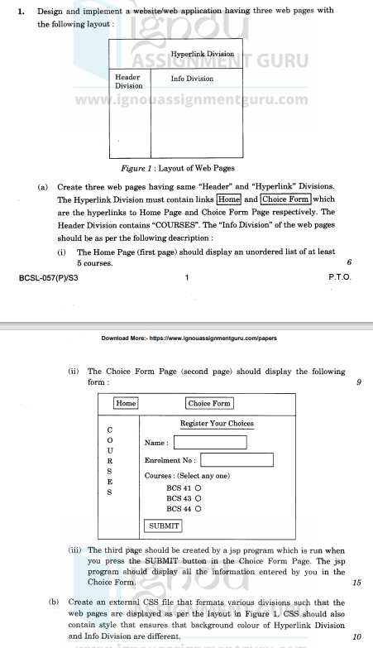

Home Page

<!DOCTYPE html>

<html lang="en">

<head>

<meta charset="UTF-8">

<meta name="viewport" content="width=device-width, initial-scale=1.0">

<title>Home Page</title>

<link rel="stylesheet" href="style.css">

</head>

<body>

<div class="header">

COURSES

</div>

<div class="hyperlink">

<a href="index.html">Home</a> | <a href="choice.html">Choice Form</a>

</div>

<div class="info">

<ul>

<li>Course 1</li>

<li>Course 2</li>

<li>Course 3</li>

<li>Course 4</li>

<li>Course 5</li>

<li>Course 6</li> </ul>

</div>

</body>

</html>