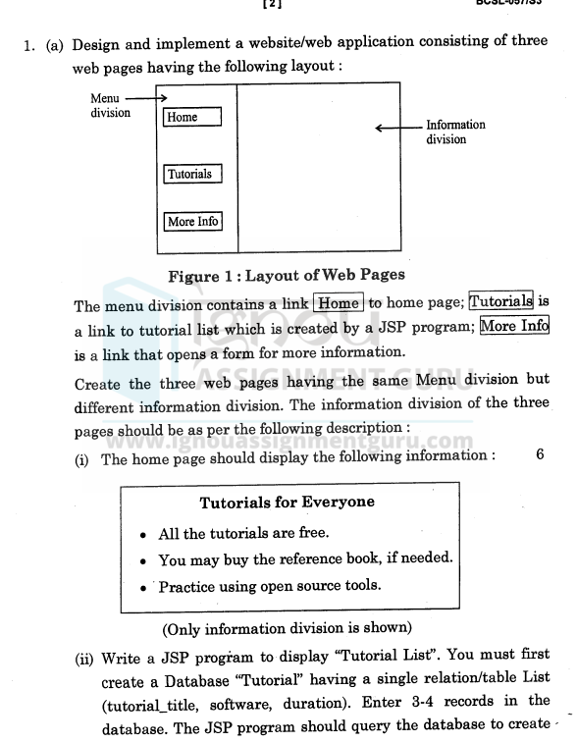

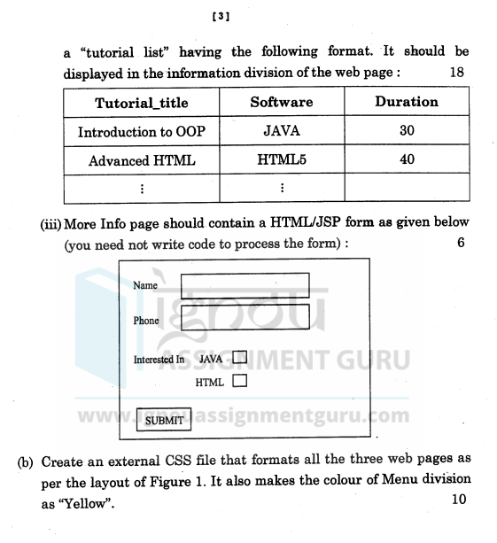

Answer

Home.jsp

<%@ page contentType="text/html;charset=UTF-8" language="java" %>

<!DOCTYPE html>

<html>

<head>

<link rel="stylesheet" type="text/css" href="../css/styles.css">

<title>Home</title>

</head>

<body>

<div class="container">

<div class="menu">

<a href="home.jsp">Home</a>

<a href="tutorials.jsp">Tutorials</a>

<a href="moreinfo.jsp">More Info</a>

</div>

<div class="content">

<h1>Welcome to the Tutorial Portal!</h1>

<h2>Tutorials for everyone</h2>

<ul>

<li>All the tutorials are free</li>

<li>You may buy reference books</li>

<li>Practice using open-source tools</li>

</ul>

</div>

</div>

</body>

</html>

tutorials.jsp

<%@ page import="java.sql.\*" %>

<%@ page contentType="text/html;charset=UTF-8" language="java" %>

<!DOCTYPE html>

<html>

<head>

<link rel="stylesheet" type="text/css" href="../css/styles.css">

<title>Tutorial List</title>

</head>

<body>

<div class="container">

<div class="menu">

<a href="home.jsp">Home</a>

<a href="tutorials.jsp">Tutorials</a>

<a href="moreinfo.jsp">More Info</a>

</div>

<div class="content">

<h1>Tutorial List</h1>

<table>

<tr>

<th>Tutorial Title</th>

<th>Software</th>

<th>Duration (Minutes)</th>

</tr>

<%

Connection conn = null;

Statement stmt = null;

ResultSet rs = null;

try {

Class.forName("com.mysql.cj.jdbc.Driver");

conn = DriverManager.getConnection("jdbc:mysql://localhost/Tutorial", "root", "password");

stmt = conn.createStatement();

rs = stmt.executeQuery("SELECT \* FROM List");

while(rs.next()) {

%>

<tr>

<td><%= rs.getString("tutorialtitle") %></td>

<td><%= rs.getString("software") %></td>

<td><%= rs.getInt("duration") %></td>

</tr>

<%

}

} catch(Exception e) {

e.printStackTrace();

} finally {

try {

if (rs != null) rs.close();

if (stmt != null) stmt.close();

if (conn != null) conn.close();

} catch(Exception e) {

e.printStackTrace();

}

}

%>

</table>

</div>

</div>

</body>

</html>

Database

CREATE DATABASE Tutorial;

USE Tutorial;

CREATE TABLE List (

tutorialtitle VARCHAR(100),

software VARCHAR(100),

duration INT

);

INSERT INTO List (tutorialtitle, software, duration)

VALUES

('Introduction to OOP', 'JAVA', 30),

('Advanced HTML', 'HTML5', 40),

('CSS Basics', 'CSS', 25),

('JavaScript Essentials', 'JavaScript', 35);

moreinfo.jsp

<%@ page contentType="text/html;charset=UTF-8" language="java" %>

<!DOCTYPE html>

<html>

<head>

<link rel="stylesheet" type="text/css" href="../css/styles.css">

<title>More Info</title>

</head>

<body>

<div class="container">

<div class="menu">

<a href="home.jsp">Home</a>

<a href="tutorials.jsp">Tutorials</a>

<a href="moreinfo.jsp">More Info</a>

</div>

<div class="content">

<h1>More Information</h1>

<form method="POST" action="submitForm.jsp">

<label for="name">Name:</label>

<input type="text" id="name" name="name" required>

<label for="phone">Phone:</label>

<input type="text" id="phone" name="phone" required>

<label for="java">Interested in JAVA:</label>

<input type="checkbox" id="java" name="interestedInJava">

<label for="html">Interested in HTML:</label>

<input type="checkbox" id="html" name="interestedInHtml">

<input type="submit" value="Submit">

</form>

</div>

</div>

</body>

</html>

submitForm.jsp

<%@ page contentType="text/html;charset=UTF-8" language="java" %>

<%@ page import="java.util.\*,java.text.\*" %>

<!DOCTYPE html>

<html>

<head>

<title>Form Submitted</title>

</head>

<body>

<h1>Form Submitted Successfully!</h1>

<p>Name: <%= request.getParameter("name") %></p>

<p>Phone: <%= request.getParameter("phone") %></p>

<p>Interested in JAVA: <%= request.getParameter("interestedInJava") != null ? "Yes" : "No" %></p>

<p>Interested in HTML: <%= request.getParameter("interestedInHtml") != null ? "Yes" : "No" %></p>

</body>

</html>

CSS

/\* styles.css \*/

body {

font-family: Arial, sans-serif;

margin: 0;

padding: 0;

}

.container {

display: flex;

min-height: 100vh;

}

.menu {

width: 250px;

background-color: #2c3e50;

padding: 20px;

color: white;

}

.menu a {

display: block;

color: white;

text-decoration: none;

padding: 10px;

margin: 10px 0;

font-size: 18px;

}

.menu a:hover {

background-color: #34495e;

}

.content {

flex-grow: 1;

padding: 20px;

}

h1 {

color: #2c3e50;

}

h2 {

color: #16a085;

}

table {

width: 100%;

border-collapse: collapse;

margin-top: 20px;

}

table, th, td {

border: 1px solid #ddd;

}

th, td {

padding: 8px;

text-align: left;

}

th {

background-color: #f4f4f4;

}

form input[type="text"], form input[type="phone"], form input[type="checkbox"] {

margin: 10px 0;

padding: 8px;

width: 100%;

}

form input[type="submit"] {

background-color: #2c3e50;

color: white;

padding: 10px 15px;

border: none;

cursor: pointer;

}

form input[type="submit"]:hover {

background-color: #34495e;

}