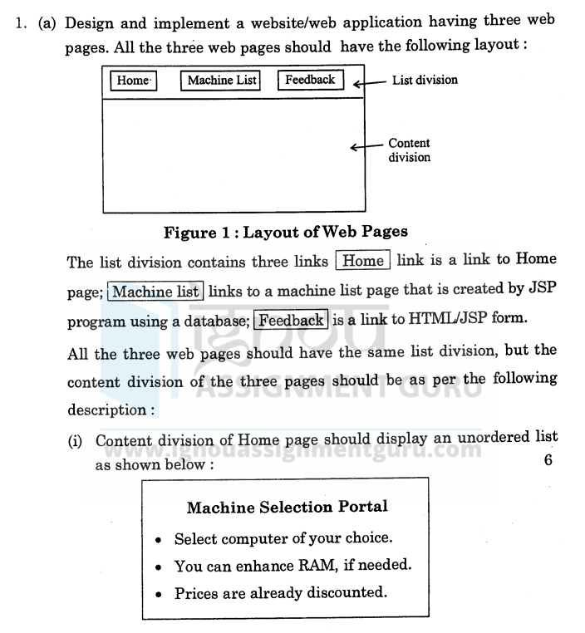

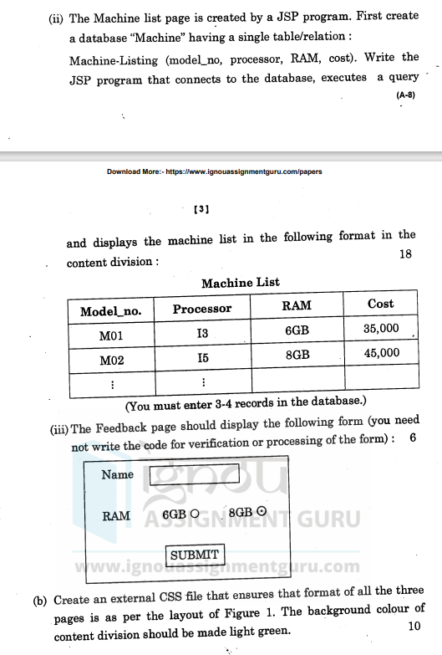

Answer :

Home.html

<!-- home.html -->

<!DOCTYPE html>

<html lang="en">

<head>

<meta charset="UTF-8">

<meta name="viewport" content="width=device-width, initial-scale=1.0">

<title>Home Page</title>

<link rel="stylesheet" href="styles.css">

</head>

<body>

<div class="container">

<!-- Navigation List -->

<div class="nav-list">

<ul>

<li><a href="home.html">Home</a></li>

<li><a href="machineList.jsp">Machine List</a></li>

<li><a href="feedback.html">Feedback</a></li>

</ul>

</div>

<!-- Content Division -->

<div class="content">

<h2>Machine Selection Portal</h2>

<ul>

<li>Select computer of your choice</li>

<li>You can enhance RAM if needed</li>

<li>Prices are already discounted</li>

</ul>

</div>

</div>

<footer>

<p>&copy; 2025 Your Company Name</p>

</footer>

</body>

</html>

Machine List. JSP

<!-- machineList.jsp -->

<%@ page language="java" contentType="text/html; charset=ISO-8859-1" pageEncoding="ISO-8859-1"%>

<%@ taglib uri="http://java.sun.com/jsp/jstl/core" prefix="c" %>

<%@ page import="java.sql.*,java.util.*" %>

<html lang="en">

<head>

<meta charset="UTF-8">

<meta name="viewport" content="width=device-width, initial-scale=1.0">

<title>Machine List</title>

<link rel="stylesheet" href="styles.css">

</head>

<body>

<div class="container">

<!-- Navigation List -->

<div class="nav-list">

<ul>

<li><a href="home.html">Home</a></li>

<li><a href="machineList.jsp">Machine List</a></li>

<li><a href="feedback.html">Feedback</a></li>

</ul>

</div>

<!-- Content Division -->

<div class="content">

<h2>Machine List</h2>

<table border="1">

<tr>

<th>Model No</th>

<th>Processor</th>

<th>RAM</th>

<th>Cost</th>

</tr>

<%

Connection con = null;

Statement stmt = null;

ResultSet rs = null;

try {

// Establish connection to the database

Class.forName("com.mysql.cj.jdbc.Driver");

con = DriverManager.getConnection("jdbc:mysql://localhost:3306/machine", "root", "password");

stmt = con.createStatement();

rs = stmt.executeQuery("SELECT * FROM Machine_learning");

while(rs.next()) {

%>

<tr>

<td><%= rs.getString("model_no") %></td>

<td><%= rs.getString("processor") %></td>

<td><%= rs.getInt("RAM") %></td>

<td><%= rs.getDouble("cost") %></td>

</tr>

<%

}

} catch (Exception e) {

e.printStackTrace();

} finally {

try {

if (rs != null) rs.close();

if (stmt != null) stmt.close();

if (con != null) con.close();

} catch (SQLException e) {

e.printStackTrace();

}

}

%>

</table>

</div>

</div>

<footer>

<p>&copy; 2025 Your Company Name</p>

</footer>

</body>

</html>

Data base Creation and entries

CREATE DATABASE machine;

USE machine;

CREATE TABLE Machine_learning (

model_no VARCHAR(50),

processor VARCHAR(100),

RAM INT,

cost DECIMAL(10, 2)

);

INSERT INTO Machine_learning (model_no, processor, RAM, cost)

VALUES

('Model1', 'Intel Core i5', 8, 500.00),

('Model2', 'Intel Core i7', 16, 800.00),

('Model3', 'AMD Ryzen 7', 8, 700.00);

CSS

/* styles.css */

body {

font-family: Arial, sans-serif;

margin: 0;

padding: 0;

background-color: #f4f4f4;

}

.container {

width: 80%;

margin: 0 auto;

}

.nav-list {

background-color: #333;

padding: 10px;

text-align: center;

}

.nav-list ul {

list-style-type: none;

margin: 0;

padding: 0;

}

.nav-list ul li {

display: inline;

margin-right: 20px;

}

.nav-list ul li a {

color: white;

text-decoration: none;

font-size: 18px;

}

.content {

background-color: #90EE90; /* Light green */

padding: 20px;

margin-top: 20px;

}

footer {

background-color: #333;

color: white;

text-align: center;

padding: 10px;

margin-top: 20px;

}

Feedback

<!-- feedback.html -->

<!DOCTYPE html>

<html lang="en">

<head>

<meta charset="UTF-8">

<meta name="viewport" content="width=device-width, initial-scale=1.0">

<title>Feedback</title>

<link rel="stylesheet" href="styles.css">

</head>

<body>

<div class="container">

<!-- Navigation List -->

<div class="nav-list">

<ul>

<li><a href="home.html">Home</a></li>

<li><a href="machineList.jsp">Machine List</a></li>

<li><a href="feedback.html">Feedback</a></li>

</ul>

</div>

<!-- Content Division -->

<div class="content">

<h2>Feedback Form</h2>

<form action="submitFeedback.jsp" method="post">

<label for="name">Your Name:</label><br>

<input type="text" id="name" name="name" required><br><br>

<label for="email">Your Email:</label><br>

<input type="email" id="email" name="email" required><br><br>

<label for="feedback">Feedback:</label><br>

<textarea id="feedback" name="feedback" rows="5" required></textarea><br><br>

<input type="submit" value="Submit">

</form>

</div>

</div>

<footer>

<p>&copy; 2025 Your Company Name</p>

</footer>

</body>

</html>