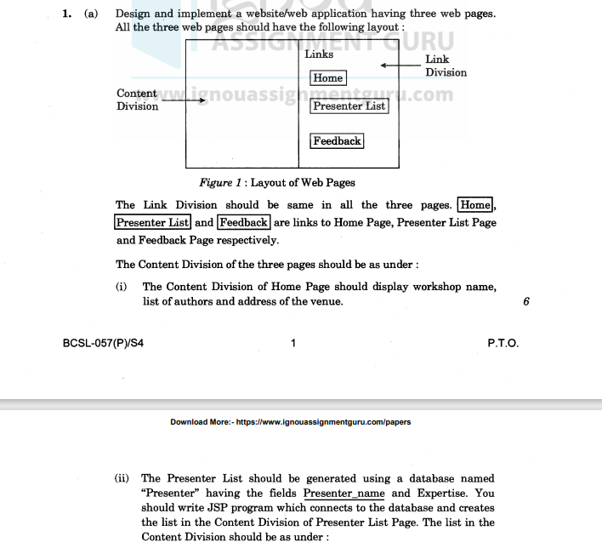

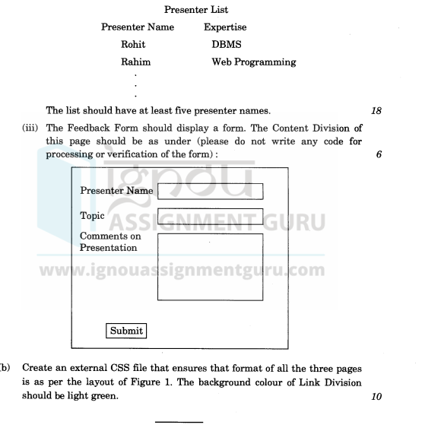

Home Page (index.html)

<!DOCTYPE html>

<html>

<head>

<title>Company Report Links</title>

<link rel="stylesheet" href="style.css">

</head>

<body>

<div id="header">

<h1>Company Report Links</h1>

</div>

<div id="content">

<p>

* These pages are for authorised persons.<br>

* Reports are for internal users only.<br>

* Please do not take print out of reports.

</p>

<ol>

<li><a href="list_of_reports.jsp">List of Reports</a></li>

<li><a href="feedback.html">Feedback</a></li>

</ol>

</div>

<div id="footer">

&copy; 2024 Company Name

</div>

</body>

</html>

2. List of Reports Page (list_of_reports.jsp)

<%@ page import="java.sql.*" %>

<!DOCTYPE html>

<html>

<head>

<title>List of Reports</title>

<link rel="stylesheet" href="style.css">

</head>

<body>

<div id="header">

<h1>List of Reports</h1>

</div>

<div id="content">

<table>

<tr>

<th>Report Title</th>

<th>Author</th>

</tr>

<%

try {

Class.forName("com.mysql.jdbc.Driver"); // Replace with your JDBC driver

Connection con = DriverManager.getConnection("jdbc:mysql://localhost:3306/Reports", "your_username", "your_password"); // Replace with your database credentials

Statement stmt = con.createStatement();

ResultSet rs = stmt.executeQuery("SELECT * FROM Report");

while (rs.next()) {

%>

<tr>

<td><%= rs.getString(1) %></td>

<td><%= rs.getString(2) %></td>

</tr>

<%

}

con.close();

} catch (Exception e) {

out.println("Error: " + e);

}

%>

</table>

</div>

<div id="footer">

&copy; 2024 Company Name

</div>

</body>

</html>

3. Feedback Page (feedback.html)

<!DOCTYPE html>

<html>

<head>

<title>Feedback</title>

<link rel="stylesheet" href="style.css">

</head>

<body>

<div id="header">

<h1>Feedback</h1>

</div>

<div id="content">

<form>

<label for="name">Name:</label>

<input type="text" id="name" name="name"><br><br>

<label for="company">Company Name:</label>

<input type="text" id="company" name="company"><br><br>

<label for="report">Report of Interest:</label>

<input type="text" id="report" name="report"><br><br>

<input type="submit" value="Submit">

</form>

</div>

<div id="footer">

&copy; 2024 Company Name

</div>

</body>

</html>

CSS File (style.css)

body {

font-family: sans-serif;

color: blue;

}

#header {

background-color: #f0f0f0;

padding: 10px;

text-align: center;

}

#content {

margin: 20px;

padding: 20px;

border: 1px solid #ccc;

}

#footer {

background-color: #f0f0f0;

padding: 10px;

text-align: center;

position: fixed;

bottom: 0;

width: 100%;

}

table {

border-collapse: collapse;

width: 100%;

}

th, td {

border: 1px solid #ddd;

padding: 8px;

text-align: left;

}

th {

background-color: #f2f2f2;

}