Hospital Management System
System Requirements Specification
Prepared by the design firm of
Ashwani and Yogesh
Version 1.0
Table of Contents..........................................................................i
Revision History……………………………………………………………………………………..ii
1. Introduction
- 1.1 Scope
- 1.2 Overview
2. Overall Description
- 2.1 Product Perspective
- 2.2 Product Features
- 2.3 Operating Environment
- 2.4 User Document
3. Functional Requirement
4. Interface Requirements
- 4.1 User Interface
- 4.2 Hardware Interface
- 4.3 Software Interfaces
- 4.4 Communication Interface
5. Non Functional Requirements
- 5.1 Performance Requirements
- 5.2 Security Requirements
- 5.3 Software Quality Attributes
6. Specific Requirements
- 6.3 Graphical Analysis
7. Dependencies
8 . Limitations

Introduction
The following subsections of Software Requirement Specifications Document should facilitate in providing the entire overview of the Information system “Hospital Management System” under development. This document aims at defining the overall software requirements for admin. Efforts have been made to define the requirements of the Information system exhaustively and accurately.

Scope

The proposed software product is the Hospital Management System (HMS). The system will be used to get the information from the patients and then storing that data for future usage. The current system in use is a paper-based system. It is too slow and cannot provide updated lists of patients within a reasonable timeframe. The intentions of the system are to reduce over-time pay and increase the number of patients that can be treated accurately. Requirements statements in this document are both functional and non-functional. The document only covers the requirement specification for the hospital management system. This document does not provide any references to the other component of the hospital management system. All the external interfaces and the dependencies are also identified in this document.

Overview

Hospital Management System is a process of implementing all the activities of the hospital in a computerized automated way to fasten the performance. This Hospital Management System is a self-contained system that manages activities of the hospital as Patient Info. Various stakeholders are involved in the hospital patient info system. In hospital management system Patients can register and take appointment. Doctors (permanent doctors, visiting doctors) can check the patients for the day list. Diagnosis stored online. Can refer to earlier diagnosis. Operations can be scheduled subject to availability of doctors and operation room.

Overall Description

Product Perspective
This Hospital Management System is a self-contained system that manages activities of the hospital as Patient Information. Various stakeholders are involved in the hospital patient info system. This project gives the procedural approach how a patient gets appointment for treatment, details about date of treatment and finally depending on different criteria like availability of doctor, appointments timing. Scheduling of operations according to availability of doctors and operation room.

HTML, CSS JAVASCRIPT
MYSQL

APACHE 2.0
PHP

Product Feature
The system functions can be described as follows:
Registration: When a patient wants to use HMS, the front-desk staff checks to see if the patient is already registered with the hospital. If he/she is, his/her register id is entered into the computer. Otherwise a new Personal Health id is given to this patient The patient’s information such as patient name, date of birth, address and telephone number is also entered into computer system. When doctor also has login id and password to check the appointment schedule and modified some information according to requirements.

Operating Environment

The software will operate with the following software components and applications: The software being developed will be running under Linux Ubuntu 16.04 embedded operating system. The hardware that will be running these programs is being developed for this specific project, and will follow the specifications that appear in this document in section 3. The synchronization procedures will be written to interface with Windows XP, Windows Vista, and Mac OS.

User Document
The system will be used in the hospital. The administrators,front-desk staff will be the main users. Given the condition that not all the users are computer-literate. Some users may have to be trained on using the system. The system is also designed to be user-friendly. It uses a Graphical User Interface (GUI).

Functional Requirements

Registration
Add patients
The HMS shall allow front-desk staff to add new patients to the system.
Assign ID
The HMS shall allow front-desk staff to give each patient a ID and add it to the patient’s record. This ID shall be used by the patient throughout his/her stay in hospital.

Medical matter management
Assign Doctor
The administrative staff in the ward shall use HMS to assign a doctor to a given patient.
Assign Nurse
The administration staff in the ward shall use HMS to assign a nurse to a given patient.
Inform Doctors
The HMS shall inform doctors of new patients.
Inform Nurses
The HMS shall inform nurses of new patients.
Emergency Case
In an emergency case, the administrative staff shall use HMS to assign an emergency room, doctors and nurses to the patient immediately.
Surgery case
In a surgery case, the administrative staff shall use HMS to assign a surgery room, surgeon and nurses to the patient.
Generate Report (normal)
The HMS shall generate the patient’s situation record every two hours for normal patients.
Generate Report(Severe)
The HMS shall generate patient’s situation record every half hour for severe patients.
Record procedure
The whole treatment procedure for the patient shall be recorded by the system.
Inform patient
The HPMS shall automatically inform the patients who are on the bed waiting list of available beds whenever they become available.

Report Generation
Patient information
Every six hours the HPMS shall generate reports on patients about the following information: patient’s PHN, patient’s name, ward name, bed number and the doctor’s name.
Bed Availability
Every six hours the HPMS shall generate reports on bed availability about the following information: ward name, bed number, occupied/unoccupied

Staff Schedule
Every six hours the HPMS shall generate reports on staff schedule about the following information: staff ID, staff name, staff type, duty shift.

Database
Patient Mandatory Information
Each patient shall have the following mandatory information: first name, last name, phone number, personal health number, address, postal code, city, country, patient identification number.
Appointment Information
The HMS shall allow the user to update any of the patient’s information as described in SRS020
Search for Patient
The HMS shall allow the user to search for patient’s information by last name or PHN or patient ID.
Staff Mandatory Information
Each staff in hospital shall have the following mandatory information: identification number, first name, last name, phone number, address, postal code, city, country, employee type, duty schedule.
Update Staff Information
The HMS shall allow the user to update any of the staff’s information as described in SRS023.

Interface Requirements
This section describes the team, their roles, and the process used to analyze the requirements and create the dependency analysis. It lists the requirements issues that were discovered, and how they were resolved. It includes the original specification, annotated with line numbers. These line numbers are referenced in the issue resolutions and in the improved requirements in section 3.

User Interface
The software provides good graphical interface for the user any administrator can operate on the system, performing the required task such as create, update, viewing the details of the book.
Allows user to view quick reports like Book Issues/Returned etc in between particular time.
Stock verification and search facility based on different criteria.

Hardware interface
Operating system : Linux 16.04
Hard disk :40GB
RAM : 256 MB
Processor : Pentium(R)Dual-core CPU

4.3 Software interface
PHP 5
MYSQL
CSS
HTML 5
JAVASCRIPT
APACHE 2.0

Communication interface
The HMS shall use the HTTP protocol for communication over the internet and for the intranet communication will be through TCP/IP protocol suite

Non Functional Requirements

Security

Patient Identification
The system requires the patient to identify himself /herself using PHN

Logon ID
Any user who uses the system shall have a Logon ID and Password.

Modification
Any modification (insert, delete, update) for the Database shall be synchronized and done only by the administrator in the ward.

Compliance
The system must comply with the Regional Health Authority Regulations concerning privacy, section 703.2RHA/2000/v78

Front Desk staff Rights
Front Desk staff shall be able to view all information in HPMS, add new patients to HPMS but shall not be able to modify any information in it.

Administrators' Rights
Administrators shall be able to view and modify all information in HPMS

Nurses' Rights
Nurses shall only be able to view all information in HPMS.

Doctors Rights
Doctors shall only be able to view all information in HPMS

Performance Requirements

Response Time
The system shall give responses in 1 second after checking the patient’s information.

Capacity
The System must support 1000 people at a time.

User-interface
The user-interface screen shall respond within 5 seconds.
The systems must conform to the Microsoft Accessibility guidelines

Software Quality Attributes

Availability
If the internet service gets disrupted while sending information to the server, the information can be send again for verification.

Security
The main security concern is for users account hence proper login mechanism should be used to avoid hacking. The tablet id registration is way to spam check for increasing the security. Hence, security is provided from unwanted use of recognition software.

Usability
As the system is easy to handle and navigates in the most expected way with no delays. In that case the system program reacts accordingly and transverses quickly between its states.

Maintainability

Back Up
The system shall provide the capability to back-up the Data

Errors
The system shall keep a log of all the errors.

Specific Requirements

Graphical Analysis
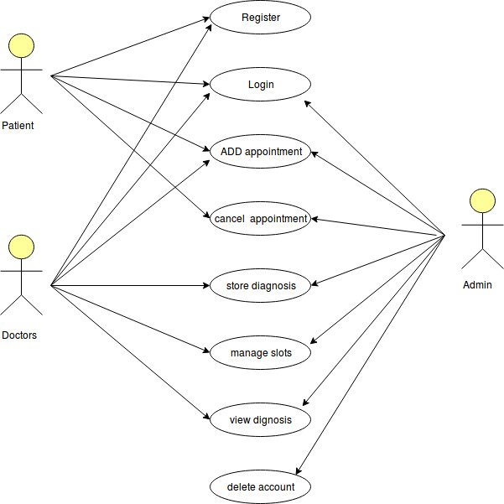

Dependencies
One assumption about the product is that it will always be used on web browser, so system must have a browser (IE or chrome etc) and another assumption is that the Internet connection in all systems must be available in some way. To install the application, there must be a server available over Windows and for database support, it must have MySQL.

Limitations
- The user must subscribe a membership for using the HMS service, for which it must provide a contact information or email-id, for authentication (like user-id or password)

- If the server is down for any reason, the service will be unavailable to the customer.

- If user does not have enough bandwidth internet connection, then user cannot avail this service

