The Stacks And Its Applications
Stack :
A stack is like a stack of plates – last in, first out (LIFO). You can push to add, pop to remove, or peek to see the top. It’s used in expressions, brackets checking, recursion, undo/redo, and browser history. Overflow happens if full, underflow if empty.
Basic features of Stack :
- Last In, First Out (LIFO) – The last item you put in is the first one to come out.
- Access from Top Only – You can push, pop, or peek only at the top element.
- Flexible Implementation – It can be made with arrays (fixed size) or linked lists (dynamic size).
- Temporary Storage – It is great for keeping short-term data like function calls or operators.
- Used in Recursion & Undo/Redo – It helps keep track of tasks in reverse order.
- Overflow and Underflow – Overflow happens when adding to a full array stack, underflow when removing from an empty stack.
Applications Of Stack :
- Expression Evaluation – It is used to solve mathematical expressions and convert infix → postfix/prefix.
- Balanced Parentheses Checking – It helps to check if brackets like (), {}, [] are correctly matched.
- Function Call Management (Recursion) – It keeps track of function calls and local variables using the call stack.
- Undo/Redo Operations – Text editors use stacks to undo or redo actions.
- Browser History – Back and forward navigation in browsers is managed using stacks.
- String Reversal – You can reverse a string by pushing characters into a stack and popping them.

Basic Operations on Stack :
- Create Empty Stack (S): Create or make stack S be an empty stack .
- Push (S,x): Insert x at one end of the stack, called its top.
- Top (S): If the stack S is not empty, then retrieve the element at its top.
- Pop (S): If the stack S is not empty,then delete the element at its top.
- IsFull (S): Determine whether stack S is full or not. Return true if S is full; return false otherwise.
- IsEmpty (S): Determine whether stack S is empty or not. Return true if S is an empty stack; return false otherwise.

Implementations Of Stack :
- Array implementation of stack ( Static Implementation )
- Linked list implementation of stack ( Dynamic Implementation)
Array implementation of stack :
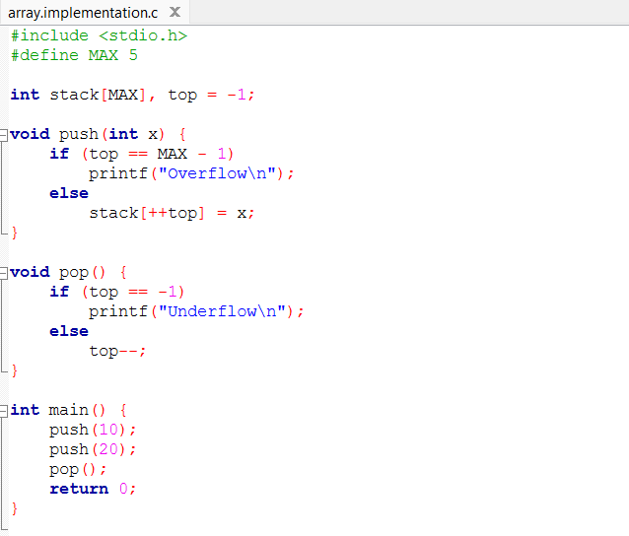
Array implementation of a stack uses a fixed-size array to store elements, with a top variable pointing to the last element. You push elements on top, pop elements from the top, and peek to see the top item. It’s simple and fast, but can face overflow if the array is full.

Linked implementation of stack :
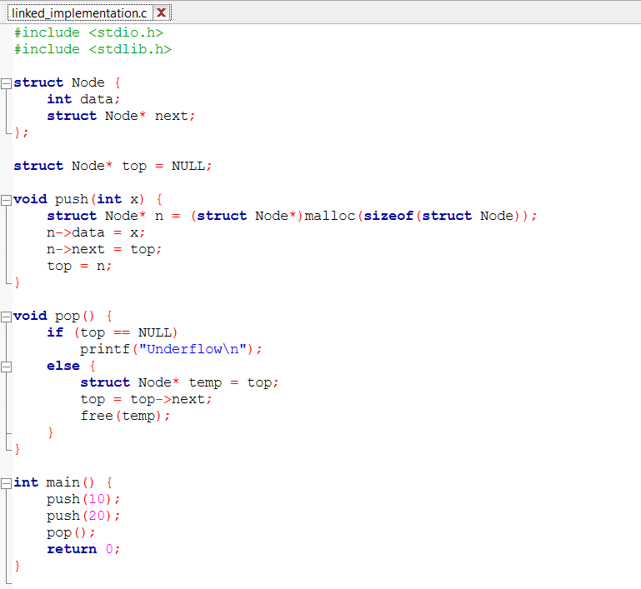
Linked list implementation of a stack uses a linked list where each node stores data and a link to the next node. The top points to the first node of the list. Elements are pushed by adding a new node at the beginning and popped by removing the top node.

Infix, Prefix and Notation:
One of the applications of the stack is to evaluate the expression. We can represent the expression following three types of notation:
- Infix Expression
- Prefix Expression
- Postfix Expression
Infix Expression :

An infix expression is an expression in which the operator is written between two operands. It is the most commonly used expression form by humans. Examples of infix expressions are A + B and (A + B) * C. In infix notation, parentheses and operator precedence rules are required to determine the correct order of evaluation. Due to this reason, infix expressions are difficult for computers to evaluate directly.

Prefix Expression :

A prefix expression, also called Polish notation, is an expression in which the operator is written before the operands. Examples include + A B and * + A B C. Prefix expressions do not require parentheses, as the order of evaluation is clearly defined by the position of the operator. This notation is easy for computers to process and is commonly used in expression evaluation.
Postfix Expression :
A postfix expression, also known as Reverse Polish notation, is an expression in which the operator is written after the operands. Examples are A B + and A B + C *. Like prefix notation, postfix notation does not need parentheses and is very easy to evaluate using a stack. Postfix expressions are widely used in compilers and calculators.

