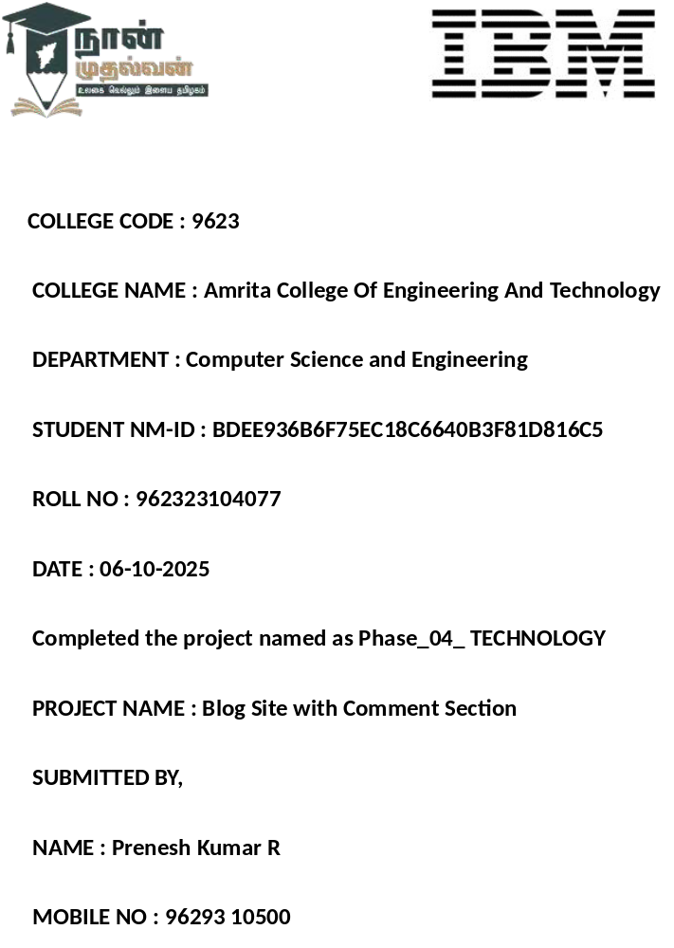

Phase 4 – Enhancement and Deployment

Additional Features

1. User Authentication System
- Added login and registration pages so users can create accounts and post comments securely.
- Used password encryption to protect user data.

2. Admin Panel
- Created an admin dashboard to manage blog posts, edit or delete comments, and monitor user activity.
- Allows easy addition of new blog posts without editing the code.

3. Search and Filter Options
- Users can search posts by keywords or filter by categories/tags for easier navigation.

4. Like and Share Buttons
- Added like buttons for each blog post to track popularity.
- Integrated social media sharing (Facebook, Twitter, etc.) to increase engagement.

5. Comment Section with Validation
- Implemented a real-time comment system with form validation to prevent spam.
- Displays user name, comment, and timestamp for every comment posted.

UI/UX Improvements

1. Modern and Clean Layout
- Designed a simple and attractive interface to give users a comfortable reading experience.
- Used proper spacing, alignment, and font hierarchy to make the content easy to read and visually appealing.

2. Responsive Design
- Ensured the website works perfectly on mobile, tablet, and desktop devices using responsive CSS and media queries.
- Adjusted image sizes and text layout automatically based on screen resolution.

3. Navigation Bar & Footer
- Added a sticky navigation bar for quick access to Home, Blog, About, and Contact pages.
- Included a footer section with social media links, contact info, and copyright details.

4. Consistent Color Theme
- Selected a professional color palette for text, background, and buttons.
- Used hover effects and color contrasts to highlight clickable elements.

5. Interactive Elements
- Added hover animations on buttons and links for a more engaging experience.
- Integrated smooth scrolling and transition effects between sections.
- Adjusted font size and line spacing for comfortable reading.

API Enhancements

1. RESTful API Integration
- Developed and integrated RESTful APIs to connect the frontend (HTML/CSS/JS) with the backend (PHP/MySQL).
- Ensured smooth data exchange between the client side and server side for blog posts, comments, and user data.

2. CRUD Operations
- Implemented API endpoints to Create, Read, Update, and Delete (CRUD) blog posts and comments.
- Enabled dynamic loading of content without reloading the entire page.

3. Comment Management API
- Created a dedicated comment API to fetch, post, and delete comments in real time.
- Added validation to prevent empty or spam comments before storing them in the database.

4. User Authentication via API
- Used API-based login and registration system with encrypted password handling.
- Implemented session management and token-based authentication for secure user access.

5. Data Fetching Optimization
- Optimized API responses using JSON format for faster and lighter communication between client and server.
- Used pagination and limit parameters to load only necessary blog posts instead of the full dataset.

Performance & Security 9Checks

1. Website Performance Optimization
- Minimized and compressed HTML, CSS, and JavaScript files to improve page loading speed.
- Used image optimization techniques (WebP format, reduced resolution) for faster rendering.
- Implemented lazy loading for images and posts to reduce initial load time.
- Reduced unnecessary API calls and enabled browser caching for better efficiency.

2. Database Optimization
- Indexed frequently accessed tables and columns to speed up SQL queries.
- Removed redundant data and optimized database structure for smoother read/write operations.
- Regularly backed up the database to prevent data loss.

3. Code Efficiency
- Cleaned up unused code and optimized loops, queries, and functions.
- Ensured modular and reusable code structure for easy maintenance and scalability.

4. Form Validation & Input Security
- Added both client-side (JavaScript) and server-side (PHP) validation to ensure safe data input.
- Prevented SQL Injection, Cross-Site Scripting (XSS), and Cross-Site Request Forgery (CSRF) attacks through input sanitization and parameterized queries.

Testing of Enhancements

1. Functional Testing
- Verified that all core functionalities such as posting blogs, adding comments, searching posts, and user login/registration work as expected.
- Checked that each CRUD operation (Create, Read, Update, Delete) through the API responds correctly without errors.
- Ensured the comment section updates dynamically after each new comment submission.

2. User Interface Testing
- Tested the UI design for correct alignment, font readability, and color consistency across all pages.
- Verified that buttons, forms, and navigation links are working and responsive.
- Checked hover effects, animations, and transitions for smooth interaction.

3. Responsiveness Testing
- Tested the website on multiple screen sizes (mobile, tablet, laptop, desktop).
- Verified layout adjustments using media queries for different resolutions.
- Ensured images, text, and buttons resize properly without overlap.

4. Performance Testing
- Measured website loading speed using browser developer tools.
- Verified optimized image loading, minified files, and reduced server requests for faster performance.

Deployment (Netlify, Vercel, or Cloud Platform)

1. Deployment Overview
- After completing the development and testing phases, the blog site was deployed online to make it accessible to users worldwide.
- The deployment was carried out using reliable hosting platforms like Netlify, Vercel, or a Cloud Hosting Service, ensuring scalability and smooth performance.

2. Hosting Platform Used
- The frontend (HTML, CSS, JavaScript) was hosted on Netlify/Vercel for fast global content delivery.
- The backend (PHP, MySQL) was hosted on a cloud server or free hosting service like 000webhost, InfinityFree, or Render for database connectivity.

3. Build & Deployment Steps
- The project files were connected to a GitHub repository for version control and easy updates.
- The repository was then linked to Netlify/Vercel, which automatically built and deployed the site on every commit.
- Configured the environment variables (like database URL, API keys) securely within the hosting platform.

4. Database Setup
- The MySQL database was deployed using phpMyAdmin on a hosting platform.
- Established a secure connection between the frontend and backend through the hosted PHP APIs.

