CV

Personal information
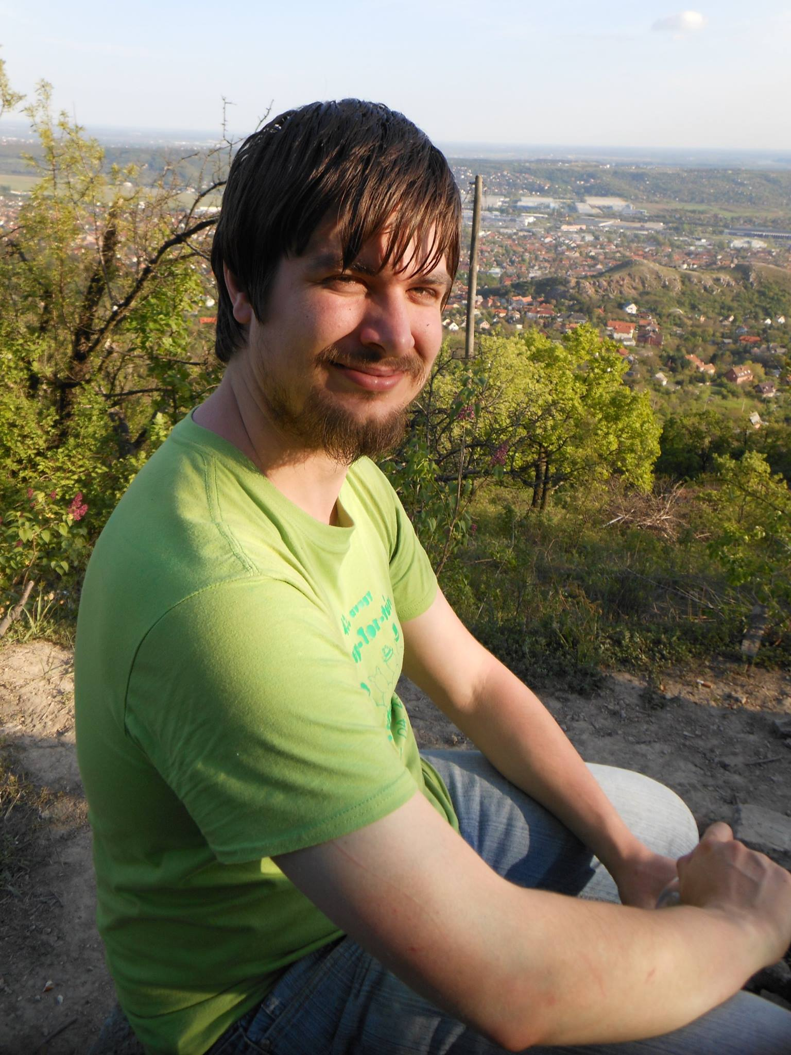 | Name: |  | Richárd István Thier
 | Born: |  | 1988. 12. 26.
 | Address: |  | 2521 Csolnok, Annavölgyi u. 8
 | Mobile: |  | 36209744324
 | Email: |  | magosit@outlook.hu,  u9vata@gmail.com
 | Blog: |  | http://ballmerpeak.web.elte.hu/devblog/
 | Github: |  | https://github.com/prenex/

Experience

Founder, CEO – MagosIT Kft. (2020-)
Responsibilities: |  | Technical lead, Company and strategy lead, hands-on work
Team size: |  | 1-3 person depending on needs and possibilities, mostly 1
Achievements: |  | - Completely self-founded (cofounders are family)
Links / media: |  | Blog:  http://ballmerpeak.web.elte.hu/devblog/  Website (under construction):  www.magosit.hu

R&D Intraprenour – Grepton Zrt. (2015 – 2018)
Responsibilities: |  | Technical lead for R&D department, high-end software-hardware development, R&D, tender writing and documentation, ...
Technologies: |  | OpenGL ES2, DirectX11, C++, C#, Unity3D, Blender, Hololens, Meta 1-2, ARToolkit5, Vuforia, Embedded, multithreading, performance optimization, Secuity drone control applications, android, linux, windows
Fields: |  | - Security systems  - Industry, Industry 4.0, IoT  - Facility management  - Automotive industry (Audi hololens training system)  - Logistics  - Fracture simulation (oil, gas or radioactive deposits)
Team size: |  | 2-10 person organized by me, varied skill levels / fields
Achievements: |  | - 5-10 successful tenders got grants for Grepton or related compenies. Around 70-90% success rate for winning grants in tenders written by me!  - Introduced agile development methods at Grepton
Links / media: |  | Index („Mit keres egy űrhajós az irodában”):  https://index.hu/video/2017/03/10/hololens_teszt_urhajos_hologram/  M5 (TV):  https://www.youtube.com/watch?v=zXumZ5Hcicg  Grepton: https://wptest5.grepton.hu/wp-content/uploads/2017/12/Grepton-HoloLens.mp4

IT Expert – Grepton Zrt. (2013 – 2018)
Responsibilities: |  | Software development, sysadmin training, customer meeting
Technologies: |  | Java, OSGi, Javascript, Python, Linux, Oracle, PL/SQL, JPA, REST web services, multithreading, C++, JSF2, Jenkins, scripting and devops, distributed systems, plugin based systems, GIT, EJB3, UX and UI design / testing
Fields: |  | - Telecommunication  - Insurance  - Document management  - Train transportation systems  - Software asset management  - Healthcare  - Enterprise software applications
Team size: |  | 1-12 person, sometimes as project architect but generally as an IT expert and not in lead roles. Also used to train and mentor junior collegues and hunt for them on carreer expos.
Achievements: |  | - Successfully finished the MÁV-FOR train control system which we had to start over from the ground up. The project was a joint Hungarian-German effort with already out of funding at our team starting the work on it. Other companies payed around 50-80 million just to get out of this OSGi projekt!  - Created a lightweight code review framework (SVN)  - Implemented a lightweight micro-service architecture in javascript and REST endpoints in Java before it became a hype.  - Fixed rarely occuring threading issues in an old legacy C++ application last touched in 2009.  - Written a reusable multithreaded and multi-node „task engine” with high reliability and throughput. It granted the company realized export possibilities.

Trial week – Prezi (2013 / summer)
Responsibilities: |  | Project: fix or mitigate multiplatform font rendering issues
Technologies: |  | Haxe, MacOS
Fields: |  | - Online business presentation software
Team size: |  | 2 person plus my mentor I never met (he worked night only)
Achievements: |  | - No. This was big failure. Actually instead of trying to patchwork this the real solution would have been to dump flash and use modern html5 and (web)gl  - Also company culture was alien for my taste anyways. I like their product though.

PKTR – Mahara integration (2011 / spring)
Responsibilities: |  | Project: integrate „PKTR” with login system of „Mahara”
Technologies: |  | PHP, SVN, Mahara
Fields: |  | - Teaching and training sector
Team size: |  | Alone – helping the family-owned company of my friend
Achievements: |  | - This small integration was successful and worked

Education
2019 |  | Entrepenour, management, business skills (short course)  „Vállalkozz velünk! E-000097/2014/D091 felnőttképzés”
2019 |  | Entrepenour and communication skills (short course)  „Vállalkozói kompetenciafejlesztés – önismeret, kommunikáció, projektszemlélet”
2013 |  | DPC Java master (Java EE)
2011-2013 |  | Eötvös Lóránd University  Software information technologist MSc  Thesis: incomplete as of now, absolved courses
2007-2011 |  | Eötvös Lóránd University  Software information technologist BSc  Thesis: „Three dimensional space-action games using the  XNA framework”
2003-2007 |  | Bottyán János high school of informatics  (Has multiple old Cisco CCNA 1-2 papers from here)

Languages
English |  | I have a B2 level exam and I use it regularly
German |  | Elementary understanding, communication and writing
Bosnian / Slavic |  | Self-taught (only the real basics)
Hungarian |  | Native speaker with interest in modern linguistics

Contests and Competitions
OSZLV: National mail-competition in informatics  (2000-2003) |  | Regularly in the yearly finals in this countrywide elementary school IT competition. Usually generic IT knowledge and a lot of „Comenius logo” (can be considered programming).
Printer fair  (2000-2003) |  | Measurable results on this local competition mostly with hardware oriented tasks. My first teamworking competitions.
„Brain of county”  History and IT  (2005, 2006) |  | Third and fifth places in this history- and IT-mixed competition for high school students. The IT parts were usually not programming related, but generic IT knowledge.
Sándor Mikola Phisics talent  (2006) |  | First place in Komárom-Esztergom county in the category for „High School” (szakközépiskola) students. Participated in phisics extra preparation courses on BME as a result.
ACM ICPC  (2007, 2009, 2011) |  | Well renown international competition for university teams for problem solving with algorithms and data structures.  We were regularly first, second place in the country-wide finals so ended up in the regional competitions in Czech and Poland. My team consisted of me, a guy much better in maths and a guy much better in algorithms. We are friends to this day.
Sapientia ECN  (2008, 2009) |  | We ended up on the second and third place. This was an international competition in Transylvania. Same team. Algoritms and data structures.
Ericsson C++  (2011, 2012) |  | Got into the finals, won second place in 2012. Same team. Algoritms and data structures.
Challenge24  (2012) |  | Got into the finals. Same team. Algoritms and data structures.

Hobbies and interests
- My hobby wine field and wine cellar
- Playing guitar (electric and classical)
- Electronics (SBCs, novelties, FPGA, Microcontrollers, audio, whatever)
- Game development, other kind of hobby development
- Modern Hungarian Linguistics
- History, myths, traditions
- Ping-pong (table tennis)
- Running
- All kinds of DIY activities. I can tile my bathroom and paint my walls whenever I want :-)
- Cultural events, concerts if it is real music (classical, rock, metal, jazz, blues, folk, etc.)
- Events with traditional values, fine dining, handmade markets and fairs, wine regions, etc.
- Spending time outside: campfire, excursion, just walking around…

Generally speaking I am a person in which being down-to-earth is mixed heavily with mentally flying around the skies with „big ideas” and strategies. I am in a relationship and have driving licence B too.

