Project 3: SQL Data Analysis Report
Introduction
This project focuses on analyzing a dataset using SQL queries to extract meaningful insights from raw data. The main objective of this project is to understand how SQL can be used for data filtering, sorting, grouping, and performing calculations on large datasets.
In this project, different SQL operations such as SELECT, WHERE, ORDER BY, GROUP BY, COUNT(), SUM(), and AVG() functions were used to analyze the dataset and generate useful business insights.

Project Objective
The main objectives of this project are:
- To understand and work with a real-world dataset.
- To import and analyze data using SQL.
- To write SQL queries for extracting specific information.
- To filter data using WHERE conditions.
- To sort records using ORDER BY.
- To group data using GROUP BY.
- To perform calculations using aggregate functions like COUNT(), SUM(), and AVG().
- To generate meaningful insights from the dataset.

Tools Used
Database Tool: MySQL / phpMyAdmin
Dataset: Provided Data Analytics Dataset

SQL Concepts Used:
- SELECT Statement
- WHERE Clause
- ORDER BY Clause
- GROUP BY Clause
- COUNT() Function
- SUM() Function
- AVG() Function

Dataset Description
The dataset contains information related to customer orders. It includes details such as:
- Order ID
- Date
- Customer ID
- Product Name
- Quantity
- Unit Price
- Shipping Address
- Payment Method
- Order Status
- Tracking Number
- Items in Cart
- Coupon Code
- Referral Source
- Total Price
The dataset was imported into the SQL database for performing analysis.

SQL Queries and Analysis
Query 1: Display Complete Dataset
To view all records available in the dataset.
SQL Query:
SELECT * FROM orders;
Output Screenshot:
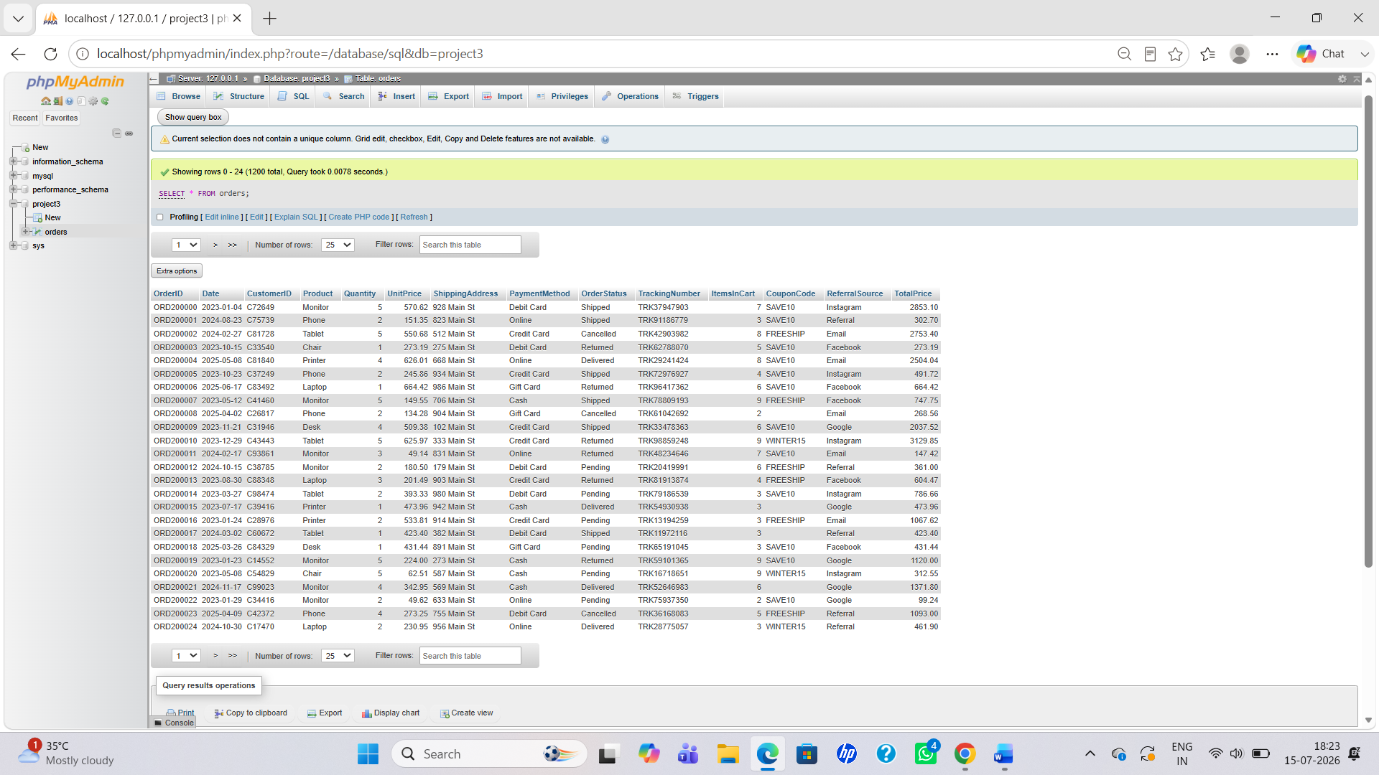

Query 2: Selecting Required Columns
To display only specific columns required for analysis.
SQL Query:
SELECT Product, Quantity, TotalPrice
FROM orders;
Output Screenshot:
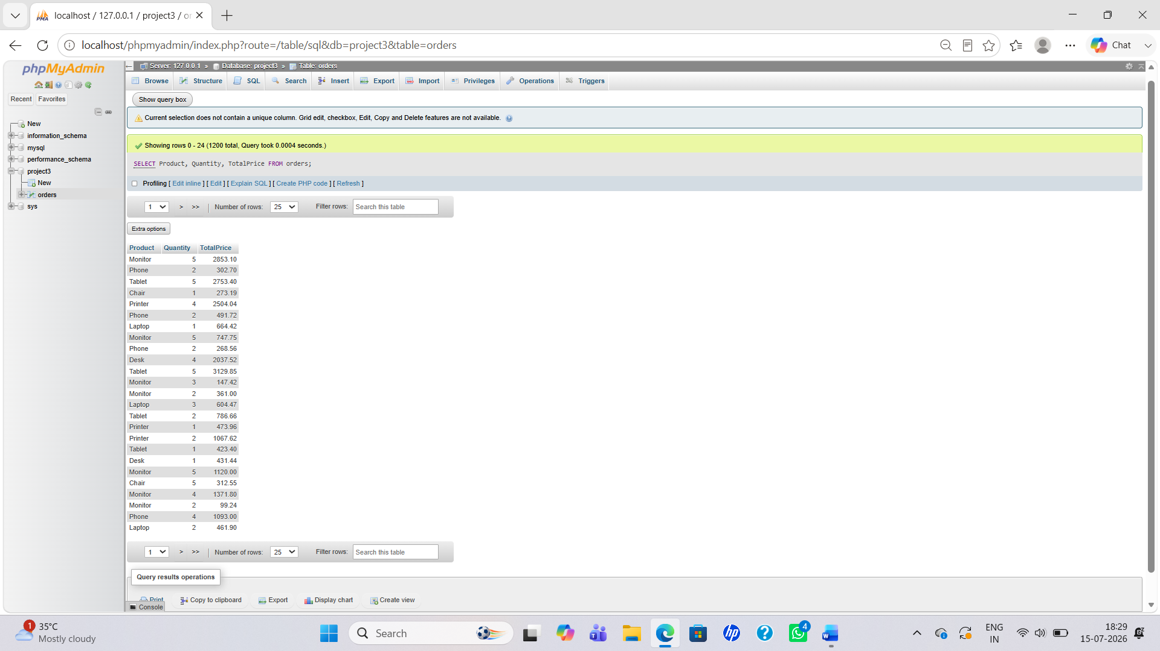

Query 3: Filtering Data Using WHERE Clause
To retrieve records based on a specific condition.
Example: Display cancelled orders.
SQL Query:
SELECT *
FROM orders
WHERE OrderStatus='Cancelled';
Output Screenshot:
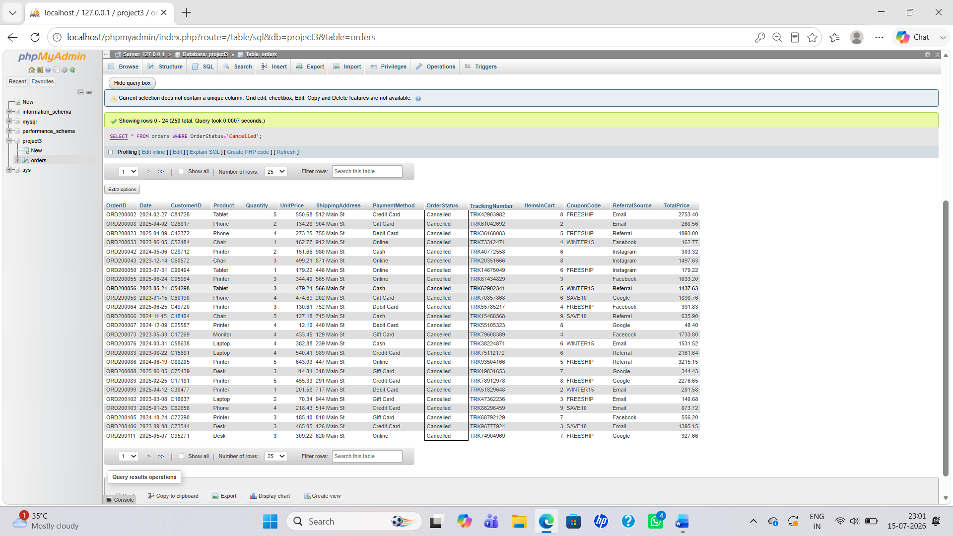

Query 4: Sorting Data Using ORDER BY
To arrange data according to price or other values.
Example: Display highest priced orders first.
SQL Query:
SELECT *
FROM orders
ORDER BY TotalPrice DESC;
Output Screenshot:
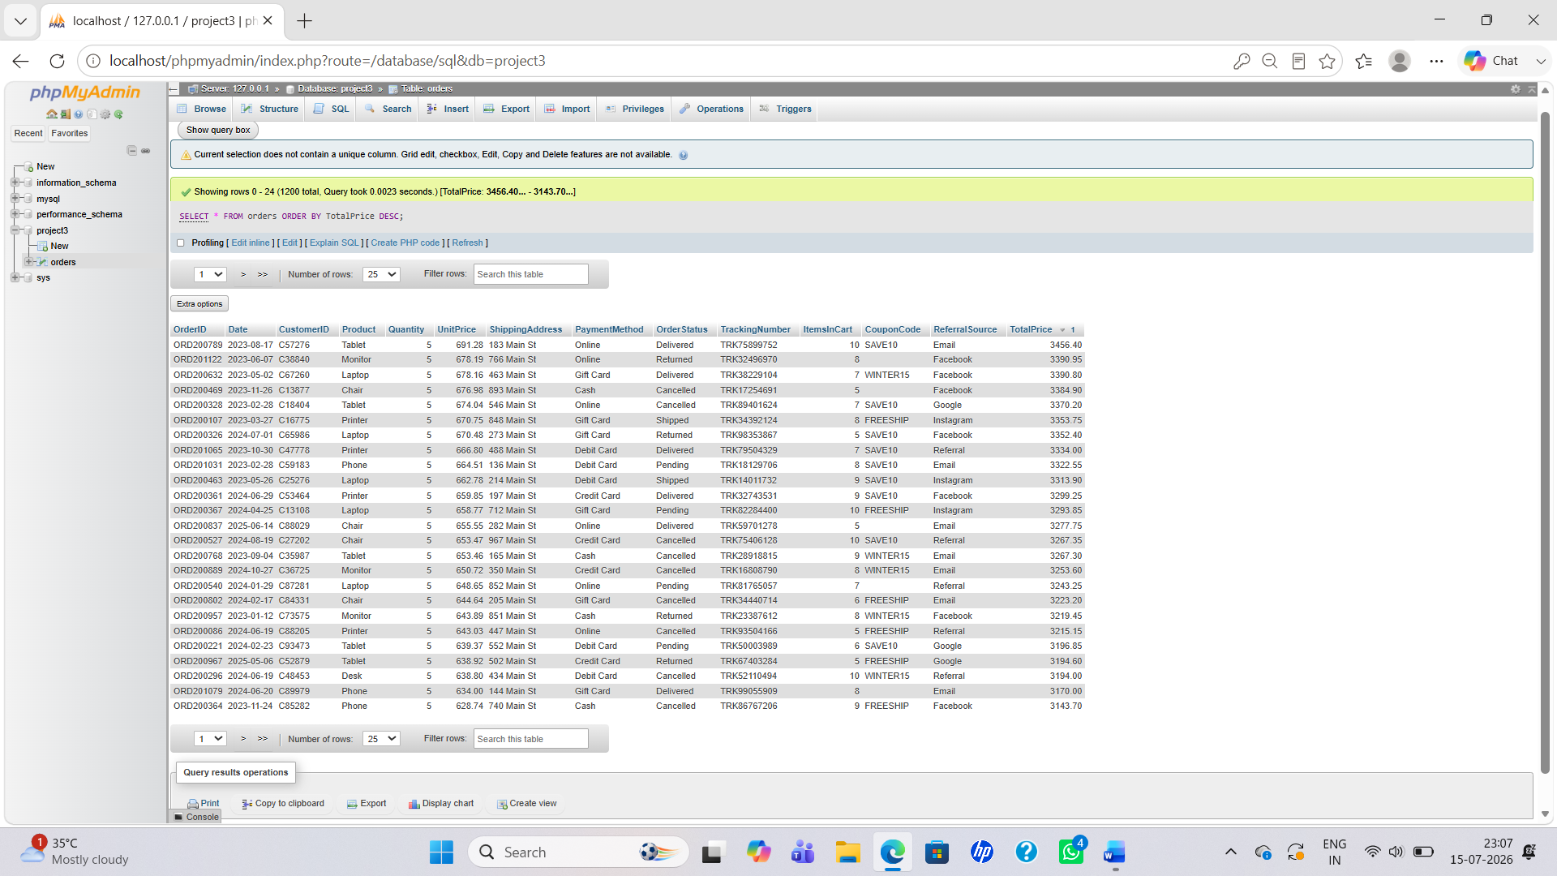

Query 5: Counting Total Number of Orders
To calculate the total number of orders available in the dataset.
SQL Query:
SELECT COUNT(*) AS TotalOrders
FROM orders;
Output Screenshot:
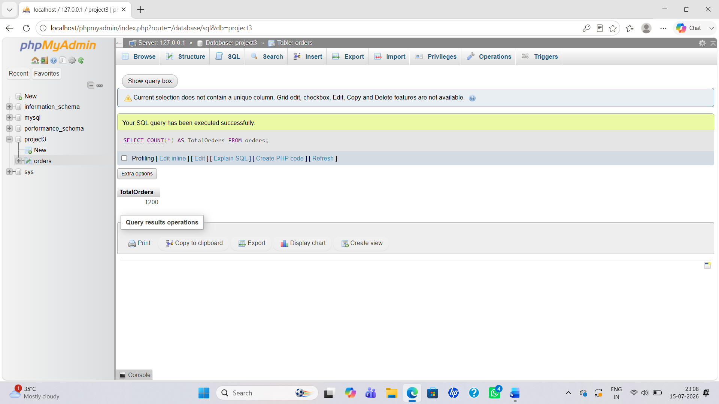

Query 6: Calculating Total Sales Using SUM()
To find the total revenue generated from all orders.
SQL Query:
SELECT SUM(TotalPrice) AS TotalSales
FROM orders;
Output Screenshot:
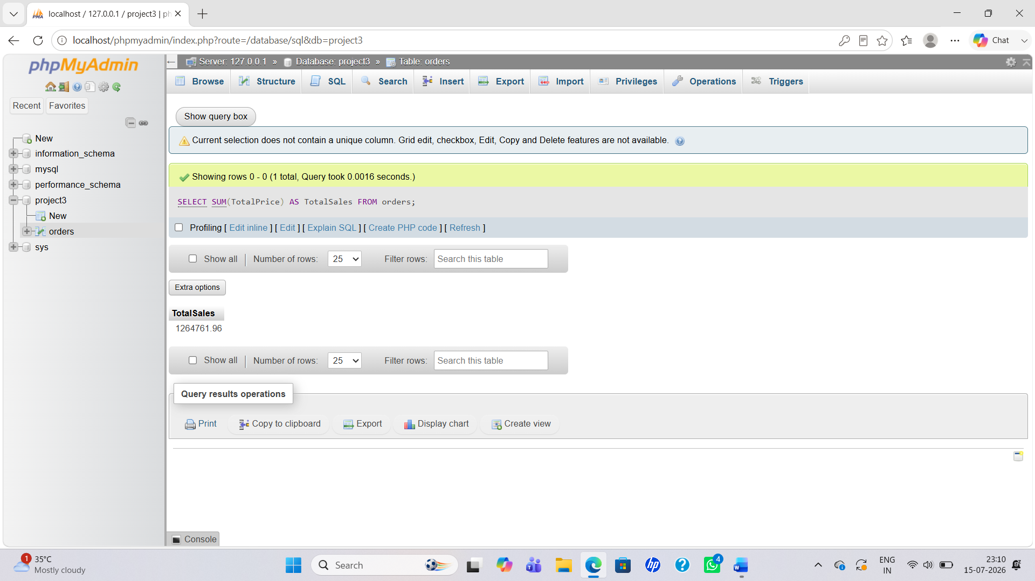

Query 7: Finding Average Order Value Using AVG()
To calculate the average price of orders.
SQL Query:
SELECT AVG(TotalPrice) AS AverageSale
FROM orders;
Output Screenshot:
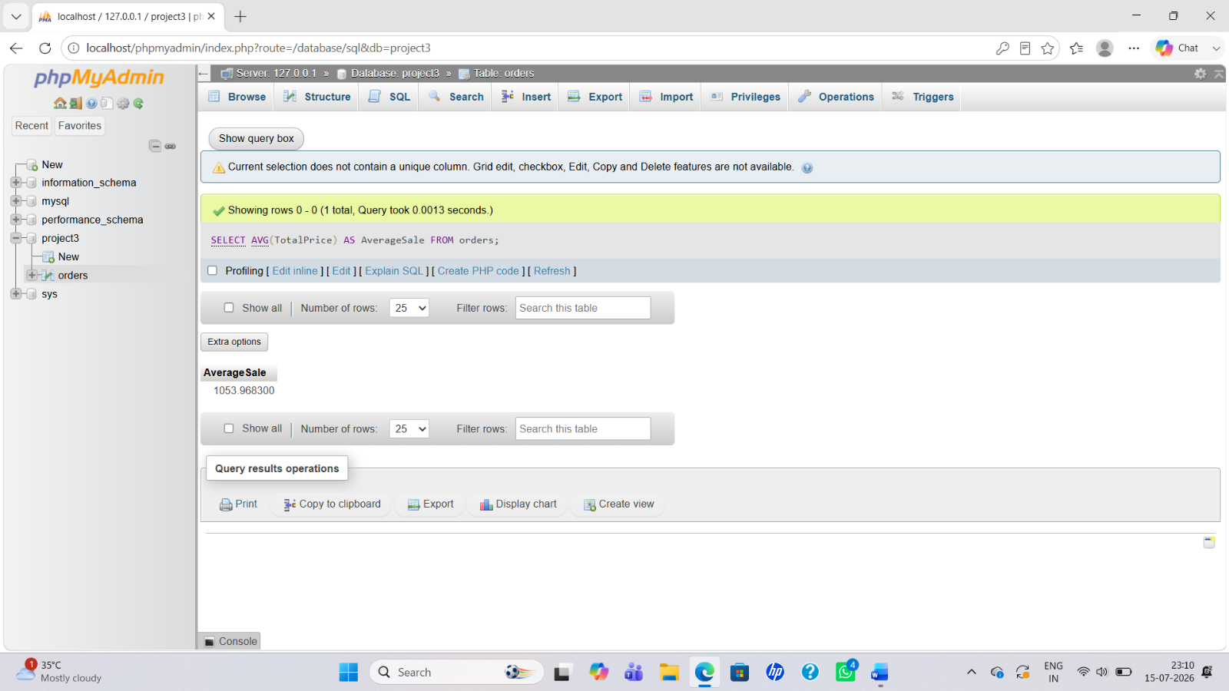

Query 8: Product Wise Order Analysis Using GROUP BY
To analyze the number of orders for each product.
SQL Query:
SELECT Product,
COUNT(*) AS TotalOrders
FROM orders
GROUP BY Product;
Output Screenshot:
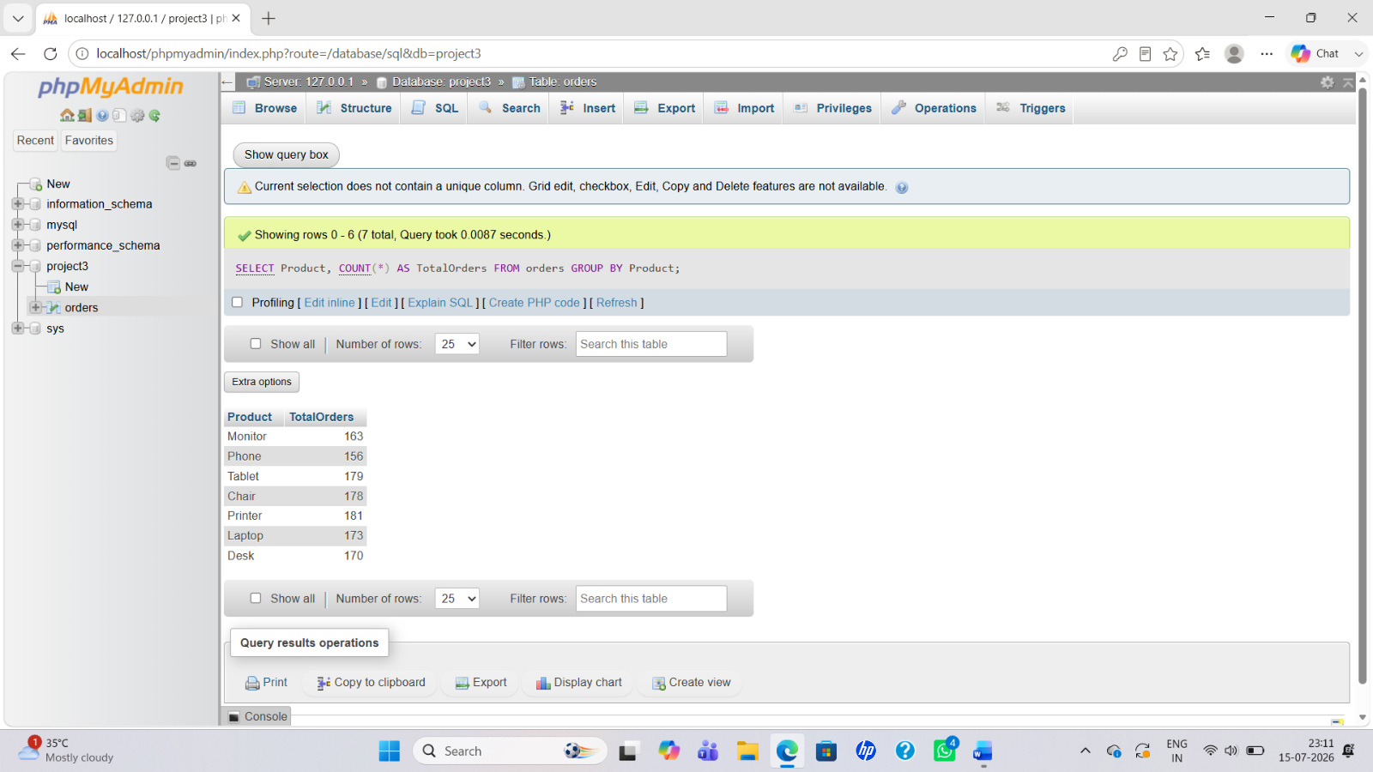

Query 9: Product Wise Total Sales Analysis
To find the total sales generated by each product.
SQL Query:
SELECT Product,
SUM(TotalPrice) AS TotalSales
FROM orders
GROUP BY Product;
Output Screenshot:
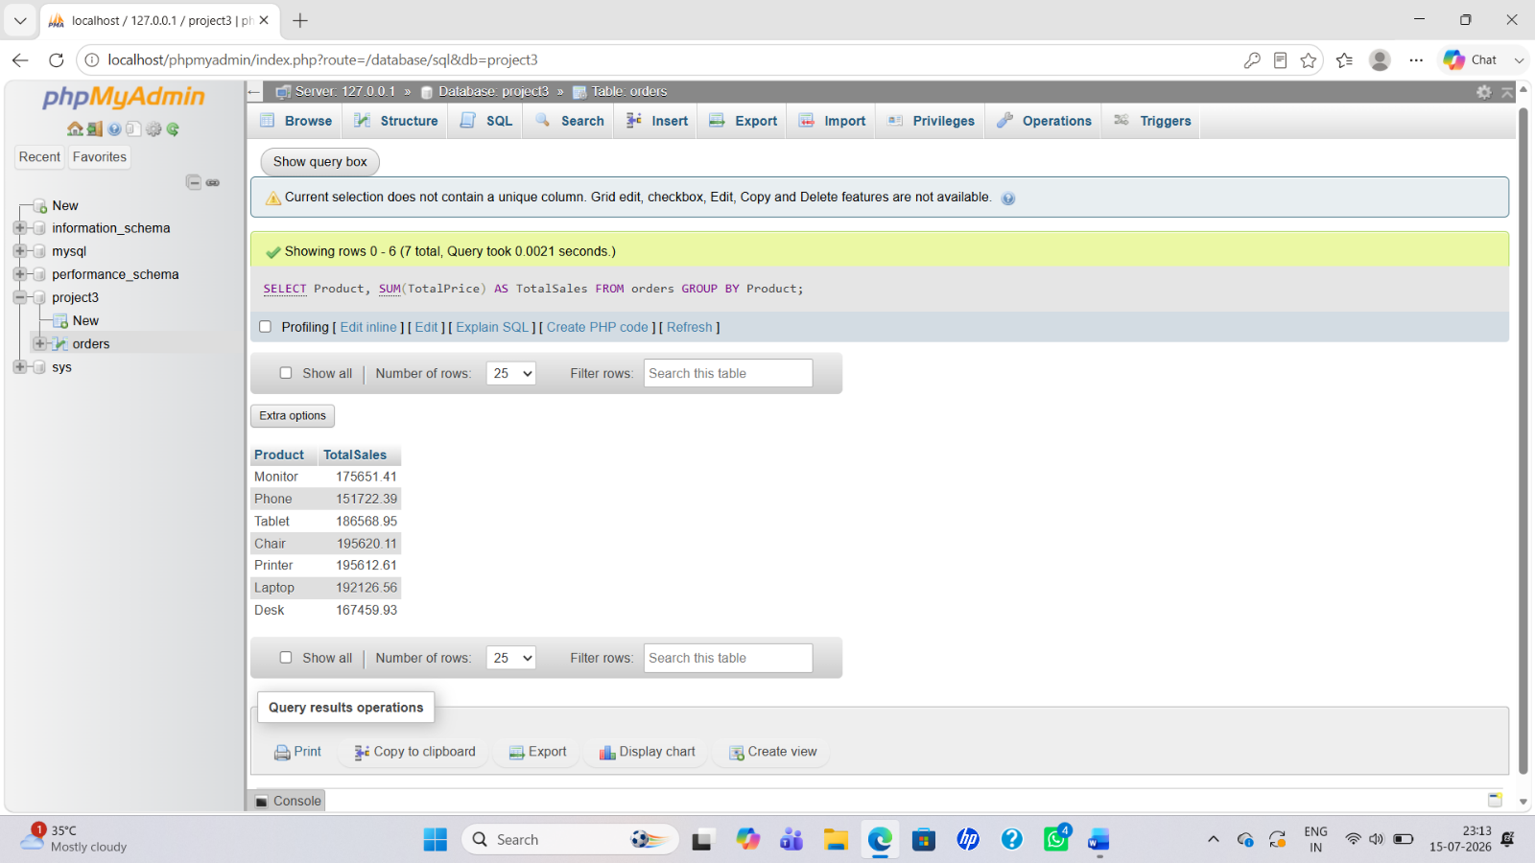

Query 10: Payment Method Analysis
To analyze the number of orders based on payment methods.
SQL Query:
SELECT PaymentMethod,
COUNT(*) AS TotalOrders
FROM orders
GROUP BY PaymentMethod;
Output Screenshot:
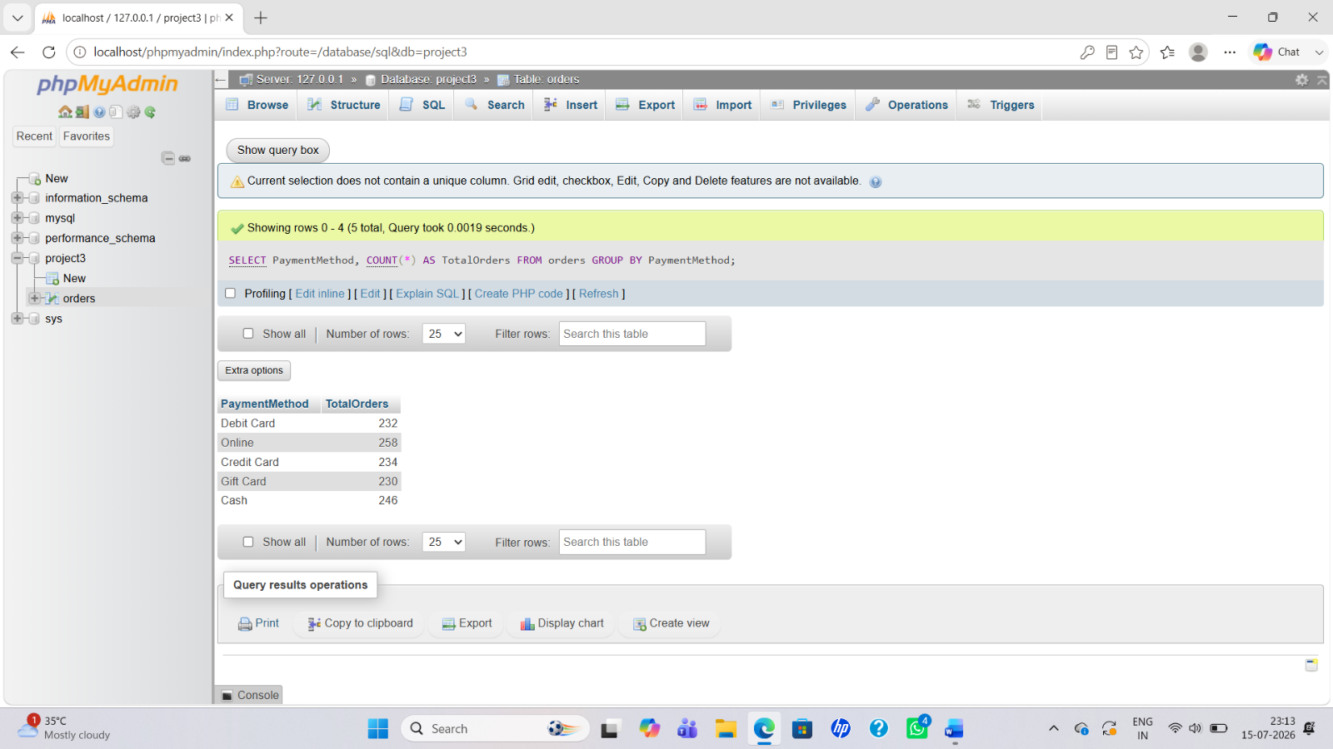

Key Findings
After performing SQL analysis, the following insights were generated:
- Total number of orders was calculated.
- Total revenue generated from orders was identified.
- Average order value was calculated.
- Product-wise performance was analyzed.
- Customer order patterns were studied.
- Different payment methods were compared.
- Order status information was analyzed.

Conclusion
This project helped in understanding the practical use of SQL for data analysis. By using different SQL queries, raw data was transformed into meaningful information.
The project improved knowledge of database querying, filtering, grouping, and performing calculations on datasets. These SQL skills are essential for a Data Analyst role because they help in extracting valuable insights from business data.

Project Completion Status
Project Name: SQL Data Analysis
Status: Completed
Skills Learned: SQL Query Writing, Data Filtering, Data Aggregation, Data Analysis

