**Supplemental Materials**

**Nonprofit supply and citizen demand: A spatial analysis of the market for third sector services**

1. Supplemental Methods
   1. Moran’s I statistic

To justify our use of the first degree neighbor median method of imputation, we explored the variables used in the model in three ways: assessing spatial autocorrelation with the Moran’s I metric (16,17), producing choropleth maps, and visualizing a correlation matrix. For neighbor to area , Moran’s I can be calculated as:

Where is the number of spatial areas, is the number of neighbors to spatial area , is a weight calculated as , is the variable of interest for spatial area , and is the mean of the variable of interest across all spatial areas. The resulting values of generally range between -1 and +1 where a negative value indicates a negative spatial autocorrelation (neighboring areas less alike, much like a checkerboard) and a positive value indicates positive spatial autocorrelation (neighboring areas more alike). A variable with no spatial autocorrelation has the expected value . With this expected value and a more complicated measure of variance, the Moran’s I metric can be transformed into a z score to formally test for the presence of spatial autocorrelation.

Supplemental Table 2 displays Moran’s I values for the outcome and predictor variables as well as the associated tests for significant spatial autocorrelation. These results suggest that there is spatial autocorrelation present for all variables. Maps of these variables are displayed in Figures 3 and 4. From the maps and Moran’s I metric, it appears that SOVI index is the most spatially correlated of these variables. Figure 5 offers the visualization of correlation matrices for each of the three sets of outcomes and predictors. From this, we see that the variables have moderate to high correlation and similar relationships between the outcomes and predictors across all three sets of variables.

* 1. Model goodness of fit comparison measures

The deviance information criterion and Watanabe-Akaike information criterion measures are functions of the models’ deviance estimates and can be written as seen below.

is the deviance.

corresponds to the effective number of parameters.

a variation of the deviance

an effective number of parameters calculation

1. Supplemental Figures

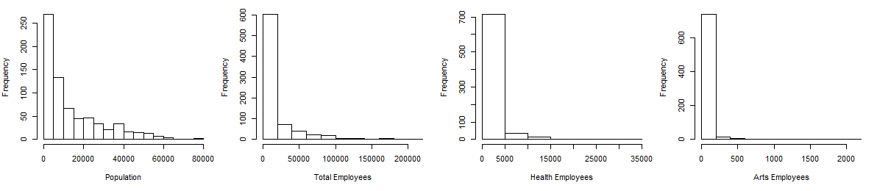

Figure S1: NC zip code population and estimates of industry employees by nonprofit industry category.

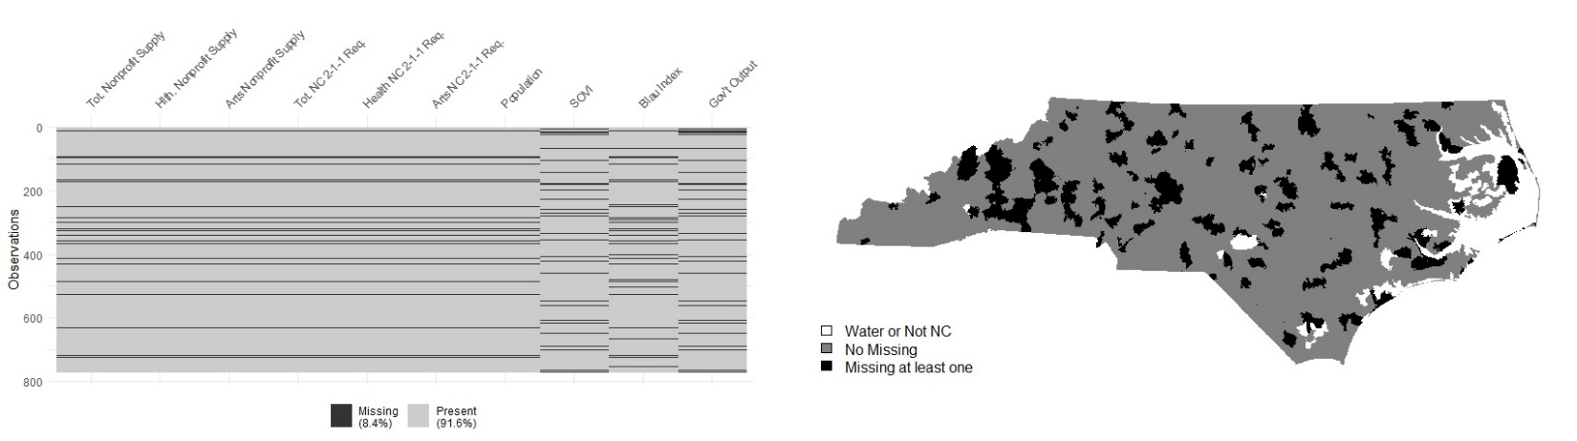

Figure S2: Visualization of variable missingness

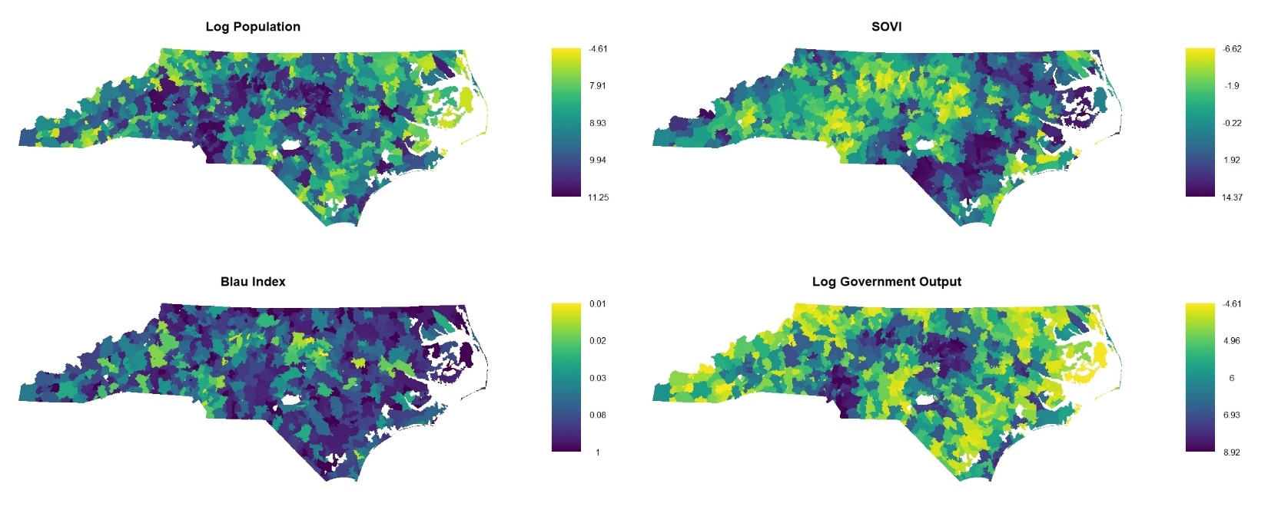

Figure S3: Choropleth maps of the common independent variables, after imputation

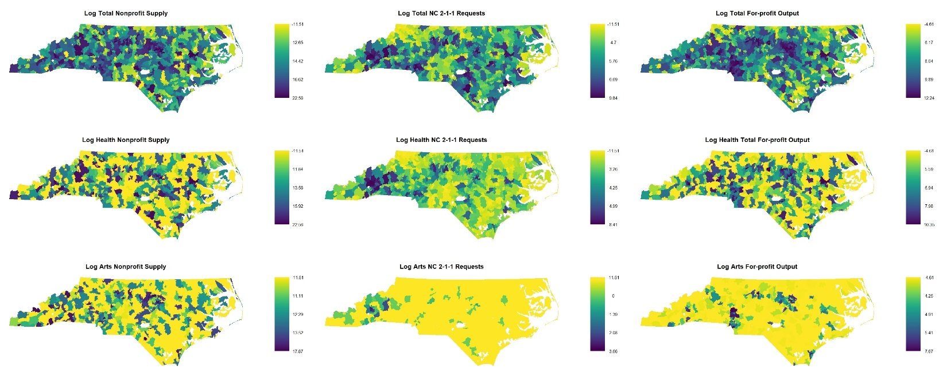

Figure S4: Choropleth maps of the nonprofit subsector-specific variables, after imputation

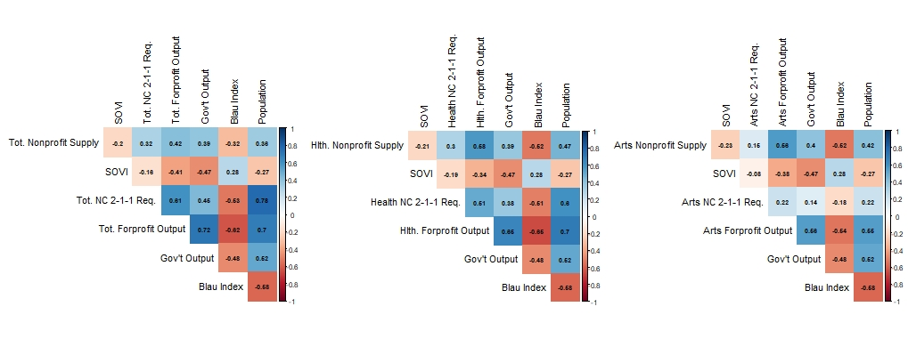

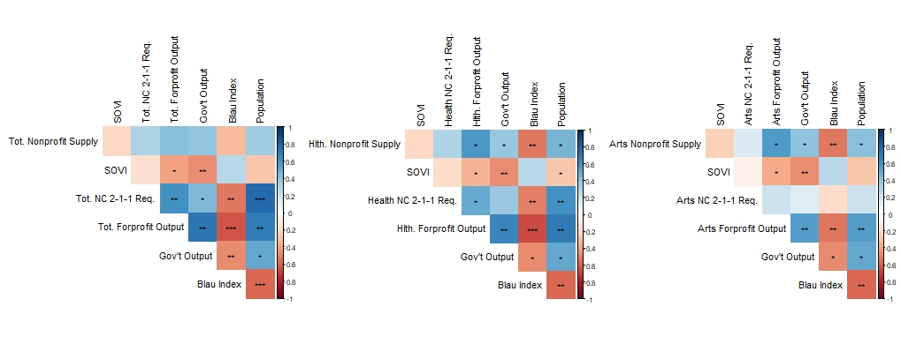

Figure S5: Correlation matrix of independent and dependent variables by nonprofit industry category, after imputation (significance codes: * 0.1, ** 0.05, *** 0.01).

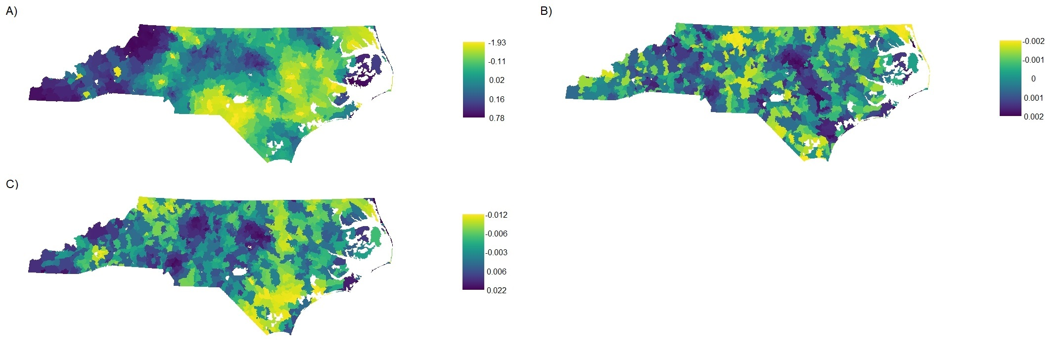

Figure S6: Correlated spatial random effects from each of the nonprofit categories.

1. Supplemental Tables

Table S1: Number of missing zip codes per variable

|  |  |  |
| --- | --- | --- |
| Variable | # Missing | % Missing |
| Total Nonprofit Supply | 66 | 8.6% |
| Health Nonprofit Supply | 66 | 8.6% |
| Art Nonprofit Supply | 66 | 8.6% |
| Total NC 2-1-1 Requests | 66 | 8.6% |
| Health NC 2-1-1 Requests | 66 | 8.6% |
| Arts NC 2-1-1 Requests | 66 | 8.6% |
| Population | 66 | 8.6% |
| SOVI | 48 | 6.2% |
| Blau Index | 90 | 11.7% |
| Government Output | 49 | 6.4% |
| Total For-profit Output | 0 | 0% |
| Health For-profit Output | 0 | 0% |
| Arts For-profit Output | 0 | 0% |

Table S2: Moran’s I metrics and significance values.

|  |  |  |  |
| --- | --- | --- | --- |
| Variable | Moran’s I | Z score | P value |
| Total Nonprofit Supply | 0.093 | 4.00 | <0.001 |
| Health Nonprofit Supply | 0.140 | 5.90 | <0.001 |
| Arts Nonprofit Supply | 0.163 | 6.89 | <0.001 |
| Total NC 2-1-1 Requests | 0.294 | 12.52 | <0.001 |
| Health NC 2-1-1 Requests | 0.219 | 9.28 | <0.001 |
| Arts NC 2-1-1 Requests | 0.241 | 10.22 | <0.001 |
| Population | 0.192 | 8.22 | <0.001 |
| SOVI | 0.523 | 22.02 | <0.001 |
| Total For-profit Output | 0.272 | 11.48 | <0.001 |
| Health For-profit Output | 0.189 | 7.98 | <0.001 |
| Arts For-profit Output | 0.310 | 13.01 | <0.001 |
| Blau Index | 0.244 | 10.30 | <0.001 |
| Government Output | 0.483 | 20.37 | <0.001 |

Table S3: Variance inflation measures for each dependent variable by nonprofit industry category

|  |  |  |  |
| --- | --- | --- | --- |
| Parameter | Total | Health | Arts |
| Community Demand |  |  |  |
| SOVI | 1.32 | 1.28 | 1.31 |
| NC 2-1-1 Requests | 2.67 | 1.68 | 1.07 |
| Market Supply |  |  |  |
| For-profit Output | 3.31 | 2.94 | 1.85 |
| Government Output | 2.25 | 2.00 | 1.82 |
| Blau Index | 1.78 | 1.92 | 1.72 |
| Population | 3.29 | 2.43 | 1.83 |