Conda

* Conda is an open-source package management system and environment management system
* Quickly installs, runs, and updates packages and their dependencies.
* Easily creates, saves, loads, and switches between environments on your local computer.
* It was created for Python programs but it can package and distribute software for any language.

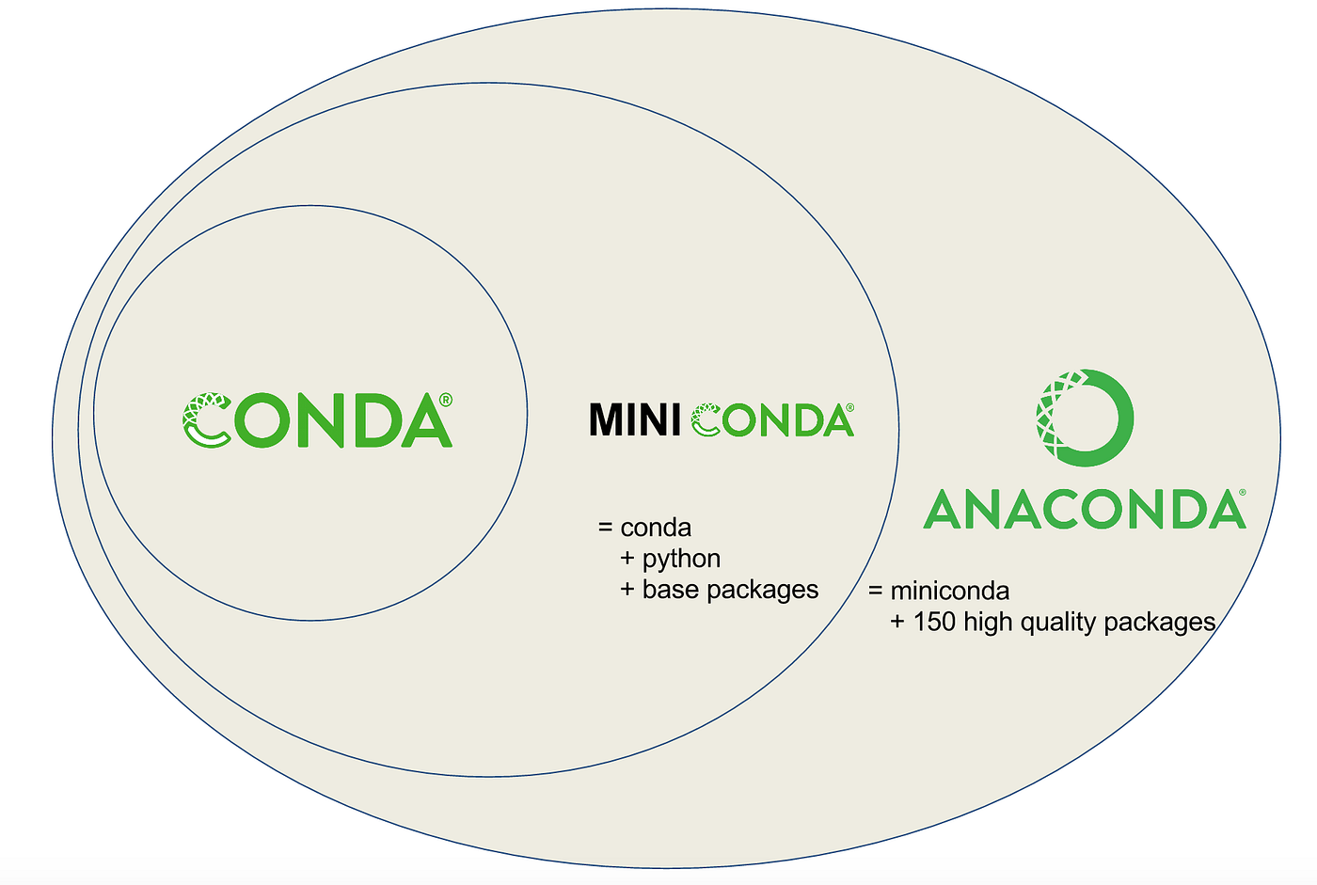

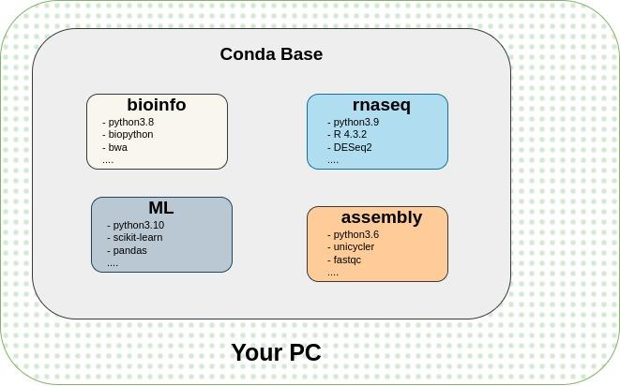

# Managing conda

## 01: Verify that conda is installed and Check its version:

|  |
| --- |
| conda --version  # or,  conda -V  # More Details  conda info |

## 02: Update conda to Current Newest Version

|  |
| --- |
| conda update conda -y |

# Managing Environments

## 03: Create a new environment and install a package in it

|  |
| --- |
| conda create --name bioinfo biopython -y |

## 04: To Activate an Environment

|  |
| --- |
| conda activate environmnetName |

The active environment is also displayed in front/top of your prompt in (parentheses) or [brackets] like this:



## 05: Deactivate Current Environment and Go To Base

|  |
| --- |
| conda deactivate |

## 06: List the Name of All Environments

|  |
| --- |
| conda info –-envs  # or,  conda env list |

# Managing Python

## 07: Create a new environment named "snakes" that contains Python 3.9

|  |
| --- |
| conda create --name snakes python=3.9 |

## 08: Check which python is used by your env

|  |
| --- |
| which python |

## 

## 09: Verify which version of Python is in your current environment

|  |
| --- |
| python --version |

## 

## Managing Packages

## 10: Install this package into the current environment

|  |
| --- |
| conda install packageName |

## 11: List all packages installed in the current environment

|  |
| --- |
| conda list |

## 