TPRV +ve CSF Sample DNA libraries working outline

TPRV Batch: 04

NextSeq Batch 17

# Sample Summary

**NextSeq Batch: 17**

**Loading Date: 24-Dec-2022**

A total of 7 samples (+ 1 EC) were extracted in this batch.

|  |  |  |  |  |  |  |  |  |
| --- | --- | --- | --- | --- | --- | --- | --- | --- |
| **Extraction Sl** | **Lib Sl.** | **StudyID** | **year** | **month** | **Sample vol** | **PBS vol** | **Remarks** | **CSF_Tetra_Seq ID** |
| 1 | 1 | 11805018322 | 2018 | 5 | 190 | 10 |  | CSF_0071_TP4 |
| 2 | 2 | 12202010981 | 2022 | 2 | 200 | 0 |  | CSF_0072_TP4 |
| 3 | 3 | 12204021111 | 2022 | 4 | 200 | 0 |  | CSF_0073_TP4 |
| 4 | 4 | 11901003831 | 2018 | 12 | 200 | 0 | Reddish | CSF_0074_TP4 |
| 5 | 5 | 11909031583 | 2019 | 9 | 110 | 90 |  | CSF_0075_TP4 |
| 6 | 6 | 11908033342 | 2019 | 8 | 180 | 20 | Reddish | CSF_0076_TP4 |
| 7 | 7 | 11905005291 | 2019 | 4 | 155 | 45 |  | CSF_0077_TP4 |
|  | EC |  |  |  | 200 |  | Water | CSF_TPRV_Batch04_EC1 |

# Set: 01

## Date: 17-Dec-2022

**Lab person: Anisur**

### Step 01: Extraction and Pool PCR

**Extraction Protocol: QIAamp DNA mini kit (Protocol: DNA Purification from Blood or Body Fluids)**

We did spin the serum samples first at **4k rpm for 10 mins** before starting the extraction.

A total of 7 **samples + 1 EC** were extracted for DNA.

* **Checkpoint: After PCR, the products were stored in –80C.**

## Date: 18-Dec-2022

**Lab person: Anisur**

#### Multiplex PCR:

We used 10uM diluted TPRV specific **pool-1** and **pool-2** PCR primer for this step.

After DNA extraction, Multiplex PCR was done using pool-1 and pool-2 primers. **NEBNext® Ultra™ II Q5® Master Mix (M0544)** was used for amplification.

* The PCR and library prep protocol was adapted from the [ARTIC-NEB: SARS-CoV-2 Library Prep V.4](https://www.protocols.io/view/artic-neb-sars-cov-2-library-prep-bp2l6n69rgqe/v4) protocol.

#### DNA Concentration:

Our target was to take around 22 ng DNA input (as per Biohub recommendation). Though protocol suggests picking **1.25 ul** for DNA (**+ 3 ul of water**), as the DNA concentration of most of the samples was quite low, we took full **4.25 ul** volume of DNA.

|  |  |  |  |  |  |  |  |
| --- | --- | --- | --- | --- | --- | --- | --- |
| **Specimen ID** | **1000F** | **10F** | **Raw** | **DNA input (ng)** | **DNA vol (ul)** | **Water (ul)** | **Remarks** |
| 11805018322 |  |  | 2.08 | 8.84 | 4.25 |  |  |
| 12202010981 |  |  | 0.688 | 2.924 | 4.25 |  |  |
| 12204021111 |  |  | too low | #VALUE! | 4.25 | 3 |  |
| 11901003831 |  |  | 0.952 | 4.046 | 4.25 |  | Reddish |
| 11909031583 |  |  | 0.498 | 2.1165 | 4.25 |  |  |
| 11908033342 | 0.732 | 73.2 |  | 91.5 | 1.25 | 3 | pick from 10F |
| 11905005291 |  |  | too low | #VALUE! | 4.25 |  |  |
| EC |  |  | too low |  | 1.25 | 3 |  |

**Master mix and template calculation:**

|  |  |  |
| --- | --- | --- |
|  | 0.5 rxn | 0.5 rxn |
| **Component** | **Pool 1 (ul)** | **Pool 2 (ul)** |
| NEBNext Ultra II Q5 Hot Start 2x master mix | 6.25 | 6.25 |
| Primer pool | 2 | 2 |
| Water | 0 | 0 |
| Template | 4.25 | 4.25 |
| Total | 12.5uL | 12.5uL |

**PCR profile:**

|  |  |  |  |
| --- | --- | --- | --- |
| **Step** | **Temp** | **Time** | **Cycles** |
| Heat Activation | 98 °C | 30s | 1 |
| Denaturation | 98 °C | 15s | 30 |
| Annealing | 64 °C | 05 min |
| Hold | 4 °C | ∞ |  |

**Lid: 105°C**

### Step 02: Gel Electrophoresis

* 1.5% gel
* 100 V
* 400 mA
* 55 mins

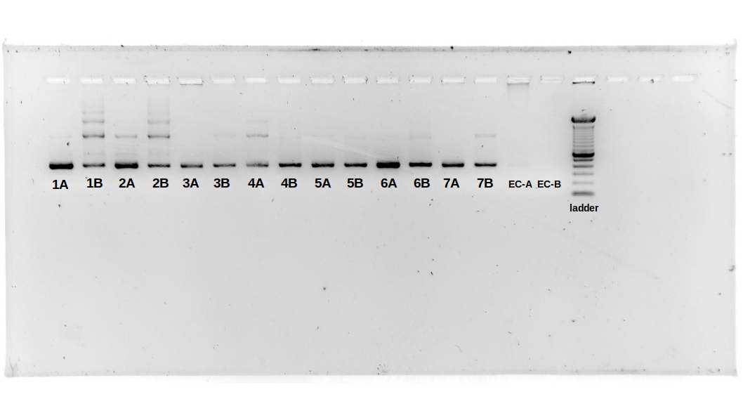

After getting the gel image, we decided to select all samples for library prep.

### Step 03: Pool and SPRI (Magnetic Bead Purification) Clean

* Used SPRI bead **1x ratio** of beads-to-total volume of sample.
* Elution: 36ul from 40ul water.

## Date: 19-Dec-2022

**Lab person: Anisur**

### Step 04: Normalization

After measuring the DNA concentration by Qubit, we normalized the volumes to take **10-100ng** DNA input in **13ul** volume.

|  |  |  |  |  |  |  |  |  |
| --- | --- | --- | --- | --- | --- | --- | --- | --- |
| **Set no** | **Batch Sl** | **Specimen ID** | **DNA (100-fold) quantification with Qubit** | **DNA (10-fold) quantification with Qubit** | **Calculated DNA conc (Raw) ul** | **Need for normalization (8ng/ul; 13 ul; total 104ng DNA)_10F** | **Water (to make 13 ul)** | **Pick from** |
| Set-1 | 1 | 11805018322 | 0.888 | 8.88 | 88.8 | 11.71 | 1.29 | 10F |
| 2 | 12202010981 | 1.12 | 11.2 | 112 | 9.29 | 3.71 | 10F |
| 3 | 12204021111 | 0.808 | 8.08 | 80.8 | 12.87 | 0.13 | 10F |
| 4 | 11901003831 | 0.976 | 9.76 | 97.6 | 10.66 | 2.34 | 10F |
| 5 | 11909031583 | 0.474 | 4.74 | 47.4 | 2.19 | 10.81 | RAw |
| 6 | 11908033342 | 1.19 | 11.9 | 119 | 8.74 | 4.26 | 10F |
| 7 | 11905005291 | 0.63 | 6.3 | 63 | 1.65 | 11.35 | Raw |
| EC |  | 0.022 | 0.22 | 2.2 | 1.00 | 12.00 | 10F |

### Step 05: Fragmentation

|  |  |
| --- | --- |
| **Reagent** | **0.5x rxn** |
| Normalized DNA (10-100ng) | 13 |
| (Yellow) NEBNext Ultra II FS Reaction Buffer | 3.5 |
| (Yellow) NEBNext Ultra II FS Enzyme mix | 1 |
| Total volume | 17.5 |
| Aliquote per tube | 4.5uL |

**PCR profile:**

|  |  |  |
| --- | --- | --- |
| **Step** | **Temp** | **Time** |
| Fragmentation | 37°C | 5 min |
| Enzyme Deactivate | 65°C | 30 min |
| Hold | 4 °C | **∞** |
| **Lid: 75°C** |  |  |

### Step 06: Adapter Ligation

|  |  |
| --- | --- |
| **Reagent** | **0.5x rxn** |
| FS Reaction Mixture | 17.5 |
| (Red) NEBNext Ultra II Ligation Master Mix* | 15 |
| (Red) NEBNext Ligation Enhancer | 0.5 |
| (Red) NEBNext Adaptor for Illumina (1:100 dilution) ** | 1.25 |
| Total volume | 34.25 |
| Aliquote per tube | 15.5 |

**\*This Master Mix is very thick, taking all volume altogether results in loss of volume. So, take to total volume in small aliquots.**

**\*\*Add adapter separately from the master mix to avoid adapter dimers.**

**PCR Profile:**

|  |  |  |
| --- | --- | --- |
| **Steps** | **Temp** | **Time** |
| Step 1 | 20°C | 15 min |
| Hold | 4 °C | **∞** |
| **Lid: Heat off** |  |  |

### Step 07: SPRI (Magnetic Bead Purification) Clean

* Used SPRI bead **0.9x ratio** of beads-to-total volume of sample.

|  |  |
| --- | --- |
| Bead Volume | 30.83ul |
| Elution | 7.5ul from 9ul water |

* **Checkpoint: Adapter ligated products were stored in -20°C.**

## Date: 20-Dec-2022

**Lab person: Anisur**

### ***Step 08: PCR Enrichment / Barcoding***

|  |  |  |
| --- | --- | --- |
| **Reagent** | **0.5x rxn** | Aliquot |
| Purified, adaptor-ligated cDNA | 7.5 |  |
| (white) USER Enzyme (Cat no. M5505L, 250uL) | 1.5 | **14** |
| (blue) NEBNext Ultra II Q5 master mix | 12.5 |
| 5uM i7 barcoded primer (NEB index primer/TruSeq/or similar) | 5* |  |
| 5uM i5 barcoded primer (NEB Universal primer/TruSeq/or similar) |  |
| Total volume | **26.5** |  |

**\*Barcode was added separately to each sample.**

**Barcode Layout:**

|  |  |  |  |  |  |
| --- | --- | --- | --- | --- | --- |
| **Set no** | **Batch Sl** | **Specimen_ID** | **CSF_Tetra_Seq ID** | **Barcode layout** | **Barcode plate** |
| Set-1 | 1 | 11805018322 | CSF_0071_TP4 | A07 | IDT-1446944+945 |
| 2 | 12202010981 | CSF_0072_TP4 | B07 | IDT-1446944+945 |
| 3 | 12204021111 | CSF_0073_TP4 | C07 | IDT-1446944+945 |
| 4 | 11901003831 | CSF_0074_TP4 | D07 | IDT-1446944+945 |
| 5 | 11909031583 | CSF_0075_TP4 | E07 | IDT-1446944+945 |
| 6 | 11908033342 | CSF_0076_TP4 | F07 | IDT-1446944+945 |
| 7 | 11905005291 | CSF_0077_TP4 | G07 | IDT-1446944+945 |
| EC |  | CSF_TPRV_Batch04_EC1 | H07 | IDT-1446944+945 |

**PCR Profile:**

|  |  |  |  |
| --- | --- | --- | --- |
| **Steps** | **Temp** | **Time** | **Cycle** |
| Step 1 | 37°C | 15 min | 1 |
| Step 2 | 98°C | 30 sec | 1 |
| Step 3 | 98°C | 30 sec | 12 |
| 65°C | 75 sec |
| Step 4 | 65°C | 5 min | 1 |
| Hold | 4 °C | **∞** |  |

**Lid: 105°C**

### ***Step 09: 0.8x SPRI (Magnetic Bead Purification) Clean***

* Used SPRI bead **0.8x ratio** of beads-to-total volume of sample.

|  |  |
| --- | --- |
| Bead Volume | 21.2ul |
| Elution | 25ul from 27ul water |

### ***Step 10: 0.75x SPRI (Magnetic Bead Purification) Clean***

* Used SPRI bead **0.75x ratio** of beads-to-total volume of sample.

|  |  |
| --- | --- |
| Bead Volume | 18.75ul |
| Elution | 15ul from 17ul water |

* **Checkpoint: Barcoded purified products were stored in -80°C.**

# Equi-conc

## Date: 24-Dec-2022

**Lab person: Anisur**

|  |  |  |  |  |  |  |
| --- | --- | --- | --- | --- | --- | --- |
| **Set no** | **Batch Sl** | **Qubit (ng/uL) after 20-fold dilution** | **Qubit (ng/uL) after 10-fold dilution** | **Original Conc** | **Volume picked (Desired DNA input 7ng) from Raw_Qubit** | **Decision for Pick** |
| Set-1 | 1 | too low | 0.152 | 1.52 | 4.61 | Raw |
| 2 | 0.134 | 0.268 | 2.68 | 2.61 | Raw |
| 3 | 0.138 | 0.276 | 2.76 | 2.54 | Raw |
| 4 | 0.136 | 0.272 | 2.72 | 2.57 | Raw |
| 5 | 0.146 | 0.292 | 2.92 | 2.40 | Raw |
| 6 | too low | 0.388 | 3.88 | 1.80 | Raw |
| 7 | 0.258 | 0.516 | 5.16 | 1.36 | Raw |
| EC | too low |  |  | 0.5 | Raw |

**Note** we pooled all tetra libraries in a single tube.**

* Total Vol: 18.38ul
* Bead Vol: 13.785ul
* Elution : 15ul
* Pool conc: 1.01ng/ul (Raw)