This is the basic idea of the screens. Please take a look and send me a list of or questions. After the first step I will send to you others implementation.

1. The Goal of the project

The goal of the project is to create a multi-device application (android and iOS).

For the first part of the project we will create a login screen where the user will be validated and the main menu.

For each option of the menu the user will inform some information and submit it to be validated on our server.

1. Enviroment

RAD Studio Delphi 10

InterBase 2007

1. DataBase

* DataBase Name: CM
* Table: EMPLOYEEINF

(Pk) EMPLOYEEID : Integer NOT NULL

LOGINID : Varchar(15) NOT NULL

SURNAME : VARCHAR(20) NOT NULL

FIRSTNAME : VARCHAR(15) NOT NULL

PHOTO : BLOD

EMAIL : VARCHAR(538)

PHONE_MOBILE : VARCHAR(30)

e.g.

User

EMPLOYEEID : 1

LOGINID : rbar

SURNAME : Bar

FIRSTNAME : Ronaldo

* Table: Translation

LANGUAGE : INTEGER (1-English 2-French 3-Portuguese)

DESCRIPTION : VARCHAR(100)

The user can change the language any time.

 This is the official color for the company. Please change the color of the follow screens.

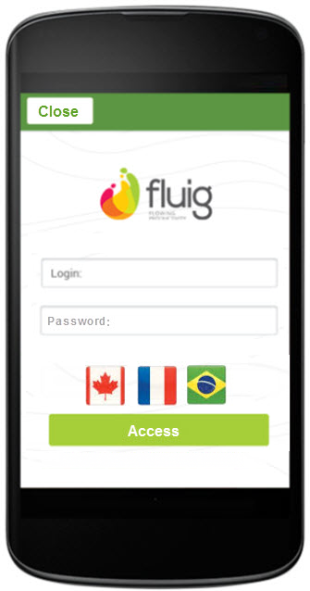

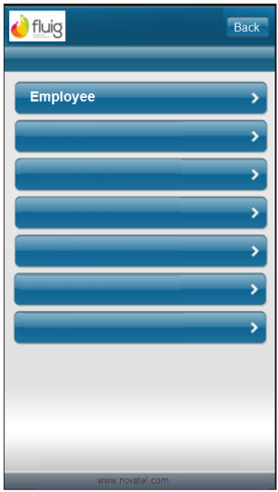

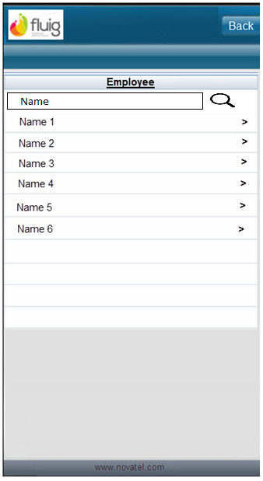

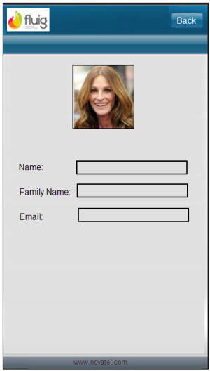

General Rules

|  |  |  |
| --- | --- | --- |
| # | Issue | Description |
| 1 | Time out | Consider a time out if the application is without utilization |
| 2 | Language | The user can change the language any time on any screen. We have three different buttons (flag) for each language. English, French and Portuguese.  Option for translation:   * Have all the file (table) translation on the device delivered with the application or translate it online when the user changes the screen. * If we decide to have the file on the device, on the next step We will need to develop a version system control to update the file. |
| 3 | Mobile vs IntraWeb | In the second step, we will develop an IntraWeb application. We can create these application on the same sub-project to share data modules and/or others units. |