All users have photos on the table, but only the first is shown.

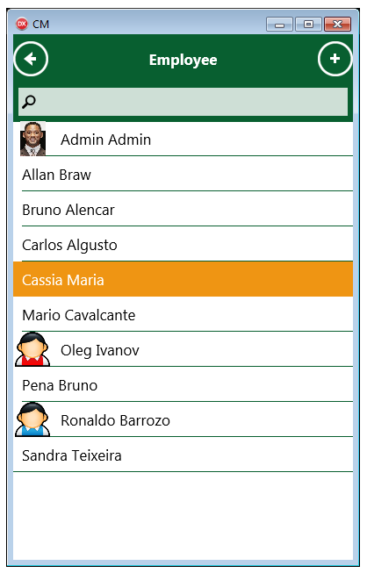

After choose a user, the application needs to search the information on the DB to show on the follow screen.

I updated the database but the information of the user was not updated on the app.

Need to show the photo of the user.

Review the functions ( add/edit/apply).

