Solution Submission Template

Name of the College/Institution: CSPIT, CHARUSAT
Student Name: CHOKSI PRERAK JIGNESHKUMAR
E-Mail ID: CHOKSIPRERAK1396@GMAIL.COM

Background
Online forums/discussion boards are of utmost importance to most of the students. Before posting a question on a forum there is a maximum probability that the same question would have been asked in a different way. The linguistic semantics is involved is such tasks. Rather than duplicating a question, it would be better to use the existing thread for getting your problem solved.
Our goal is to predict which of the provided pairs of questions contain two questions with the same meaning.

Scope
- Works for English language only.

Out of Scope
- Won’t work for any other language other than English.

Solution Approach
- Firstly question are processed and words like won’t, can’t are converted to willnot, cannot, etc. This ensures that our LSTM don’t learn new things from this similar features.
- Words which occur more than 100 times in the train set are collected. The rest is considered as rare words and replaced by the word "memento" irrelevant to almost anything, it acts as a placeholder.
- How many of the rare words are common in the both pairs and how many of them are numeric are used as features. This whole process leads to better generalization in LSTM so that it cannot overfit particular pairs by just using these rare words.
- The features mentioned above are merged with NLP and non-NLP features. As a result, 4+15+6=25 features are prepared for the network.
- The train data is divided into 10 folds. In every run, one fold is kept as the validation set for early stopping. So, every run uses 1 fold different than the other for training which can contribute to the model variance. Since we are going to ensemble the models, increasing model variance reasonably is something we may want.
- Finally post process of data is done.

Technical Architecture
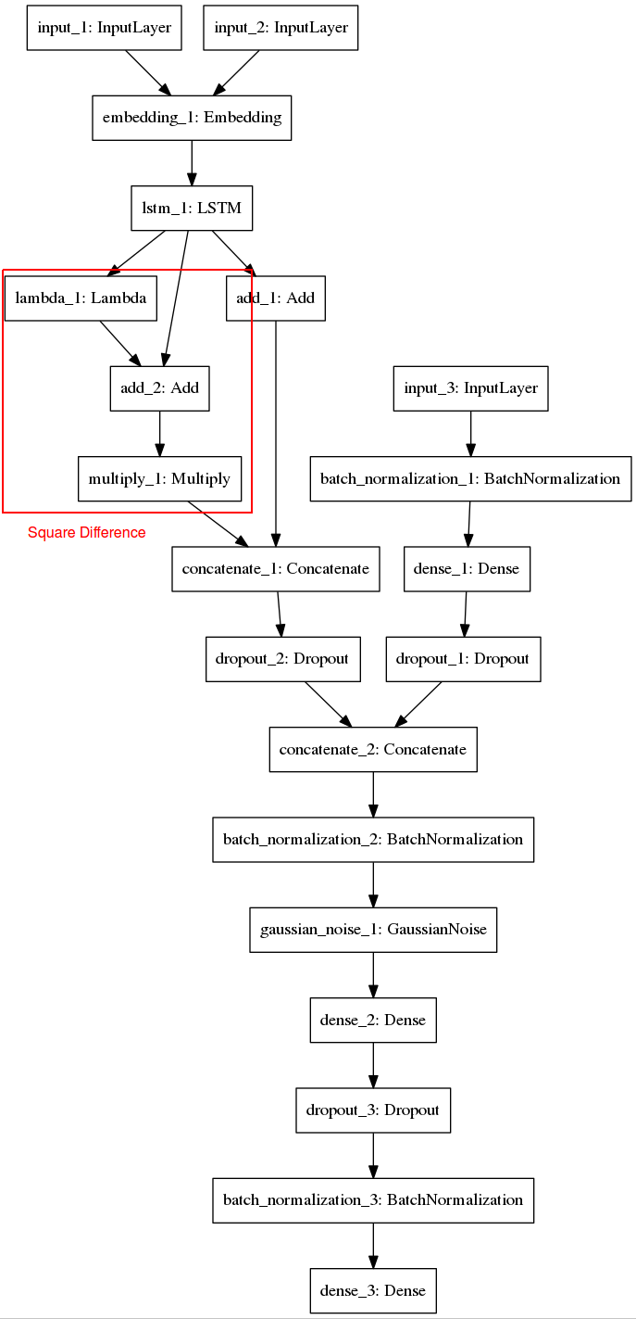

Source: https://github.com/aerdem4/kaggle-quora-dup/blob/master/model.png

Implementation Framework
General Implementation Approach
Includes Hardware and Software Details
Used pre-trained word vectors available at https://nlp.stanford.edu/projects/glove/ ie glove.840B.300d.txt

- Solution Submission

References

https://www.linkedin.com/pulse/duplicate-quora-question-abhishek-thakur/
https://en.wikipedia.org/wiki/Quora
https://www.kaggle.com/c/quora-question-pairs
https://engineering.quora.com/Semantic-Question-Matching-with-Deep-Learning
https://pdfs.semanticscholar.org/ff89/c3925581c9551323e9fd7deff699fa149dcb.pdf
https://towardsdatascience.com/identifying-duplicate-questions-on-quora-top-12-on-kaggle-4c1cf93f1c30
https://github.com/howardyclo/Kaggle-Quora-Question-Pairs
https://github.com/camronkhan/quora_question_pairs/blob/master/quora_question_pairs.ipynb

