Prerak Chaudhari

**Performance Task: Log**

Day 1: June 12, 2017

* Completed the necessary code to establish communication between two computers on the same network.
* Completed the necessary code for the client to control the on-board led on the arduino via the server.
* Next Steps:
  + Make the client GUI.
  + Make the breadboard circuit(output devices only).

Day 2: June 13, 2017

* The client GUI is somewhat finished.
* There is an error saying that the network library constructor and methods do not exist.
* Next Steps:
  + Figure out why I’m getting the network library error and fix it.
  + Make the breadboard circuit(output devices only).

Day 3: June 14, 2017

* Fixed the network library error. I had to change the name of the processing files.
* Worked on the client GUI. The user can click on a button and turn the on-board light on the arduino on and off.
* Next Steps:
  + Add support for multiple LEDs in the GUI.
  + Make the breadboard circuit(output devices only).

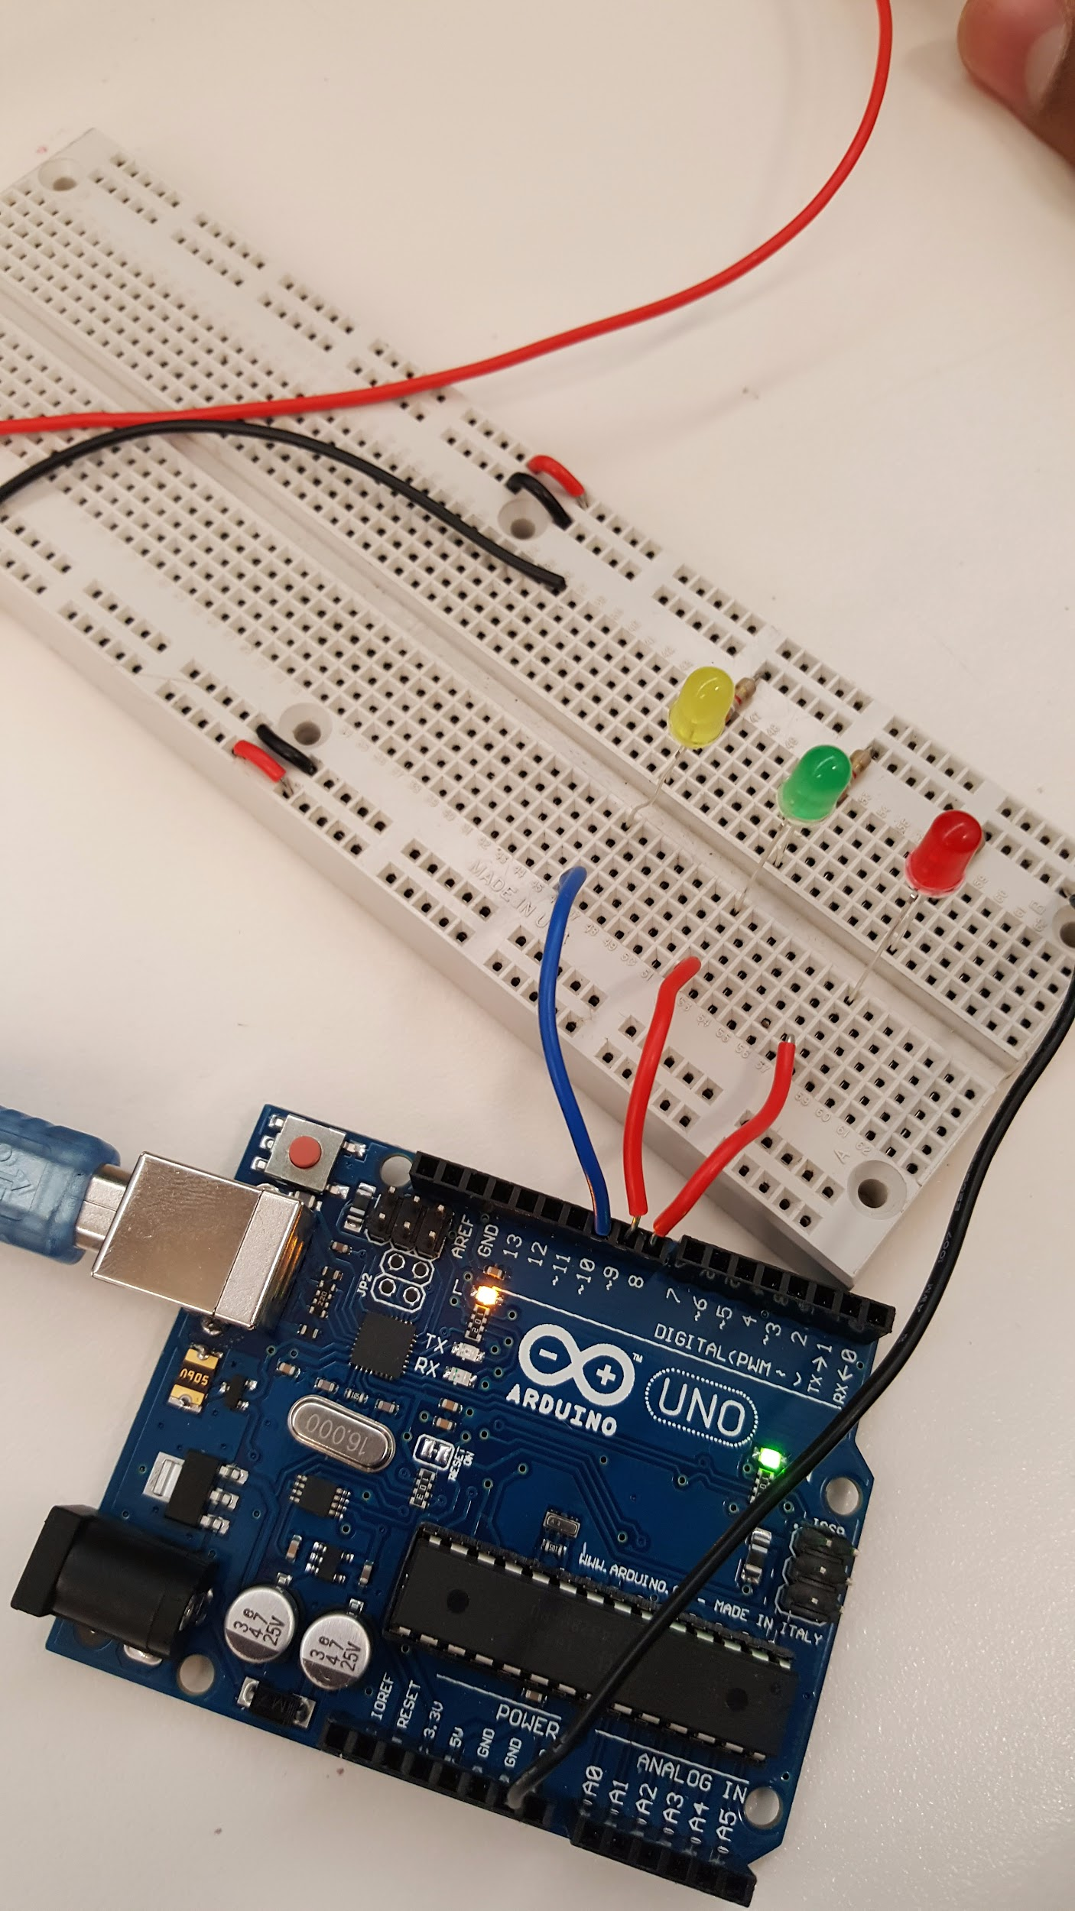

Day 4: June 15, 2017

* Tried to add support for 3 LEDs, but now none of the buttons work.
* Assembled breadboard circuit with three LEDs connected to the arduino.
* Next Steps:
  + Fix the program, adding support for all three LEDs.
  + Work on incorporating a sensor or two into the project.

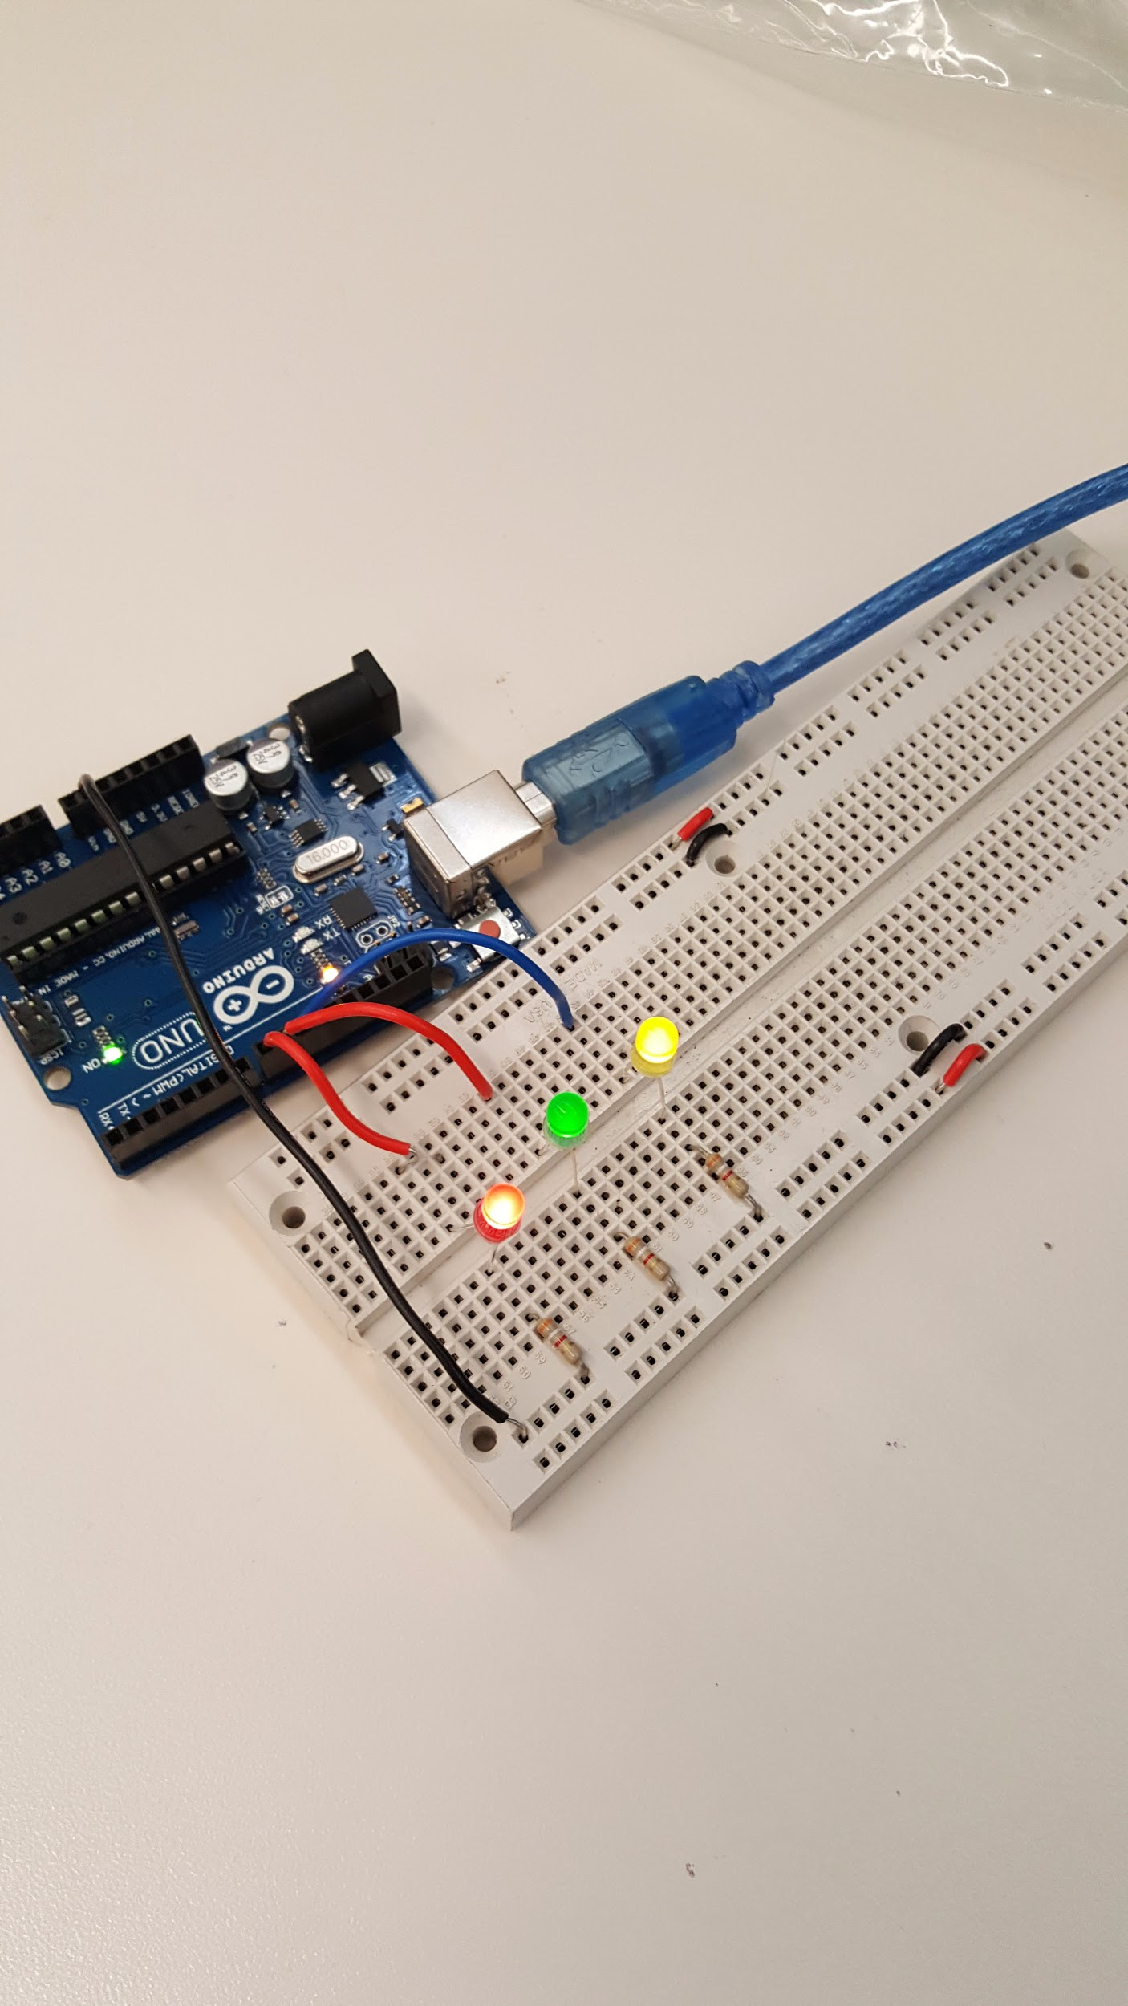

Day 5: June 16, 2017

* Added support for all three LEDs.
* Next Steps:
  + Continue working on the GUI, making it more aesthetically appealing.
  + Work on incorporating a sensor or two into the project.

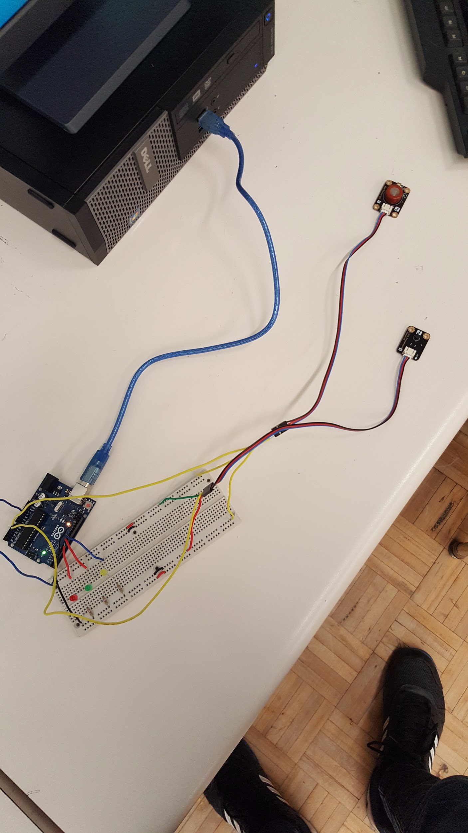

Day 6: June 19, 2017

* Incorporated a carbon monoxide and temperature sensor into the project.
  + The data readings from the sensors can be seen on the serial monitor in the arduino ide.
* Next Steps:
  + Continue working on the GUI, making it more aesthetically appealing.
  + Send the sensor data readings to the client, having it show up on the GUI.
  + Add in a function that receives the current states of the LEDs from the server when using the GUI so if an LED is already on when the program is started, the button is green rather than red.

Day 7: June 20, 2017

* The data readings from the sensors are now displayed on the client GUI.
* Sometimes, the program reads null instead of actual data readings.
  + Not a big issue so consider fixing it if you have time.
* Next Steps:
  + Continue working on the GUI, making it more aesthetically appealing.
  + Add in a function that receives the current states of the LEDs from the server when using the GUI so if an LED is already on when the program is started, the button is green rather than red.

Day 8: June 21, 2017

* Tried to add in the function that would receive the current states of the LEDs from the server but now the program doesn’t function properly. The temperature and CO readings are still working but the buttons no longer work.
* Next Steps:
  + Continue working on the GUI, making it more aesthetically appealing.
  + Either fix the buttons or remove the ability to receive the current LED states.

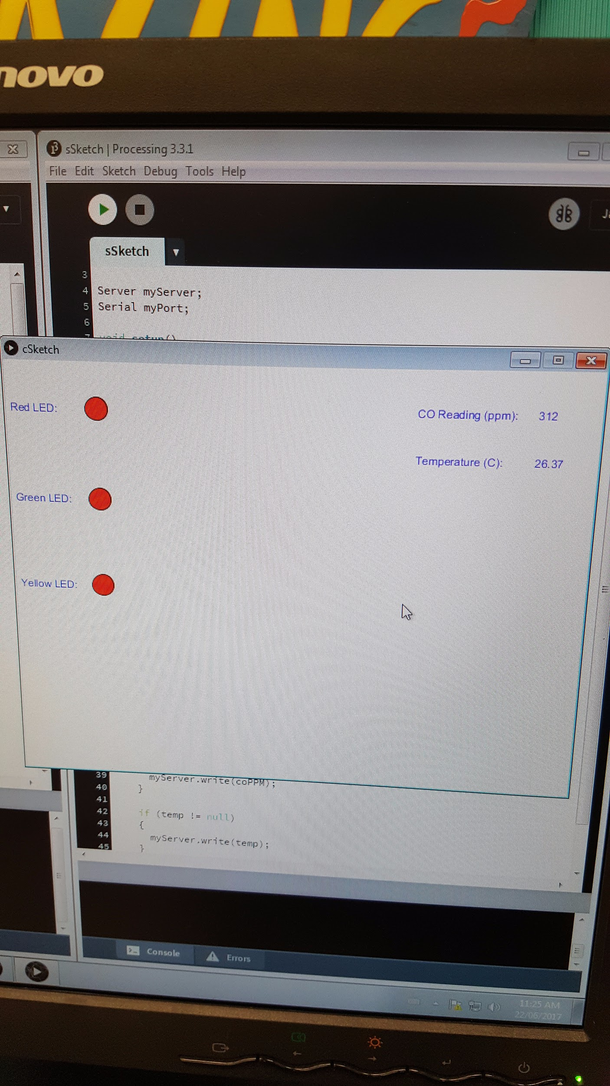

Day 9: June 22, 2017

* Decided to remove the function to receive the current LED states because the program would no longer work properly.
* Made the GUI more aesthetically appealing.
* Next Steps:
  + Trim and colour code the wires.