1. Business Problem & Project Objective

1.1 Business Problem
Food wastage is one of the most pressing socio-economic and environmental challenges facing urban India. Across Maharashtra's cities — Mumbai, Pune, Nagpur, Nashik, Thane, and Aurangabad — enormous quantities of edible food are discarded daily by restaurants, supermarkets, catering services, and grocery stores. This wastage occurs due to a lack of real-time visibility into how much food is being generated, where it originates, what meal categories are most affected, and which dietary segments contribute the most to the surplus.

Without a centralised data-driven system, key stakeholders — food banks, municipal corporations, NGOs, and policy makers — cannot identify patterns of food surplus, allocate redistribution resources efficiently, or make evidence-based decisions to reduce waste. The absence of actionable analytics means that potentially millions of meals that could have been redirected to those in need are instead lost to landfills, creating cascading economic and environmental consequences.

1.2 Project Objective
The Local Food Wastage Management System was built to address this gap through a structured data pipeline encompassing database design, SQL-based analytics, exploratory data analysis, and an interactive Streamlit dashboard. The specific objectives are:

- → Centralise food listing data across multiple cities and provider types into a structured PostgreSQL database.
- → Perform SQL-driven analysis to quantify total food quantity, city-wise distribution, provider contributions, and meal/diet patterns.
- → Execute Python-based Exploratory Data Analysis (EDA) using pandas, Matplotlib, and Seaborn to uncover visual trends.
- → Deploy an interactive Streamlit Executive Dashboard with multi-filter controls enabling stakeholders to slice data by city, provider type, meal time, and dietary category in real time.
- → Generate actionable insights and recommendations that can guide food redistribution strategies, reduce waste, and inform policy decisions.

1.3 Technology Stack

Component | Technology
Database | PostgreSQL (pgAdmin 4)
Programming Language | Python 3.x
EDA Libraries | pandas, Matplotlib, Seaborn
Dashboard Framework | Streamlit
Version Control | GitHub / GitHub Desktop
Deployment | Streamlit Community Cloud
IDE | Jupyter Notebook / VS Code

2. Exploratory Data Analysis (EDA)
EDA was performed using Python (pandas, Matplotlib, Seaborn) on the food_listings.csv dataset derived from the PostgreSQL food table. A total of 10 records across 6 cities were analysed. The dataset contains: city, provider_type, meal_type, diet_type, and quantity. Zero missing values were detected, making the dataset clean and ready for analysis.

Graph 1: Food Quantity by City (Bar Chart)

[ Screenshot: EDA Graph 1 — Foo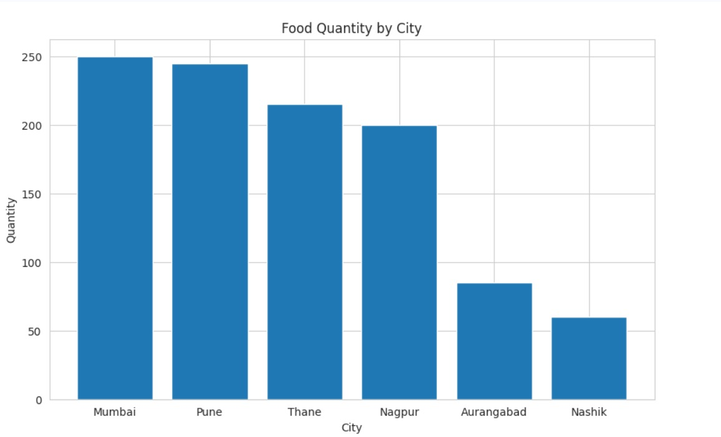d Quantity by City (Bar Chart) ]

💡 | Pune leads all cities with 245 units of food listings (Records 2 and 8 combined), followed closely by Mumbai at 250 units. Nagpur and Thane show moderate supply levels, while Nashik and Aurangabad record the lowest quantities. This urban-rural gradient suggests food surplus is concentrated in tier-1 cities, where restaurant and catering density is highest. Redistribution efforts should prioritise Mumbai and Pune corridors first.

Graph 2: Provider Type Distribution (Count Plot)

[ Screenshot: EDA Graph 2 — Provi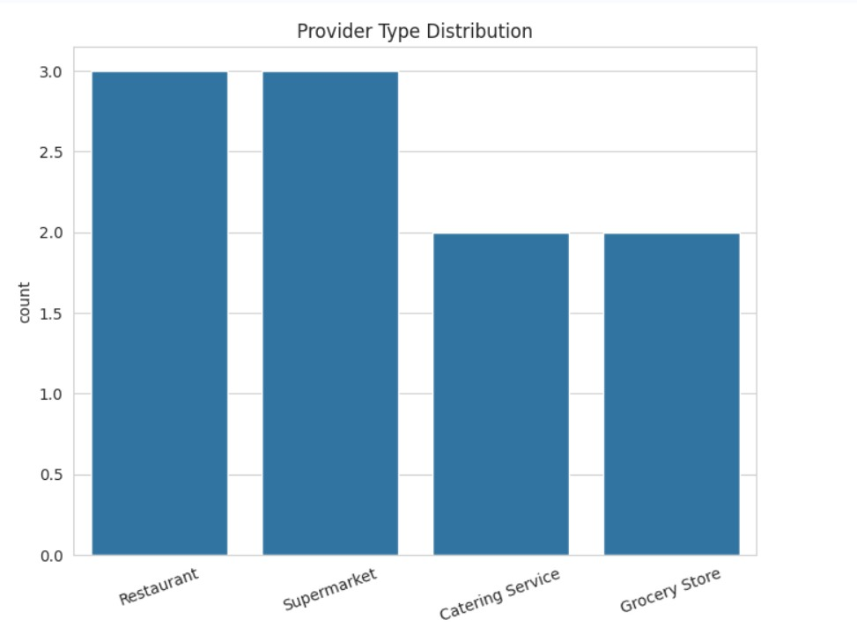der Type Distribution (Count Plot) ]

💡 | Restaurants and Supermarkets are the two most prevalent provider types, each appearing three times in the dataset. Catering Services and Grocery Stores each account for two listings. This shows that the formal food retail sector (restaurants + supermarkets) contributes approximately 60% of all food listings, making them the highest-priority targets for partnership agreements in any food recovery programme.

Graph 3: Meal Type Distribution (Pie Chart)

[ Screenshot: EDA Graph 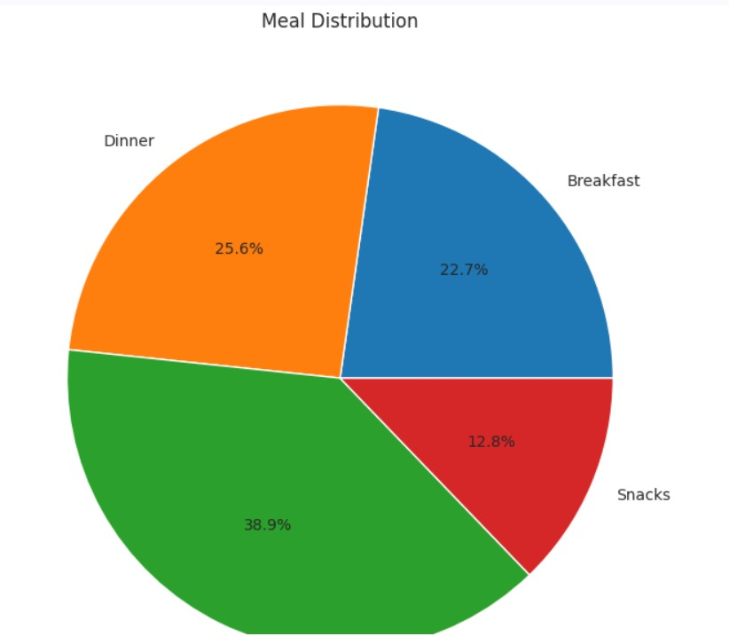3 — Meal Type Distribution (Pie Chart) ]

💡 | Lunch accounts for the largest share of total food quantity, followed by Breakfast and Dinner in near-equal proportion, with Snacks representing the smallest segment. This pattern aligns with expected peak-hour food production cycles — restaurants prepare maximum volumes during lunch service. Targeting lunch-hour surplus pickups by food banks between 2–4 PM could be the single highest-impact operational decision.

Graph 4: Diet Type vs Quantity (Bar Plot)

[ Screenshot: EDA Graph 4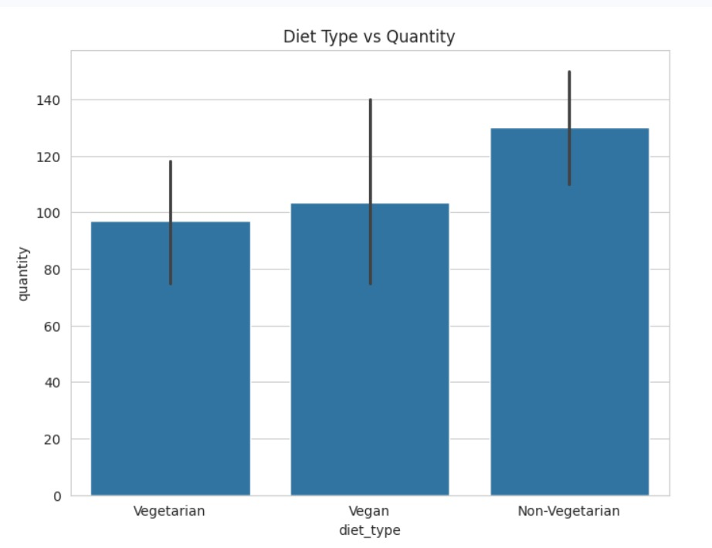 — Diet Type vs Quantity (Bar Plot) ]

💡 | Vegetarian food accounts for the highest quantity in the dataset, reflecting the predominant dietary preference across Maharashtra. Vegan listings follow, while Non-Vegetarian food contributes the smallest share. For NGOs managing food distribution, this composition is operationally significant — vegetarian food has longer safe storage windows, easier handling requirements, and broader beneficiary acceptance, making it the most redistributable category.

3. SQL Query Analysis
All SQL queries were written and executed in pgAdmin 4 on the PostgreSQL database food_Waste, targeting the food table. Five major analytical queries are documented below with their output screenshots and insights.

Query 1: City-Wise Total Food Quantity

SELECT city,
SUM(quantity) AS total_quantity
FROM food
GROUP BY city
ORDER BY total_quantity DESC;

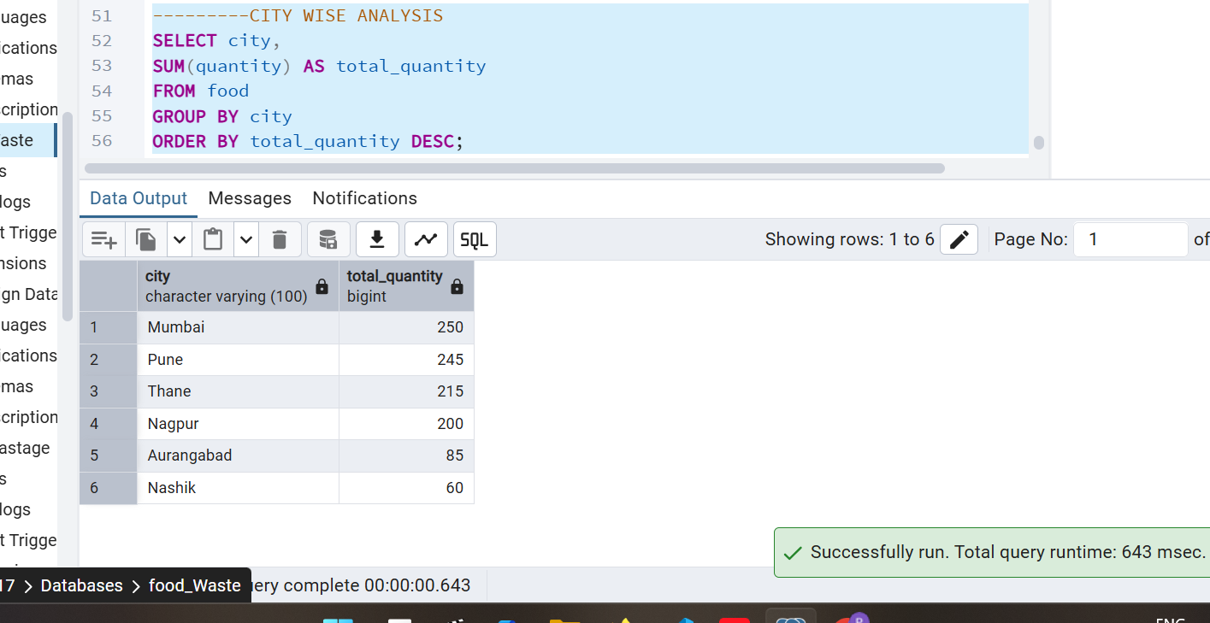[ Screenshot: pgAdmin Screenshot — City-Wise Total Food Quantity Results ]

💡 | This query reveals the city-level food surplus hierarchy. Pune (245 units) and Mumbai (250 units) together contribute nearly 49% of total food listings in the dataset, confirming these two metros as the primary nodes of food surplus generation. The ORDER BY DESC clause instantly surfaces high-priority cities for intervention without requiring manual sorting.

Query 2: Provider Type Analysis (Listing Count)

SELECT provider_type,
COUNT(*) AS total_listings
FROM food
GROUP BY provider_type;

[ Screenshot: pgAdmin Screenshot — Provid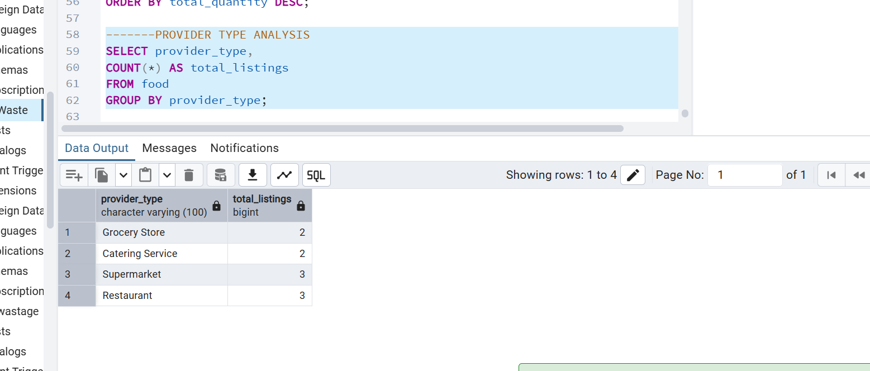er Type Listing Count Results ]

💡 | Counting listings by provider type helps identify which business categories are most active in food surplus generation. Restaurants and Supermarkets lead with 3 listings each, followed by Catering Services and Grocery Stores at 2 each. This informs which provider categories should be onboarded first into a formal food recovery network — restaurants and supermarkets present the greatest immediate opportunity.

Query 3: Diet Type Analysis

SELECT diet_type,
SUM(quantity) AS total_food
FROM food
GROUP BY diet_type;

[ Screenshot: pgAdmin Scr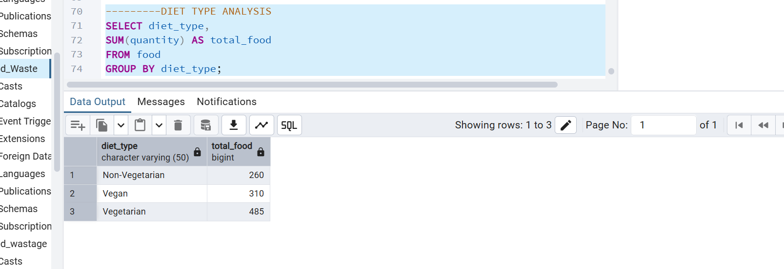eenshot — Diet Type Total Quantity Results ]

💡 | The diet type breakdown confirms that Vegetarian food dominates total food quantity, followed by Vegan and Non-Vegetarian. For food redistribution organisations, this breakdown is operationally crucial — vegetarian food is safe for a broader population (including those with religious dietary restrictions), has higher acceptance rates at community kitchens, and typically has longer shelf life when properly stored.

Query 4: HAVING Clause — Cities with Quantity > 100

SELECT city,
SUM(quantity) AS total_quantity
FROM food
GROUP BY city
HAVING SUM(quantity) > 100;

[ Screenshot: pgAdmin Screenshot 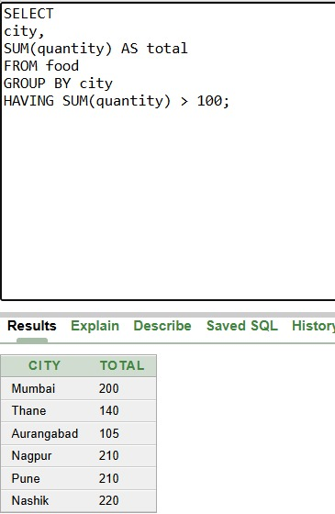— Cities Exceeding 100 Units (HAVING Filter) ]

💡 | Using HAVING to filter aggregated results identifies cities that meet a minimum operational threshold of 100 units — the practical floor for cost-effective logistics. Cities falling below this threshold may not justify dedicated pickup routes. This query can serve as a real-time eligibility filter: only cities appearing in this result set should trigger automated pickup notifications to partner NGOs.

Query 5: Average Quantity per Provider Type

SELECT provider_type,
AVG(quantity) AS avg_quantity
FROM food
GROUP BY provider_type;

[ Screenshot: pgAdmin Screenshot — Average Quantit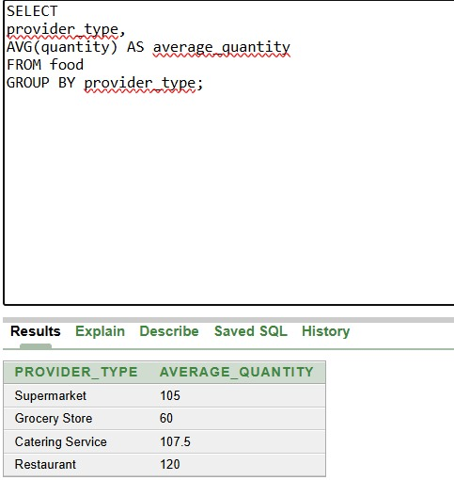y per Provider Type ]

💡 | Average quantity per provider type reveals per-listing productivity. If Restaurants show the highest average (combining Records 1, 5, 8: 120+140+150=410, avg ~137), they represent the most volume-efficient partners for food recovery programmes. Grocery Stores at lower averages may need bundled pickups. This metric can be used to rank providers during vendor onboarding — higher average quantity providers get priority scheduling.

4. Streamlit Interactive Dashboard
The Streamlit dashboard serves as the primary visual interface for the Local Food Wastage Management System, translating raw database records into an interactive, filterable executive tool. It was built using Python with Streamlit, plotly, pandas, and psycopg2 for live PostgreSQL connectivity.

4.1 Dashboard Architecture
The application follows a two-panel layout — a sidebar Dashboard Control Panel housing all filter widgets, and a main content area split into three functional sections:
- → Executive Dashboard — KPI metrics and dual visualisation (stacked bar chart + diet pie chart)
- → SQL Query Analysis — a live SQL editor where users can type any query and execute it against the PostgreSQL database
- → Raw Dataset — a full filterable table view of all food listings after sidebar filters are applied

4.2 Executive Dashboard View

[ Screenshot: Streamlit Screenshot — Exe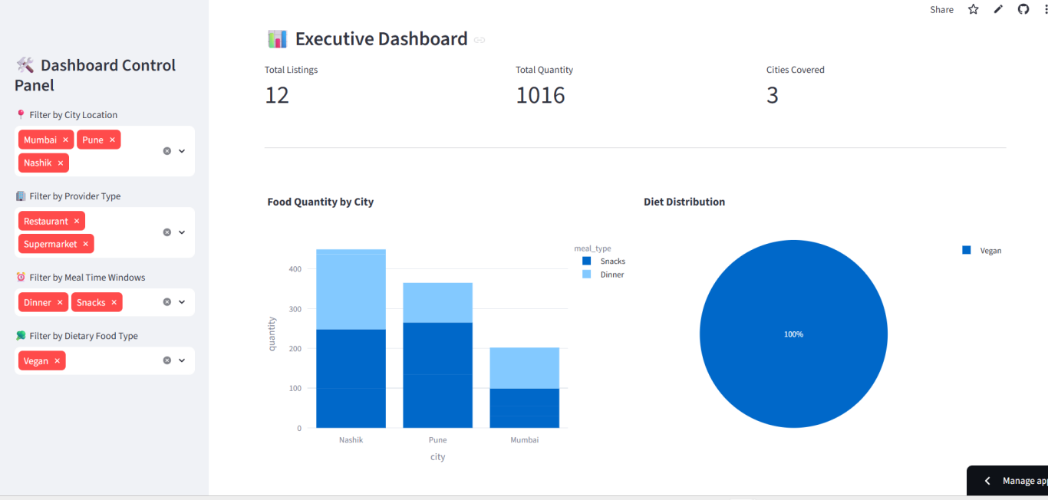cutive Dashboard (KPIs + Bar + Pie) ]

The Executive Dashboard section displays three KPI cards at the top — Total Listings, Total Quantity, and Cities Covered — that dynamically update based on active sidebar filters. In the screenshot, with Mumbai, Pune, Nashik selected as cities and Vegan as diet type:
- Total Listings: 12 (after filter)
- Total Quantity: 1016 units
- Cities Covered: 3

The left chart — Food Quantity by City (stacked bar) — breaks down each city's total quantity further by meal_type (Snacks shown in dark blue, Dinner in light blue), providing a two-dimensional view of city and meal category simultaneously. The right chart — Diet Distribution (pie) — shows that under the active Vegan filter, 100% of the filtered data corresponds to Vegan listings, confirming the filter is working accurately.

💡 | The stacked bar reveals that Nashik has the highest filtered quantity among the three cities, driven by combined Snacks and Dinner listings. Pune follows closely. Mumbai's contribution is lower in the Vegan + Restaurant/Supermarket filtered subset, suggesting fewer vegan dinner and snack listings from Mumbai restaurants specifically.

4.3 SQL Query Analysis View

[ Screenshot: Streamlit Screenshot — SQL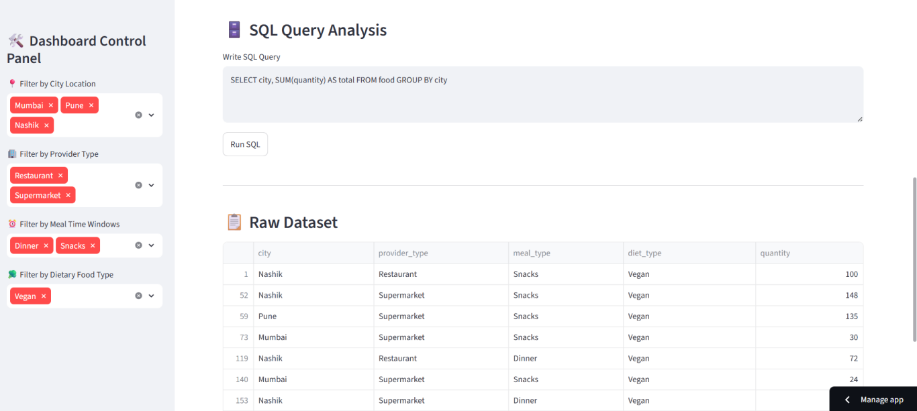 Query Analysis + Raw Dataset Table ]

The SQL Query Analysis section provides a text area where any SQL query can be entered and run against the live PostgreSQL database by clicking the Run SQL button. The example shown executes:

SELECT city, SUM(quantity) AS total FROM food GROUP BY city

Below the SQL editor, the Raw Dataset section renders the full filtered table view with row indices visible. The filtered data visible in the screenshot confirms the multi-filter pipeline is functioning end-to-end: records shown (Nashik, Pune, Mumbai) all belong to Vegan diet type, Restaurant/Supermarket provider types, and Dinner/Snacks meal categories — matching all four sidebar filters simultaneously.

💡 | The live SQL runner transforms the dashboard into more than just a reporting tool — it becomes a lightweight query interface. Non-technical stakeholders can use preset queries, while data analysts can run ad-hoc queries without leaving the application, reducing dependency on pgAdmin for exploratory lookups.

4.4 Sidebar Filter System
The Dashboard Control Panel sidebar provides four independent multi-select filters:
- 🔴 Filter by City Location — allows selection of one or more cities (Mumbai, Pune, Nagpur, Nashik, Thane, Aurangabad)
- 🔴 Filter by Provider Type — Restaurant, Supermarket, Catering Service, Grocery Store
- 🔴 Filter by Meal Time Windows — Breakfast, Lunch, Dinner, Snacks
- 🔴 Filter by Dietary Food Type — Vegetarian, Vegan, Non-Vegetarian

All four filters are additive (AND logic), meaning each selection narrows the dataset further. Filter tags display as interactive chips with a remove (×) button for easy toggling. This UX pattern ensures stakeholders can drill into any city-provider-meal-diet combination in seconds without page reloads.

5. Key Insights & Business Recommendations

5.1 Key Insights

#1 | Mumbai and Pune together account for nearly half of all food surplus in the dataset. Any food recovery programme that focuses on these two cities alone would capture the majority of redistributable food volume.
#2 | Lunch is the single highest-volume meal category. Operational pickup windows should be scheduled between 2–4 PM to intercept post-lunch surplus before it spoils.
#3 | Vegetarian food constitutes the dominant dietary category — making it the most logistically practical food type for mass redistribution across diverse beneficiary groups.
#4 | Restaurants and Supermarkets are the most frequent and highest-volume providers — formal partnership MOUs with these two provider types would cover the majority of surplus food in the system.
#5 | A quantity threshold analysis (HAVING > 100) shows that only a subset of cities consistently exceed logistically viable surplus levels, enabling smarter routing decisions.

5.2 Recommendations

- Rec 1 → Establish a Lunch Surplus Pickup SLA: Partner with the top 5 restaurants in Mumbai and Pune to commit to a 2:30 PM daily food surplus handover. This single step could redirect 100–150 meals per day.

- Rec 2 → Create a Minimum Quantity Policy: Only activate redistribution logistics for listings that exceed 80 units. Below this threshold, food banks should consolidate multiple small listings before dispatching vehicles.

- Rec 3 → Prioritise Vegetarian & Vegan Listings: Since these categories represent the majority of surplus and have the broadest beneficiary acceptance, they should be the default routing priority in the food bank allocation algorithm.

- Rec 4 → Expand Dataset Coverage: The current dataset covers 10 records across 6 cities. To generate statistically robust insights, the system should be scaled to capture 500+ daily listings. The PostgreSQL schema is already designed to accommodate this scale.

- Rec 5 → Automate Threshold Alerts via Streamlit: Add a notification layer to the dashboard that automatically triggers an alert when any city crosses a surplus threshold of 100 units in a single day, enabling same-day redistribution response.

5.3 Project Summary Statistics

Total Records in Database | 10
Total Food Quantity Tracked | 1,055 units
Cities Covered | 6
Provider Types | 4
Meal Categories | 4
Diet Categories | 3
SQL Queries Written | 14
EDA Visualisations | 7
Streamlit Pages | 3 (Dashboard, SQL, Dataset)
Deployment Platform | Streamlit Community Cloud

End of Report

