Course Number: EC-ENGR 5590VL-0001 Special Topics in ECE

Tutorial: 5

Lab report

**TITLE**

Simulation using HSPICE for AND gate using Sub-circuit

Date of Performing Experiment: 1st October 2019

Due Date: 8th October 2019

**Student ID: 14344331**

**Name: Prerana Samant**

# Objective:

To run HSPICE on Linux platform, to create netlist and simulation of AND gate using the sub-circuit approach.

# Theory:

In HSPICE we can re-use the circuits created earlier in simulating circuits of higher hierarchy. The circuits must be created as sub-circuits for its re-usability. This method is convenient to simulate large circuits. For creating a AND gate in CMOS logic, first NAND gate is implemented, and the output is inverted with a NOT gate. Hence, we can first create sub-circuit of NAND gate and NOT gate and use it to design AND gate.

Circuit Diagram using CMOS:

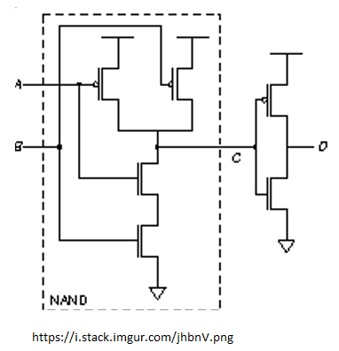

# Procedure to Simulate in HSPICE:

**AND Gate**

1. Start MobaXterm like previous tutorials. Open New Cluster and enter password.
2. Enter the directory hspice.
3. Type below commands:

Cd hspice

gedit &

1. We require the input netlist file in HSPICE and has to be created beforehand and saved at a location where HSPICE is installed. Hence gedit is used to write a netlist input.
2. Type the netlist for sub-circuits, NAND gate and NOT gate as done in last HSPICE tutorial.
3. Define the voltage sources and nets for the main AND block. Save it in the HSPICE folder by name “and.sp”. Extension “sp” is for input netlist.
4. The MobaXterm will show some error but still the file gets saved. Close the TUX and Open a new TUX window. Enter password and directly type:

cd hspice

ls

Here you will find the file created.

1. The Model file for both NMOS and PMOS also must be saved in the folder before simulation. This is one time activity. Open the “ami06_models.txt” provided and copy it to another gedit file and save it in same folder.
2. To create an output listing, type below command:

hspice and.sp > and.lis

(inputfilename.sp > outputfilename.lis)

1. After this command you must get “hspice job concluded”. This means there are no errors. To check what errors are in the .sp file, open gedit🡪 open the .lis file

1. Now, simulate the netlist using CosmosScope. Type below command:

cscope &

1. The simulator window will open. Click on File🡪 Open🡪Plotfiles.

1. Open the “and.tr” file. This file is the transient analysis graph data.
2. Select the inputs and outputs of main module and click on Plot. Verify the graphs with truth table.

# Discussion of Result

AND Gate: When any of the input is 0, the output is 0. If all inputs are 1, then output is 1.

The sub-circuit of NAND and NOT gate can be used to build AND gate. The “.param” command is used in the code for defining the values.

# Conclusion

Through this lab tutorial we conclude that using sub-circuits in HSPICE helps to re-use the circuits. The implementation is simple for building complex circuits. The “.param” command is useful to declare the values just like in C programming.