Course Number: EC-ENGR 5590VL-0001 Special Topics in ECE

Tutorial: 3

(Lab report + Homework)

**TITLE**

Simulation using HSPICE for NOT, NAND and NOR gates

Date of Performing Experiment: 17th September 2019

Due Date: 24th September 2019

**Student ID: 14344331**

**Name: Prerana Samant**

# Objective:

To run HSPICE on Linux platform, to create netlist and simulation of NOT, NAND and NOR gates using the netlists files.

# Theory:

SPICE stands for Simulation Program with Integrated Circuit Emphasis. HSPICE is a Synopsys tool for circuit simulations using netlist. This is simpler and easy way to simulate complex circuits if you know the circuit diagrams well. We require a model file for the components added in the netlist to simulate the circuit. We can view the results on CosmosScope. HSPICE does transient, steady-state and frequency analysis. Input netlist is required before beginning the simulation. Extension of input netlist is “.sp”, output listing is “.lis” and transient analysis file is “.tr”.

Circuit Diagram using CMOS:

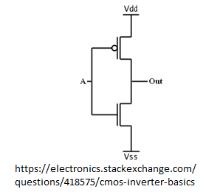 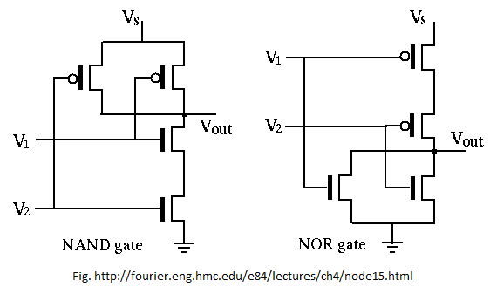

# Procedure to Simulate in HSPICE:

**NOT Gate**

1. Start MobaXterm like previous tutorials. Open New Cluster and enter password.
2. Create a directory for installing HSPICE in MobaXterm.
3. Type below commands:

Mkdir hspice

Cd hspice

gedit &

1. We require the input netlist file in HSPICE and has to be created beforehand and saved at a location where HSPICE is installed. Hence gedit is used to write a netlist input.
2. Type the netlist for NOT gate and save it in the HSPICE folder by name “inverter.sp”. Extension “sp” is for input netlist.
3. The MobaXterm will show some error but still the file gets saved. Close the TUX and Open a new TUX window. Enter password and directly type:

cd hspice

ls

Here you will find the file created.

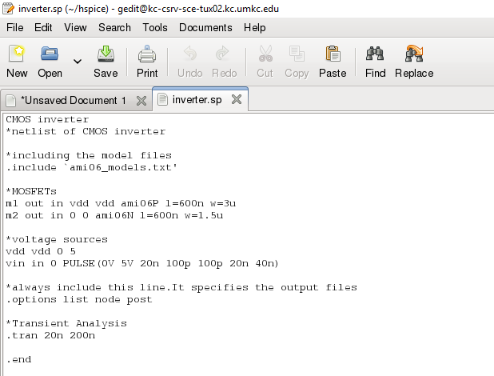

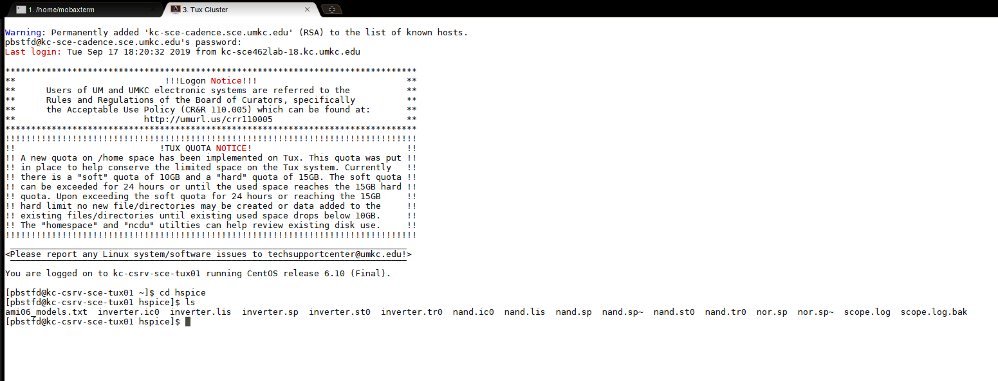

1. The Model file for both NMOS and PMOS also has to be saved in the folder before simulation. This is one time activity. Open the “ami06_models.txt” provided and copy it to another gedit file and save it in same folder.
2. You will see errors again but you can open new TUX window again.
3. To create a output listing, type below command:

hspice inverter.sp > inverter.lis

(inputfilename.sp > outputfilename.lis)

1. After this command you must get “hspice job concluded”. This means there are no errors. To check what errors are in the .sp file, open gedit🡪 open the inverter.lis file (in short open the .lis output listing file)
2. After correcting errors, again run the command from point no. 9.
3. Now, we have to simulate the netlist using CosmosScope. Type below command:

cscope &

1. The simulator window will open. Click on File🡪 Open🡪Plotfiles.

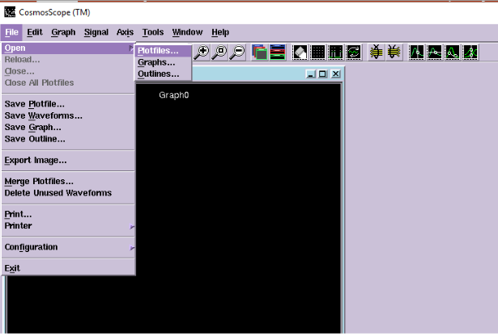

1. Open the “inverter.tr” file. This file is the transient analysis graph data.

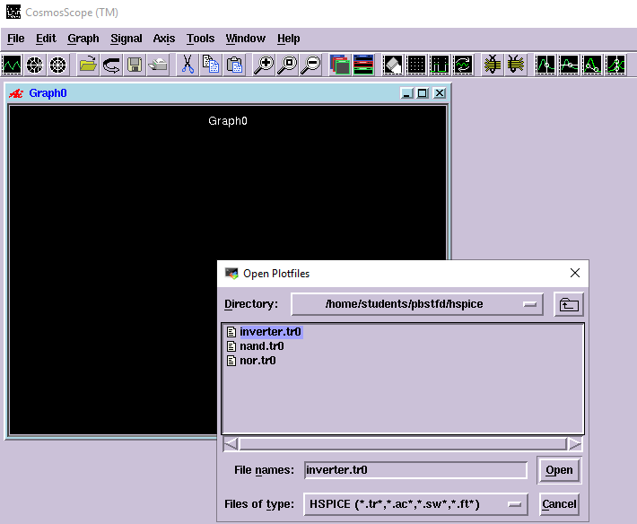

1. Select the inputs and outputs and click on Plot. Verify the graphs with truth table. When input = 0, output = 1 and vice versa.

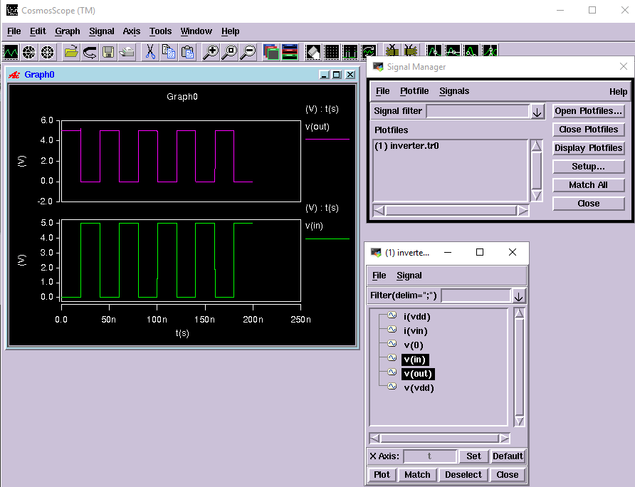

# Tables/Graphs for NAND Gate

1. Netlist NAND Gate (gedit window)

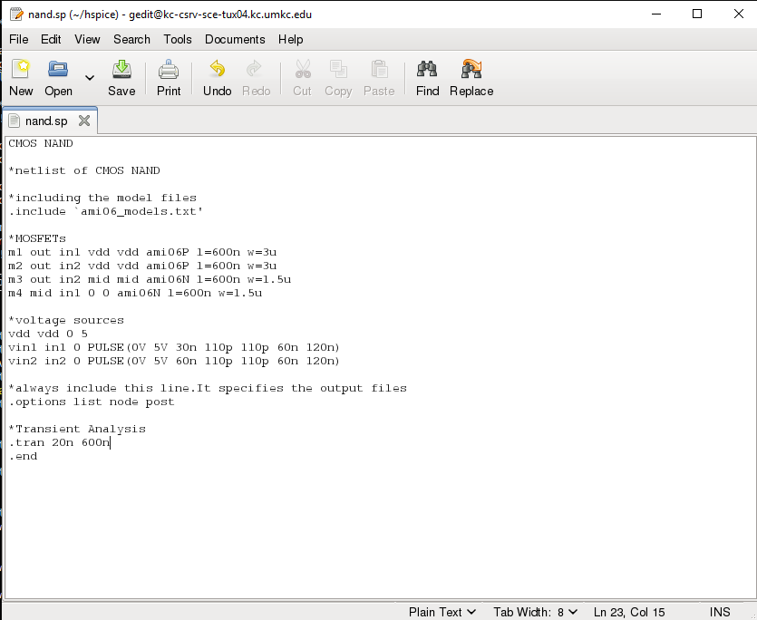

1. NAND Output listing

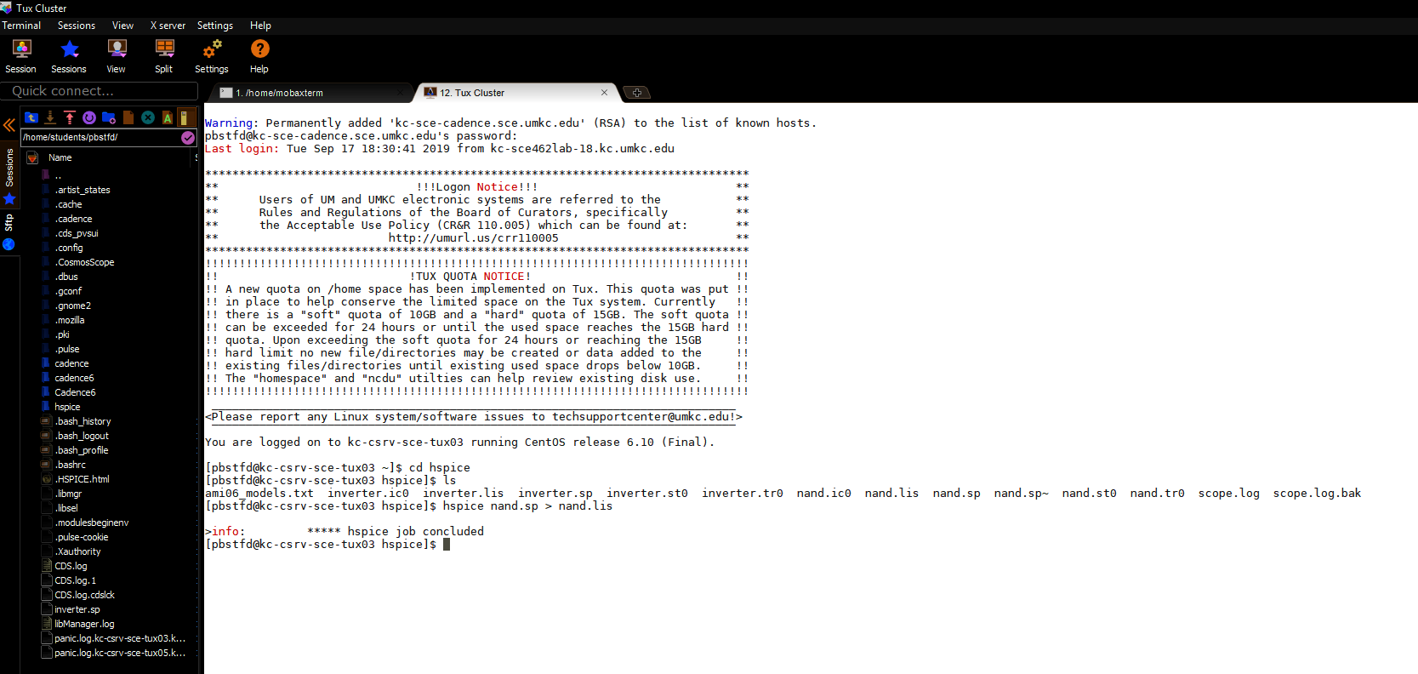

1. NAND open transient analysis file

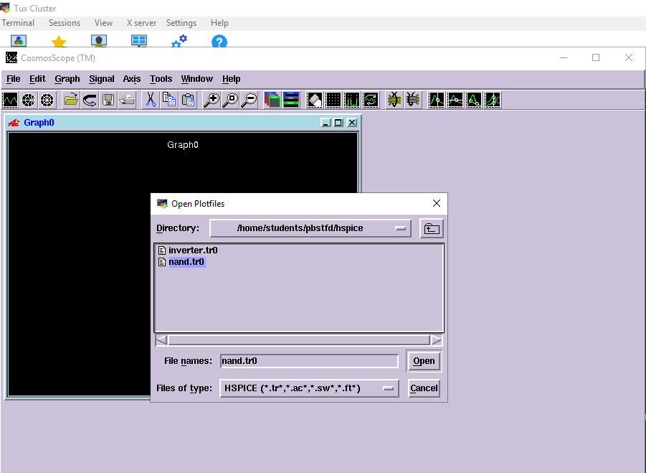

1. CosmosScope simulation: NAND Gate

When any input is zero, output is 1. Output is 0 only when all inputs are 1.

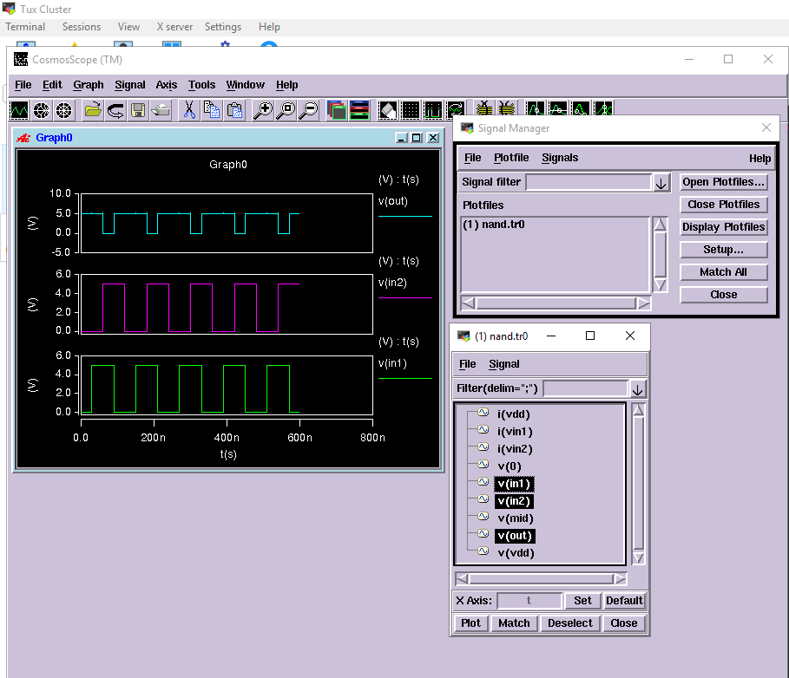

# Tables/Graphs for NOR Gate

1. Netlist NOR Gate (gedit window)

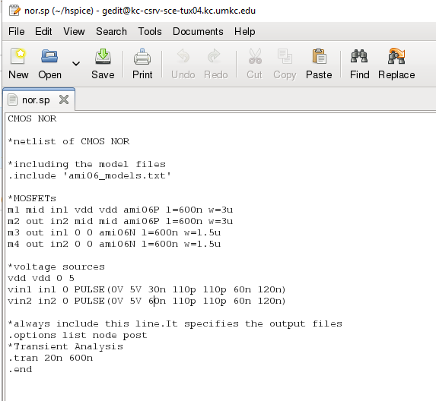

1. NOR Output listing

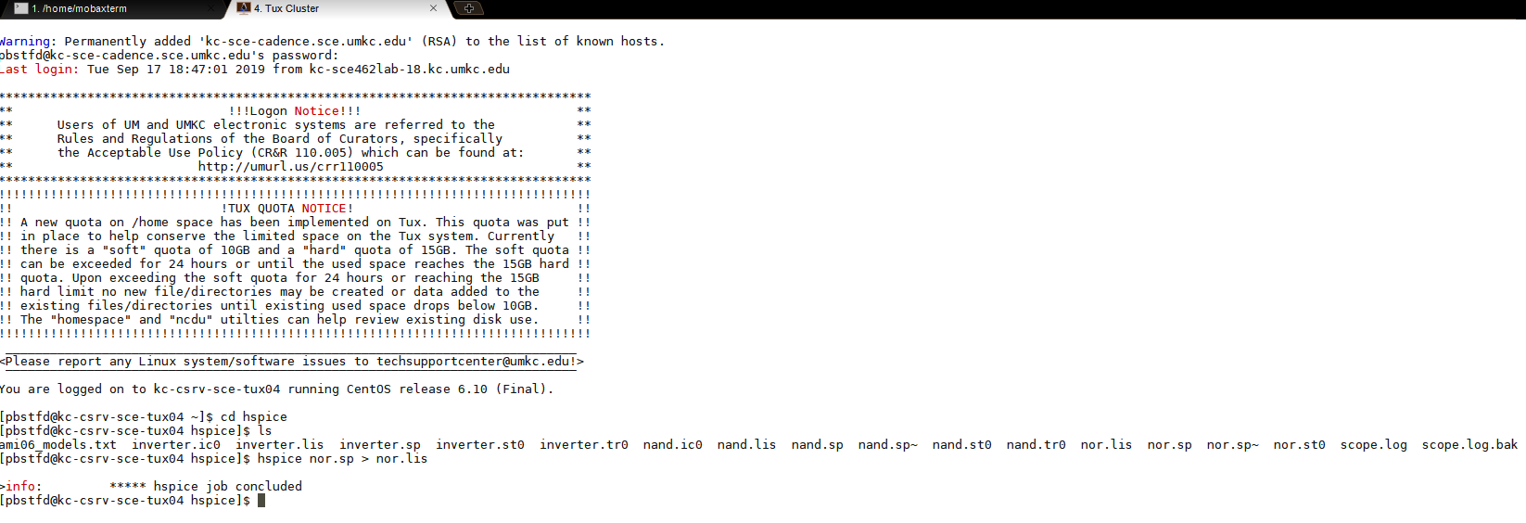

1. NOR Open Transient analysis file

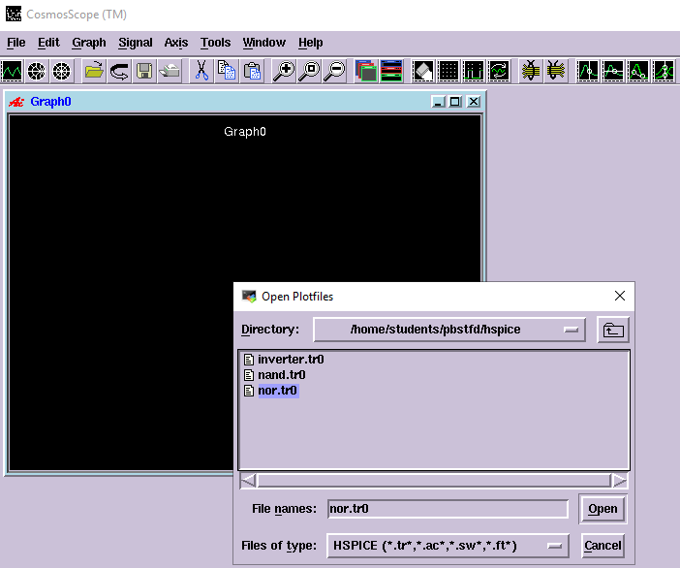

1. Simulation NOR Gate:

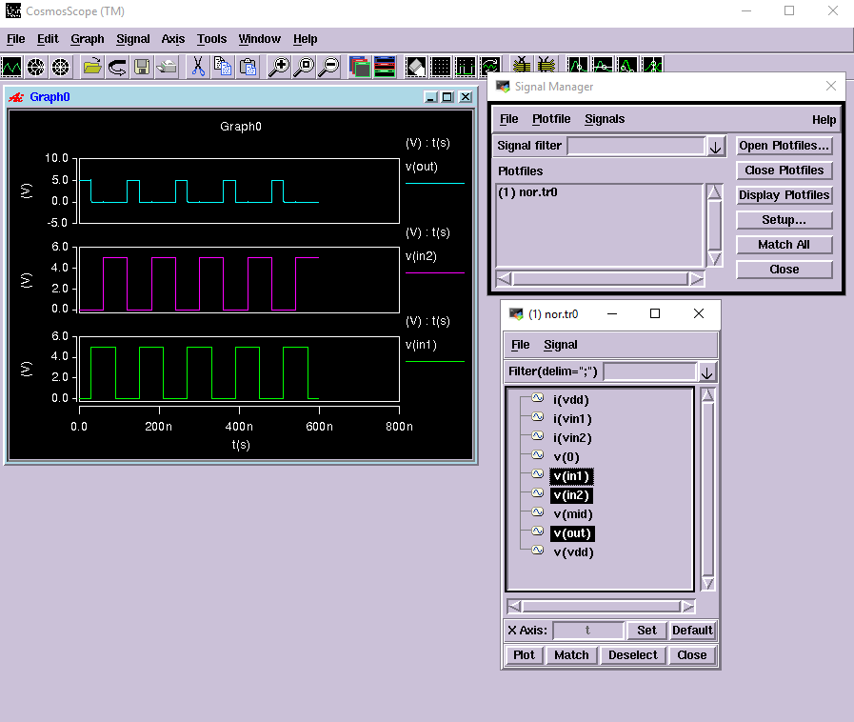

# Discussion of Result

NOT Gate: When input = 0, output = 1 and vice versa.

NAND Gate: When any input is zero, output is 1. Output is 0 only when all inputs are 1.

NOR Gate: When all inputs are 0, output is 1. If any input is 1, output will be 0.

The netlist works perfectly with the model files to simulate the gates. Creating correct listing file is important to get correct simulation output.

# Conclusion

Through this lab tutorial we conclude that HPICE is simpler method to simulate the integrated circuits. We learnt to create netlist for NOT, NAND and NOR gates. The HSPICE software was run on Linux and we learnt the commands to create listing file and simulating the results in CosmosScope.