Course Number: EC-ENGR 5590VL-0001 Special Topics in ECE

Homework: 5

Homework report

**TITLE**

Simulation using HSPICE for OR gate using Sub-circuit

Date of Performing Experiment: 1st October 2019

Due Date: 8th October 2019

**Student ID: 14344331**

**Name: Prerana Samant**

# Objective:

To run HSPICE on Linux platform, to create netlist and simulation of OR gate using the sub-circuit approach.

# Theory:

In HSPICE we can re-use the circuits created earlier in simulating circuits of higher hierarchy. The circuits must be created as sub-circuits for its re-usability. This method is convenient to simulate large circuits. For creating an OR gate in CMOS logic, first NOR gate is implemented, and the output is inverted with a NOT gate. Hence, we can first create sub-circuit of NOR gate and NOT gate and use it to design OR gate.

Circuit Diagram using CMOS:

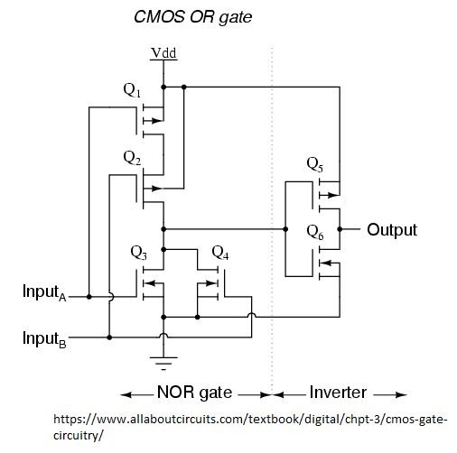

# Procedure to Simulate in HSPICE:

**OR Gate**

1. Start MobaXterm like previous tutorials. Open New Cluster and enter password.
2. Enter the directory hspice.
3. Type below commands:

Cd hspice

gedit &

1. We require the input netlist file in HSPICE and has to be created beforehand and saved at a location where HSPICE is installed. Hence gedit is used to write a netlist input.
2. Type the netlist for sub-circuits, NOR gate and NOT gate as done in last HSPICE tutorial.
3. Define the voltage sources and nets for the main OR block. Save it in the HSPICE folder by name “or.sp”. Extension “sp” is for input netlist.
4. We have used the “.param” to declare width of NMOS and PMOS, Length, rise and fall time, and vdd. We have declared VDD as global variable.

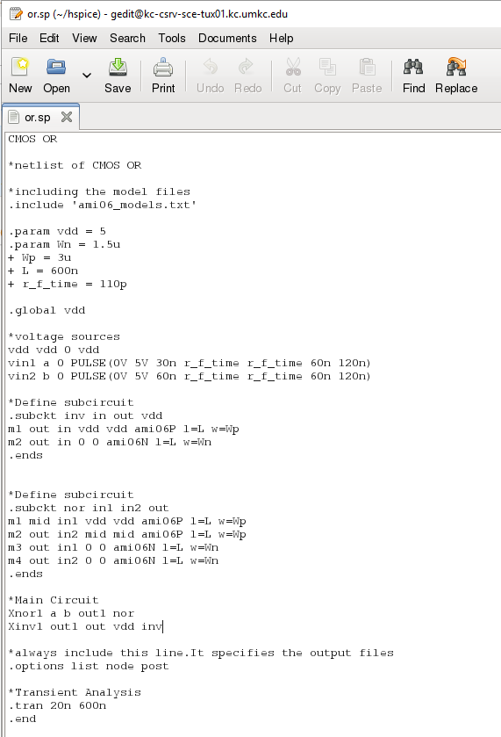

1. The MobaXterm will show some error but still the file gets saved. Close the TUX and Open a new TUX window. Enter password and directly type:

cd hspice

ls

Here you will find the file created.

1. The Model file for both NMOS and PMOS also must be saved in the folder before simulation. This “ami06_models.txt” file will be already available in hspice folder from previous simulations.
2. To create an output listing, type below command:

hspice or.sp > or.lis

(inputfilename.sp > outputfilename.lis)

1. After this command you must get “hspice job concluded”. This means there are no errors. 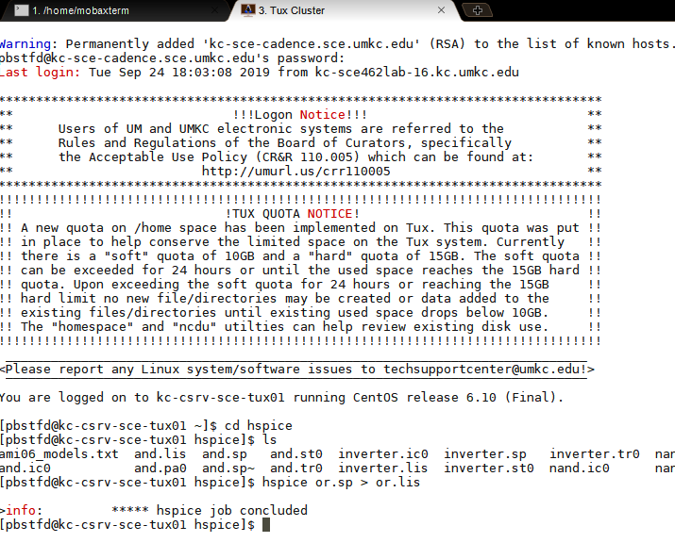
2. Now, simulate the netlist using CosmosScope. Type below command:

cscope &

1. The simulator window will open. Click on File🡪 Open🡪Plotfiles.
2. Open the “or.tr” file. This file is the transient analysis graph data.

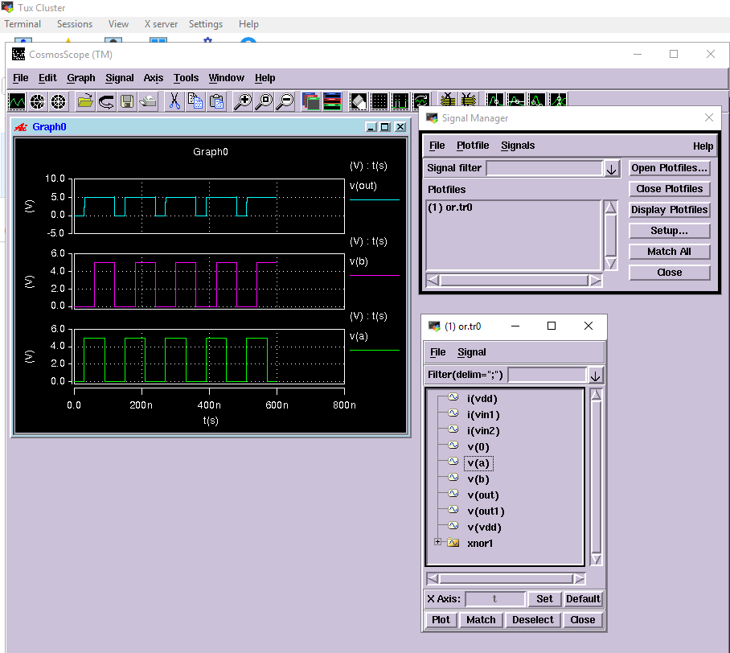

1. Select the inputs and outputs of main module and click on Plot. Verify the graphs with truth table.

# Discussion of Result

OR Gate: When any of the input is 1, the output is 1. If all inputs are 0, then output is 0.

The sub-circuit of NOR and NOT gate can be used to build OR gate. The “.param” command is used in the code for defining the values.

# Conclusion

Through this homework tutorial we learned to create OR gate and simulate it. We can conclude that using sub-circuits in HSPICE helps to re-use the circuits.