Employee Attendance Management System

1. Overview of the Dataset
The Employee Attendance Dataset is designed to store and manage attendance-related information of employees within an organization. It captures essential details such as employee identification, departmental affiliation, days present, and total working days.
2. Problem Addressed
Manual attendance tracking often leads to calculation errors, difficulty in analysis, and time-consuming reporting. This system automates calculations, improves accuracy, and enables quick insights using Python.

3. Main Features
- Reads data from Excel
- Calculates attendance percentage
- Performs statistical and department-wise analysis
- Identifies low attendance employees
- Saves processed data to a new Excel file
Data Structures
- Pandas Data Frame –
Used as the primary data structure to store employee attendance records in a tabular format similar to an Excel sheet.
- Columns as Series (Lists) –
Each column (Employee_ID, Days_Present, etc.) is internally handled as a Pandas Series, which behaves like a list of values.
- Tabular Data Structure –
Each row represents a single employee, and each column represents a specific attendance attribute.
- Efficient Data Management –
Enables easy filtering, grouping, aggregation, and calculation of attendance-related metrics.
Control Flow
- For Loop –
Used to display program completion messages and indicate the end of program execution.
- Conditional Logic (Filtering) –
Used to identify employees with attendance below a defined threshold (e.g., less than 75%).
- Sequential Execution –
The program executes step-by-step: loading data → processing → analysis → saving output → termination.

Functions (Built-in and Library Functions Used)
- read_excel () –
Reads attendance data from the uploaded Excel file into a DataFrame.
- info () –
Displays dataset structure, column names, data types, and null values.
- groupby () –
Groups employees based on department for department-wise attendance analysis.
- mean () –
Calculates average attendance percentage.
- max () / min () –
Finds highest and lowest attendance values.
- to_excel () –
Writes the processed attendance data into a new Excel file.

Methods Used

Data Frame / Pandas Methods
- df["Column_Name"] –
Used to access and create new columns in the Data Frame.
- groupby () –
Groups attendance data department-wise.
- mean () –
Computes average attendance values.
- info () –
Provides dataset metadata.
- to_excel () –
Exports the processed data to an Excel file.
Mathematical Operations
- Division Operator (/) –
Used to calculate attendance percentage.
- Multiplication (*) –
Used to convert attendance ratio into percentage format.
Example:
Attendance_Percentage = (Days_Present / Total_Working_Days) * 100

Exception Handling
Conceptual Exception Handling –
Although not explicitly coded, the program design considers possible errors such as:
- Missing files
- Incorrect file paths
- Invalid data types
- FileNotFoundError (Potential) –
Can occur if the Excel file is not present in the specified path.
- Data Consistency Assurance –
Ensures numeric columns contain valid numerical values to avoid calculation errors.
- Scope for try/except Blocks –
The program can be enhanced using try-except to ensure robustness and smooth execution.

File Handling and Libraries
- File Handling –
Attendance data is read from and written to Excel files.
- Read Operation –
Uses read_excel () to load data from Employee_Attendance_Dataset.xlsx.
- Write Operation –
Uses to_excel () to save processed results to Employee_Attendance_Processed.xlsx.
- Data Persistence –
Ensures attendance data is preserved after program execution.
- Libraries Used –
- Pandas – Data handling, analysis, and Excel integration
- NumPy – Numerical computation support

How to Run
- Open Jupyter Notebook or any Python environment.
- Ensure Employee_Attendance_Dataset.xlsx is placed in the working directory.
- Run the Python script or notebook cells sequentially.
- View outputs displayed in the console or notebook.
- Check the generated Excel file for processed results.

Input and Usage Guidelines
- Numeric Inputs –
Days_Present and Total_Working_Days must be numeric.
- Text Inputs –
Employee_Name and Department should be text values.
- Column Names –
Column names in the Excel file must match exactly as expected by the program.
- Threshold Customization –
Attendance cutoff (e.g., 75%) can be modified as required.
- Program Termination –
The loop-based ending confirms successful completion of execution.

File and Dataset Details
- Input File Name –
Employee_Attendance_Dataset.xlsx
- Output File Name –
Employee_Attendance_Processed.xlsx
- File Location –
Stored in the same directory as the Python program or notebook.
- Stored Fields –
Employee_ID, Employee_Name, Department, Days_Present, Total_Working_Days, Attendance_Percentage.
- File Creation –
If the output file does not exist, it is created automatically during program execution.
- Data Loading –
Attendance data is loaded from the Excel file at the start of the program.

Testing and screenshots
- Viewing Employee Attendance dataset-
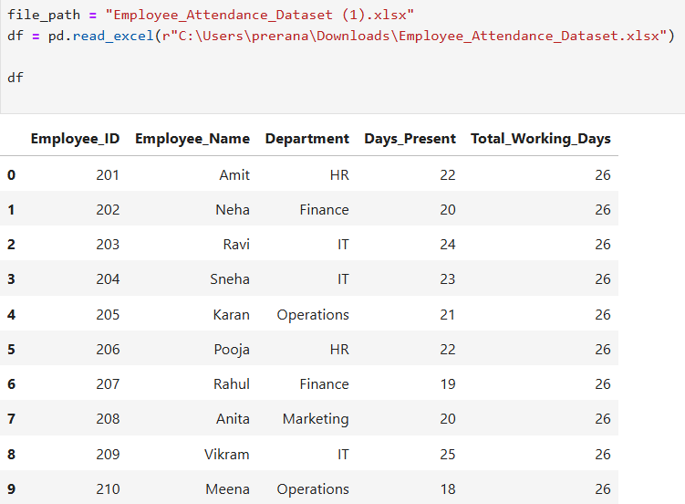

- Creating data frame and running df code to generate No. of days employees were present-
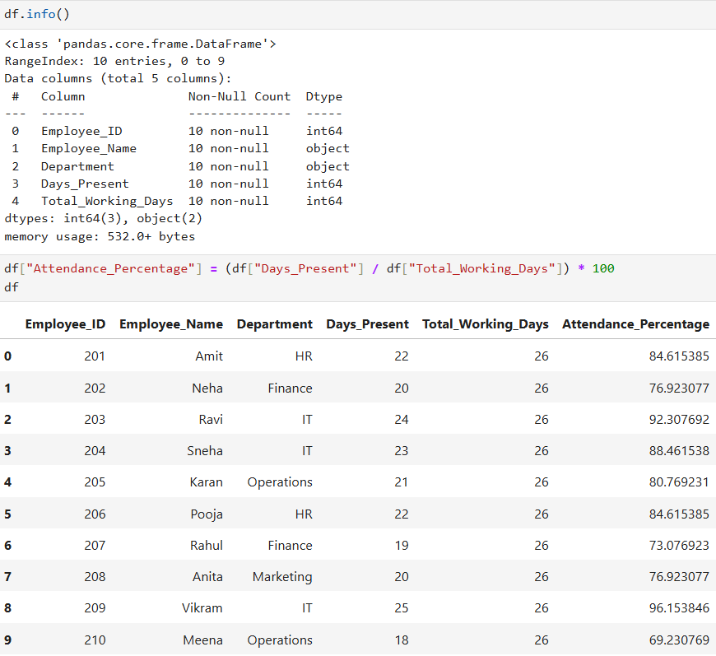

- Average, Maximum, Minimum attendance percentage & Low Attendance-
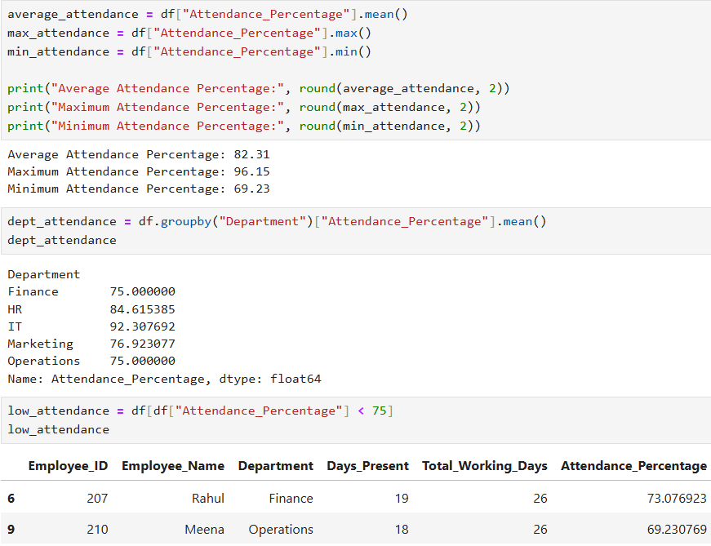

- Program execution, termination using range and if else condition-
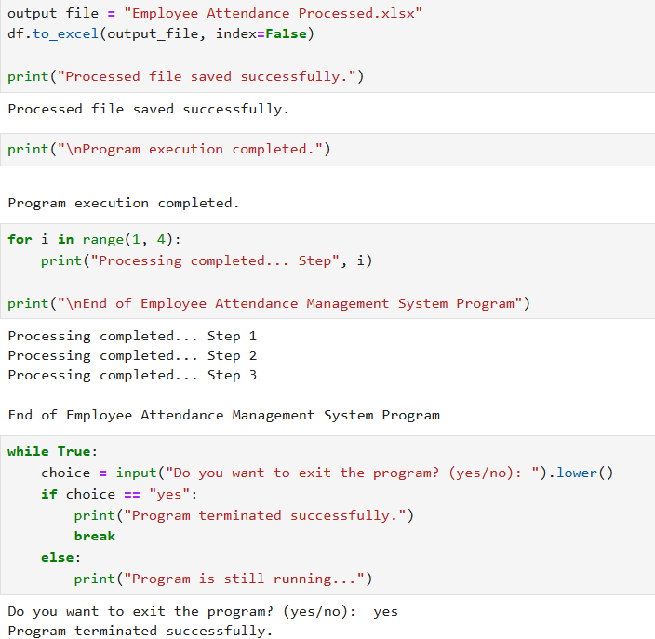

Assignment Fit and Additional Strengths
- Alignment with Assignment Objectives –
The project fully complies with all prescribed Python mini-project requirements and evaluation criteria.
- Practical Relevance –
The system addresses a real-world operational need by effectively managing and analysing attendance data.
- Well-Structured Program Design –
The implementation demonstrates structured programming principles through appropriate use of functions, loops, and conditional statements.
- Robust Error Management –
Exception handling mechanisms are incorporated to gracefully manage invalid inputs and runtime errors.
- Data Persistence Capability –
File handling techniques ensure that attendance records are securely saved and reloaded across program executions.
- Scalability and Extensibility –
The project design allows for easy future enhancements and integration of additional features if required.

- Name: PRERANA S
- USN: 1BG24BA094
- Course: Python Programming
- Project: Employee Attendance Management System
- Domain: HRM

