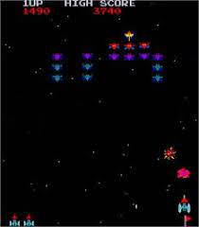

**1.Game Overview:**

* + The game is a top-down view of a spaceship shooter.
  + Enemies try to bring down the player spaceship.
  + Controls are simple and intuitive, arrow keys and WASD keys are used for movement of two players.
  + The distance covered or the enemies killed can be used for tracking score.
  + Collision of a player spaceship with enemies or enemy projectiles decreases its health line.
  + The player respawns where he died after his health line is depleted and returns to the main menu screen when he loses all his lives.
  + The player encounters higher challenges longer he plays due to speeding gameplay, difficult enemies, bosses etc.
  + The player has to complete a level to progress to a further level.
  + Each level will be a distinct combination and variant of enemies.
  + Includes floating power-ups for types of guns, shields etc.
  + Implement a simple leaderboard to track high scores, encouraging competition.

1. **Player Overview:**

* The player moves forward and sideways whilst pointing the gun and face upwards only.
* Damage taken from enemies and projectiles depend upon their types.
* Players can shoot projectiles.

The base gun will be available every time.

The guns gained from power ups will disappear after a certain period of time.

* Player wins the game after all levels are completed.

1. **Minimum Requirements:**

* Collision Detection: Used for interaction of player and enemy with each other and bullets.
* Sound: Different sounds for background music, boss music, main menu/pause music, and sound effects for shooting, hit, death etc.
* Scoring System: The score is based on the type and number of enemies killed.
* Levels: 4 levels with different enemy variants and/or combinations in each level.
* Responsive: Suitable to play in different viewports.
* Multiplayer option.

1. **Add Ons:**

* Multiplayer action with AI.
* Refined animations and game feel.